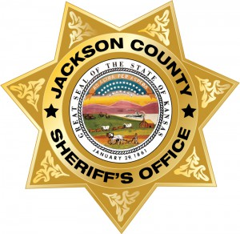
JACKSON SHERIFF
MOST WANTED
Name: Gary Wayne Emery Jr.
Alias:
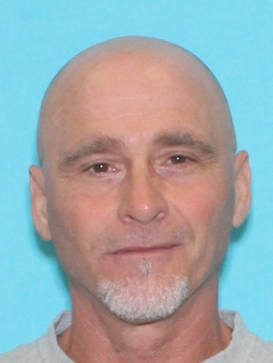
Description
Sex:---------------------------- Male
Race:-------------------------- Caucasian
Age:---------------------------- 52
Place of Birth:----------------Kansas
Height:-------------------------508
Weight:------------------------185 lbs
Eyes:-------------------------- Brown
Hair:--------------------------- Bald
Skin Tone:--------------------Medium
Scars/Tattoos:--------------
Wanted For: ………….…Burglary and Theft
Warrant Issued: ....…....Jackson County District Court
Date of Warrant: ....…....09/14/2023
Warrant #: 23-CR370
Bond: N/A

Suspect Information: Suspect may be in the Jefferson County or Topeka area.

REWARD: A reward is being issued for the information that leads to the capture of Gary Wayne Emery
Contact: The Jackson County Sheriff’s Office, 210 US Hwy 75, Holton, Kansas 66436 or call 785-364-2251.
NOTICE: Before arrest, verify warrant through the National Crime Information Center (NCIC). If subject is arrested or whereabouts known, contact the nearest law enforcement agency. Have a tip? E-mail tim.morse@jasoks.org For more information, see the JASO website: www.jasoks.org

