**JACKSON COUNTY SHERIFF’S OFFICE 2021 ANNUAL REPORT**



**SUBMITTED BY TIM MORSE, SHERIFF**

**JACKSON COUNTY, KANSAS**

**2021 Year in Review**

Each year presents a number of challenges for every law enforcement agency. 2021 was definitely not an exception for Jackson County. Jackson County Sheriff Tim Morse was sworn in for another four year term in January. 2020 provided many obstacles with the ongoing Worldwide Pandemic and those obstacles bled over into 2021 as well. Keeping the Sheriff’s Office and Jail workforce well in addition to keeping an ever growing inmate population from illness was a never ending task. As always, the answer to our success was our amazing staff and the people of Jackson County. Our staff has undergone a tremendous amount of work and sacrifice the last couple of years like many others. The Pandemic has caused an enormous amount of stress and workload for employees of the Sheriff’s Office. As they did in 2020, the Jackson County Sheriff’s Office staff performed magnificently to rise above the challenges of 2021.

It has always been the goal of Sheriff Tim Morse to preserve the great rural life that Jackson County has to offer by aggressively pursuing would be criminals. The Jackson County Sheriff’s Office is here to serve every single citizen in the county. Sheriff Morse understands the desire of citizens to live in freedom without fear of criminal activity. Citizens work hard to earn the things they have and want their children to grow up in a safe society. Sheriff Morse and the members of the Jackson County Sheriff’s Office have worked to build a model law enforcement agency to interdict criminals before they strike. When crime does strike the Sheriff’s Office is there to work to diligently solve those crimes and apprehend perpetrators.

**Communications Division**

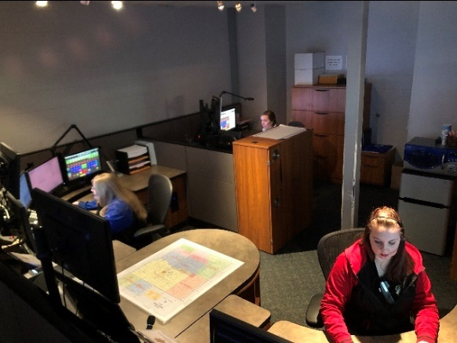The Jackson County Sheriff’s Office Communications Division is the central answering point for 911 in Jackson County. The Communications Center dispatches for five law enforcement agencies, eight fire departments and two EMS (Emergency Management Services) agencies. In 2021, the Communications Center dispatched over 25,000 incidents, although the vast majority were for law enforcement, a number of fire and EMS calls were dispatched as well.

Dispatchers are the true first responders and are the vital link between those in need and emergency services. The Communications Center’s primary responsibility is to assist the citizens within Jackson County. However, our dispatchers received several calls throughout the year from people needing assistance somewhere else. One example of this was a female in Holton called stating she received a call from her son and believed he may be suicidal. We were able to get in touch with him over the phone, but he didn’t know his location due to the amount of medication he had taken. After getting a general location he quickly became unresponsive. We then contacted the sheriff’s office near his location in the southern part of Kansas and deputies were able to locate him. The ambulance arrived soon after and he was transported to a local hospital where he received the care he needed. This is just one example of the many times our dispatchers have worked together with other agencies to provide the best service possible to our community and the citizens of Kansas.

Dispatchers don’t just answer phones and dispatch calls, they also have a variety of other duties including helping individuals who walk into the Sheriff’s Office lobby to seek help. They also are the holder of the warrants for the Jackson County District Court. There are approximately 1,150 Jackson County District warrants that are outstanding. Dispatchers have to confirm whether a warrant is valid when a law enforcement officer encounters a fugitive. When the California Highway Patrol stops a subject and finds they have a Jackson County warrant, Jackson County Dispatchers must confirm whether the warrant is valid or not. Stolen items and missing people are also entered in the N.C.I.C. (National Crime Information Center) system by dispatchers. Dispatchers must confirm when those stolen items or missing persons are found.

The Communications Center also has a state-wide function for Wildlife, Parks and Tourism. The Wildlife, Parks and Tourism’s Operation Game Thief hotline is answered at the Jackson County Sheriff’s Office for the entire State of Kansas.

The Jackson County Sheriff’s Office 911 Center has eight dispatch positions, but have been short staffed all year. Thanks to our dedicated staff there has been no interruption of 911 services.

**The Communications Center dispatched the following number of incidents for the various agencies in 2021:**

**Jackson County Sheriff** **18,443**

**Holton Police Department 690**

**Jackson County EMS 1,534**

**Hoyt Police Department 517**

**Mayetta Police Department 85**

**Wildlife and Parks 22**

**Operation Game Theft 1,343**

**Kansas Highway Patrol 119**

**Potawatomi Tribal Police 262**

**Netawaka Fire Department 111**

**Mayetta Fire Department 536**

**Soldier Fire Department 102**

**Holton Fire Department 75**

**Delia Fire Department 168**

**PBPN Fire/EMS 333**

**Whiting Fire Department 104**

**Hoyt Fire Department 557**

**Jackson Co. Storm Spotters 2**

**911**

The total number of 911 calls received at the Jackson County Sheriff’s Office in 2021 was **4,108**.

Additional information regarding administrative calls in and out of the Sheriff’s Office is as follows:

**Admin calls:** Incoming calls: **24,328**

Outgoing calls: **12,754**

**Sheriff’s Office Grant Projects**

For the past several years the Sheriff’s Office has sought out and utilized federal grant funding to strengthen our overall efforts to protect and serve the community, without adding additional financial burdens to the residents of Jackson County. Since starting these efforts in 2016, the Sheriff’s Office has been awarded $1,197,295.00 in federal funding to support our mission. Last year the Sheriff’s Office applied for and received three grants to build our capacity in a variety of areas. All these funding opportunities were made possible by the U.S. Department of Justice.

**The Federal Edward Byrne Memorial Justice Assistance Grant (JAG)**

This grant provides criminal justice systems and community partners funding opportunities to address crime and public safety concerns. The Kansas Criminal Justice Coordinating Council (KCJCC) is responsible for overseeing these federal funds. The Kansas Governor’s Grants Program (KGGP) serves as the staff for the KCJCC and point-of-contact for the federal JAG program. In October 2021 the Sheriff’s Office was awarded $75,186.00 to purchase new equipment and technology to enhance officer safety, suspect apprehensions and investigations.

**The Federal Victims of Crime Act (VOCA)**

The Victims of Crime Act, passed by President Ronald Reagan in 1984, created the Victims of Crime Act Fund, or VOCA Fund. This established a dedicated source of funding to support victim service programs. This funding source does not depend on taxpayer dollars, the funds are derived from fines and penalties paid by convicted offenders at the federal level. Last year the Sheriff’s Office was awarded $82,675 to continue funding of our victim service division. This division is in its 7th year of operation and funding. The mission of this project is to provide crime victims with access to immediate information, referrals, crisis services, ongoing criminal justice support as well as to strengthen and expand aid to crime victims in Jackson County. All services are provided free of charge to crime victims and their families.

**Federal Services*Training*Officers*Prosecutors Violence Against Women Formula Grant Program (S.T.O.P. VAWA)**

This grant funding source was established through the 1995 Violence Against Women Act and following reauthorizations. The S.T.O.P. VAWA funding seeks to support communities in their efforts to develop and strengthen effective law enforcement and prosecution strategies to combat violent crimes against women, strengthen victim services and promote a coordinated community response to victims of domestic violence, dating violence, sexual assault/rape, and stalking.

This grant project started in 2019 and funds a full-time detective position that specializes in investigating these violent crimes for the Sheriff’s Office. Research widely acknowledges the most effective strategy, particularly for smaller communities, is to have at least one specifically trained professional on staff to handle these cases. This is because crimes of this nature require trauma informed professionals and are often the most difficult and timing consuming to investigate.

**Patrol Division**

The Jackson County Sheriff’s Office Patrol Division is comprised of three elements. These elements include Patrol, Court Security, Registered Offenders, Civil Process and the School Defender Initiative program. The uniformed Patrol Division is under the leadership of Captain Scott Morris.

The Patrol Division continues to be the primary enforcement division, and is the most visible division of the Sheriff’s Office.  The Patrol division has the responsibility of patrolling, traffic enforcement, accident investigation, and responding to calls for service in Jackson County. In 2021, the Patrol Division initiated and/or responded to 18,333 calls for service. The Patrol Division provides proactive enforcement for the citizens of Jackson County, these Deputies vigorously patrol 24 hours a day, 365 days a year. They strive to remain visible in high crime areas and work to keep crime rates low.

The Jackson County Sheriff’s Patrol Division Deputies patrol an estimated half a million miles of Jackson County roadways each year. The Patrol Division answers calls for service in the entire county. The Patrol Division also assists other agencies within and surrounding Jackson County.

In addition to patrolling the roadways of Jackson County, Patrol Deputies work diligently to provide quality community policing within our county. This is done by working in the communities, participating in programs and events that establish a positive relationship between law enforcement and the public.

The Patrol Division currently consists of four shifts, with each being led by a sergeant. Patrol Deputies have a variety of functions while on duty. Deputy Sheriffs serve warrants, patrol Jackson County, conduct investigations, enforce traffic laws, serve civil process and make arrests. Three Police Service Dog teams are assigned to the Patrol Division as well.

**Patrol Division notable responses in 2021**

**Jackson County Sheriff Deputies respond to a report of an individual choking at a Holton Restaurant.**

On 01/22/2021 at approximately 11:55 hours the Jackson County Sheriff Dispatch received a 911 call, in reference to an individual at Trails Café in Holton that was choking and turning blue. Sgt. Matt Honas was patrolling nearby and immediately responded. Upon arrival Sgt. Honas exited his patrol vehicle and without hesitation ran into the business. Once inside, he located the choking subject, quickly evaluated the situation and rendered aid. Sgt. Honas began to administer abdominal thrusts in an attempt to dislodge the obstruction. After a short time and the application of approximately six abdominal thrust the object was successfully dislodged, allowing the subject to breathe freely. The man was able to regain his composure, began breathing on his own and refused any further medical attention. Once EMS was on scene Sgt. Honas returned to his patrol vehicle and resumed his patrol duties.

The selfless actions by Sgt. Honas that day are an excellent representation of both courage and compassion, which exemplifies the Jackson County Sheriff’s Office commitment to duty, and the citizens that we serve. **There is no doubt from the testimony of bystanders who witnessed the incident, and video footage, that the gentlemen possibly would not have survived if it were not for Sgt. Honas’s quick thinking and response.** Sgt. Honas’s decisive and selfless application of life saving measures are without a doubt a true reflection of the Jackson County Sheriff’s motto of Honor, Courage, and Fidelity.

**-On 05/10/2021 Deputies responded to a Rural Holton Home that is destroyed by an explosion, leaving one person dead another seriously wounded.**

**-On 10/13/2021 pursuit of stolen vehicle leads to arrest at 8th and Fairlawn in Topeka.**

**_On 08/16/2021 Rape suspect arrested after multi agency manhunt**

**-On 08/03/2021 Jackson County Sheriff’s Office hosts a local National Night Out event.**

**-On 09/16/2021 Soldier man arrested following armed domestic incident**

**-On 12/07/2021 Suicidal subject safely taken into custody following lengthy pursuit and standoff.**

**Patrol calls for service in 2021**

In **2021**, the Patrol Division either responded to, initiated and or investigated the following:

24 - Mental/Suicidal (55 in 2020)

626 - Escorts/Transports

1216-Civil Process (914 in 2020)

576 – Arrest Warrants (252 in 2020)

4983 - Car Stops (4585 in 2020)

19-Vehicle pursuits (19 in 2020)

03-Fatality Accidents (2 in 2020)

248- Non-Injury Accidents (238 in 2020)

85 - Injury Accidents (78 in 2020, 88 in 2019)

19 - Structure Fires

47 – Fire calls (non-structure)

85- Alarm Calls (107 in 2020, 165 in 2019, 154 in 2018)

14 - Fight Calls (11 in 2020, 23 in 2019, 33 in 2018)

61 - Domestic Violence Calls (116 in 2012, 118 in 2019, 125 in 2018)

16 - Assault/Battery/Harassment Calls (27 in 2019, 53 in 2019, 101 in 2018)

11 – Stolen car (18 in 2020)

471 - Animal Calls (560 in 2020, 595 in 2019)

831 - Assist Citizens Calls (1,016 in 2020, 1,106 in 2019)

573 - 911 Hang Up Calls (562 in 2020, 534 in 2019)

83- Disturbance Calls (72 in 2020)

366- Suspicious Person/Activity Calls (302 in 2020, 375 in 2019)

15 – Missing person (07 in 2020, 08 in 2019)

101 - Juvenile Calls (86 in 2020, 91 in 2019, 161 in 2018)

32 - Sex Offenses (31 in 2020, 28 in 2019, 50 in 2018)

185 - Welfare Checks (129 in 2020, 140 in 2019)

15 – Dead person (12 in 2020)

144 - Theft Calls (160 in 2020, 285 in 2019)

262 - Receive Information/Service Request Calls (267 in 2020, 376 in 2019)

898- Service Request (800 in 2020)

673 - Traffic Problems (803 in 2020, 746 in 2019)

3,591 - Building/Area Checks (6,614 in 2020, 5,040 in 2019)

24 - Illegal Hunting/Criminal Trespass Calls (20 in 2020, 12 in 2019)

389 - Back Up/Assist Other Agency Calls (131 in 2020, 122 in 2019)

14 - Search Warrants (20 in 2020, 31 in 2019, 30 in 2018)

15 - Vandalism/Criminal Damage to Property Calls (31 in 2020)

12 - Illegal Trash Dumps (10 in 2020, 14 in 2019, 12 in 2018)

314 - Speak with Deputy Calls (355 in 2020, 426 in 2019, 286 in 2018)

19 – Pursuits (19 in 2020, 24 in 2019)

15 – Road slide offs (35 in 2020, 58 in 2019, 67 in 2018)

91 – Assist outside agency (131 in 2020, 130 in 2019)

89 – Abandoned vehicle (111 in 2020, 104 in 2019)

178 – Medicals (159 in 2020, 222 in 2019)

19 - Criminal Trespass (17 in 2020, 47 in 2019)

800 - Service requests

262 - Receive information (267 in 2020)

1 – Haz Mat incident

**Police Service Dog Program**

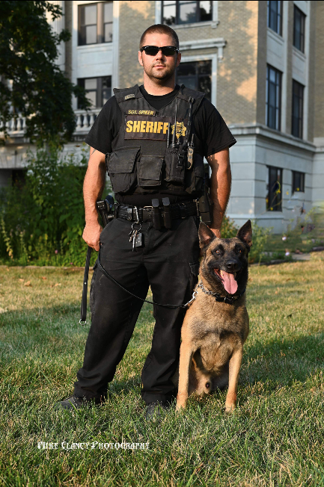

Sgt. Travis Spiker and Ike

The Jackson County Sheriff’s Office Patrol Division is fortunate to include a Police Service Dog Unit. The PSD Unit is comprised of three teams with each team including a canine and handler.

For many years now canines in the United States have proven to be a vital part of law enforcement. These dogs utilize their unique skills and abilities to enhance the safety of their human counterparts on a daily basis. Since the 1990’s Canine Teams have been a part of the Jackson County Sheriff’s Office. These teams have been used to locate contraband, find lost citizens, apprehend criminal suspects, recover evidence, and protect officers.

The job of a Sheriff’s canine team is one that is very demanding, it requires a huge commitment from both the handler and dog. To become a certified Police Service Dog Team, they must first complete very intensive basic training, which is approximately 10 weeks long. During this training the teams receive instruction in a number of areas, to include narcotic detection, handler protection, tracking, and apprehension. Once the team has successfully completed the basic training and certification, they must attend weekly maintenance training in order to remain proficient in their skillsets. Even though the position of canine handler is extremely demanding, it also very rewarding, the longer the team works together, the stronger their bond becomes.

Currently the Jackson County Sheriff’s Canine teams are comprised of Sgt. Travis Spiker with his assigned PSD Ike, Deputy Lane Slocum with his assigned PSD Mate, and PSD Kreto, who will be paired with a new handler in early 2022.

In addition to Sgt. Spiker’s duties as a PSD handler, he also serves the Sheriff’s Office as a patrol supervisor.

**Jackson County Sheriff’s Office adds new Police Service Dog Team in 2021:**

In early 2021, Jackson County Sheriff Tim Morse announced that the JASO PSD Unit would be adding a new Police Service Dog team. This addition would bring the total number of JASO PSD Teams to 3, providing better availability to the Patrol Deputies and other officers in the area. In July PSD Mate was purchased from Hill Country Dog Training Center in Pipe Creek Texas. Deputy Lane Slocum was selected as the handler. Lane and Mate soon began the strenuous basic training program and successfully completed it in late summer. This was the first time that Jackson County Sheriff’s Office conducted its own K-9 Training Program. Captain Scott Morris served as the instructor for the program. Having the training program in house saved on travel and overtime. Captain Morris has provided Jackson County with one of the state’s best K-9 programs. Once their initial training was completed the team immediately went to work and providing an impact on criminal activity in the Jackson County Community.

**Sheriff Canine assists with illegal drug arrest that leads to search warrant of local residence:**

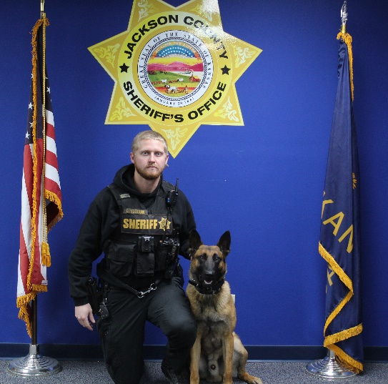On December 14th, 2021, a Jackson County Deputy initiated a traffic stop on a vehicle in the area of K16 Hwy & K79 Hwy. During the stop the Deputy became suspicious of illegal activity and requested a K9 sniff of the vehicle. PSD handler Deputy Lane Slocum and his assigned PSD (Mate) arrived on scene and conducted the sniff. Deputy Ballenger was working on a written warning for the driver. Mate made a positive indication to the presence of illegal drug odor on the vehicle. A search of the vehicle revealed a large amount of Methamphetamine. The driver was arrested and transported to the Jackson County Jail. Just prior to being stopped the vehicle had left from a residence in rural

Deputy Lane Slocum and Mate

Jackson County.

A search warrant for the residence was sought and obtained. During the service of the search warrant more Methamphetamine and drug paraphernalia was located. A resident of the house was arrested as well.

**Training:**

Law enforcement is an extremely demanding field that is constantly changing and challenging; therefore, it requires officers to have specific skills and knowledge. The Jackson County Sheriff’s Patrol Division recognizes that training of officers is essential to develop and maintain the skills and knowledge necessary to prepare our officers to do their jobs both safely, and lawfully. The Patrol Division provided a number of training opportunities throughout 2021. The Jackson County Sheriff’s Offices makes much of this training available to other law enforcement agencies as well. Some of the training provided in 2021 included Police Service Dog training, Open Area Suspect Search (manhunt), Vehicle Stop Tactics/Safety, and Building Clearing. The Jackson County Sheriffs’ Office understands that a better trained officer, is not only safer for officers, but also the citizens that they are sworn to protect.

**Sheriff’s Office provides training**

In October of 2021 the Jackson County Sheriff conducted a large scenario based training session at Banner Reservoir. This training involved coordination with several units of the agency, including patrol, police service dogs, dispatch, command truck and drone. During this training deputies and officers received both instructional and practical training. The training was open to other agencies.

**Court Security**

The Jackson County Sheriff’s Office Patrol Division provides court security for the Jackson County District Court. Deputies keep the court rooms free of weapons and maintain order. In addition, deputies make arrests and take custody of inmates that are remanded to the Sheriff by the court. The year of 2021 continued to be challenging with the COVID pandemic still looming, and construction in the courthouse. Many times, during 2021 court proceedings were altered to better provide for public health, with many cases being heard remotely utilizing computer cameras via Zoom. As always, the JASO Deputies handled this challenge professionally and continued to provide the citizens of Jackson County with a safe and professional representation in the courtroom.

**Offender Registration**

The Jackson County Sheriff's Office is currently monitoring a total of 50 registered offenders. This includes thirty-nine (39) Sex offenders, three (3) drug offenders, and eight (8) violent offenders. The Jackson County Jail is currently holding fourteen (14) registered offenders. The registered offenders in the Jail are not necessarily offenders from our county, they may have to register in other counties, but have been arrested in Jackson County for other crimes. The Jackson County Sheriff's office has ten (10) Juvenile offenders obligated to register in our county.

**Offender Registration Explanation**

The Jackson County Sheriff's Office is responsible for keeping track of registered offenders in Jackson County. Most people associate a "Registered Offender" with a sex crime. The truth is, the Kansas Offender Registration Act (KORA), requires the Sheriffs, of all Kansas counties, to track other offenders as well. KORA states that, aside from sexual crimes, individuals adjudicated of certain drug and violent crimes must register.

Once a person is required to register, they must do so quarterly. The registration is done from the individual's birth month and every third month after. This obligates an offender to register four (4) times a year. The offender must also notify the Jackson County Sheriff's Office of any changes in vehicles, addresses, phone numbers, etc. within three (3) days of the change. All offenders are obligated to make sure they remain compliant, or, they will be charged with a registration violation.

Though the Jackson County Sheriff's Office only monitors Fifty (50) offenders regularly, we are responsible for the initial registration of any person prosecuted in the Jackson County court system. If a person lives in another county, it is the Jackson County Sheriff's Office that must do an initial registration before that person can register with their county. The offender is required to complete initial registration within three (3) business days of conviction. Even if the individual is in jail, they are to be entered.

If a registered offender is arrested and placed in jail for any length of time, their obligation to register is suspended. This means that if an individual is required to register for fifteen (15) years, goes to jail after two years of registration, and serves three (3) years in jail, they still owe a registration obligation to the state of

thirteen (13) years. The Jackson County Sheriff's Office is responsible for ensuring offenders stay compliant or face charges for failing to comply with the law.

**Civil Process and Explanation**

The Jackson County Sheriff's Office served just over 1200 civil process papers in 2021. An important part of the American court system is process service. There are many different types of service, from tacking to personal, which is another responsibility of the Sheriff's Office. When a case is filed in court, the individual(s) named in the case must be notified so they can defend themselves or appear as a witness. The Jackson County Sheriff's Office is tasked with these notification duties in the form of Process Service.

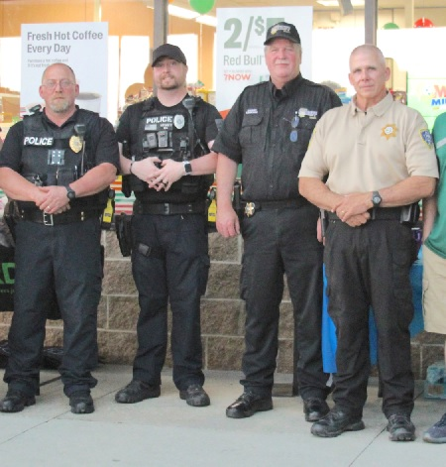Process refers to the starting point of a court case and informs the individual(s) they need to show up for court or they could lose the case by default. If a person refuses to show, or accept a paper, they could also be charged with "obstruction." Obstructing the legal process is a crime, even if you're facing a civil case. Refusal to allow the process to move forward can cause more problems than simply showing up for court. Notification for civil cases on the reservation are handled by the Prairie Band Potawatomi Tribal Police Department. However, all criminal summons, state tax warrants, and Subpoenas are done by the Jackson County Sheriff's Office.

Figure Chief Steve Frederick, Officer Matt Storey, Sheriff Tim Morse and Capt. Scott Morris

Vehicle Maintenance

The Jackson County Sheriff’s Office is continually improving the equipment responsible for the safety of the county. Maintaining clean, functioning vehicles, are one way of ensuring both officer and public safety.

The Jackson County Sheriff's office completes routine in-house maintenance on all vehicles to ensure the best response times. The vehicle(s) are inspected and repairs are done immediately, when discovered. If a vehicle breaks down on the way to a call for service, a citizen or even an officer could be injured.

Taking care of our vehicles has provided a higher trade in value for the county.

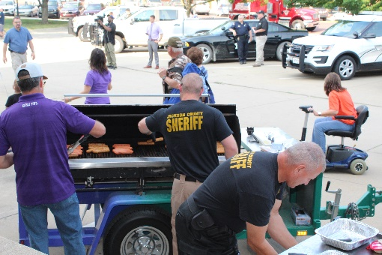

**School Defender Initiative**

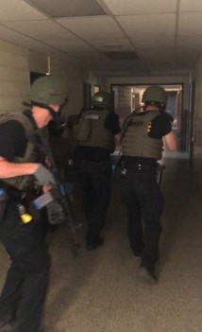In 2018, Sheriff Tim Morse voiced his ideas in making Jackson County Schools safer. Sheriff Morse who has seen senseless killings in our nation’s schools and believes there are better ways in keeping children safe in schools. In 2019, Sheriff Morse was featured in the Kansas Leadership Journal. The article discussed some of Sheriff Morse’s goals in making Jackson County schools safe.

Sheriff Tim Morse stated the following in a 2018 Op-Ed article: *“The first thing parents do after hearing about another school shooting is they confirm it isn’t their child’s school. Enough is enough, when will our politicians get it? For over 20 years now, children have been the targets of deranged persons who have slaughtered innocent children in a place we expect them to be safe, their schools.  In 20 years, our federal and state government has done little to nothing to make them safer. The time has come for the people to stand up and demand that their children be protected from these disturbed individuals. Unfortunately, for a variety of reasons, there has been an increase in deadly violence among some of our young people. Nevertheless, our world is a different place than it once was.”*

Deputy Joe Romans has been tasked with the assignment of implementing Sheriff Morse’s School Defender Initiative program. For over the past three years Deputy Romans has been working with Jackson County School Districts to improve the security of their facilities and provide a much safer environment for our children.

Deputy Romans is an excellent representative for the Sheriff’s Office for this position as he brings great experience and knowledge to the position.

CSM C. Joseph (Joe) Romans retired in December 2008 after a 30 years of active duty service.    Deputy Romans first enlisted in 1968 and served with the Marine Corps as a Corpsman for 4 years. He was honorably discharged in 1973 and then pursued a career as an EMT and Paramedic in Indianapolis and then 5 years as a Remote Arctic Air Force Radar Site Medic in Alaska. He re-enlisted in the Army in 1982 and served for 26 more years.

In 2021, the Jackson County Sheriff’s Office continued to move forward with the school defender initiative despite the challenges presented by the COVID-19 pandemic.

In 2021, 52 Jackson County School Staff were trained and certified by Deputy Joe Romans in “Stop the Bleed” class.

Deputy Romans wrote and implemented a school bus emergency operations plan. School bus drivers in all three school districts were trained in actions to keep school children safe during an active crisis event.

Deputy Romans conducted a multi week detailed and thorough security assessment of three more schools. Jackson Heights high school and middle school, and Royal Valley middle school. This detailed and thorough multi week assessment identified many areas for improvement, in safety and security, including infrastructure, emergency operations plans, equipment, procedures, staff and student training. Of the 9 schools, 6 have now have the security assessment. In 2022, the remaining three school assessment will be completed.

JASO responded to a school shooting threat at Holton HS, kept a deputy presence at the school until the suspect was apprehended.

JASO safety and security training was conducted by JASO Deputy 335 for over 90 Holton hospital nursing staff.

JASO Deputy 335 conducted training and concealed carry certification for the Holton First Baptist Church Security Team. A security assessment for the church was conducted with a list of improvements identified, suggested and implemented.

A.L.I.C.E. (Alert, Lockdown, Inform, Counter, Evacuate) training will be completed for over 200 School staff and bus drivers in 2022.

JASO Deputies in 2022 will continue to train on tactics and procedures for active violence events at schools.

A multi-agency active shooter exercise will be conducted in the fall, at a JC school location (to be determined), as a capstone to several years of preparation and training.

Other actions provided by 335. The armored HUMV was brought up to operational capability at a nominal cost for the improved security and safety of JASO Deputies and JC citizens. 335 obtained government surplus equipment to assist the JASO maintenance supervisor in his duties. A forklift, skid steer, 60 KW generator, 5 KW generator, a tandem axle trailer for Investigations and Patrol use on major incidents.

Deputy Romans provided ground security fort the JC Health care team over a multi week period during the covid vaccination effort at the Fairgrounds.

**Jail Division**

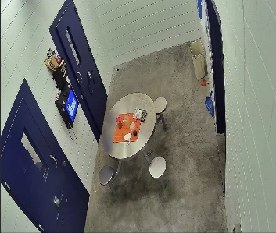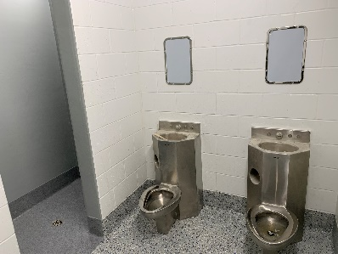In 2021, the Jackson County Jail opened up the new addition to the Jail for housing. Federal funding provided for the addition of a medical isolation holding unit. This addition also provided restroom and showers in each cell as well as restroom and shower facilities that are adjacent to another inmate holding area. The complete addition provided for space for 20 additional inmates if needed. The isolation area can also be used for segregation or extra holding space when medical isolation isn’t necessary.

It has been yet another changing and challenging year for the Jackson County Jail and its staff. Covid has changed the way we do business and operate in the jail. The vast majority of our court appearances happen over Zoom now. These changes have reduced the need to move big numbers of inmates to the court house. Due to Covid restrictions with District Court, the Jail only made 32 trips to District Court with inmates this year.

Jail staff have been busy transporting inmates almost every day this year. The Jail logged 975 transports over the past year. Early in the year, Jail staff had to transport inmates to either the hospital, or the Health Department for Covid testing. The Jail has implemented their own in-house Covid testing procedure for inmates and employees. This move has helped lower transport costs and quarantine time. The Jail transported over 200 inmates being held on Jackson County warrants in other counties this year. Staff made over 350 trips to the Federal Court house and about 107 Doctor Visits. Over 55 inmates were transported from Jackson County to the Kansas Department of Corrections. The Jail made 10 juvenile transports either to or from juvenile holding facilities. Jail transport staff transported 29 inmates to other counties that were being held on their warrants. These transports were made to make more room in the Jail facility. Staff transported 77 inmates for Covid testing along with other transports that were not classified such as out of state extraditions.

Jail staff booked in and processed 1,351 people this last year. This takes a considerable amount of manpower hours as it takes between 40 to 60 minutes to process one person into the jail. The Jail averaged around 92 inmates in the jail throughout the year. The average local inmate count for the year was 49.41 from Jackson County and 42.33 were contract inmates from various agencies. The highest monthly average was in December, with a daily average of 116 inmates, 66 of those being local and 50 contract.

The Jail provided inmate housing for 5 additional agencies. These agencies were federal, state and county. The Jail is tasked with providing a portion of the agencies budget from inmate housing. Much of the necessities for inmates no longer comes from taxpayer monies, but comes from the inmate welfare fund. These funds are generated from inmates through inmate commissary and inmate telephone services.

To be more competitive in the job market, a pay increase was approved by the BOCC for corrections officers in 2021. Prior to the increase, it was becoming difficult to attract and keep employees due to many new opportunities. The Jail moved from 8 hour shifts to 12 hour shifts in order to provide a more attractive schedule for employees. Over all, the Jackson County Jail Division continues to improve all the time. They are headed in a good direction and continue to look for better and more efficient ways to serve the county they represent.

**Investigations Division**

The Jackson County Sheriff’s Office Investigation Division is tasked with investigating person and property crimes for all of Jackson County. This division has both detectives that are generalists, investigating a myriad of crimes, as well as two specialized positions. Our specialized investigators are charged with addressing two very serious crime areas, Narcotics investigations and violent crime investigations. These positions have extensive field specific training and provide the Sheriff’s Office with expertise to develop the best practices and procedures to effectively combat violent crimes and narcotic crimes for Jackson County.

As a unit, these detectives are responsible for making collaborative efforts with neighboring counties and agencies to maximize resources and organize efforts to respond to serious crimes. These efforts have included the development of a central point for criminal intelligence sharing in Jackson County, access to child advocacy centers and forensic interviewers for young child victims of violence and access to technology assistance when investigating internet crimes against children.

Most recently In December 2021, the Jackson County Sheriff’s office joined the newly formed Kaw Valley Anti-Human Trafficking Task Force. This task force includes several local law enforcement agencies, state agencies and the Shawnee County District Attorney’s Office. The purpose of this Task Force is to identify, prevent, investigate, disrupt, and prosecute human trafficking crimes in the greater Topeka and surrounding areas, with a victim centered, trauma-informed mentality. Two Investigators from the Jackson County Sheriff’s Office attended the first official Task Force training session last year and will participate quarterly in this project.

The investigation division’s case work included a total of 103 cases last year. This involved a variety of crimes both person crimes such as, attempted murder, assault as well as property crimes, thefts, identity theft and fraud. The unit investigated 27 sex related crimes. There were 13 death investigations completed. These investigations included deaths by natural cases, accidents and suicides.

Last year the investigations division solved 50% of reported business and residential burglaries. The national average noted by the Department of Justice and FBI crimes statistics, reports a 13.5% national clearance rate for burglaries. Jackson County had the lowest residential Burglaries reported in recent history.

**The Second Judicial District of Kansas**

There is no doubt that Jackson County is the busiest county in the Second Judicial District of Kansas. Jackson County ranks 3 out of 4 in population, but number one in most criminal cases. Jackson County being a destination county, U.S. 75 Hwy, and the close proximity to one of the major metropolitan cities in Kansas provides for a lot for a law enforcement officer to do. Jackson County leads most of the criminal categories in the district.

|  |  |  |  |  |  |  |
| --- | --- | --- | --- | --- | --- | --- |
| **SECOND JUDICIAL DISTRICT** | | | | | | |
| **2021 Case Filings** | | | | | | |
|  |  | **JA** | **JF** | **PT** | **WB** | **TOTALS** |
| CR | Criminal: Misdemeanor | 339 | 136 | 167 | 54 | **696** |
| CR | Criminal: Felony | 379 | 107 | 143 | 53 | **682** |
| MR | Extradition | 16 | 3 | 1 | 9 | **29** |
| MR | Inquisition/Search Warrants | 19/98 | 0/26 | 86 | 52 | **138** |
| TR | Traffic | 900 | 368 | 1272 | 1120 | **3660** |
|  | DUI | 71 | 35 | 53 | 21 | **180** |
|  | DWS | 259 | 54 | 76 | 63 | **452** |
| FG | Fish & Game | 10 | 35 | 13 | 2 | **60** |
|  | Transfer In (CSO) | 6 |  |  | 6 | **12** |

*Statistics provided by the Second Judicial District of Kansas*

**EVENTS AND INCIDENTS OF 2021**

The following are only a portion of the events and incidents of 2021 and not an exhaustive list. Typically, the Sheriff’s Office by itself has about 25,000 incidents a year and it would be impossible to include every single event that takes place in a given year.

**SGT. SPIKER RECEIVES MEDAL OF VALOR**

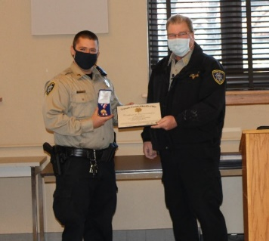**JACKSON COUNTY, Kan. (JASO)-**Sheriff Tim Morse reports that Sgt. Travis Spiker has been awarded the Jackson County Sheriff’s Office Medal of Valor for an incident that occurred in 2017. On December 3, 2017, Sgt. Travis Spiker was on patrol in the central district in Jackson County when he was dispatched to assist the Holton Police Department on a domestic dispute that led him to 802 Ohio Street. An armed female involved in the altercation was taken into custody for questioning and placed into Sgt. Spiker’s patrol vehicle. Sgt. Spiker and other members of the police department started taking gunfire from the residence and later from a second story window pining Sgt. Spiker behind his vehicle. Sgt. Spiker’s vehicle was riddled with gun fire. Sgt. Spiker knowing the female’s life was in jeopardy and under the threat of gun fire. He was able to enter his vehicle from the passenger door and crawled over a variety of law enforcement equipment, mobile data terminal, radio equipment to get to his driver’ seat exposing himself in direct view of the assailant. Sgt. Spiker was able to remove the woman from the gunfire to safety. Sheriff Morse said, “This award was a long time coming, and Sgt. Spiker is a true hero and is a person of courage and bravery.”

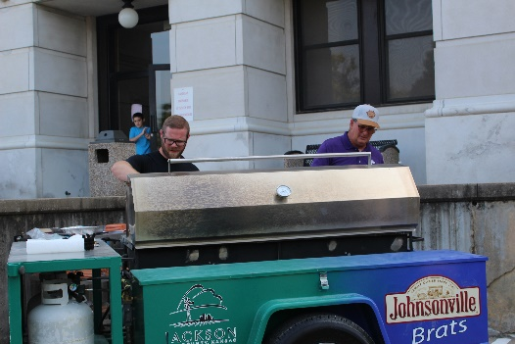

Detective Sergeant Tyler Caudle and Commissioner Keith Kelly

**DEPUTY RECEIVES LIFE SAVING AWARD**

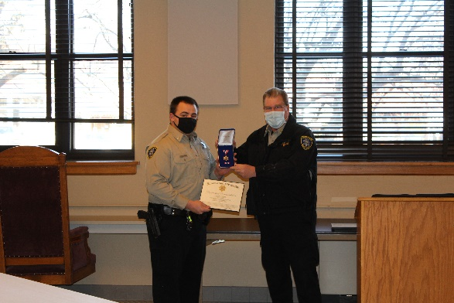**JACKSON COUNTY, Kan. (JASO)-**Sheriff Tim Morse reports that Deputy Chad Ballenger has been awarded the Jackson County Sheriff’s Office Life Saving Award. On July 20, 2020, at approximately 8:30 p.m., Deputy Chad Ballenger was on patrol in his district in southern Jackson County when a medical was dispatched to 13027 134th Road to the home of Marvin Cummings. Mr. Cummings was changing the oil on his son’s vehicle. Mr. Cummings was beneath his son’s vehicle that had been jacked up when the car fell off of the jack and onto Mr. Cummings. The vehicle was crushing Mr. Cummings’ chest making it impossible for him to breathe. Deputy Ballenger who was in the area, rushed to the scene and guided panic stricken family members with instructions to stabilize the vehicle. Deputy Ballenger was able to us his jack to raise the vehicle off of Mr. Cummings prior to emergency personnel’s arrival. Mr. Cummings survived the incident and credited Deputy Ballenger for saving his life. Sheriff Morse said, “Deputy Ballenger is a true hero, and we are blessed to have him serving this great county.”

**VALLEY FALLS MAN ARRESTED ON METH CHARGES FOLLOWING PURSUIT**

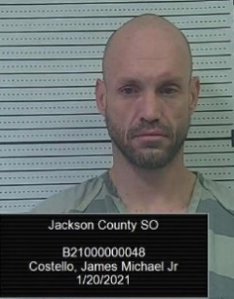A Jackson County Sheriff’s Office deputy observed a male subject in the Walmart parking lot in Holton Wednesday night that appeared to be behaving in a suspicious manner. The subject left in a 1997 Honda passenger car and headed south of Holton on US Hwy 75 allegedly at a high rate of speed. The deputy observed the vehicle heading east on 162nd Road and allegedly committing traffic infractions. A short pursuit ensued into the City of Mayetta where the pursuit was terminated. The driver and only occupant was identified as James Michael Costello Jr., 40, of Valley Falls. Costello was arrested for being in possession of methamphetamine, possession of drug paraphernalia, criminal carrying a weapon and eluding a law enforcement officer. The Mayetta Police Department assisted with the incident. Costello was booked into the Jackson County Jail.

**Three arrested on alcohol, drugs, weapons and stolen property**

**JACKSON COUNTY, Kan. (JASO)-**Sheriff Tim Morse reports that Jackson County Sheriff’s deputies stopped a northbound Ford F-150 truck bearing a Texas license plate pulling a trailer in the City of Holton near 9th and Arizona Ave on January 26, 2021, shortly before 1 p.m. Deputies stopped the vehicle for allegedly committing a traffic infraction. Deputies discovered that the South Dakota license plate on the trailer had been reported stolen. Deputies also located a piece of tape on the trailer tongue that had been spray painted to match the trailer. The piece of tape was covering the VIN number. The trailer had been reported stolen out of Cherry County, Nebraska in October of 2020. Jackson County deputies made contact with the Cherry County Nebraska Sheriff’s Office and was advised that an additional trailer had been stolen near the same time in Nebraska. Further investigation led deputies to contact the Orange County, Texas Sheriff’s Office who then recovered the second stolen trailer.

The driver, Michael A. Hall, 35, of Mauriceville, Texas, was arrested for the following: possession of a hallucinogenic drug, driving while suspended, transporting an open container and he had an outstanding felony warrant.

Brian D. Miller, 29, of Sulphur, Louisiana, was arrested for the following: possession of a hallucinogenic drug, possession of drug paraphernalia, criminal use of a weapon, and possession of a firearm by a person addicted/use controlled substance, criminal possession of a weapon by felon; convicted in last 5 years.

Shane E. Sanger, 46, of Vidor, Texas, was arrested for the following: transporting an open container and possession of stolen property; felony. All three men were booked into the Jackson County Jail.

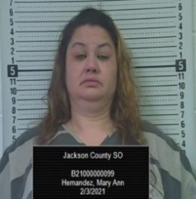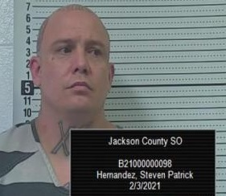**Two arrested in U-HAUL truck with meth**

**JACKSON COUNTY, Kan. (JASO)-**Sheriff Tim Morse reports that two people were arrested on Wednesday in a U-Haul truck on drug charges. Jackson County Sheriff’s deputies stopped a southbound U-Haul truck near 134th and US Hwy 75 in southern Jackson County for a traffic infraction shortly after 1:30 p.m. Wednesday afternoon. A Jackson County Sheriff’s K-9 was deployed and indicated the detection of the odor of illegal narcotics. The driver, Steven Patrick Hernandez, 41, of Kansas City, Missouri, was arrested for possession of methamphetamine, possession of drug paraphernalia and driving while revoked. The passenger, Mary Ann Hernandez, 46, of Kansas City, Missouri, was arrested for possession of methamphetamine, possession of a hallucinogenic drug and drug paraphernalia.

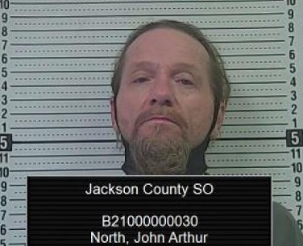**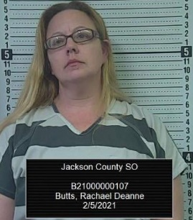Search warrant served southeast of Hoyt**

**JACKSON COUNTY, Kan. (JASO)-**Sheriff Tim Morse reports that a drug search warrant was served early Friday morning at 9915 T.4 Road southeast of Hoyt. The search warrant was issued as a result of a drug investigation by the Jackson County Sheriff’s Office and the Drug Enforcement Administration. Jackson County Sheriff’s Office deputies, detectives and DEA agents served the warrant where. Rachel Deanne Butts, 45, of Hoyt, was arrested for possession of methamphetamine, possession of drug paraphernalia and two counts of endangering a child. Also arrested was John Arthur North, 51, of Hoyt, for possession of methamphetamine, possession of drug paraphernalia and possession of stolen property. Deputies recovered a 2014 Chevy Cruze on the property which had been reported stolen out of Jefferson County. Two children in the residence were taken into police protective custody.

**Woman arrested on meth and child endangerment charges**

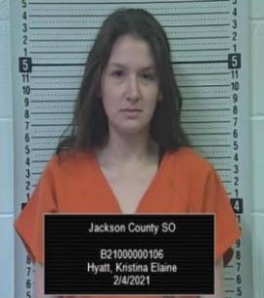JACKSON COUNTY, Kan. (JASO)-The Jackson County Sheriff’s Office arrested a woman on Thursday night following a deputy checking on the welfare of her children. A deputy stopped at a residence in the 300 Block of Topeka Street in Holton around 8 p.m. to follow up on a report of child neglect. The deputy placed the woman, Kristina Elaine Hyatt, 32, of Holton, under arrest for possession of methamphetamine, possession of drug paraphernalia and three counts of child endangerment.

**UPDATE ON DEATH OF TOPEKA MAN**

**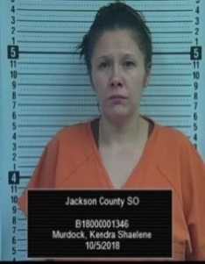 JACKSON COUNTY, Kan. (JASO) -** Sheriff Tim Morse reports the identity of the man who died following a Saturday morning traffic stop by a Jackson County deputy. Trevar Lamont Johnson, 37, of Topeka died following a traffic stop near the Brown County line on US Hwy 75 shortly before 10 a.m. Johnson had been the passenger in the vehicle and told a deputy on scene that he had ingested methamphetamine and needed to go to the hospital. Johnson was rushed to the Holton Community Hospital where he died minutes later. Johnson’s identity had not initially been made public pending the notification of his family.

Deputies seized a quantity of methamphetamine, marijuana, drug paraphernalia, counterfeit bills, credit cards, and a handgun. The driver, Kendra Shaelene Murdock, 37, of Topeka, was arrested for distribution of methamphetamine, trafficking contraband into a correctional facility, possession of marijuana, possession with intent to distribute drug paraphernalia for illegal use, criminal use of weapons, counterfeiting currency, driving while suspended, and no insurance. Murdock is currently being held in the Jackson County Jail.

As per protocol, Sheriff Morse requested an outside agency to investigate the death of Mr. Johnson. The Shawnee County Sheriff’s Office is in charge of the death investigation.

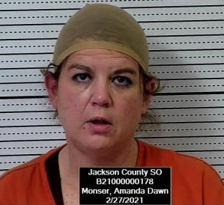**JACKSON COUNTY, Kan. (JASO)-**Sheriff Tim Morse reports that a Horton woman was arrested on meth charges Saturday afternoon. A Jackson County Sheriff’s deputy stopped a 2017 Chevy Cruze near 174th and US Hwy 75 around 2:30 p.m. for a traffic infraction. Further investigation led to the arrest of the driver, Amanda Dawn Monser, 45, of Horton, for possession of methamphetamine, possession of drug paraphernalia and driving without a license. Monser was booked into the Jackson County Jail.

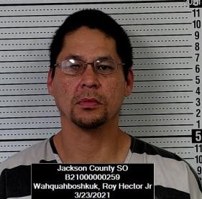**JACKSON COUNTY, Kan. (JASO)-**Sheriff Tim Morse reports that a Mayetta man is in custody following a traffic stop south of Holton on US Hwy 75 near 214th Road Wednesday afternoon. A Jackson County Sheriff’s Deputy stopped a 1997 Honda Accord when the deputy believed the license of the driver was suspended. Further investigation led to the discovery of alleged illicit items inside the vehicle. The driver, Roy Hector Wahquahboshkuk Jr., 44, of Mayetta, was arrested for possession of methamphetamine, possession of marijuana, possession of drug paraphernalia, transporting open container and driving while suspended.

**Meth found following traffic stop with a stolen pickup truck**

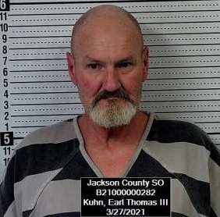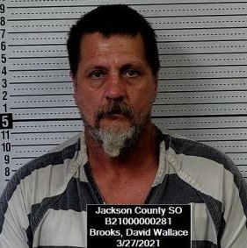**JACKSON COUNTY, Kan. (JASO)-**Sheriff Tim Morse reports that two Topeka men are in custody following a traffic stop north of Delia in southwestern Jackson County. Shortly after noon on Saturday, a Jackson County Sheriff’s Deputy initiated a traffic stop on a 2002 Chevy Silverado pickup truck that was southbound on E. Road from 142nd Road after the deputy determined that the vehicle was allegedly exceeding the speed limit and displaying a tag not assigned to the vehicle. After further investigation, the deputy discovered the truck had been reported stolen out of the City of Topeka. The driver, Robert W. Brooks, 55, of Topeka, was arrested for possession of stolen property and driving while suspended. The passenger, Earl Thomas Kuhn III, 58, of Topeka, was arrested for possession of methamphetamine, interference with law enforcement and had an outstanding warrant for a parole violation. Both subjects were booked into the Jackson County Jail.

**Three Topekans arrested on drug charges**

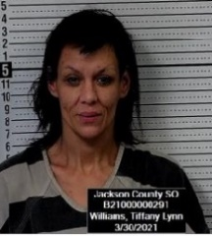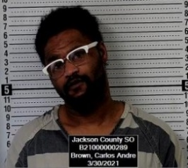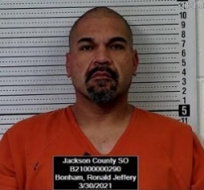**JACKSON COUNTY, Kan. (JASO)-**Sheriff Tim Morse reports that three have been arrested on drug charges following a traffic stop in Jackson County. Shortly before 4 pm a Jackson County Sheriff’s deputy stopped a 1995 Chevrolet Blazer near 150th and US Hwy 75 for an alleged registration violation. Further investigation during the traffic stop led to the discovery of drug paraphernalia. The occupants of the vehicle were arrested by deputies. The driver, Ronald Jeffery Bonham, 38, of Topeka was arrested for possession of methamphetamine and drug paraphernalia. A passenger, Andre Carlos Brown, 31, of Topeka, was arrested for possession of methamphetamine and drug paraphernalia. Another passenger, Tiffany Lynn Williams, 43, of Topeka was arrested for possession of methamphetamine and drug paraphernalia. All three suspects were booked into the Jackson County Jail.

**Banner Reservoir Director killed during explosion**

**JACKSON COUNTY, Kan. (JASO)-**Sheriff Tim Morse reports that a rural Holton man, Billy Lu Griffiths, 61, was killed at an explosion at his home Monday evening. At around 6:15 pm, the Jackson County Sheriff’s Office was notified of a large explosion that could be heard over 10 miles away. Rescue units responded to the residence located at 27284 Q.4 Road over 3 miles north of Holton, or about ¾ of a mile northeast of Jackson Heights School. The Holton Fire Department, Jackson County EMS and the Jackson County Sheriff’s Office responded to the scene. Responders found the residence to be completely leveled and on fire. Deputies located Mrs. Griffiths outside the residence who was airlifted to a Kansas City hospital with serious injuries. The Kansas Fire Marshal’s Office also responded to the scene. It is believed that the home owners had been working on remodeling the residence. The incident remains under investigation.

**JACKSON COUNTY, Kan. (JASO)-**Sheriff Tim Morse reports The Jackson County Sheriff’s Office is providing an update on the investigation into the explosion that occurred last Monday evening at 27284 Q.4 Road north of Holton. The Kansas State Fire Marshal’s Office and the Jackson County Sheriff’s Office have been involved in the investigation into the cause of the explosion. On Friday, an area around the residence was excavated for investigative purposes. The preliminary results of the investigation indicate the following:

1. The explosion was not a result of a criminal act.
2. It is confirmed that the explosion was that of a propane explosion.
3. A sizeable amount of propane is believed to be missing from the propane tank, which potentially leaked into the residence.
4. It is believed that an unidentifiable leak occurred inside the residence. Little to no part of the residence remains intact. This makes the investigation even more challenging.
5. It is unknown what the actual source was that ignited the explosion.
6. Injuries of both victims provides a strong indication they were inside the residence at the time of the explosion.

The body of the deceased victim underwent an autopsy. The complete coroner report has not yet been made available.

Further testing and investigation is expected to be conducted by the home owner’s insurance company.

**JACKSON COUNTY AGENCIES, SCHOOLS AND SHERIFF’S OFFICE COLLABORATE TO IMPROVE THE SAFETY AND SECURITY OF SCHOOL STAFF AND STUDENTS IN THE EVENT OF A VIOLENT THREAT**

**JACKSON COUNTY, Kan. (JASO)-**Sheriff Tim Morse reportson April 5, 2021, multiple Jackson County agencies conducted an active shooter exercise at the Holton High School campus. All agencies agreed that this exercise was a success. This exercise was a joint effort, led by the Jackson County Emergency Management Director, Pat Korte and the USD 336 Superintendent, Bob Davies. Those supporting the effort, were the Jackson County Sheriff, Tim Morse, the Holton Fire Chief, Kevin Ingels, Holton Police Chief, Steve Frederick, and Jackson County EMS, led by Con Olson. The USD 336 Transportation Director, Ginger Binkley and the USD 336 Maintenance Director, Mike Porter, were key to planning the event. Training modifications and improvements have been and are being made as a result. The Sheriff congratulated the participants for the planning and hard work that went into the event, noting that the Sheriff’s office is 100 percent behind the effort to keep our kids safe. Bob Davies, the USD 336 Superintendent, said, “This just one more step in the ongoing mission to improve and evolve safety and security in our schools.” Pat Korte, the emergency management director for Jackson County, summed it up, “we are committed to pull out all the stops to protect our most precious resource, our children.”

**Topeka man arrested on burglary charges**

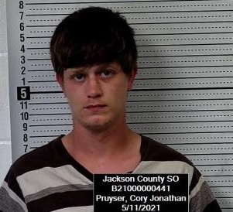**JACKSON COUNTY, Kan. (JASO)-**Sheriff Tim Morse reports a man is in custody following a burglary in Hoyt. On Tuesday May 11th, at approximately 10:30 am, the Jackson County Sheriff’s Office received a report of a burglary and theft from a residence located at 110 W. 1st Street in the City of Hoyt. Deputies found a window broken in the residence and it was reported that a 65 inch flat screen T.V., a Play Station 4 and an electric sander was taken from the residence. Deputies and detectives along with the Shawnee County Sheriff’s Office and Kansas Highway Patrol located the suspect and missing items in Topeka where he was arrested near 8th and Fairlawn. The suspect, Cory Jonathon Pruyser, 29, of Topeka was arrested and booked into the Jackson County Jail for burglary, theft and criminal damage to property.

**Two arrested on theft and meth charges**

**JACKSON COUNTY, Kan. (JASO)-**Sheriff Tim Morse reports two individuals were arrested on theft and drug charges following a traffic stop on Friday afternoon. The Sheriff’s Office 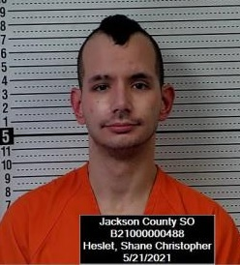received a report that a theft suspect from the day before was inside the Holton Walmart. Deputies responded to the store and after the suspects left the store, a Jackson County deputy stopped the suspect’s vehicle just south of Banner on US 75 Hwy. Deputies located a number of items including a large quantity of electronic products and drug contraband. The driver, Shane Christopher Heslet, 31, of Topeka was arrested for theft, possession of stolen property, trespass, possession of methamphetamine and drug paraphernalia. The passenger, Andrew Liam Myer, 25, of Topeka was arrested for theft, possession of methamphetamine and drug paraphernalia. Heslet and Myer were both booked into the Jackson County Jail.

**Felon in possession of a firearm**

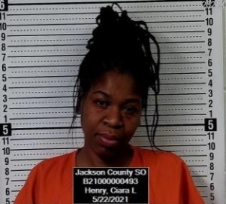**JACKSON COUNTY, Kan. (JASO)-**Sheriff Tim Morse reports a Kansas City, Missouri woman was arrested following a Saturday night traffic stop. A Jackson County Sheriff’s Deputy stopped a northbound Dodge Caliber for a traffic infraction near 134th and US Hwy 75 around 10:30 p.m. The passenger, Ciara Lynne Henry, 36, of Kansas City, Missouri was subsequently arrested for being a felon in possession of a firearm, criminal use of a weapon and transporting an open container.

**One person dead following pursuit**

**JACKSON COUNTY, Kan. (JASO)-**Sheriff Tim Morse reports that the Jackson County Sheriff’s Office was advised that a Holton Police officer was in a vehicle pursuit with a Dodge Avenger at approximately 10:50 p.m. Thursday night in Holton. The driver of the Dodge passenger car failed to stop for the officer and continued northbound out of the City of Holton on US Hwy 75. The vehicle then headed eastbound on 254th Road and then north on W. Road. Jackson County deputies assisted with the pursuit. The suspect vehicle then headed westbound on 286th Road and failed to stop at US Hwy 75 striking a southbound Jeep Renegade. Both vehicles left the roadway, with the suspect vehicle landing on its side. Jackson County EMS, PBPN EMS, Holton Fire and Netawaka Fire responded to the scene. Both occupants of the Jeep were triaged code green and transported to a Topeka hospital. Two occupants of the Dodge passenger car were triaged code yellow and transported to a Topeka hospital. A third occupant of the Dodge passenger was pronounced dead at the scene. The name of the deceased victim is not being released until the notification of family. Sheriff Morse requested the Kansas Highway Patrol to investigate the accident and incident. Any further inquiries are asked to be directed to the KHP. At 3:15 a.m. a portion of Hwy 75 remains closed with traffic being detoured north of Holton.

**Heroin and meth arrest**

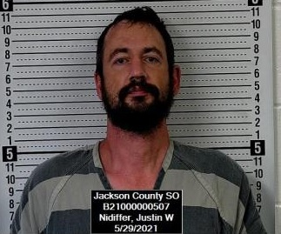**JACKSON COUNTY, Kan. (JASO)-**Sheriff Tim Morse reports on May 29, 2021 shortly before 1 a.m. a Jackson County Deputy stopped a 2007 Chrysler Aspen for a traffic infraction near US 75 Hwy and Third Street in Holton. The passenger of the vehicle, Justin Wayne Nidiffer, 40, of , was arrested on a Wyandotte County, Kansas warrant for possession of methamphetamine. Illicit contraband was found in Nidiffer’s possession and he was charged with the following: possession of heroin, possession of methamphetamine, possession of marijuana, possession of prescription drugs and drug paraphernalia. Nidiffer was booked into the Jackson County Jail.

**BARACADED WANTED FELON TAKEN INTO CUSTODY**

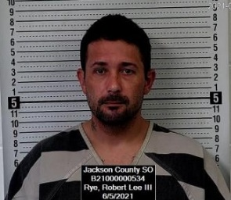Jackson County Sheriff’s Deputies, Holton Police and the Kansas Highway Patrol spent short of two hours persuading a wanted fugitive from Nemaha County to surrender to law enforcement Friday night. The Sheriff’s Office received information that Robert L. Rye, 35, of Wetmore, was at a residence in Jackson County at 12349 244th Lane, Holton, Kansas.

Rye was wanted out of Nemaha County on a felony probation warrant. At 11:16 p.m. Rye surrendered without incident to law enforcement. Rye was booked into the Jackson County Jail for interference with law enforcement and on a felony probation warrant.

**Suspected semi thief arrested**

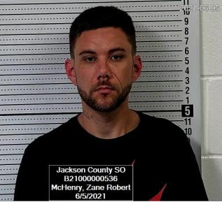**JACKSON COUNTY, Kan. (JASO)-**Sheriff Tim Morse reports that a Topeka man is in custody in connection with an April 8th, semi theft in northern Jackson County. The Jackson County Sheriff’s Office was notified in April of the theft of a 1989 Peterbilt semi-tractor from the 11000 block of 310th Road. On April 10th, the Jackson County Undersheriff as well as several callers observed the stolen semi in north Topeka. The Peterbilt was recovered at that time. Today, the suspect in the case, Zane Robert McHenry, 35, of Topeka was stopped on a traffic stop near 150th and US Hwy 75. McHenry was arrested on a felony no bond Jackson County District Court warrant for burglary, felony theft and criminal damage to property. McHenry was booked into the Jackson County Jail.

**Nebraska fugitive in Jail following two-state pursuit**

**JACKSON COUNTY, Kan. (JASO)-**Sheriff Tim Morse reports that a Nebraska fugitive is in custody following a two state pursuit Saturday night. A Holton Police officer stopped a 2015 Dodge Durango for a traffic infraction in the 400 Blk of Arizona Street in Holton shortly before 11 p.m. The suspect vehicle stopped in the Casey’s General Store parking lot. It was discovered that the driver, Davionne Marquise Stark-Briggs, 23, of Houston, Texas was wanted out of Nebraska on a felony robbery warrant. The suspect was to be considered armed and dangerous. The Holton Police officer attempted to arrest Stark-Briggs when he allegedly fled in his vehicle striking the Holton Police vehicle. Jackson County Deputies entered into the pursuit with Holton Police north of Holton on US Hwy 75. The pursuit continued into Brown County and into Nebraska. Several law enforcement agencies attempted to use tire deflation devices to stop the pursuit, however, 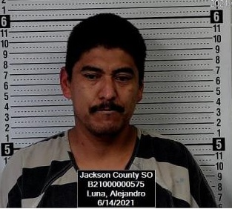the pursuit continued through Dawson, Nebraska and then east to Fall City. Just north of Fall City, the suspect vehicle left the highway and into the ditch. The suspect fled on foot from the vehicle heading east into a field. Jackson County deputies pursued the suspect on foot capturing him and taking him into custody about 200 yards from where the vehicle pursuit ended. Deputies from Brown County and Richardson County, Nebraska assisted with the incident. Starks-Briggs is currently being held in the Richardson County Jail and further charges are pending.

**Two arrested following pursuit**

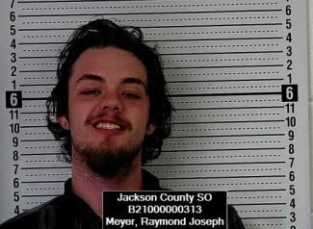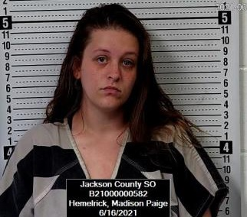**JACKSON COUNTY, Kan. (JASO)-**Sheriff Tim Morse reports a Jackson County Sheriff’s Deputy attempted to stop a Chevy Cavalier near 126th and 75 Hwy for allegedly speeding and a registration violation around 11:30 a.m. The vehicle failed to yield and a pursuit ensued. The pursuit continued into NW Shawnee County and then into the City of Topeka. A KHP aircraft unit was able to follow the vehicle into central Topeka and observed the suspects park the vehicle and enter an apartment building at 1320 SW Polk Street. Law enforcement officers were able to apprehend the pair at that location. The driver, Raymond Joseph Meyer, 21, of Topeka was arrested and booked into the Jackson County Jail for felony fleeing and eluding, interference with law enforcement, possession of a hallucinogenic drug, possession of drug paraphernalia, driving without a license. Meyer also had an outstanding Shawnee County warrant and an outstanding Topeka warrant. The passenger, Madison Paige Hemelrick, 22, of Mayetta was arrested and booked into the Jackson County Jail for interference with law enforcement, possession of a hallucinogenic drug and drug paraphernalia. The Shawnee County Sheriff’s Office, Kansas Highway Patrol, the Hoyt Police Department and the Topeka Police Department assisted with the incident.

**Topeka man arrested on meth charges**

**JACKSON COUNTY, Kan. (JASO)-**Sheriff Tim Morse reports that a Topeka man was arrested around 9:30 p.m. Monday evening near 150th and Q. Road. A Jackson County Sheriff’s Deputy stopped a white Chevy Avalanche for traffic infraction. Deputies discovered a quantity of methamphetamine allegedly in the driver’s possession. The driver, Luna Alejandro, 41, of Topeka was arrested and booked into the Jackson County Jail for possession of methamphetamine with the intent to sell and having no drug tax stamp.

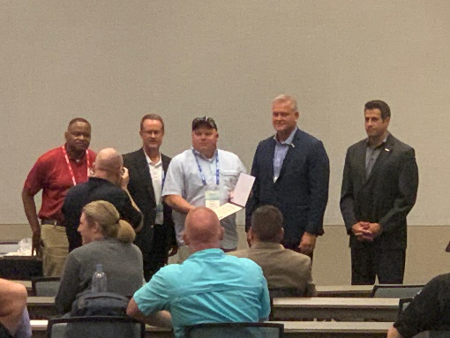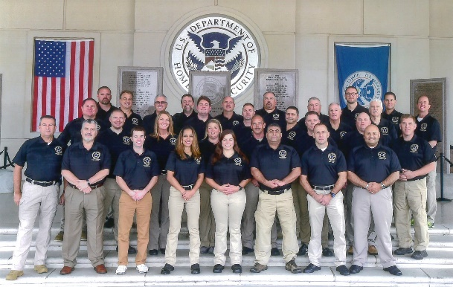

**Undersheriff Chapman completed Homeland Security Program**

Jackson County Undersheriff Darrel Chapman has completed a program that he has been working on since the beginning of 2020. Undersheriff Chapman attended training that was a combined program between the Department Homeland Security and the National Sheriff’s Association designed for public safety leadership. In 2020, Undersheriff Chapman attended the first part of the federally funded training in Glynco, Georgia. After completing the entire program in June of 2021, Undersheriff Chapman was awarded certification as a Homeland Protection Professional from the Homeland Protection Professional Certification Board in Phoenix, Arizona.

“The Certified Homeland Protection Professional (CHPP) designation was established to ensure that an individual who possesses the designation has the requisite knowledge, skills and abilities to be considered a professional in the area of homeland protection. Those who hold the Certified Homeland Protection Professional (CHPP) designation are prepared to help their organizations prevent, protect against, prepare for, respond to, mitigate and recover from all hazards including terrorism. They have demonstrated competency, knowledge, skills and abilities in the blended discipline area of Homeland Protection and have completed a rigorous qualification program. Homeland Protection Professionals must have a predetermined blend of experience and education and show completed course work in the knowledge areas required by the Certification Board.”

**Deputy’s watchful eye catches identity fraud suspect**

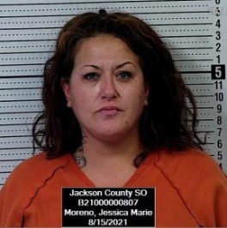**JACKSON COUNTY, Kan. (JASO)-**Sheriff Tim Morse reports an Emporia woman is in custody following a traffic stop on 150th Road west of Mayetta Sunday morning. A Jackson County Sheriff’s Office deputy observed a vehicle belonging to a wanted fugitive. The deputy observed the wanted woman in a Chevy Malibu and conducted a traffic stop. The woman was taken into custody on a Jackson County District Court for theft. A police service K-9 alerted on the vehicle for the presence of narcotics. Narcotics and drug paraphernalia was seized from the vehicle. In addition, various driver’s licenses, social security cards, passport, credit cards and various other identification cards were allegedly found in possession of the suspect. Some of which, had been reported stolen in burglaries in Overland Park. The suspect, Jessica Marie Moreno, 41, of Emporia, was arrested by deputies and booked into the Jackson County Jail on the Jackson County theft warrant, identity theft, identity fraud, possession of methamphetamine, possession of a hallucinogenic drug, and possession of drug paraphernalia.

**Sex crime suspect captured this morning**

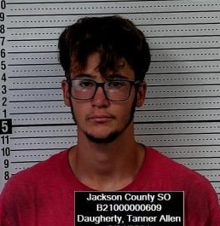**JACKSON COUNTY, Kan. (JASO)-**Sheriff Tim Morse reports that a Topeka man is now in custody following the report of a sex crime alleged to have occurred at Banner Lake early this morning. The Jackson County Sheriff’s Office was notified shortly after 2 a.m. Monday morning. The suspect fled the area on foot prior to law enforcements arrival. Deputies were unable to locate the suspect in the immediate area. Shortly after 8 a.m. Jackson County deputies received a tip that the suspect may be in the 16,000 block of I. Road. Deputies responded to the area where they were advised the suspect fled into a large wooded area west of the location. Deputies, detectives, and K-9 units soon arrived. Additional help from KHP and PBPN Police arrived and formed a perimeter. A KHP helicopter and the JASO Drone searched the area. A K-9 team located the suspect south of 166th Road east of H. Road in a corn field. The suspect surrendered to law enforcement without incident at 11:50 a.m. The suspect was transported to the Jackson County Jail where he will be booked into the Jail on a Jackson County District Court warrant for aggravated indecent liberties with a child. The suspect, Tanner Allen Daugherty, 19, of Topeka, is believed to have been staying in the Banner Creek Reservoir campground west of Holton.

**Topeka man arrested on drug and weapon charges**

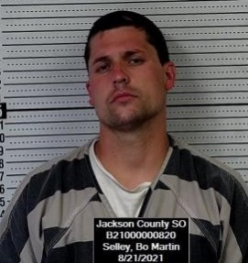**JACKSON COUNTY, Kan. (JASO)-**Sheriff Tim Morse reports a Jackson County Sheriff’s Deputy stopped a vehicle on Saturday around 4 pm near 142nd and US Hwy 75 for a traffic infraction. The driver, Bo Martin Selley, 29, of Topeka, was arrested after allegedly being in the possession of illegal contraband. Selley was booked into the Jackson County Jail for possession of ecstasy, possession of a hallucinogenic drug, possession of drug paraphernalia, criminal use of a weapon, driving while suspended, no registration and transporting an open container.

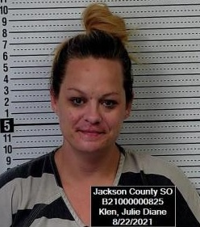**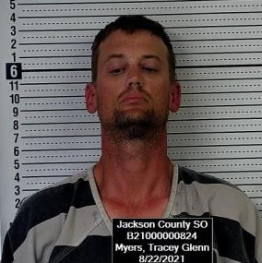JACKSON COUNTY, Kan. (JASO)-**Sheriff Tim Morse reports a Jackson County Sheriff’s deputy conducted a traffic stop on a Toyota passenger car for a traffic infraction near 302nd Road on US 75 Hwy around 5:30 a.m. Sunday morning. The deputy discovered illegal contraband during a search of the vehicle. The driver was identified as Tracey Glenn Myers, 39, of Brownfield, Texas. Myers was arrested and booked into the Jackson County Jail for possession of methamphetamine, possession of drug paraphernalia, no proof of insurance and no vehicle registration. The passenger was identified as Julie Diane Klen, 38, of Brownfield, Texas. Klen was arrested and booked into the Jackson County Jail on possession of methamphetamine, possession of drug paraphernalia and for an outstanding felony warrant out of Abilene, Texas.

**Mayetta man arrested for burglary and drugs**

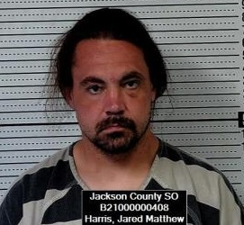**JACKSON COUNTY, Kan. (JASO)-**Sheriff Tim Morse reports Jackson County Sheriff’s Deputies arrested a Mayetta man Friday morning after receiving a call from a resident reporting finding a man sleeping on their porch. Deputies responded to 10755 X Road in southeastern Jackson County around 6:50 a.m. Deputies located a man identified as Jared Matthew Harris, 30, of Mayetta. Deputies located a vehicle believed to have been driven by Harris, a Nissan Altima near 114th and W.6 Road. Deputies discovered that a residence at 11468 W.6 Road had been burglarized. Deputies recovered property that had been taken from the residence. Harris was arrested and booked into the Jackson County Jail on charges of burglary, theft, possession of narcotics and drug paraphernalia.

**Barricaded subject arrested following standoff**

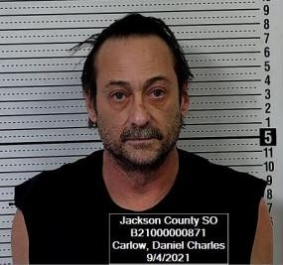**JACKSON COUNTY, Kan. (JASO) -** Sheriff Tim Morse reports a Hoyt man is behind bars following a domestic incident shortly before 10:00 p.m. Friday night. The Jackson County Sheriff’s Office received a 911 call from 14081 Q. Road where the caller reported that the male subject at the residence allegedly was intoxicated and fired a weapon a number of times from the residence. A female occupant of the residence was able to escape the premises without serious injury. The heavily armed male suspect fled the residence into an adjacent wooded area. Deputies encountered the subject where a standoff ensued. After law enforcement negotiated with the man for a period of time, the suspect surrendered to law enforcement a little after 10:30 p.m. The suspect, Daniel Charles Carlow, 63, of Hoyt was arrested and booked into the Jackson County Jail for the following: **aggravated assault, criminal threat, domestic battery, disorderly conduct and possession of a stolen firearm.**

**Two arrested on theft and drug charges**

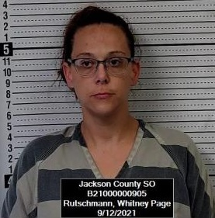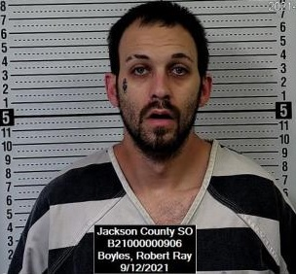**JACKSON COUNTY, Kan. (JASO) -** Sheriff Tim Morse reports that a Jackson County Sheriff’s deputy responded to the Holton Walmart in reference to a report of a theft in progress on Saturday shortly after 2:30 p.m. A male suspect fled on foot with the deputy pursuing on foot inside the store. The deputy took the suspect to the ground and placed him in custody. During the struggle, allegedly items believed to be drug paraphernalia fell from the suspect’s person. The suspect allegedly attempted to identify himself through a stolen passport out of Colorado. The suspect was eventually identified as Robert Boyles, 32, of Longmont, Colorado. Boyles was arrested and booked into the Jackson County Jail on the following charges: interference with law enforcement, possession of heroin, possession of methamphetamine, possession of a hallucinogenic drug, and possession of drug paraphernalia, identity theft, displaying an I.D. card belonging to someone else, no drug tax stamp, and possession of stolen property. In addition, Boyles had 5 outstanding warrants from the State of Colorado. A second suspect, Whitney Rutschmann, 38, of Topeka, was also arrested and booked into the Jackson County Jail on the following charges: theft, criminal trespass, possession of methamphetamine, and possession of drug paraphernalia,

**Two Jackson County men arrested on meth charges**

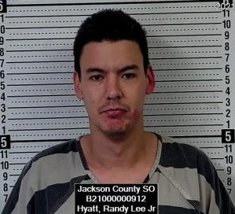

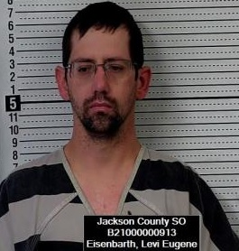**JACKSON COUNTY, Kan. (JASO) -** Sheriff Tim Morse reports that two men are in custody on meth charges following a traffic stop last night. A Jackson County Sheriff’s deputy stopped a northbound passenger car on US Hwy 75 near 162nd Road around 11 p.m. for a traffic infraction. A Jackson County Sheriff K-9 was deployed during the traffic stop indicated the presence of narcotics in the vehicle. Deputies located items believed to be drug contraband. The driver, Levi Eugene Eisenbarth, 32, of Soldier, was arrested and booked into the Jackson County Jail for possession of methamphetamine and drug paraphernalia. The passenger in the vehicle, Randy Lee Hyatt Jr., 30, of Holton, was arrested and booked into the Jackson County Jail for possession of methamphetamine and drug paraphernalia.

**Soldier man arrested following domestic disturbance**

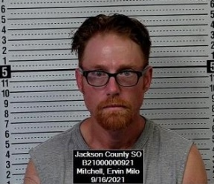**JACKSON COUNTY, Kan. (JASO) -** Sheriff Tim Morse reports a Soldier man is in custody following a Thursday afternoon disturbance. The Jackson County Sheriff’s Office received a report of a disturbance at 2340 238th Road, Soldier around 4:16 p.m. Deputies found a female victim that it was reported had been strangled during the incident. Deputies deployed stop sticks to disable the vehicle the suspect was driving southbound on K-62 Hwy north of the City of Soldier. Deputies took the suspect into custody at that time. Ervin Milo Mitchell, 45, of Soldier was arrested and is being held in the Jackson County Jail on charges of attempted 2nd degree murder, aggravated domestic battery, criminal restraint and criminal threat.

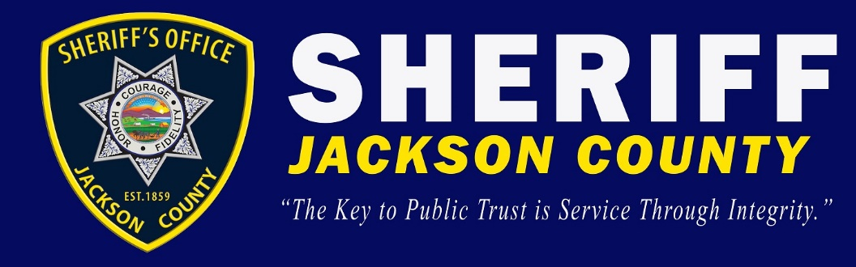

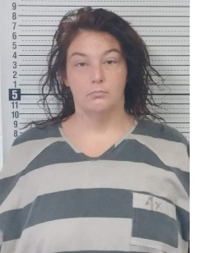**JACKSON COUNTY, Kan. (JASO) -** Sheriff Tim Morse reports an Oskaloosa woman is in Jail following an early Tuesday morning traffic stop near 150th and Q. Road in Jackson County. A Jackson County Sheriff’s deputy stopped the woman in a 2005 Nissan for a traffic infraction around 4 a.m. The woman allegedly provided a false name to the deputy. A Jackson County K-9 alerted to the presence of illegal narcotics within the vehicle. Deputies’ located contraband believed to be methamphetamine and drug paraphernalia. The woman was identified as Stephanie Renee Meier.

**Two Michigan men in custody following robbery**

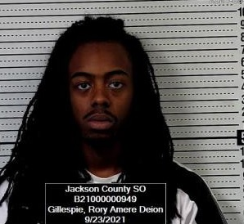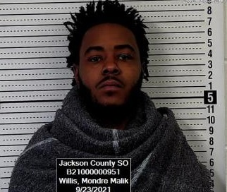**JACKSON COUNTY, Kan. (JASO) -** Sheriff Tim Morse reports that two Michigan men are being jailed after a robbery and theft at a local convenience store Wednesday night. Authorities were notified shortly after 11 pm Wednesday night of an alleged robbery at the Seven Eleven store located at 111 US Hwy 75 in Holton. The men left after allegedly taking a financial card from the clerk. The men left the premises in a white Dodge Charger. Holton Police and Jackson County Sheriff’s deputies responded to the area. A Jackson County Sheriff’s deputy located the vehicle two miles south of the City of Holton and executed a car stop on the vehicle on US Hwy 75. An assortment of area law enforcement officers descended on the scene where the two men were taken into custody. Mondre Malik Willis, 21, of Flint, Michigan, was arrested and booked into the Jackson County Jail for robbery, criminal use of weapons, possession of firearm by an addicted person, possession of a hallucinogenic drug and possession of drug paraphernalia. Rory Amere Deion Gillespie, 20, of Flint, Michigan was arrested and booked into the Jackson County Jail for robbery, possession of a hallucinogenic drug, and possession of drug paraphernalia.

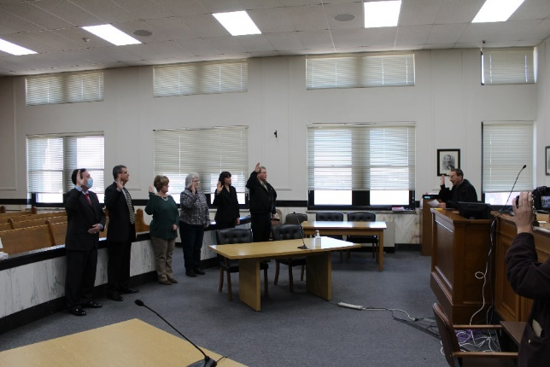

Jackson County elected officials being sworn in by District Judge Norbert Marek in January

**Topeka woman arrested for on drug distribution charge**

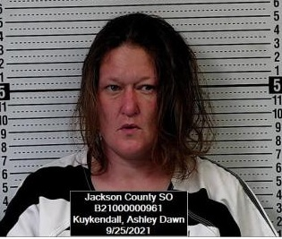**JACKSON COUNTY, Kan. (JASO) -** Sheriff Tim Morse reports a Topeka woman was arrested early Saturday morning during a traffic stop near 110th and US Hwy 75. A Jackson County Sheriff’s deputy conducted a traffic stop on a 1999 Toyota Corolla for a traffic infraction shortly after 3 a.m. A Jackson County Sheriff’s K-9 indicated with a positive alert for illegal narcotics on the vehicle. The passenger, Ashley Dawn Kuykendall, 37, of Topeka, was arrested for felony distribution of a hallucinogenic drug and possession of drug paraphernalia. The driver, Robert Jason Hobbs, 45, of Fairview, was arrested on an outstanding Brown County warrant.

**Two men wanted by Idaho State Penitentiary arrested by deputies**

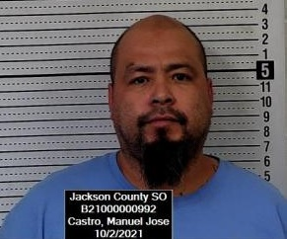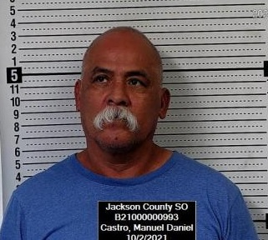

**JACKSON COUNTY, Kan. (JASO) -** Sheriff Tim Morse reports two Idaho men were arrested on Saturday during a traffic stop. A Jackson County Sheriff’s deputy stopped a Honda Accord with Minnesota plates for an alleged registration violation. The driver, Manuel Daniel Castro, 58, of Idaho was arrested on an Idaho parole warrant for escaping and illegal drugs. The passenger, Manuel Jose Castro, 44, of Idaho, was also arrested on an Idaho warrant for illegal drugs, rioting, trafficking and escaping.

**Tennessee man arrested on drug and weapon charges**

**JACKSON COUNTY, Kan. (JASO) -** Sheriff Tim Morse reports a Tennessee man was arrested following a Friday morning traffic stop. A Jackson County Deputy stopped a 2018 Toyota Forerunner for an alleged traffic infraction around 8:30 a.m. on 126th Road east of Hwy 75. During the course of the traffic stop, the deputy discovered illegal narcotics. The driver, Richard Nguyen, 28, of Memphis, Tennessee was arrested for possession of cocaine, possession of a hallucinogenic drug, possession of drug paraphernalia, criminal use of a weapon.

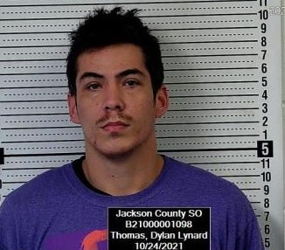**Holton man being held on burglary charge**

**JACKSON COUNTY, Kan. (JASO) -** Sheriff Tim Morse reports a Holton man is in custody following a burglary report to a Holton residence on Sunday morning. Shortly after 12:30 a.m. law enforcement was notified of an intruder inside a residence at 217 W. 4th Street in Holton. The Holton Police and Jackson County Sheriff’s Deputies responded to the address. Deputies and Police Officers found signs of forced entry to the residence and a man on the floor being held at gunpoint by the owner of the property. The man, Dylan Lynard Thomas, 27, of Holton was placed under arrest. Thomas was booked into the Jackson County Jail for attempted aggravated burglary, criminal damage to property and criminal trespass. It was reported that the subject had been dressed in a Halloween type costume.

**Hoyt man arrested on methamphetamine distribution charge**

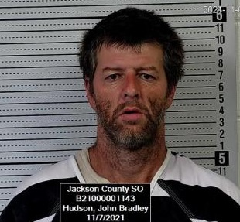**JACKSON COUNTY, Kan. (JASO) -** Sheriff Tim Morse reports a Hoyt man is in custody on drug charges following a traffic stop. A Jackson County Sheriff’s Deputy stopped a Ford Ranger in the 100 Blk of W. 2nd Street in the City of Hoyt for a traffic infraction. The passenger, John Bradley Hudson, 46, of Hoyt was arrested and booked into the Jackson County Jail for possession of methamphetamine, possession of methamphetamine with intent to distribute, possession of a hallucinogenic drug and possession of drug paraphernalia.

**Mayetta woman arrested on methamphetamine charges**

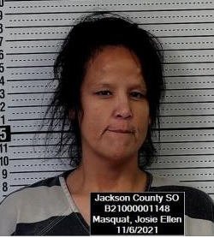**JACKSON COUNTY, Kan. (JASO) -** Sheriff Tim Morse reports a Mayetta woman was arrested Saturday afternoon west of Mayetta. A Jackson County Sheriff’s Deputy stopped a Toyota Avalon shortly before 4 p.m. on 158th Road west of U.S. Hwy 75 for a traffic infraction. A Jackson County Sheriffs K-9 indicated the presence of illegal narcotics within the vehicle. The driver, Josie Ellen Masquat, 44, of Mayetta was arrested by deputies and booked into the Jackson County Jail for possession of Methamphetamine, felony trafficking of contraband into a correctional facility and possession of drug paraphernalia.

**Three arrested for Walmart thefts**

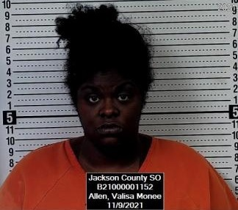**JACKSON COUNTY, Kan. (JASO) -** Sheriff Tim Morse reports three Texas women were arrested Tuesday morning by Jackson County Sheriff’s Deputies. The Jackson County Sheriff’s Office was alerted to a possible theft in process at the Holton Walmart shortly before 10 a.m. Tuesday. Deputies stopped the suspect vehicle, a black 2015 Dodge Charger east of Arizona Avenue on Banner Road. Three female occupants were taken into custody. Deputies located items believed to have been taken from the Holton Walmart as well as other items believed to have been stolen from other Walmart stores including 22 IPhones believed to have been stolen from a Houston, Texas Walmart.

All three women were booked into the Jackson County Jail on theft charges. Jovanna Richae Davis, 25, of Galveston, Texas was arrested and booked into the Jackson County Jail for possession of stolen property, theft, possession of a hallucinogenic drug and drug paraphernalia. Davis also had outstanding felony warrants for theft and burglary out of Texas and Arkansas. Desiree Glenntrice Dunford, 27, of Galveston, Texas was arrested for theft of property and booked into the Jackson County Jail. Valisa Monee Allen, 25, of Galveston, Texas was arrested for possession of stolen property, theft, and criminal damage to property. Allen also had an outstanding felony warrant from the Galveston County Sheriff’s Office in Galveston, Texas.

**Texas man in custody following two-county vehicle pursuit**

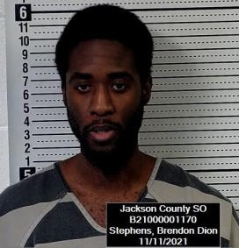**JACKSON COUNTY, Kan. (JASO) -** Sheriff Tim Morse reports a Texas man is in custody following a Thursday evening two county vehicle pursuit. The Jackson County Sheriff’s Office was alerted to a pursuit by the PBPN Police Department northbound on U.S. 75 Hwy near 206th Road around 5:30 p.m. for allegedly speeding over 100 mph. Jackson County Deputies continued the pursuit into Brown County. Brown County Deputies deployed tire deflation devices which disabled the vehicle. The suspect vehicle went into the ditch west of Fairview on 36 Hwy. The driver fled the vehicle on foot. Law enforcement officers located the suspect and took him into custody around 5:50 p.m. The suspect was identified as Brendon Dion Stephens, 31, of Sachse, Texas. Stephens is currently being held in the Jackson County Jail on felony flee and eluding charges.



**New deputy serving Jackson County**

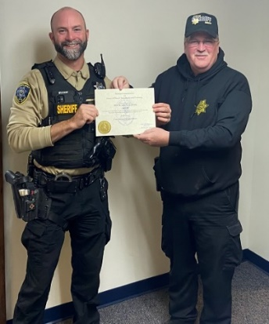**JACKSON COUNTY, Kan. (JASO) -** Sheriff Tim Morse reports that Deputy Michael Klenk is now a Kansas certified law enforcement officer. Deputy Klenk previously served as a patrol sergeant with the Buchanan County Sheriff’s Office in Missouri. Deputy Klenk has been employed with the Jackson County Sheriff’s Office since May 31, 2021, when he was granted a provisional Kansas certification. Deputy Klenk underwent the Kansas Law Enforcement Training Center Reciprocity Program. Deputy Klenk received his Kansas Full-Time Law Enforcement Certification on Monday. Deputy Klenk is enjoying serving the citizens of Jackson County.

**Airplane make emergency landing on U.S. 75 Hwy**

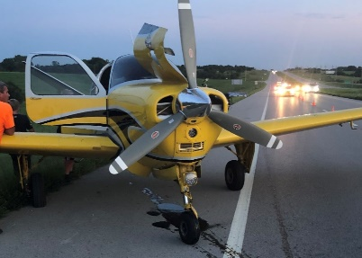On August 14th, a 1961 Bonanza V-35 made an emergency landing near 142nd and U.S. Hwy 75. The plane was enroute from Topeka to Omaha, Nebraska. The plane began to have mechanical issues and was forced to make an emergency landing sometime after 8:15 p.m. Saturday night. The plane had four occupants who reported no injuries. Traffic was reduced to one lane until the plane could be removed.

**Topeka man in custody following burglary to local business**

**JACKSON COUNTY, Kan. (JASO) -** Sheriff Tim Morse reports that a Topeka man is in custody following a burglary to a business. The Jackson County Sheriff’s Office was notified of a vehicle in the roadway north of the One Stop Gas Station located at 190th and US Hwy 75. A Jackson County Deputy found the vehicle abandoned in the roadway. A Tribal Police Officer found the front window of the business broke out and male dressed in dark clothing fleeing on foot. Jackson County Deputies and K-9s responded to the scene along with an aircraft unit from KHP to search for the suspect. Deputies took the suspect into custody near 178th Road and U.S. 75 Hwy. Colby Christopher Kastens, 44, of Topeka was placed under arrested by Jackson County Sheriff Deputies and Tribal Police.

**NATIONAL NIGHT EVENT OUT IN HOLTON**

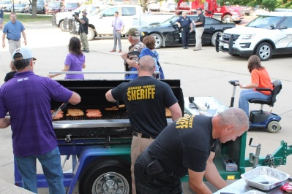

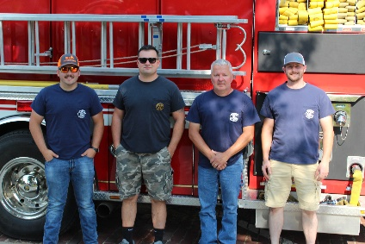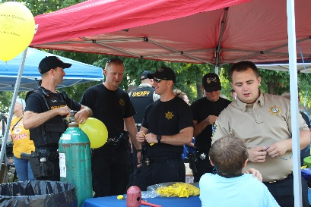Sheriff Tim Morse and the Jackson County Sheriff’s Office and Holton Chief of Police, Steve Fredrick and the Holton Police Department hosted the first ever National Night Out Celebration on August 3rd on the eastside of the Jackson County Courthouse. Representatives from a number of area public safety agencies were on hand with personnel and equipment that was on display. A number of area agencies and businesses helped in sponsoring this event. A variety of 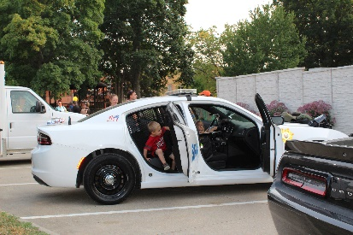government officials including county 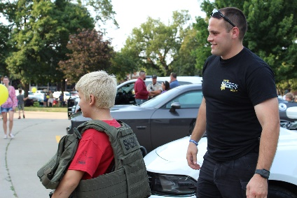commissioners took part in the event. The Kansas Highway 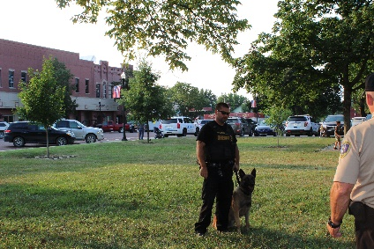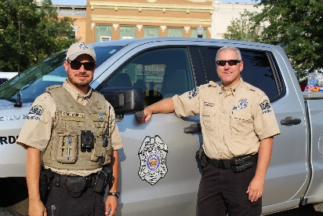Patrol, Jackson County EMS, Holton Fire Department, Kansas Wildlife and Parks, PBPN Tribal Police, Mayetta Police Department, Hoyt Police Department, Holton Police Department and the Jackson County Sheriff’s Office were on hand. The National Night Out provides an opportunity for the members of our public safety agencies and the public the opportunity to build and strengthen relationships. The Sheriff’s Office provided a K-9 demonstration, a Drone demonstration. Various pieces of equipment and fire apparatus were also on display. Dinner was provided to the public by 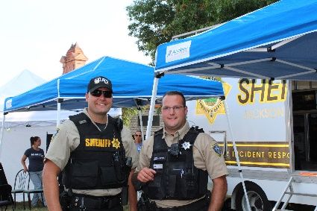government officials and public safety members. Hundreds of people attended this event. Sheriff 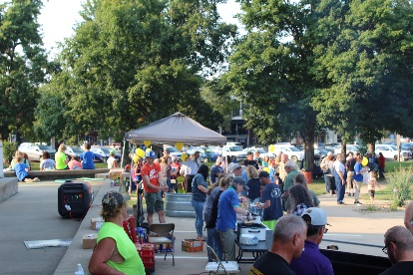Tim Morse said at the event, “A lot of us have been cooped up for a long time and a lot of us haven’t been able to get out. I think everyone is enjoying the wonderful weather that we’re having here tonight and I think they are also enjoying to get together with other people and building those friendships. We’re all local people, were all here to take care of one another.”

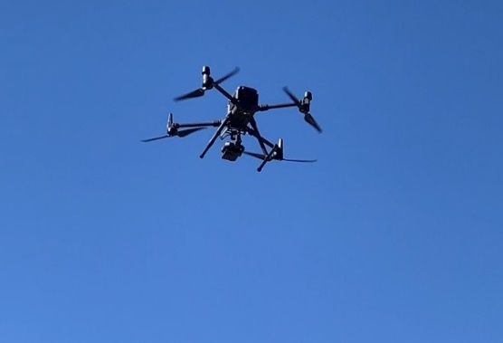

**LIFE AND LEGACY OF CHIEF GAYLE GAKLE**

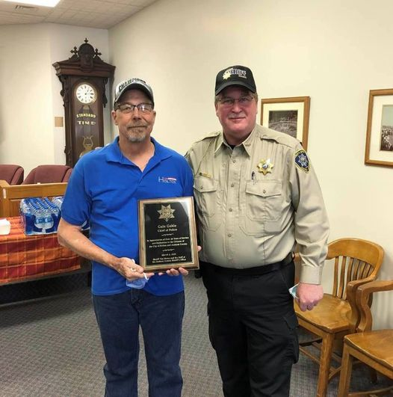“During my career in law enforcement there was always Gary Thiessen and Gayle Gakle. Gayle came to the Holton Police Department in 1980 when I was only 13 years old. I had been to numerous incidents with Gayle over the years. I found him to always be a kind man who had his own way of keeping the peace. I believe Chief Gakle is the longest continuous serving law enforcement officer in Jackson County. I was happy for Chief Gakle when he announced his retirement in the spring of 2021. He served the people of the City of Holton and Jackson County for over 40-years. I remember what seemed like my entire tenure as sheriff, Chief Gakle would talk about his retirement. He talked about all the things he wanted to do and see. We all were surprised that his long awaited retirement was cut so short. Hopefully, Chief could see the hundreds who came to show their respect for him. Agencies from across the country attended his funeral, and for a short time, the City of Holton was shut down in his honor with his motorcade heading to the Holton Cemetery. One thing I observed was the tremendous love his family had for him, and the great loss his death was to them. There are many of us in law enforcement that are hated by some, Chief Gakle was one that no one could hate. We will miss Chief Gakle and may God bless his family and many friends.”

**Marie Katz Retires**

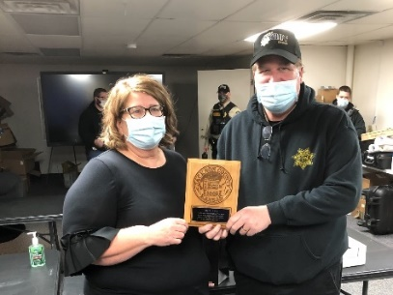Longtime employee, Marie Katz retired in February of 2021. Marie had served as a dispatcher in the Communications Center and also worked in the Business Office of the Sheriff’s Office in recent years. Marie was a dedicated and hardworking employee and was loved by all. We wish her well in her retirement. Marie served two different sheriff administrations.

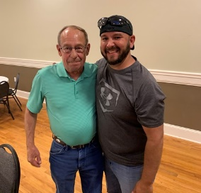**Deputy Chris Miller Retires**

Deputy Chris Miller retired from the Sheriff’s Office in June of 2021 after over fourteen years of service to Jackson County. Deputy Miller was charged with overseeing the Support Services Division of the Sheriff’s Office. Deputy Miller was responsible for civil process, registered offenders, conceal carry, sheriff sales and auctions, and wore a number of additional hats as well. Deputy Miller served two different sheriff administrations. (*picture of Chris Miller on left, and former JASO Deputy and KBI Agent, Robert Besenyi on right.)*

**Office Manager Sherri Ladner Retires after 40-Year Plus Career**

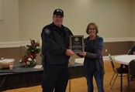Sherri Ladner retired in 2021 after serving Jackson County for over 40 years. Sherri worked in Emergency Management and the Sheriff’s Office. Sherri retired as the Sheriff’s Office Manager and 911 Coordinator. In December, we celebrated Sherri’s career with the county. Sherri served 5 different Jackson County Sheriff Administrations starting with Sheriff Phil McManigal. Sherri served Sheriff Morse for over the last 10 ½ years.

**Fatal Accidents**

April 6th, an injury accident at 158th Road and U.S. Hwy 75 took the lives of two. Rachel Louise McCoy, 29, of Holton and Wayne A. Dunn, 83, of Lyndon, died as a result of their injuries sustained in the accident.

May 27th A passenger, Shai Boyd, 26, of Topeka, in a vehicle being pursued following a traffic stop that the Holton Police Department initiated, died at the scene of an accident.

Aaron Jack Minde, 34, of Holton, passed away Friday, Aug. 6, 2021, as the result of a UTV accident near Denison.

In November, Jimmy A. Robbins, 77, while attempting to cross Arizona Street (U.S. Hwy 75) in Holton, was struck by a vehicle. Robbins died as a result of his injuries.

**JASO takes part in anti-human trafficking taskforce**

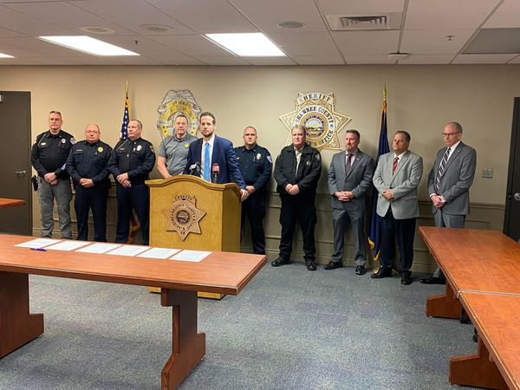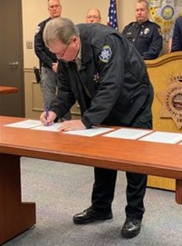In December, the Jackson County Sheriff’s Office joined area chiefs and sheriffs and Shawnee County District Attorney Mike Kagay in forming the Kaw Valley Anti-Human Trafficking Task Force. Sheriff Morse said, “Human Trafficking is occurring right before our eyes. Law enforcement has to do a better job in investigating and working with the victims of these crimes. By combining skills, experience and resources we will be better prepared to have better outcomes with these cases and deliver prosecutable cases for prosecution.”



**Opiate Crisis**

Jackson County is not unfamiliar with the Opiate Crisis that this Nation is facing. This county has seen a number of avoidable deaths due to individuals overdosing with opiates such as fentanyl and heroin. It is so important that we work to educate our children and the public the consequences of using illicit drugs. Many of those who ingest such drugs are not doing so with the intent to end their lives. These drug many times include doses of lethal amounts.

Sheriff Morse closed the year with his 11th balanced budget as Sheriff. Sheriff Tim Morse and his staff are excited to serve the Citizens of Jackson County for another year. Each year presents with another set of obstacles and challenges for law enforcement. However, the continued support from the people of Jackson County always makes those challenges much easier. Happy New Year!!!