JACKSON SHERIFF
MOST WANTED
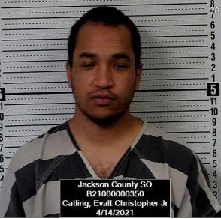
Name: Evalt Christopher Catling Jr.
Alias:
Description
Sex:---------------------------- Male
Race:-------------------------- African American
Date of Birth:----------------- 25-years-old
Place of Birth:----------------Kansas
Height:-------------------------509
Weight:------------------------145 lbs
Eyes:-------------------------- Brown
Hair:--------------------------- Black
Skintone:--------------------- Light Brown
Scars/Tattoos:--------------
Wanted For: ………….…Motion to revoke bond- Subject was ordered to surrender himself to law enforcement by the court. Subject failed to comply with the court’s order.
Warrant Issued: ....….......Jackson County District Court
Date of Warrant: ....…......
Warrant #: CR 20 CR-444
Bond: None

REWARD: A reward is being issued for the information that leads to the capture of Evalt Christopher Catling Jr.
Contact: The Jackson County Sheriff’s Office, 210 US Hwy 75, Holton, Kansas 66436 or call 785-364-2251.
NOTICE: Before arrest, verify warrant through the National Crime Information Center (NCIC). If subject is arrested or whereabouts known, contact the nearest law enforcement agency. Have a tip? E-mail tim.morse@jasoks.org For more information, see the JASO website: www.jasoks.org

