JACKSON COUNTY SHERIFF’S OFFICE 2018 ANNUAL REPORT

SUBMITTED BY TIM MORSE, SHERIFF
JACKSON COUNTY, KANSAS

In order to be transparent, Jackson County Sheriff Tim Morse provides the stockholders, the citizens of Jackson County with this annual End of the Year Report. This report is an opportunity to share the many accomplishments and challenges of the year. It also features several public servants who have done some truly outstanding acts to make this community safer and better.
Reduction in Crime Continues
Jackson County has benefited in recent years in a decline in crime. Some major reductions have occurred in a variety of areas. All statistics used here in this report have been obtained by the Kansas Bureau of Investigations. The recent crime statistics for this report are from 2017. Since 2011, the Jackson County Sheriff’s Office has been very proactive in deterring crime with a different approach than in the past. Patrol zones and sub-stations were initially implemented in June of 2011, and has helped to increase rural patrols and reduce response times. This move has allowed for a better use of county resources to cover the entire county rather than just a portion of the county.
Total Crime Index
Last year we reported that crime was at a 10-year low, and that decline in crime continues another year. Currently, the total crime index for the sheriff’s reporting area in Jackson County is currently 12.7 which is a .3 increase from the year prior, although, this is still a tremendous decrease from what the crime index was 10 years ago. The current statistical data available is for 2017. In 2008, the crime index was 25.7, which means there were 25.7 offenses per 1000 people in 2008 compared to 12.7 offenses per 1000 people in 2017. Therefore, there has been a 51% reduction in the crime index from what it was more than 10 years ago. The state average total crime index is 35.5 offenses per 1000 people. This makes the total crime index for the sheriff’s reporting area 64% less than the state average. The total crime index for the City of Topeka is 58.3 which is 4 ½ times more than the Jackson County Sheriff’s reporting area.
Property Crime
In 2008, the property crime index for the sheriff’s reporting area for Jackson County was at 22.0 crimes per 1000 people. In 2017, the crime index for the sheriff’s reporting area for Jackson County was at 10.3 crimes per 1000 people, which is a 53% decrease in property crimes from 2008. In addition, there was a significant decrease in burglaries. There was a 68% decrease in comparing theft statistics from 2008 with 60 burglaries to 19 in 2017. There was a 31% decrease in burglaries in the reporting area from 2016 to 2017. In addition, there has been a decrease in violent crime when comparing statistics from 10 years ago. Car thefts have increased across the state and has increased 20% in the 10-year average. However, the sheriff’s reporting area has decreased when comparing from 10-years ago by 25%. The violent crime index in 2008 was 3.7 and in 2017, it was 2.4, which is a 35% decrease in violent crime. The property crime index for the City of Topeka is 51.9, which is over 5 times greater than the Jackson County Sheriff’s Office reporting area.

Arrests
Part of reducing crime and keeping the crime indexes low is through apprehending and arresting criminal offenders. The Jackson County Sheriff’s Office has been proactive in apprehending criminals, thus reducing the number of offenders on the streets. Arrests can take offenders off the streets, which can decrease future offenses from occurring. Even if the offender remains free and on probation, the offender may go to another community, where there is less pressure on criminal activity to prevent being re-arrested. In 2017, the Jackson County Sheriff’s Office made more adult arrests than any of the six surrounding county agencies including Shawnee County. Jackson County Sheriff’s Office made 637 adult arrests in 2017, whereas its counterpart in Shawnee reported 354.
Car Stops
The sheriff’s office uses car stops as a way to interdict criminals and to reduce crime. Deputies use traffic stops 24 hours a day to not only enforce traffic laws, but to apprehend criminals before they strike. Thousands of car stops are made each year, and car stops are the leading way in which criminals are apprehended. A reduction in crime can be attributed to proactive deputies looking for criminal activity and stopping it before making you or your loved ones the next victim.
Traffic laws can be enforced a variety of ways. Sometimes citations are issued; typically, many more warnings are issued. Sometimes during traffic stops, deputies will hear motorists say that law enforcement is just out getting their “quota.” Many believe traffic citations bring revenue to the sheriff’s office. However, unlike cities, to correct misconceptions, counties receive no revenue from fines when issuing citations.
Reputation
Reputation goes a long ways in decreasing crime. Communities where crime goes unchecked sees little change in decreasing the number of offenses. The news of every arrest and conviction spreads to other areas and to would be criminals. Jackson County in many ways is a bedroom community to the Topeka metro area and a significant percentage of our crime comes from there. Certain area attractions bring many people to and through Jackson County, however, a certain percentage of those coming commit criminal offenses during their stay. When it becomes common knowledge that a certain community is proactive in enforcing the law, many offenders will avoid the community all together. Law enforcement in Jackson County are hearing criminals say “I don’t come to Jackson County, because you will get arrested there.” Other criminals have said when going north they avoid the county all together. This is a theme the Sheriff’s Office is hearing quite often.
Skilled and Motivated Law Enforcement Personnel
The days of just pinning a badge on someone and issuing a firearm and patrol vehicle should be over. Law Enforcement is a profession and it is important to attract and retain quality law enforcement officers. Fortunately, Jackson County has been very successful in attracting and retaining skilled and able men and women to serve the county. It takes more than just being able to make good use of your resources to decrease crime; it takes motivation and people with skills and abilities to interdict criminal activity and solves crimes. Now, there are numerous law enforcement job openings, our nation is at full employment and law enforcement is not the sought after profession as it once was. Thankfully, we have not gone long periods with open positions, and when there has been openings, they have been filled quickly with quality employees.
Challenges
Employment
Every law enforcement agency has challenges and difficulties in carrying out their mission. The mission of the Jackson County Sheriff’s Office is to protect and to serve the citizens of this county. However, doing so is easier said than done. Attracting and retaining the right people with the right skills can be extremely difficult, especially in these times. Law enforcement is not the attractive career as it once was, with an ever-increasing percentage of people who are anti-law enforcement along with the number of law enforcement officers who have been slain across the nation, makes it more difficult to find interested applicants. In addition, unemployment in the country is at an all-time low, minimizing the pool of quality candidates to choose from.
A rural county has similar needs as any other county or community when it comes to law enforcement. Although, being adjacent to a metropolitan area where pay, retirement and resources are better make it more difficult to attract quality candidates. Out of the six surrounding counties of Jackson County, four of those counties have a better retirement system for law enforcement officers. Again, this makes it more difficult for Jackson County to attract and retain quality employees.
In recent years, Jackson County in spite of the difficult position it is found in, has been very successful in finding and keeping great and talented employees. However, it is unknown how long this can be maintained. It is difficult to be competitive and attract the best in law enforcement when the larger and higher paying agencies have multiple job openings. Some solutions in keeping quality law enforcement officers is to add some industry to the community. Citizens can only be taxed so much; however, the county has minimal industrial revenue that produces funding for essential services. The largest employer in the county, the casino, does not provide tax revenue for the county. A great amount of land has been taken off the tax rolls in Jackson County due to the Tribe purchasing land and placing it into trust. Therefore, it is important for the county to look to new revenue sources to be able to sustain the needs of the community.
Jackson County being so close to Topeka creates the need for the best law enforcement possible, unfortunately it takes funding to be competitive in order to obtain the very best.
Law enforcement officers in rural communities need to be a jack-of-all-trades when it comes to skills. Larger agencies have the benefit of having specialty units that have specialized training and equipment to handle certain situations, where in the rural world, deputies must know how to handle every type of crisis and to be able to handle them in a professional and thorough manner. For instance, in a larger jurisdiction, an officer might work in a hit and run investigations unit that only investigates vehicle hit and runs. These officers are essentially experts in their particular field, but may know little on investigating a homicide. While in the rural setting, a deputy must be able to work a hit and run investigation, but may have to work a rape, a robbery or even a murder case. Rural law enforcement officers typically are more well rounded in their experience, and are expected to be able to deal with a variety of very difficult cases.

Drugs: Methamphetamine and Opiates
The drug epidemic in this nation is completely out of control. The sheriff’s office deals with aspects of it each and every day, and the vast majority of all incarcerated individuals in our jail are suffering from some sort of drug addiction. Unfortunately, the amount of drug users have multiplied in recent years, and many people suffer from a variety of psychiatric problems. Mental health issues in the community and in our jail have seemed to skyrocket in recent years. Law enforcement spends much of its time dealing with such issues.
Over the last decade, there has been some major changes in the illicit drug world. While marijuana remains the most abused illicit drug, there are other drugs that are raining havoc on our population. In years past, Jackson County was ranked number three in the state for having the most recovered methamphetamine drug labs. Back in the day, drug labs were found almost on a daily basis. However, due to changes made by the Kansas legislature in restricting the purchase of drug precursors and the purchase of pseudoephedrine, drug labs are becoming a thing of the past in Kansas. Jackson County has only had one lab in the last 8 years, which turned out being in transit from another county and was discovered in a car stop.
Methamphetamine currently is being supplied to Kansas and Jackson County by Mexican drug cartels. Methamphetamine is being smuggled across the U.S. border and distributed by drug mules to drug hub cities throughout the United States then to local communities. Methamphetamine is an extremely addictive drug that has caused significant destruction to the lives of many Americans, and continues to be a source of crime throughout the nation. Methamphetamine is the most prevalent illicit drug in the Mid-West, and is one on the biggest challenges for law enforcement in Jackson County.
There are a number of opioid drugs that are causing plenty of havoc as well. While methamphetamine is a stimulant that causes lots of physical and mental destruction to its users, many individuals are becoming addicted to opioids across the nation. Some of these drugs are abused pharmaceuticals such as codeine, morphine, methadone, oxycodone, hydrocodone, oxymorphone and fentanyl. Opioid abuse is a major problem for law enforcement and with it is the arrival of heroin. Heroin was predominately a big city drug; however, it has arrived in Jackson County and is becoming more common. Regardless where one stands on the issue, of whether drug offenders should be imprisoned or not, the fact remains, that drug abuse brings crime. Most who are apprehended for thefts and burglaries are typically addicted to some sort of illicit drug.
Adjacent to Metro Area
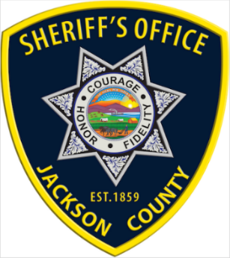
One of the major challenges that Jackson County has to deal with is its location being adjacent to a metropolitan area with a four-lane highway system spilling traffic into it. That metropolitan area has over 5 times more crime than Jackson County and a portion of that crime comes here.

Some of the challenging incidents in 2018

Two killed in Netawaka house fire
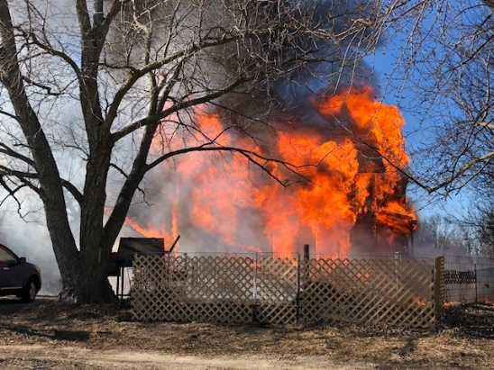
In the morning of February 16th, the sheriff’s office received a report of a structure fire at 421 Whiteway Street in Netawaka. A dozen fire departments from surrounding areas including the Netawaka Fire Department responded to the scene. Upon arrival, the two-story residence was fully engulfed with fire. The fire threatened a residence to the east. The fire was brought under control in a little over an hour. A family dog was rescued from the fire. Following the fire, two deceased persons were found inside. Fire investigators from the Jackson County Sheriff’s Office and the Kansas State Fire Marshal’s Office investigated the cause of the fire. Autopsies were conducted by the Coroner in the investigation. The two victims were later identified as Richard D. Willits, 55, and Denise Willits, 47, both of Netawaka. The fire was believed to have started from a wood burning stove. Another fatality fire occurred in Netawaka just months earlier in December of 2017, when 75-year-old Catherine A. Duncan was killed after her clothing ignited from a cooking stove being used to heat her home.
Peaceful ending to Delia standoff
A Delia woman was arrested following an armed standoff northeast of Delia in the afternoon of February 20th. The Jackson County Sheriff’s Office was notified of an armed woman who allegedly pulled a shotgun on her boyfriend north of Delia. The man and a child escaped the residence unharmed. Deputies with the Sheriff’s Office responded to the scene where the woman remained held up inside the residence for over an hour. The Undersheriff and Sheriff negotiated with the woman, which led to the woman’s surrender to law enforcement where she was transported to the Jackson County Jail. The Kansas Highway Patrol, Jackson County EMS, Delia, Mayetta and PBPN Fire Departments responded to the incident.
Former volunteer firefighter arrested for arson
On March 21st, a former Jackson County volunteer firefighter was arrested by Jackson County Sheriff’s Investigators. The suspect was arrested following an investigation conducted by the Jackson County Sheriff’s Office. The investigation focused on numerous suspected arson grass fires that occurred from February 28th, 2018 to March 20, 2018 in southwestern Jackson County. The suspect was suspected of setting these fires, who then responded to many of the fires with the Delia Fire Department. Investigators obtained a search warrant for a tracking device to be placed on the suspect’s vehicle which connected the suspect to a number of the fires. The suspect was arrested and held in the Jackson County Jail on 13 counts of arson.

Missouri theft ring trio arrested on theft charges
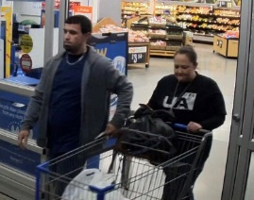
On March 28th, three Missourians were arrested by the Jackson County Sheriff’s Office in Holton on theft charges. The sheriff’s office sent out photos of two of three suspects to the public earlier in the week for identification purposes following a prior theft. Raven Alexandria Neece, 36, of Ferrelview, Missouri and Joshua Braxton Thigpen, 31, of Ferrelview, Missouri were suspected of two separate thefts at the Holton Walmart store. The first theft occurred on February 9th, 2018 and the second on March 25, 2018. The two were suspected of stealing a number of electronic devices on both occasions. On Wednesday morning, March 28, 2018 the two individuals returned to the Holton Walmart Store where store staff recognized the duo and alerted law enforcement. Shortly thereafter, deputies stopped a 2018 Nissan passenger car near the store, which was occupied by the couple. The vehicle was also occupied by a third person, Karly Lyndon Barnes, 27, of Gladstone, Missouri. All three subjects were taken into custody by sheriff’s deputies. The three were also suspected of an attempted theft at Walmart on March 28th.
The individuals were suspected of removing theft detection devices from high-end electronic products, specifically electronic tablets, IPads and video games. A search warrant on the vehicle Wednesday, deputies discovered thousands of dollars of high-end electronic products believed to have been stolen from the four state area of Missouri, Iowa, Nebraska and Kansas. Other Walmart stores and other department stores were believed to be have been targeted in these thefts. These suspects were suspected to be operating an EBAY business where stolen merchandise was being sold online.
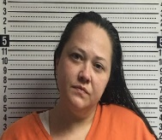
Raven Neece was arrested and was held in the Jackson County Jail on the following charges: 3 counts of aggravated burglary, 3 counts of criminal trespass, felony theft, attempted theft, and 2 counts of tampering with a theft detection device.
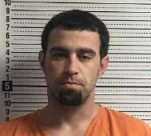
Joshua Thigpen was arrested and was held in the Jackson County Jail on the following charges: 3 counts of aggravated burglary, 3 counts of criminal trespass, felony theft, attempted theft, and 2 counts of tampering with a theft detection device.
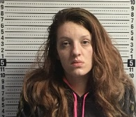
Karly Lyndon Barnes was arrested and was held in the Jackson County Jail on the following charges: Conspiracy to commit aggravated burglary, and tampering with a theft detection device and theft. Barnes also used the identity of her sister in initially identifying herself to investigators.
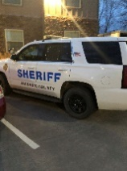
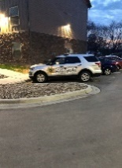
Jackson County Investigators later served a search warrant on the group’s residence in Ferrelview, Missouri which is located close to the Kansas City International Airport. Items believed to have been stolen from the Holton Walmart was seized from the residence. In addition, other electronic devices, ledgers and documents was seized from the Ferrelview residence that are believed to connect the trio to the illegal theft and EBay operation. Ultimately, all three were convicted and sentenced to prison.
Two more Missourians arrested in Walmart thefts
Jackson County Sheriff’s Deputies arrested two more Missourians on April 2nd, following alleged thefts at the Holton Walmart store. This new incident is not believed to be connected with the March 28th arrests.
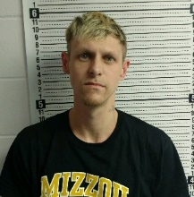
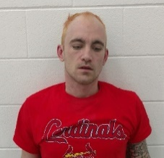
Jason Allen Aubrey, 30, of Bethany, Missouri and Kevin Lee Parker, 31, of Bethany, Missouri were arrested east of Holton on K-116 Hwy following a traffic stop by deputies. Three T.V.s were recovered during the traffic stop and a sound bar was found in Atchison County that were believed to have been stolen from the Walmart store. The Sheriff’s Office recovered an additional T.V. from a Denison residence Monday evening believed to have been stolen by the same suspects. At the time of the thefts, theft detection devices had been removed from the products as well.
Both Aubrey and Parker were wanted by the Missouri Department of Corrections. Parker at the time of arrest was on house arrest and was wearing an ankle monitoring device.
Aubrey and Parker were held in the Jackson County Jail on the following charges: Two counts of felony removing a theft detection device, two counts of misdemeanor theft, conspiracy to commit theft and criminal damage to property.
Fugitive found hiding in attic
On April 5th, the Jackson County Sheriff’s Office arrested a fugitive that was believed to have been on the run for several months. Chelsea Jean Finch, 25, of Hiawatha, was arrested by Jackson County Sheriff’s Office deputies following serving a search warrant in the City of Horton. Deputies found Finch hiding in the attic of the residence. A male subject, Dylan Lynard Thomas, 23, of Horton, was arrested by Horton Police for felony interference with law enforcement. Finch was placed into custody, and transported to the Jackson County Jail. While at the jail, it was discovered that Finch allegedly trafficked methamphetamine into the facility. Finch was held on two no bond Jackson County warrants and for trafficking contraband into a correctional facility, possession of methamphetamine with the intent to sell, and possession of drug paraphernalia. Bond on the drug charges was set at $50,000.00. The Horton Police Department and the Brown County Sheriff’s Office assisted in the investigation and apprehension of Finch.
Eleven arrested during drug interdiction campaign
On April 22nd, the Jackson County Sheriff’s Office participated in the Six State Area 4-20 Campaign. Law enforcement from the states of Iowa, Missouri, Arkansas, Nebraska, Oklahoma and Kansas participated in an effort to minimize traffic deaths caused by impaired driving, whether it be from alcohol or drugs. During the campaign law enforcement cited drivers for a variety of traffic related infractions. As a part of the campaign, the Jackson County Sheriff’s Office performed a saturation patrol on US Hwy 75. The saturation took place over a three-hour period in the late afternoon on Friday April 20th. The saturation yielded in 11 arrests and 22 traffic stops. The following charges were issued: one possession of methamphetamine, one possession of prescription narcotics, eight possession of marijuana, nine possession of drug paraphernalia, one interference with law enforcement, one driving under influence, one transporting open container, one no insurance, one trafficking contraband into a correctional facility, two speeding, one impeding the flow of traffic, one expired registration, one driving in violation of restrictions, one driving without interlock device.
Hiawatha man arrested following early morning incident
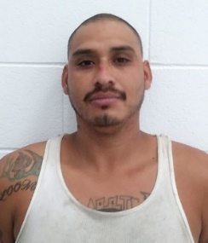
On June 23rd, Jackson County Sheriff’s Deputies responded to an incident shortly before 5 am Saturday morning in western Jackson County. Deputies responded to an address on B. Road in western Jackson County in reference to a report of a possible injury accident near a rural residence. The report stated that there was a vehicle in the ditch with its wheels spinning and another vehicle on fire. When Deputies arrived on scene, arrested was Adrian Ramirez, 32, of Hiawatha.
It appeared that Ramirez’ vehicle caught fire after he wrecked it near the residence. Ramirez then allegedly entered a shed, and stole a 1997 Chevrolet pickup from the residence in which, he subsequently crashed again just past the end of the victim’s driveway. At the time, Ramirez was in the accompany of his 4-year-old child at the scene. Jackson County Fire Departments and EMS were dispatched to the scene. Fire departments were able to extinguish the vehicle and a grass fire. Deputies found Ramirez huddled with the child hiding in the pickup bed of the Chevrolet pickup.
Ramirez was medically evaluated and transported to the Jackson County Jail where he was booked in on the following charges: burglary, felony theft, felony DUI, aggravated child endangerment, driving without an interlock device, and failure to report an accident. Bond on Ramirez is pending at this time. The child was uninjured.
Sheriff’s Day Camp was a success
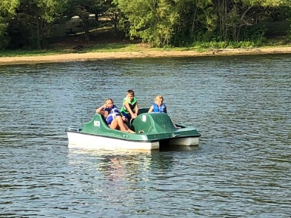
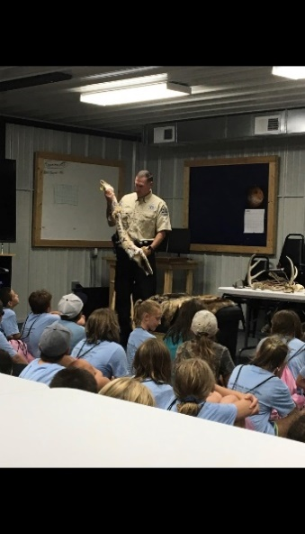
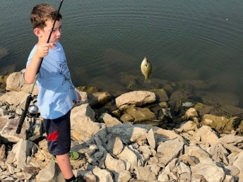
In August, The Jackson County Sheriff’s Office hosted the 17th annual Sheriff’s Day Camp. Over 260 kids attended the camp. The Sheriff’s Day Camp has been successful in building strong bonds and lasting relationships between the law enforcement community and the youths of our county. The Day Camp provides a positive encounter with kids and cops. Unfortunately, kids encounter law enforcement during very difficult times too frequently. Day Camp has been extremely beneficial allowing kids to see cops as real people who are concerned about them and their safety. The 17th annual Jackson County Sheriff's Office Day Camp was held at Banner Creek Reservoir near Holton on August 9th and 10th.
The Sheriff's Day Camp featured the following events and activities: an emergency vehicle demonstration and display, including fire trucks, ambulance, law enforcement vehicles, and an armored swat truck. Emergency responders demonstrated their equipment and techniques, including a Jaws of Life demonstration, a K-9 illegal drug detection demonstration, 911 demonstration and education, Life Star Helicopter landing and much more.

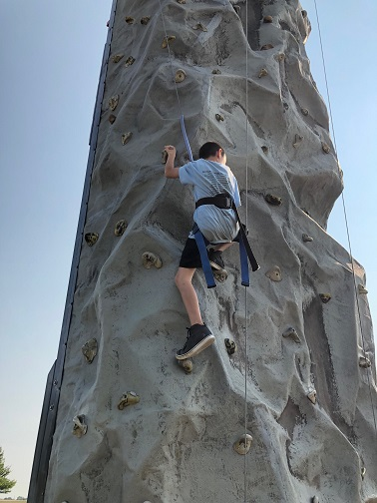
Kids also were able to participate in archery, swimming, canoeing, peddle boats, fishing, hay rack ride, rock wall climbing, 24’ mountain, Boot Camp Obstacle Course, Extreme Obstacle Course, A demonstration at the Banner Creek Observatory and Science Center and a program by the Department of Wildlife, Parks and Tourism animal and fishing program. Numerous volunteers including some elected and local governmental officials assisted with the camp including:

The Jackson County Commissioners, Banner Creek Reservoir, Jackson County Appraiser’s Office, Jackson County Emergency Management, Jackson County Road and Bridge Department, Jackson County EMS, Kansas Department of Wildlife Parks and Tourism, Kansas Highway Patrol, Shawnee County Sheriff’s Office Swat Team, Potawatomi Tribal Fire Department, Potawatomi Tribal Police, City of Holton, Holton Police Department, Hoyt Fire Department, Holton Fire Department, Banner Creek Science Center and Observatory, Honey Do’s Septic Tank and Drain, Walmart, Roush and Son’s Towing and Recovery, LLC, United Rental, Circleville Christian Church, City of Onaga Swimming Pool, Derik Kesler, Dan Madere, Shawnee County Parks and Recreation, Holton Lion’s Club, Bikers Against Child Abuse, Walmart, United Rentals, Life Star of Kansas, many more volunteers and the men and women of the Jackson County Sheriff’s Office assisted with or sponsored the event.

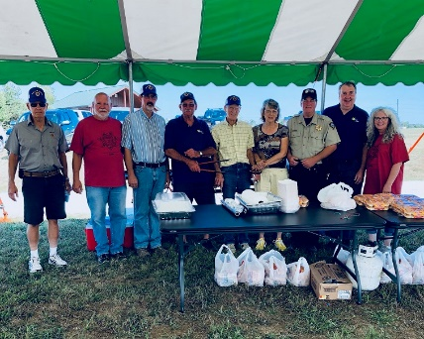
We would also like to thank the Holton Lions Club who has prepared lunch for our campers at Day Camp throughout the years. The Holton Lions Club disbanded in 2018, but made lunch for the kids one last time, making the Jackson County Sheriff’s Office Day Camp their final event as an organization. We appreciate the Holton Lions Club for their many years of dedication and contributions to Holton and Jackson County. We wish the very best for each and every member.

The 2019 or 18th Annual Sheriff’s Day Camp will be held August 8th and 9th at Banner Creek Reservoir. Registration forms can be found on the Jackson County Sheriff’s Office website at www.jasoks.org and they will be available starting May 1st, 2019 at the Jackson County Sheriff’s Office located at 210 US Hwy 75, Holton, Kansas, or for more information call 785-364-2251.
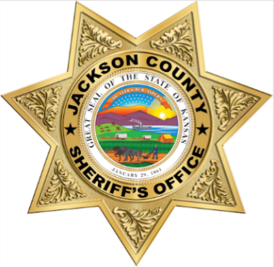

Burglary suspect captured
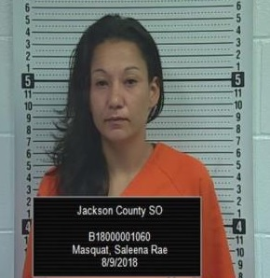
A Jackson County woman was in custody after being arrested on August 9th. Saleena Rae Masquat, 33, of Mayetta, was arrested after a Jackson County deputy stopped to assist with a disabled silver 2008 Dodge Caravan on P. Road near 254th Road. The deputy determined that the vehicle had been stolen from the Sac and Fox Casino earlier in the day. Masquat was placed under arrest and was alleged to be in possession of methamphetamine and drug paraphernalia.
In addition, Masquat has been alleged to be tied to three Jackson County burglaries. Jackson County deputies and detectives investigated a burglary to an occupied residence located on 326th Road where items including a television had been taken on August 9th. Deputies and detectives also worked a burglary to an unoccupied dwelling located on 326th Road in rural Whiting on August 9th. Detectives also investigated a burglary to a shed near 254th and P. Road close to where the arrest of Masquat occurred, where an assortment of tools had been stolen. Deputies recovered a considerable amount of the missing property that had been alleged to be in Masquat’s possession. On August 13, a fourth report was made to the sheriff’s office in reference to a burglary to a shed located on P. Road in rural Holton. The victim reported missing an assortment of tools and power tools. The burglary is also believed to have occurred on August 9th. Again, many of the items are believed to be recovered from the fourth burglary. Masquat who is still being held in the Jackson County Jail was booked on the new burglary charge on the 14th and bond on Masquat was raised to $20,000.00.
Missing boys found near Delia
The Jackson County Sheriff’s Office received a report of two missing children near Delia shortly before 4 pm on August 16th. Deputies along with Delia Firefighters and community members responded to the residence on the outskirts of the City of Delia in southwestern Jackson County. Two boys, ages four and seven, went missing in the early afternoon after playing outside on the family’s farm. The family notified law enforcement after they had been unsuccessful in locating the two boys. Deputies, KHP Troopers, Delia firefighters, family, and neighbors searched a variety of rural locations outside of Delia. The Union Pacific Railroad dispatch was notified placing trains on standby. A KHP aircraft and search dog were responded to the scene. A drone was also used to search the area. A creek that ran through the property was searched along with the area railroad tracks and cornfields. A passerby contacted the sheriff’s office reporting that they had seen the boys north of Delia earlier in the afternoon. Deputies began to scour the area north of Delia. Shortly, thereafter and shortly before 6 pm both boys were found at a farm near 134th and E. Road approximately 3.5 miles north of their residence. The two boys were found to be in good condition and were returned to their family.
Overbrook man arrested following pursuit
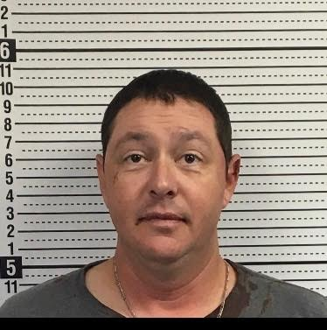
An Overbrook man was arrested the night of August 23rd following a pursuit in Jackson County. Shortly before 8 pm, the Jackson County Sheriff’s Office was notified of a reckless driver northbound on US Hwy 75 near the Shawnee County line. A Jackson County Sheriff’s Deputy attempted to stop a silver 2004 Ford Mustang near 134th and US Hwy 75. The vehicle failed to yield and fled northbound to 150th Road where the vehicle headed eastbound. The vehicle then went south to 142 Road and continued back towards US Hwy 75 when a Jackson County Sheriff’s Deputy and a Potawatomi Tribal Police Officer deployed stop sticks flattening three of the vehicle’s tires. The vehicle made its way back to US 75 Hwy and headed north turning westbound on 150th Road. Deputies, KHP Troopers and Tribal Police brought the vehicle to a stop west of Q. Road on 150th. Law enforcement attempted to remove the driver from the vehicle when the driver accelerated, crashing the Mustang into a Potawatomi Tribal Police vehicle. The driver was removed from the vehicle and taken into custody. The driver was identified as Kristin Michael Downs, 38, of Overbrook. Downs was taken to an area hospital for medical evaluation.
Suspect arrested in alleged school threat
The Jackson County Sheriff’s Office a 19-year-old Topeka man on a Jackson County District Court warrant for criminal threat and telephone harassment. The sheriff’s office was informed on the morning of August 29th of a series of alleged criminal threats directed towards several area teenagers. The Royal Valley High School was placed on modified lockdown during the morning and additional deputies were on scene for precautionary purposes. The suspect in the case was arrested in Topeka and was booked into the Jackson County Jail.
Sheriff Morse invited to the White House
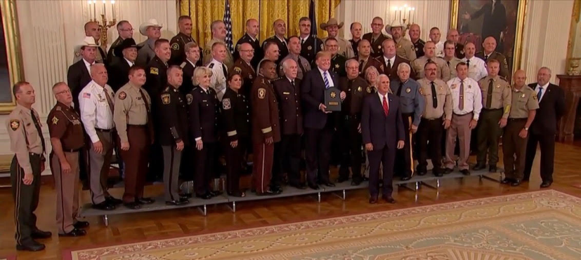
In September, Jackson County Sheriff Tim Morse was one of forty-four sheriffs from 35 different states invited to the White House to meet with top administrative personnel from the Executive Branch. The sheriffs briefed Department of Justice, Border Patrol, Immigration and Custom Enforcement leaders and policy advisors on immigration issues within their jurisdictions. The sheriffs also met with President Trump and Vice President Pence. Sheriff Morse is a member of the National Sheriff’s Association Immigration and Border Security Committee. Public funds were not used for the trip.
Man arrested in father’s murder
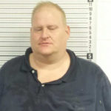
The Jackson County Sheriff’s Office received a 911 call shortly after 3 am on September 18th, from a residence located on Q.4 Road north of Holton. The caller advised that her son had shot his father in the head, and she was barricaded inside a bedroom of the residence.
Deputies responded to the scene and observed a male inside the residence armed with a long gun. Deputies were able to approach the house and extricated the female from a bedroom window while the suspected shooter tried to break down the bedroom door. Deputies were able to move the woman to safety without injury.
The Sheriff was able to make contact with the suspect by telephone and spoke with him for several hours. The suspect refused to follow directives and refused to exit the residence. Deputies propelled tear gas into the residence at which time the suspect allegedly fired a shotgun towards deputies striking a vehicle they were using for cover. The suspect subsequently exited the residence and surrendered to law enforcement around 8:30 am Tuesday morning. Deputies found the other male occupant deceased inside the residence, who was identified as Gaylen Bohnenkemper, 73, of Holton. The suspect Derrick G. Bohnenkemper 49, of Holton, was evaluated by EMS and transported to the Jackson County Jail where he is being held on the following charges: murder in the 1st degree, aggravated assault and 5 counts of aggravated assault on law enforcement officers. Bond on Bohnenkemper was set at $250,000.00.
Mayetta teen arrested on attempted murder charge
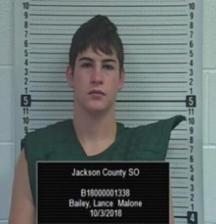
The Jackson County Sheriff’s Office received a call shortly after 3:30 pm on October 4th reporting a shooting in rural Jackson County. The caller reported a shooting that took place on L. Road on the Potawatomi Reservation west of Mayetta. A car occupied by three females drove into the driveway of the residence, when Lance Malone Bailey, 18, of Mayetta allegedly opened fire with a rifle striking the female victim who was then standing in the drive. The incident is believed to have occurred during a verbal altercation between the suspect and victim. The female victim also of Mayetta, was 17-years of age. The three girls left the scene in the vehicle and called law enforcement. The Jackson County Sheriff’s Office and the Potawatomi Tribal Police responded to the scene. Bailey was taken into custody and was later transported to the Jackson County Jail. The victim was transported to a Topeka hospital by PBPN EMS. Deputies and Officers obtained a search warrant Wednesday evening and processed the scene. Bailey was booked into the Jackson County Jail on the following charges: attempted 1st degree murder, aggravated battery, 3 counts of aggravated assault, possession of a controlled substance and possession of drug paraphernalia. In December 2018, following a plea deal, Bailey was sentenced to 5 years in prison.
Suspect in Ukele family deaths captured
Maria De Jesus Perez-Marquez, 49, of Omaha, Nebraska has been captured in Nebraska by U.S. Marshals on October 23rd. Perez-Marquez is a suspect in the traffic deaths of three members of the Ukele family who were killed in November 2017. Perez-Marquez failed to appear on charges for three counts of involuntary manslaughter and two counts of aggravated battery and reckless driving on October 11, 2018 in the Jackson County District Court. The Jackson County Sheriff’s Office requested the assistance from the U.S. Marshals to locate Perez-Marquez. Perez-Marquez who was arrested on a no bond warrant from Jackson County District Court warrant, was transported to the Douglas County Jail in Omaha, Nebraska and was later extradited to Kansas.
Three in custody on burglary charges
Two men and one juvenile were arrested for burglary charges in Jackson County. A Jackson County resident saw a red Chevy passenger car leaving their address on 98th Road in southeastern Jackson County and discovered their residence had been broken into, on November 5th. The resident then found the red Chevy vehicle disabled near 98th and V.4 Road and parked in the roadway. Jackson County Sheriff’s Office deputies, KHP, Jefferson County Sheriff’s Office scoured the area looking for the suspects. It was later determined that a passerby had picked up the vehicle’s three occupants and drove them to a residence in the 9000 block of Topeka Blvd. in Shawnee County. A Shawnee County Deputy saw two subjects west of the address in a wooded area. Deputies from Shawnee County, Jefferson County, Jackson County and KHP Troopers arrived in the area. A KHP aircraft also assisted with the search. One of the suspects was taken into custody after being bitten by a KHP K-9 unit. Two more subjects were taken into custody west of the address in the 8900 block of Rochester Road. All three subjects were transported to the Jackson County Sheriff’s Office.
Taken into custody were 21-year-old Ty Daniel Haire, of Mayetta, 20-year-old Robert Anthony Witmer, of Topeka and a 17-year-old male, of Hoyt who were transported to the Jackson County Jail.
Kansas City man escapes private inmate transport company temporarily
On November 28th, a Kansas City, Kansas man being extradited from a Kansas City, Missouri Jail to Topeka on multiple Shawnee County warrants tried to escape from a private inmate transport officer that afternoon. Shortly before 1 pm, a private transport company arrived at the Jackson County Sheriff’s Office in Holton, Kansas to pick up an inmate that was being held on a Shawnee County warrant. One of the private transport officers entered the jail awaiting the transfer of the inmate to their custody, while a second private transport officer escorted a second inmate who was in their custody to a public restroom in the lobby of the jail. The inmate was being transferred from KCMO to Topeka. The inmate allegedly removed his handcuffs while in the restroom and assaulted the second private transport officer and fled the jail lobby. Sheriff’s Deputies and Correction Officers subdued the inmate in the Sheriff’s Office parking lot.
The inmate identified as Jacob Daniel Kull, 38, of Kansas City, Kansas was arrested by Jackson County Sheriff’s Deputies for aggravated escape from custody and battery. Bond was set at $50,000. Kull had Shawnee County charges for burglary, theft and forgery.
Private transport companies are often contracted to transport inmates across the state and nation for counties. However, the Jackson County Sheriff’s Office does not use private transportation services for the extradition of inmates.
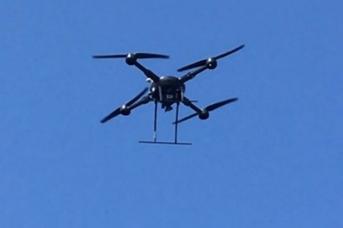
Topeka man jailed following pursuit into Shawnee County
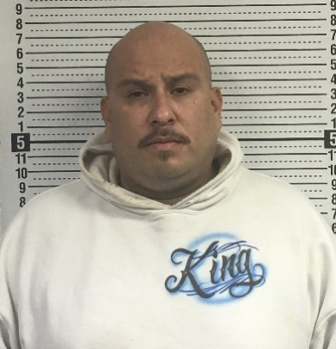
A Topeka man was taken into custody during the evening of December 11th following an early morning Jackson County pursuit. Shortly before 8 am, a Jackson County Deputy attempted to stop a silver 2009 Impala in southern Jackson County on US Hwy 75 near 110th Road. The driver allegedly failed to stop and fled from the deputy in the vehicle heading south into Shawnee County. The deputy continued the pursuit which led to the area of Topeka Blvd. and NW Independence Avenue where the deputy terminated the pursuit. KHP Troopers and Shawnee County Deputies assisted with the search for the driver and vehicle. Later in the day, the Jackson County Sheriff’s Dispatch was contacted by the suspect, Michael Todd Belaire-Serna, who stated he had reported his car stolen in Topeka. Topeka Police went to meet with Belaire-Serna to take a stolen vehicle report. Topeka Police took Belaire-Serna into custody and released him to Jackson County Sheriff’s Office. Belaire-Serna was booked into the Jackson County Jail on the following charges: Felony flee and elude, reckless driving, felony interference with law enforcement, and driving while revoked. Belaire-Serna was also cited for numerous traffic offenses. Belaire-Serna’s vehicle was recovered in the 1900 of NW Fillmore Street in Topeka and impounded.
School Defender Initiative

In 2018, Sheriff Tim Morse voiced his ideas in making Jackson County Schools safer. Sheriff Morse who has seen senseless killings in our nation’s schools and believes there are better ways in keeping children safe in schools.

Sheriff Tim Morse stated the following: “The first thing parents do after hearing about another school shooting is they confirm it isn’t their child’s school. Enough is enough, when will our politicians get it? For over 20 years now, children have been the targets of deranged persons who have slaughtered innocent children in a place we expect them to be safe, their schools. In 20 years, our federal and state government has done little to nothing to make them safer. The time has come for the people to stand up and demand that their children be protected from these disturbed individuals. Unfortunately, for a variety of reasons, there has been an increase in deadly violence among some of our young people. Nevertheless, our world is a different place than it once was.”

Sheriff Morse pointed out the changes in security that have taken place after the Oklahoma City bombing in stepping up security at courthouses and the upgrade in security at airports across the country following the 9/11 terrorist attacks. Sheriff Morse has advocated for enhanced security in county schools due to the threats Jackson County faces with its location next to the capital city, the abundant amount of mental health issues in the community and surrounding areas, along with the proliferation and accessibility of unsecured weapons in the rural community.

Sheriff Morse has stated that school districts in larger counties have their own police departments or added law enforcement already in their schools; however, those schools in the rural area are much more vulnerable. Sheriff Morse believes students, teachers and parents should not have to worry about safety in the school, students should focus on learning, and teachers should be able to focus on teaching.
Since Jackson County is a rural county with little industry and less funding than urbanized counties. Sheriff Morse suggested training reserve deputies that would be charged with securing our schools. These deputies would be sworn law enforcement that would have specialized training in building security, active shooter trainings and a variety of training that would be specific to school security. The Sheriff also proposed a second component to the plan that would allow upon school board approval, a limited number of non-teaching school employees to undergo the same training who would serve as a back up to uniformed reserve deputies. All participants would be highly vetted, screened, tested, polygraphed, and would have to undergo the same hiring requirements as any deputy sheriff.

The insurance company that insures Jackson County has approved Sheriff Morse’ plan for school security. Sheriff Morse continues to work with districts in making schools safer and is planning for a reserve law enforcement academy to start in the near future.

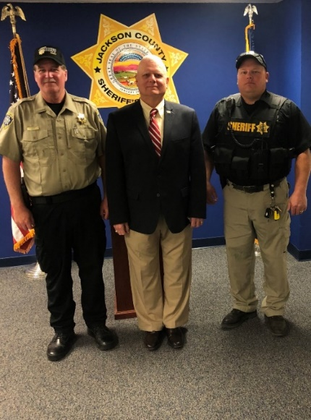
To assist with the implementation of the School Defender Initiative, Sheriff Tim Morse appointed Deputy Joe Romans to serve as a coordinator for the program. Deputy Romans will work with schools on improving building security and coordinating reserve law enforcement efforts.

This announcement was made when Deputy Romans was appointed to the position, “The Jackson County Sheriff’s Office is proud to announce that Joe Romans has accepted the position as deputy in charge of the Jackson County Sheriff’s Office School Defender Initiative. Deputy Romans will be tasked in helping make our children safer within our school districts. Deputy Romans will play an essential part in training other volunteer reserves for the purpose of securing our schools. CSM C. Joseph (Joe) Romans retired in December 2008 after a 30 year Active Duty Career. Deputy Romans first enlisted in October 1968 and served with the Marine Corps as a Corpsman for 4 years. He was honorably discharged in 1973 and then pursued a career as an EMT and Paramedic in Indianapolis and then 5 years as a Remote Arctic Air Force Radar Site Medic in Alaska. He re-enlisted in the Army in 1982 and served for 26 more years.

Deputy Romans attended every level of the Army Non-Commissioned Officer Education system culminating with the Sergeant Major Academy. He served in the following military occupational specialties; Medic, Infantryman, Cavalry Scout and Armor Crewman. He held the following leadership positions; Team leader, Squad leader, Tank Commander, Scout Platoon Sergeant, Mortar Platoon, Armor Platoon Sergeant, Company First Sergeant, Intelligence Sergeant and Operations Sergeant Major. Deputy Romans was a Command Sergeant Major at the Battalion, Regiment and Brigade level. Joe was the NCOIC of the Kansas National Guard Counterdrug Special Operations Team. Deputy Romans attended the DEA Drug Unit Commanders Course, DEA Highway Interdiction Course, DOJ Community Policing Course, KBI SWAT Course, KBI Aerial Narcotics Smuggling Course, Reduced Light Firearms Instructor Course, Close Quarters Battle Course, ASP Baton Instructors Course, Topeka Police Department Law Enforcement Firearms Instructors Course, DEA Clan Lab Course, Armed Vehicle Operations Course, Edged Weapons Course and many others.

Deputy Romans served in the following campaigns or countries. Viet Nam era, Operation Desert Shield, Operation Desert Storm, Operation Joint Guardian and Operation Iraqi Freedom. He served in Saudi Arabia, Kuwait, Iraq, Kosovo, Macedonia, Japan, Germany and Korea. Deputy Romans served in or was attached to the following units. 1st Battalion - 635th Armor Regiment 35th Infantry Division, 1st Marine Regiment-1st Marine Division; 235th Regiment (RTI); 32nd Armor Regiment -1st Cavalry Division; 5th Battalion (Eskimo Scouts) 297th Infantry Brigade; and 2ndBrigade 40th Infantry Division. Deputy Romans was attached to the 5th Special Forces Group and SEAL Team 3 as part of the Combined Joint Special Operations Task Force-Arabian Peninsula; in Iraq. Deputy Romans has 25 ribbons and medals to include various combat, campaign, service awards and achievement awards. This includes foreign decorations from Saudi Arabia, Kuwait, Denmark, Germany and a NATO Meritorious Service Medal. He has two unit awards, Superior Unit Citation and Meritorious Unit Commendation. Badges include the Combat Action Badge and Navy Enlisted Expeditionary Warfare Badge. Deputy Romans has been nominated for the Kansas National Guard Hall of Fame and will be boarded for that honor in February 2019.

Deputy Romans is married to a loving and wonderful wife, Nancy. He has four children, Kyle, Debbie, Joe Jr and Holly. Kyle is an Assistant Fire Chief and reserve Police Officer, who is married with one son and lives in Montana. Debbie is a homemaker and mother with two daughters and lives in Texas. Joe Jr is Sergeant in the U.S. Army Infantry and is on his second combat deployment. Holly is a U.S. Navy Petty Officer Second Class on the Littoral Combat ship USS Jackson, home ported in San Diego. Deputy Romans and Nancy reside in Hoyt Kansas.

Deputy Romans has demonstrated his commitment in making America safe throughout his entire military career, and Deputy Romans desires to make our children safe right here at home. The Sheriff’s Office is very honored to have someone with his dedication and abilities, and Deputy Romans is a fine example of the type of individuals the Sheriff’s Office plans to recruit in the School Defender Initiative.

Sheriff Tim Morse said, “Most active shootings and acts of violence take place in seconds or in just a few minutes. Response times could be more than 10 minutes, and in some places, much longer. The quicker the response, the greater the chance to save lives. Trained and armed personnel on scene are much more effective than waiting for help to arrive. The only effective way to stop an armed person is with a trained and armed person. While a lot has been done in dealing with the aftermath of school shootings, little has been done to prevent these tragedies from occurring in the first place. As Sheriff, I am willing to do whatever it takes to keep every child safe.”

Sheriff’s Office Grant Projects
The sheriff’s office has taken advantage of a number of grants over recent years. In 2018, a number of grants have been submitted. The sheriff’s office has been awarded the VOCA grant, as well as a JAG grant for equipment, and additional grant for a domestic violence and sex crime investigator position is being pursued.
The Federal Victims of Crime Act (VOCA)
The Jackson County Sheriff’s Office received a third year of funding for Project A.C.T. (Addressing Crime Together). This grant project provides immediate support services to victims reporting a crime, and ongoing services to crime victims involved in the criminal justice process. This continuum of support from report to sentencing of a crime has been a successful method to improve victim safety and offender accountability in our county. Services are initiated when law enforcement contacts project staff at the time a crime is reported. All services are provided free of charge to victims and their families. This grant project is one of only a handful of victim service positions throughout the state, working directly with law enforcement. This grant project is unique not only in its rural setting but also in the development of victim services in Kansas.
This project is made possible by the Victims of Crime Act passed in 1984 which established the Crime Victims Fund. These funds are distributed to the states by the U.S. Department of Justice. In Kansas, the (KGGP) Kansas Governor’s Grant Program administers these funds. The Jackson County Sheriff’s Office was awarded $76,720 in federal funds for this project in 2018. The sheriff’s office applied for and received a fourth year of funding for this project for 2019.
To date the Victims of Crime Act funding has allowed for 325 primary and secondary victims of crime in Jackson County to receive services, serving 112 victims in 2018. This year a variety of victims were assisted regarding crimes such as; sexual assault, physical assault, stalking, domestic violence, identity theft, elderly abuse, survivors of homicide victims, victims of child sexual assault and teen dating violence.

Project staff and volunteers provided immediate support services, information, referrals, advocacy and criminal justice support for victims reporting a crime in Jackson County. These services were collectively provided 1,434 times to 25 children and 87 adults in 2018.

The Federal Edward Byrne Memorial Justice Assistance Grant (JAG)
This program provides funding opportunities to state and local jurisdictions for the purpose of improving community and law enforcement safety through information, technology, victim services and reduced recidivism. The Kansas Criminal Justice Coordinating Council (KCJCC) oversees the JAG Program in the State of Kansas. The Kansas Governor’s Grants Program (KGGP) serves as the staff for the KCJCC and point-of-contact for the federal JAG program.
In 2018, the Jackson County Sheriff’ Office applied for and received $70,623 in JAG funding, pending written notification. These funds will be used to replace outdated camera equipment for Jackson County Sheriff’s Office and acquire essential protective gear for deputies and detectives addressing a wide range of high risk situations.
Sheriff’s Business Office
The Business Office of the Sheriff’s Office is under the leadership of Sherri Ladner. The Business Office is in charge of numerous responsibilities including: records, fiscal accounting, billing of services, preparing all employee payroll, dissemination of open record documents, accident reports, offense reports, arrest reports, jail commissary, inmate accounts, civil process, vehicle identification inspections, sheriff sales, inventory, computer network and database management, liaison between a variety of agencies, and supports the Sheriff and Undersheriff.
Sherri Ladner also serves as the 911 Coordinator for Jackson County.
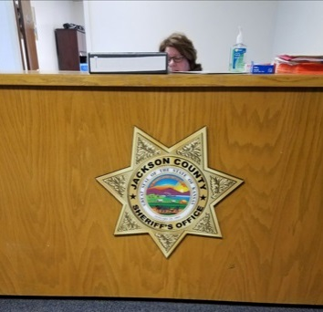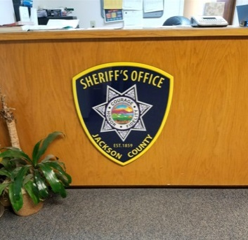
Civil Process
In 2018, the Sheriff’s Office served 2,664 papers for the District Court of Jackson County. In 2018, $12,582.00 in revenue was received from civil process. In 2017, the Sheriff’s Office served 2148 papers with revenue of $10,350.00. In 2016, the Sheriff’s Office served 2,735 papers with revenue of $11,590.00. In 2015, 2,904 papers were served with revenue amounting to $13,440.00.
In 2018, the Sheriff’s Office served 927 summons, 1,138 subpoenas, 125 tax warrants, 7 show causes, 8 writs of assistance, 184 orders to appear, 42 citations in contempt, 101 garnishments, 40 protection from abuse orders, 76 notice of hearing.
VIN Inspections
In 2018, deputies performed 844 vehicle identification number inspections and collected $15,192.00 in revenue. In 2017, deputies performed 916 vehicle identification number inspections and collected $16,488.00 in revenue. In 2016, deputies performed 792 vehicle identification number inspections compared with 740 in 2015. These inspections resulted in $14,256.00 in revenue compared to $13,320.00 in 2015 and $13,302.00 in 2014.
Conceal Carry
In 2018, 30 concealed carry permits were processed by the Jackson County Sheriff’s Office and $975.00 in revenue was collected. In 2017, 24 concealed carry permits were processed by the Jackson County Sheriff’s Office and $780.00 in revenue was collected. Conceal carry permits doubled in 2016 from the year prior. In 2015, following the Kansas legislature easing restrictions on concealed carry, 16 permits were issued comparted to 57 in 2014.
Fingerprints
The Sheriff’s Office in 2018 fingerprinted 88 individuals for employment or background purposes. The Sheriff’s Office collected $880.00 for fingerprints.
Copies of reports
The Sheriff’s Office collected $1037.55 for copies of reports in 2018.
Sheriff Sales
In 2018, the Sheriff’s Office conducted 9 sheriff sales and earned revenue from the sales of $67.50.
Special Law Enforcement Fund
During the year, $11,369.27 was awarded to the Sheriff’s Office through the asset forfeiture procedure. Purchases made from this fund totaled $8,181.34. Ending balance on December 31, 2018 is $7,015.57. These funds can only be used for training and equipment.
Technology
Four new computers were purchased at the beginning of the year to replace outdated computers. Two office printers were also replaced during the year due to equipment failure. Computers are placed on a rotation and are replaced about every 4 years unless they develop other issues sooner.
Kansas Department of Health and Environment and the sheriff’s office information technology provider has coordinated to get the agency’s Intoxilizer 9000 updated so updates can be made through KDHE’s cloud.
Progress has been made in adding additional Panasonic tablets in patrol vehicles. Deputies access sheriff’s office, dispatch and the detention center data. In addition, they also have the ability to access vehicle, driver’s license and criminal history information remotely. Deputies may also complete reports in the field. Two years ago, the sheriff’s office received a grant that paid for the purchase of 10 of these systems.
The sheriff’s office has started the process of upgrading to the State’s sponsored E911 solution through AT&T. This will provide Jackson County with a new state of the art 911 system. Completion of the project is expected in February 2019.
Patrol Division
The Patrol Division of the Sheriff’s Office is one of the most visible parts of the Sheriff’s Office along with being the primary enforcement division. The Patrol Division is also the uniformed division of the Sheriff’s Office and has the primary responsibility of patrolling, traffic enforcement, accident investigation, and responding to calls for service in Jackson County. In 2018, the patrol division initiated and/or responded to 20,790 calls for service. The patrol division strives to remain visible in high crime areas and takes a proactive approach to help keep crime rates lo w. The patrol division operates 24 hours a day, 365 days a year.
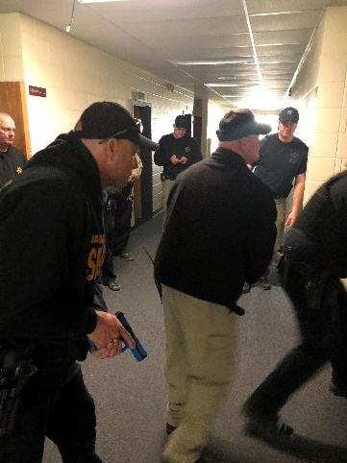
In 2018, the patrol division finished equipping patrol vehicles with Mobile Data Terminals (MDT). MDT’s allow deputies to see pending/ongoing calls and complete reports from their vehicle. MDT’s allow deputies to remain in their assigned patrol zone and reduce time spent in the office completing reports. In April and May, Deputies participated in Active Shooter Response training. Deputies were trained on proper techniques and tactics for quickly and safely ending an active shooter situation. Each Deputy participated in 16 hours of training, consisting of 8 hours in the classroom and 8 hours of scenario based training. The Jackson County Sheriff’s Office trained with both the Topeka Police Department and Kansas Highway Patrol.
In June, two deputies attended the Reno/Harvey County Swat basic training. Deputies trained in less lethal munitions, advanced building clearing and advanced firearms training. These deputies were able to bring back information and incorporate it into in-house training. Deputies also attended trainings in narcotics and dui investigations and officer involved shooting investigations. Prior to 2018, the Sheriff’s Office created a Major Crime Response Team, where deputies were cross-trained in interview and interrogation as well as crime scene processing. This team responds to major crimes to assist the investigations division by supplying extra manpower and skills that are initially needed on crime scenes. In 2018, additional deputies received similar training beneficial to the team.
Patrol deputies continue to make a concerted effort to reduce crime by remaining proactive in the apprehension of criminals. As a result, residential burglaries were down 38% from 2016 and down 68% from 10-years ago. Traffic stops have continued to rise from 2,709 in 2016, 4,095 in 2017 and 4,279 in 2018. Traffic stops play an important role in the apprehension of wanted criminals, drugs and stolen property.
Patrol deputies responded to many calls throughout the year. Several calls this year turned violent and resulted in an armed standoff. These calls require an enormous response commitment from deputies and requires many deputies to be called out from home during their time off. The response for each of these events was near 100%, which is a tremendous achievement. Deputies are notified simultaneously through an alert system.
The K9 unit continued to assist the patrol division in finding illegal narcotics. The K9 unit assists the patrol division on traffic stops and search warrants, but also assists the Detention Center and local schools in attempting to remain drug free facilities. The K9 unit is called upon approximately 100 times a year for narcotics and evidence recovery as well as suspect tracking and apprehension. Both K9’s, Benny (Sgt. Travis DeBarge) and Ike (Sgt. Travis Spiker) maintain their high level of training through the Kansas Highway Patrol and are required to recertify each year.
In 2018, deputies with the Jackson County Sheriff’s Office patrolled over a half a million miles of Jackson County roadways.

Clarification on statistics
Totals of crime offenses compared with calls dispatched are not always equivalent in number. The reason for this is, the call may be reclassified to another type of call or the facts simply don’t support the call as reported. A call may be reported as a robbery and when deputies arrive they find the call to be a theft instead. Sometimes deputies arrive to a scene and find there is no crime committed at all. If deputies are dispatched to a domestic violence call and find there is no offense made, dispatch statistics will show a response was made to a domestic call, but the crime statistics will not list a domestic violence offense.

Patrol responses in 2018

In 2018, the Patrol Division either responded to or initiated the following:
40 - Mental/Suicidal (4 in 2017, 60 in 2016)

609 - Escorts/Transports (205 in 2017)

1,908- Civil Process (1,720 in 2017, 1,957 in 2016)

928 - Warrants (781 in 2017, 742 in 2016)

4,279 - Car Stops (4,095 in 2017, 2,709 in 2016)

274 - Non-Injury Accidents (270 in 2017, 313 in 2016)

96 - Injury Accidents (104 in 2017, 108 in 2016)

14 - Structure Fires (10 in 2017, 15 in 2016)

103 – Fire calls (non-structure)

154 - Alarm Calls (137 in 2017, 138 in 2016)

33 - Fight Calls (17 in 2017, 24 in 2016)

125 - Domestic Violence Calls (122 in 2017, 103 in 2016)

101 - Assault/Battery/Harassment Calls (57 in 2017, 49 in 2016)

595 - Animal Calls (527 in 2017, 474 in 2016)

1,059- Assist Citizens Calls (1,105 in 2017, 1,031 in 2016)

332- 911 Hang Up Calls (391 in 2017, 476 in 2016)

73- Disturbance Calls (66 in 2017, 73 in 2016)

334- Suspicious Person/Activity Calls (354 in 2017, 401 in 2016)

161- Juvenile Calls (101 in 2017, 107 in 2016)

50 - Sex Offenses (31 in 2017, 43 in 2016)

114- Welfare Checks (124 in 2017, 108 in 2016)

280 - Theft Calls (182 in 2017, 151 in 2016)

511- Receive Information/Service Request Calls (426 in 2017, 938 in 2016)

746 - Traffic Problems (750 in 2017, 734 in 2016)

4,825- Building/Area Checks (6,400 in 2017, 5,034 in 2016)

13- Illegal Hunting/Criminal Trespass Calls (5 in 2017, 19 in 2016)

184 - Back Up/Assist Other Agency Calls (252 in 2017, 322 in 2016)

30 - Search Warrants (22 in 2017, 24 in 2016)

6 - Vandalism/Criminal Damage to Property Calls

12 - Illegal Trash Dumps (8 in 2017, 16 in 2016)

286- Speak with Deputy Calls (262 in 2017, 329 in 2016)

2 – Fatality

1-Homicide

20– Pursuits (15 in 2017 )

67 – Road slide offs (7 in 2017)

55 – Criminal damage to property

275 – Assist outside agency

61 – Abandoned vehicle

188 – Medicals

34 - Criminal Trespass

183 - Back up

827 - Service requests

510 - Receive information

13- Dead person

160 – Juvenile calls

21 – Missing person

30 – Stolen car

4 – Gas leak

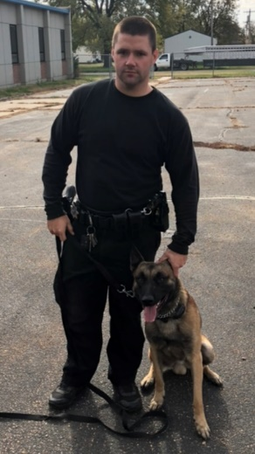
The Sheriff’s Office is made up of some of the greatest public servants in Kansas and in the nation. The office is comprised of men and woman who have given of themselves unselfishly to keep the Citizens of Jackson County safe and secure. Every single employee is essential in carrying out the mission of the Sheriff’s Office.
Jackson County being small in numbers has a vast array of talented people that are serving in public safety. One employee, Sgt. Travis Spiker is a fine example of those who have dedicated themselves to this profession and have given their very best to make us all safer.
Sgt. Spiker serves as a patrol supervisor, making sure that all calls are answered and that citizens get quality service when needed. Sgt. Spiker has also served for a number of years now as a K-9 handler. His partner, Ike, a Belgian Malinois is certified in drug detection, tracking, handler protection and patrol. On the night of December 3, 2017, Sgt. Spiker responded to a domestic dispute in the 800 block of Ohio Street in Holton. The dispute was between a married couple. The Holton Police Department was also dispatched to the scene. The female, who was armed, was taken into custody and placed in the back of Sgt. Spiker’s patrol vehicle, when gunfire erupted from the residence toward the police officer and Sgt. Spiker. The gunfire pinned Sgt. Spiker behind his patrol vehicle. His patrol vehicle sustained a significant amount of damage from the gunfire. Sgt. Spiker, not knowing the intentions of the shooter, acted to get the female out of harm’s way. Sgt. Spiker placed himself in the line of fire and made his way back to the driver’s seat of his patrol vehicle, which was in direct line of sight of the shooter. Sgt. Spiker was able to safely remove the female from the scene. Sgt. Spiker also was involved in another heroic rescue of a woman in 2018 who was barricaded in a room while the suspect in a homicide attempted to break his way inside.
Sgt. Spiker is one of many heroes that make up this agency. He has demonstrated his bravery on multiple occasions. The citizens of Jackson County are extremely fortunate to have Sgt. Spiker serving them. Sgt. Spiker has been recommended to receive the medal of valor for his actions.
In 2018, Jackson County gained a new deputy sheriff. Lane Slocum was promoted to a deputy sheriff after having served as a corrections officer in the Jackson County Jail for approximately one year. Deputy Slocum began his field-training program prior to leaving for the law enforcement academy. Deputy Slocum graduated from the Kansas Law Enforcement Center in Hutchinson, Kansas in December and will complete the final portion of the field training prior to being released for patrol duties in 2019.
Sheriff Morse & Deputy Slocum

Investigation Division
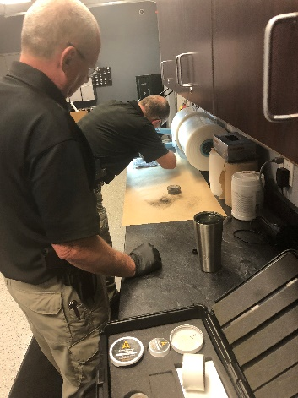
As mentioned in last year’s report, one of the major reasons for the reduction of crime in Jackson County is due to the dedication of the Sheriff’s Office Investigations Division. The Investigations Division is under the leadership of Andy Caviness. This division consists of three investigators and primarily focuses on serious felony criminal offenses. During 2018, the Jackson County Investigations Division worked an estimated 278 cases. Of these 278 cases, 34 were residential burglaries and 12 of these cases were solved resulting in a 35 % clearance rate. The National average for solving a burglary in 2018 is 13.2% (According to the National Council for Home Safety and Security). The unit investigated 74 theft’s to include identity theft, motor vehicle thefts and financial crimes.
The unit investigated 36 sex related cases all of these cases where cleared by arrest or by prosecution, or are still currently under investigation. The investigation unit puts a high priority to these types of person crimes and dedicates time and resources to investigating these crimes to insure a thorough investigation is conducted and all aspects are considered.
The investigation unit is also responsible for the handling of evidence; this includes evidence submitted by patrol deputies for testing at the state crime lab or further investigation of electronic evidence. During 2018, the evidence room logged, stored or tested 2,824 pieces of evidence.
The Investigations unit conducted one homicide investigation this year, and with an arrest of the suspect who is currently awaiting trial. The unit also investigated two other shootings with one conviction and the other currently awaiting trial.
During the year, the Investigations unit served 42 search warrants and 12 inquisitional subpoenas.
The Investigations unit has an investigator on call status 24 hours a day and 365 days a year. The purpose of this is to ensure that no matter the time of day, an investigator will be able to respond to and investigate any crime and be able to travel at a moment’s notice to investigate or assist Patrol Deputies with investigations.
The investigation unit is tasked with crime scene investigation, which includes documenting the crime scene, collecting evidence and submitting biological evidence, narcotics, firearms and cyber evidence to the state crime lab. The Jackson County Sheriff’s investigation unit has helped and investigated crimes for other law enforcement departments in the county and outside the county, to include cases with the State of Kansas and federal law enforcement agencies.
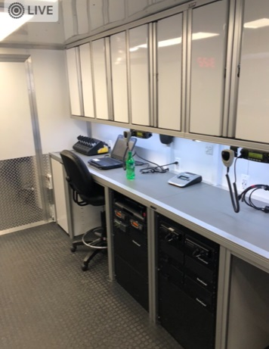
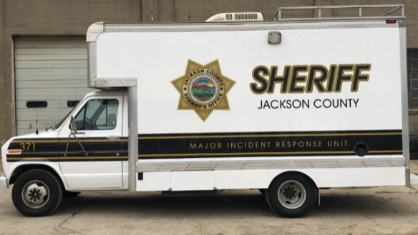
This year the unit investigated an alleged domestic homicide. The Investigations division quickly responded to the scene of this shooting, interviewed witnesses and collected evidence. The Investigations unit also works closely with county and federal prosecutors to prepare and testify in court trials and motions.
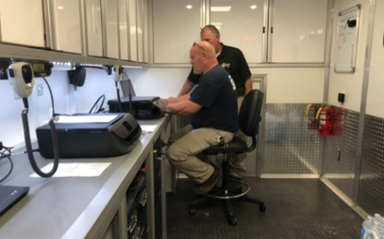
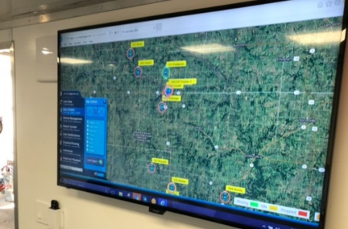
The Jackson County Sheriff’s Office Investigations Division makes use of a large 1990 box style Ford truck for a myriad of purposes. The sheriff’s office acquired the low mileage truck many years ago, which is referred to as the Major Incident Response Unit. In 2018, the MIRU has been updated with some of the most sophisticated crime scene equipment available. The vehicle is also equipped with internet, a generator, a variety of radio communications equipment that is interoperable with all other law enforcement and public safety agencies. The vehicle serves also as a mobile office, allowing investigators to prepare search warrants on scene, send them electronically to a judge and receive them back without ever leaving site. This saves valuable time since crime scenes can be as far as 30 miles from the sheriff’s office within the county. The vehicle also not only contains equipment, but also provides a controlled environment to process, test and package evidence. It also provides for a backup dispatch in times of disaster as well as place for crisis negotiations. The vehicle has also been used as a mobile command center, which provides a location near the scene of an incident for public safety commanders to oversee operations. We are expecting some major changes within the Investigations Division in 2019 to improve services and to make a major impact on crime in Jackson County.
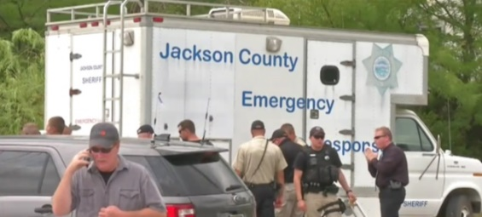
Joan Rebar located
In May, after about two and half years, the vehicle and body of missing person, Joan Rebar, was found in a pond of a rural residence near Meriden, Kansas in Jefferson County. Joan Rebar who was a resident of Jackson County had been reported missing and was last seen at the VFW in Meriden. Extensive manhunts and searches were made in an attempt to locate her. Sheriff Morse formed a task force made up of investigators from Jackson, Jefferson and the KBI. Additional state and federal resources were used in the investigation. Since locating Joan Rebar, the Jefferson County Sheriff’s Office is in charge of the investigation. The Jackson County Sheriff’s Office continues to assist in the investigation. If anyone has any information regarding the disappearance and death of Joan Rebar, they are asked to contact either the Jefferson County or Jackson County Sheriff’s Offices.
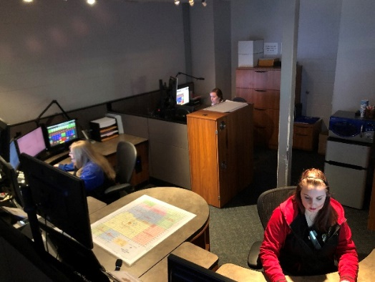
Jackson County Communications Center
The Communications Division of the Sheriff’s Office is under the leadership of Dispatch Supervisor, Kylie Mercer. In 2012, the Jackson County Sheriff’s Office 911 and Communications Center was upgraded with the state-of-the-art equipment. The Communications Center update was grant funded. The Communications Center is staffed 24-hours-a-day, 7-days-a-week. The Sheriff’s Office has an authorized workforce of eight dispatchers. The center receives all 911 calls for the county and dispatches for the Sheriff’s Office, Jail, 2 police departments, Kansas Department of Wildlife, Parks and Tourism, Kansas Highway Patrol, 8 fire departments, and 2 ambulance services.

In 2017, the Jackson County Sheriff’s Office began answering statewide calls for the Kansas Department of Wildlife, Parks and Tourism Operation Game Thief line. The Sheriff was approached by and entered into a partnership with the Kansas Department of Wildlife, Parks and Tourism to handle callers on their 1-800 hotline. Dispatchers in Jackson County answer hunting violation calls for the entire State of Kansas. The information obtained from these calls are forwarded to the game wardens throughout the State of Kansas.

In 2018, there were 62,140 telephone calls either made or received in the communications center, up from 61,295 in 2017. Of those calls, there were 34,979 incoming administrative calls, 23,016 outgoing administrative calls and 4,145 were 911 calls, of which 1,042 came from landlines, and 2,337 were wireless. In addition, 45 911 calls were transferred to other agencies and 721 calls were not identified.

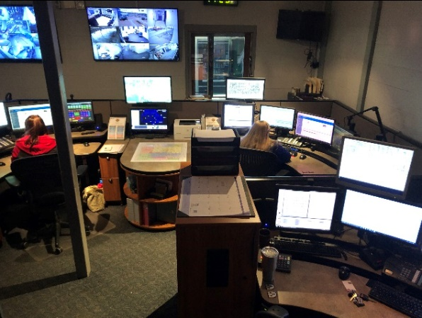
26,704 Incidents Dispatched in 2018
Jackson County Sheriff 20,893
KHP 141
Wildlife and Parks 307
Holton Police 670
Hoyt Police 402
Mayetta Police 171
Tribal Police 343
Jackson Co. EMS 1,521
Hoyt Fire 566
Delia Fire 114
PBPN Fire/EMS 320
Netawaka Fire 136
Mayetta Fire 526
Soldier Fire 88
Holton Fire 82
Whiting Fire 118
OPERATION GAME THIEF 306
Total Incidents 26,704
Being a telecommunications operator can be a very rewarding and fulfilling profession. Filling these spots can be difficult in these times due to the stressful nature of the job and long hours. A dispatcher must be able to make decisions and act on them with limited time and information in situations where there is an element of danger. It requires both physical skills and mental abilities. He or she must be able to remain calm and professional while dealing with people in various emotional states. Stringent standards are necessary to ensure that dispatchers are able to meet the physical and mental demands of the job.

Dispatchers must be able to type at least 40 words per minute, pass entrance testing, pass a background investigation, have strong multi-tasking skills and be able to work nights and weekends. If you are interested in being a part of the dispatch team, contact Kylie Mercer at 785-364-2251.
Jail Division
The Jackson County Jail is a busy place and 2018 was no exception. Having about 100 confined men and women at any one time presents lots of wear and tear on the facility. In addition, preparing 300 meals a day can be a significant challenge. There have been a number of updates with the facility in 2018 as well as numerous repairs to the jail’s infrastructure.
There were 821 inmate transports conducted by the jail in 2018. There were 307 transports to the Jackson County District Court. Fugitives were transported back to Jackson County from 29 different Kansas counties with Shawnee County having the largest number of trips at 179. There were 72 inmates transported from 5 different Kansas prisons. The jail made 87 transports to various hospitals including Osawatomie State Hospital and Larned State Hospital. As mental health issues in the correctional setting seems to be worsening over time, multiple trips were made to both state hospitals in 2018. There were 8 inmates transported to 4 different treatment centers. Inmates were extradited from 6 different states: California, Colorado, Iowa, Missouri, Nebraska and Oklahoma.
The jail currently employs 13 full time and 2 part time officers with one full-time position open.
This year corrections officers have trained on use of force, personal defensive tactics, Prison Rape Elimination Act, suicide prevention, medical protocols, firearms qualifications and fingerprints.
Over 1,708 people were booked into the jail in 2018, which is believed to be an all-time high for Jackson County. Corrections officers were on the roadways transporting inmates from across Kansas. In addition, inmates were also extradited from California, Georgia, Oklahoma, Missouri, Iowa and Nebraska.

In 2018, Sheriff Morse placed the Registered Offender Unit under the oversight of the Jackson County Jail Division. The move provided more needed support and manpower to the unit. The following is a breakdown of offenders in Jackson County:
Sex Offenders 38
Drug Offenders 6
Violent Offenders 4
Out of county contract inmate housing
The Jail housed out of county inmates in 2018 for the United States Marshals Service, Kickapoo Tribal, Prairie Band Potawatomi Tribal Police, Kansas Department of Corrections and Douglas County. Between December 2017 and November of 2018 the Sheriff’s Office billed the United States Marshal Service $158,646.89 for housing, mileage and personnel time. Kickapoo Tribal was billed $4,170.00; while Prairie Band Tribal was billed $11,805.00. The Kansas Department of Corrections was billed $421,105.00 and Douglas County was billed $158,868.00 for a total of $754,594.89 for contract housing.
Inmate welfare fund
The Jail provides commissary services for inmates as well as telephone, video visitation and emailing privileges. Over $124,000.00 was generated in 2018 from commissions received for these services. These funds are used in a variety of ways to take care of the needs of inmates, which reduces the burden on taxpayers.
Narcan
In 2018, the Jackson County Jail Division received a shipment of the lifesaving drug Narcan. Narcan is used for responders and members of the public who are exposed to opiates. An overdose of narcotics can stop ones breathing. Narcan is a narcotic antagonist, which means that it reverses the effects of a narcotic drug. Responders can innocently be effected by some of the narcotic drugs that they may be exposed to. Sheriff Morse distributed Narcan to law enforcement agencies and fire departments throughout Jackson County. In recent years, the Kansas Legislature has made it legal for law enforcement and other responders to administer Narcan. The Sheriff’s Office received the supply of Narcan from the Kansas Department of Corrections and was paid for by a grant through the University of Kansas.
Building and vehicle maintenance
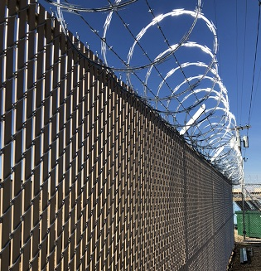
The maintenance department has done many things for the year of 2018. Vehicle and building maintenance being the main focus, but has also included assisting with the Sheriffs Day Camp, and occasionally helping citizens along the roadways. The maintenance department has been able to make great improvements to the Jackson County Jail, including replacement of old inefficient lighting with LED lighting. Preventive maintenance has also been a priority of the maintenance department. Changing rooftop filters, cleaning and inspecting all kitchen appliances and making sure all safety equipment is in working order. Many other smaller repairs have been made as well; these repairs include the clearing of toilets as needed and replacement of any jail plumbing water system parts. A new security fence and gate was installed around the east and south sides of the jail. The gate is controlled from the Jail’s Control Center. The security fence replaced a dilapidated 20 plus year-old fence that provided no security. The purpose of the fence is to provide for a secured area to evacuate inmates to in a building crisis. The area would provide for a loading area for inmates to be transferred to other facilities during a crisis situation. The area also allows for a secure area for inmate workers to perform outside work tasks. The security fence improves the security of the jail by also preventing foot traffic access to the more remotes parts of the jail.
Also, in the same area around the jail, the asphalt drive and parking area was resurfaced. The area had not been improved since the construction of the jail. The asphalt was in poor repair and drainage around the structure was becoming a problem. Jail transport vehicles use the area for delivering inmates to and from the jail.
The sewer pit behind the jail received an update. The metal screen that prevented larger items from entering into the city’s sewer had rusted out and was not working as designed. A new screen was fabricated and installed.
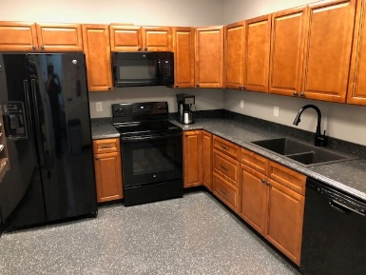
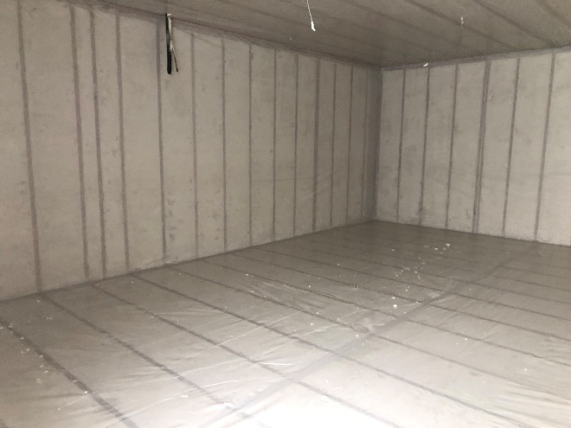
A new 911-equipment room is being constructed above dispatch to house the new 911 system and is to be completed in early 2019. A new food storage freezer that will also be completed in early 2019 that will be used for storage of food for inmates. For some time the jail has stored large quantities of food and meat in an ice house in Topeka. In reducing food costs, it is important to purchase wisely, and sometimes those purchases need to be in large amounts. The icehouse discontinued renting out space in 2018, therefore, it was necessary to be able find a place to keep the current supply of food and keep costs affordable. The jail is currently constructing their own 22’ X 22” walk-in freezer that will store all frozen goods at -10 degrees. This will eliminate off-site storage costs and is being paid for out of the inmate welfare fund and not taxpayer funds.
In 2018, the maintenance supervisor updated the employee breakroom area, making the area a full functioning kitchen.
Fleet maintenance is another large part of the maintenance department. The maintenance department is responsible for all aspects of the agency’s vehicles. The approximate number of oil changes performed for the year of 2018 is around 90. The number of full brake replacement is approximately 15 and partial brake replacement was approximately 20. Tire repair/replacement was approximately 75 for 2018. Some of the many repairs that took place in 2018 were the replacement of power steering pumps and fuel pumps. There have also been a few wrecks with deer and other vehicles that the maintenance department has played a part in repairing. The sheriff’s office routinely updates vehicles in the fleet and as that happens the maintenance department often disassembles the old vehicles. As the new vehicles are built, the maintenance department coordinates with the builders to supply any and all parts and equipment they may need and assist with construction. The maintenance department has worked closely with the deputies to address any and all needs/concerns they may have. In doing so, the maintenance department installs and repairs the WatchGuard camera system, in-car and body-cams and installs and services communication equipment.
Jackson County leads the Second District in many areas
Another function of the Sheriff’s Office is serving the Jackson County District Court. Not only does the Sheriff’s Office provide court security for the courts, but it also serves paper process, and is the holder of all district court warrants, and is responsible in apprehending fugitives. The Sheriff’s Office also serves state tax warrants, subpoenas, arrest warrants, protections orders, summons and writs. The Jackson County District court has been busy in 2018 with having a record number of criminal case filings at 705 with 411 misdemeanor and 294 felony cases. There were more than 90 criminal cases filed in 2018 than in 2017. There were 25 protection from abuse orders and 12 protection from stalking orders.

Statistics for the Second Judicial District of Kansas
Jackson Jefferson Pottawatomie Wabaunsee
Misdemeanor 411 118 316 35
Felony 294 94 189 92
Extradition 18 4 3 14
Search Warrants/Inq 100 39 76 0
Traffic 620 414 1,769 980
DUI 82 23 19 12
DWS 216 48 55 106
Total 2,825 1,934 3,877 1,685
Summary
Every year brings new challenges as well as opportunities. The sheriff’s office is honored to be able to serve some of the greatest people in the country. Serving great people makes our job easier and motivates us to give our all. Every single person has the right to receive justice and deserves to live in peace. Regardless of race or economic status, we value each and every person equally and strive to do our very best in giving you the best services possible. We welcome your feedback on our performance and to hear suggestions to improve our service to the citizens of Jackson County. Thank you for your support and have a safe 2019.

