**JACKSON COUNTY SHERIFF’S OFFICE 2020 ANNUAL REPORT**

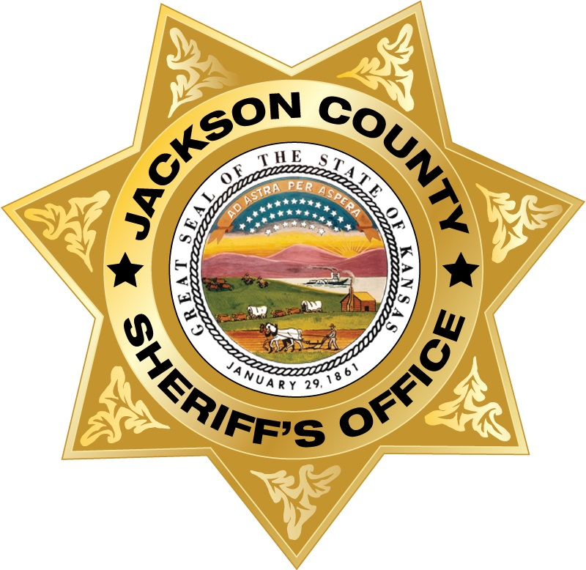

**SUBMITTED BY TIM MORSE, SHERIFF**

**JACKSON COUNTY, KANSAS**

**2020 in Review**

Every year the Jackson County Sheriff’s Office submits a report of the accomplishments and challenges that took place in the year prior in providing the statutory duties of the Office of Sheriff. The year 2020, is a year that will definitely live in infamy. The worldwide pandemic presented many challenges to people around the world, in the United States, the State of Kansas and here in Jackson County. Despite the pandemic, the men and women of the Jackson County Sheriff’s Office never failed in their commitment in providing their very best for the citizens of Jackson County, Kansas. The pandemic provided a number of difficult tasks for staff, however, all in all these struggles have made the agency more resilient and better able to adapt. Some of those challenges and accomplishments will be discussed further in this report.

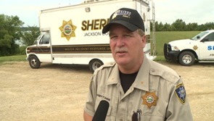The Jackson County Sheriff’s Office is under the leadership of Sheriff Tim Morse. Sheriff Morse was first appointed by the Governor of Kansas in April of 2011. Sheriff Morse was elected in 2012, 2016 and 2020 and is grateful to have done so by some of the largest margins in Jackson County history. During his tenure as Sheriff, he has worked to lessen the burden of the Sheriff’s Office on the taxpayers, as well as improve the capabilities of the agency and to lower the crime rate in the county. When Sheriff Morse and Undersheriff Darrel Chapman took office, employee morale was at an all-time low, and the Jail which was separate from the Sheriff’s Office for the previous 7 years, was one half a million dollars in the red. Since that time, Sheriff Morse has balanced 10 budgets and turned the Jail into a revenue producing entity that has prevented further tax increases. Sheriff Morse has improved employee morale and has been able to draw and maintain some of the best law enforcement officers in the State of Kansas. Due to making the most of our resources by implementing patrol zones and sub-stations, property crimes have dropped tremendously. It was not uncommon in the past for deputies to work burglary investigations during the workweek. Many times burglars would break into homes while citizens were at work and would steal irreplaceable items such as grandma’s jewelry and grandpa’s shotgun. Homeowners would return home from their day’s work and find that their homes were burglarized. These invasions of privacy have a lifetime effect on their victims. Sheriff Morse not only changed the way the agency patrolled, but improved the investigative arm of the Sheriff’s Office and incorporated the help from the citizens they serve. Deputies and investigators received further investigative training combined with state of the art equipment. Sheriff Morse established the Jackson County Community Watch program with the help of 23% of the residents of Jackson County participating. Sheriff Morse refers to this group as his Electronic Posse whose partnership has been invaluable in reducing crime in Jackson County.

Jackson County Sheriff Tim Morse

**Office of Sheriff**

The Office of Sheriff has been around since the beginning of this nation. The Sheriff originated from England as far back as the 9th century. This makes the sheriff the oldest continuing, non-military, law enforcement entity in history. In America, in most cases, the Sheriff is elected by the citizens and is the chief law enforcement officer of the county. The Sheriff does not answer to a council or a mayor such as a Chief of Police, but answers directly to the citizens. Since the Sheriff is elected and not appointed, he or she is responsible in making spending and employment decisions. The Sheriff is one of several elected offices of county government. A Kansas Attorney General Opinion, 2016-16, stated that elected offices of county government are separate but equal branches of county government, none are subordinate to one another and all have separate and distinct powers and responsibilities. For example, the Kansas Supreme Court in Board of County Commissioners of County of Lincoln v. Nielander adopted the following characterization of the relationship between a sheriff and the BOCC:

“The sheriff is an independently elected officer whose office, duties, and authorities are established and delegated by the legislature. The sheriff is not a subordinate of the board of county commissioners and neither are the undersheriff or the sheriff's deputies and assistants. Rather, the sheriff is a state officer whose duties, powers, and obligations derive directly from the legislature and are coextensive with the county board.”

“In Blume v. Meneley, a case decided shortly after Nielander, the United States Federal District Court of Kansas decided that the sheriff’s position, as well as other elected positions in county government, were not subordinate to one another, but are equal positions, each empowered with the task of running one of the departments of county government.”

Our founding fathers established this nation with three equal branches of government. Counties in the United States were established with the same idea of separating powers and duties.

The Sheriff by state statute has specific duties such as being the keeper of the Jail, keeping the peace and serving the courts. The Sheriff is responsible for not only keeping the Jail, but is the holder of all district court warrants and is responsible for capturing fugitives and returning them before the court. The Jackson County Sheriff’s Office currently hold over 1,200 outstanding district court warrants. The Sheriff is responsible for answering calls for service and for investigating crimes, serving civil process, court security, tax sales, foreclosures, conceal carry permits, registered offenders.

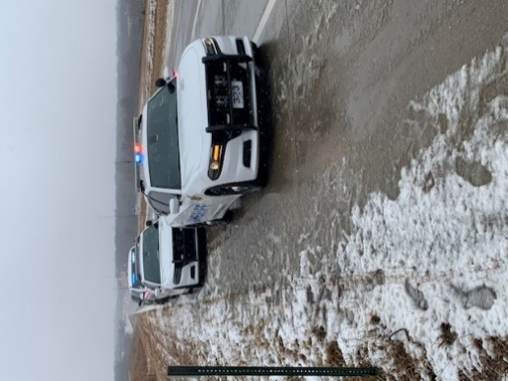

**Crime Statistics Show Improvement**

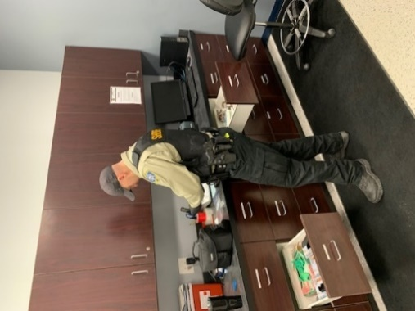The Kansas Bureau of Investigations collects statistical crime data for the entire State of Kansas. The most up to date available crime data is for the year 2019. The total Crime Index for the State of Kansas in 2019 is 29.3 per 1000 people. The Violent Crime Index for the State of Kansas is 4.3 per 1000 people. The Property Crime Index for the State of Kansas is 25.0 per 1000 people.

Deputy Cory Lusk processing evidence

Jackson County fairs very well when compared to the state average for crime. With the State of Kansas Crime Index at 29.3 per 1000 people, compared to Jackson County’s crime index at 17.5 per 1000 people, which is 40.27% less than the state’s.

Jackson County’s Violent Crime Index rating has decreased from 3.8 per 1000 people in 2018 to 1.6 per 1000 people in 2019, which is a 57% decrease from the previous year. This is 62.79% less than the State’s violent crime index.

Jackson County’s Property Crime Index is slightly up to 16.0 per 1000 people from 14.8 per 1000 people the previous year. This increase is attributed to the Sheriff’s Office Retail Crime Campaign. Due to the increase in the Office’s pursuit of these cases there are increased theft statistics reported. However, there were six less burglaries in 2019 than in 2018.

Jackson County’s Crime Index in 2009 was 22.9 per 1000 people. The Violent Crime Index in 2009 was 3.7 per 1000 people. Jackson County’s Property Crime Index was 19.2 per 1000 people. In 2009, there were 52 burglaries reported compared with 20 burglaries reported in 2019. That is a 61.54% decrease in burglaries from ten years ago. In 2019, the Jackson County Sheriff’s Office made 595 adult arrests. This is down from 715 in 2018.

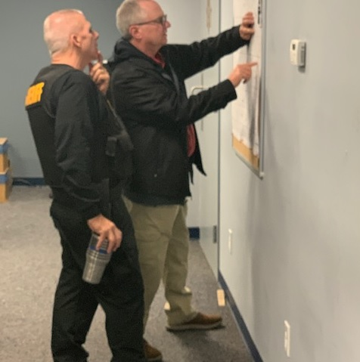There are a number of reasons for the decrease in burglaries in Jackson County. One major difference is the change in patrol tactics. Sheriff Morse established patrol zones and sub-stations for patrol. Patrol deputies have specific districts or zones to patrol. This keeps the deputy in the area and allows for patrolling areas that didn’t get much attention in the past. Sub-stations allows for the deputy to stay in the area and provides a place for reports to be completed while still in the field. This also reduces response times and allows for a deputy to stay active in their area.

Former Jackson County Sheriff/Detective Phil McManigal and Captain Scott Morris

In addition in having experienced and skilled deputies, the sheriff’s office has a skilled and experienced set of investigators. When citizens become victims of crime, the sheriff’s office has the skilled staff and state of the art crime scene equipment to help resolve these matters by bringing justice to victims. No crime is too small and no crime is too big to solve. Deputies are not just report takers, but are case solvers. It is important that every crime is properly investigated. Crime is reduced by solving small crimes, as small crimes can lead to bigger crimes.

**District Court**

Jackson County is in the Second Judicial District of Kansas which is made up of Pottawatomie, Wabaunsee, Jefferson and Jackson counties. Jackson County being the 3rd most populated of the four leads in many categories. Jackson County leads all four counties in felonies, misdemeanors, DUIs, driving while suspended cases, inquisitions and search warrants.

**Fatality Accidents**

One of the very worst jobs in law enforcement is working fatality accidents. Every fatality changes the lives of family and friends forever. It is the goal of law enforcement to work in enforcing traffic laws for the purpose of preserving life and reducing injuries. Unfortunately, fatalities still occur and there were three vehicle fatalities in Jackson County for 2020, summarized by the following press release.

**Fatal accident takes life of Jackson County man**

On Friday February 28th, a southbound truck on V. Road that turned west short of the intersection on K 116 Hwy ended in a fatality Friday night. The Jackson County Sheriff’s Office received a 911 call at 10:06 pm from a caller reporting a pickup truck that was hanging off the roadway and teetering next to a culvert at K116 Hwy and V. Road approximately four miles east of Holton. A nearby resident attempted to pull the 2006 Dodge 3500 pickup out when the truck rolled over and into the deep ditch and into the water. The driver’s head was entrapped beneath the water. A Jackson County deputy, the Holton Fire Department and Jackson County EMS arrived, freed the man from the vehicle, found him to be pulseless and not breathing, and began performing CPR. Lifestar Air Ambulance landed at the Holton hospital where the man had been transported by Jackson County EMS and was pronounced dead. The female passenger of the truck had been freed from the vehicle prior to first responder’s arrival. The accident remains under investigation by the Jackson County Sheriff’s Office. The victim was identified as Larry D. Hladky, 59, of Holton.

**FATALITY UTV ACCIDENT NEAR NETAWAKA**

On July 05, 2020 at approximately 2:05 a.m., the Jackson County Sheriff’s Office received a report from the Horton Police Department Dispatch Center of an accident involving a UTV approximately ½ mile west of S. Road on 318th Road in northern Jackson County. The caller reported one person was possibly deceased and others injured. Upon arrival, a deputy sheriff and a passenger administered CPR to an occupant who was ejected and who was later pronounced deceased. Five of the other surviving occupants were transported to Stormont vail in Topeka and Sabetha Hospital with life-threatening and non-life-threatening injuries.

The initial investigation determined that the driver had been operating a 2020 Honda  UTV traveling westbound on 318th Rd (a low maintenance road) from S. Road running along the side of another UTV. The 2020 Honda UTV left the roadway and lost control and overturned, ejecting a 13 y/o passenger. The 13 y/o passenger was pronounced dead at the scene. The Sheriff’s Office is investigating whether alcohol was a contributing factor to the accident. Netawaka, Whiting, and Holton Fire Departments and Jackson County EMS, PBPN EMS, and Horton EMS responded to the scene. The fatality victim's name isn't being released at this time pending the notification of family.  The incident remains under investigation by the Jackson County Sheriff's Office.

**Saint George man killed in early morning accident**

On July 22, at 02:18 hours the Jackson County Sheriff’s Office received a 911 call regarding an injury accident just south of 254th rd. on K-62 highway south of the town of Soldier. Deputies and first responders arrived and found the 2004 Nissan Maxima rolled over in a rocky ravine on the east side of the highway. The driver, Clifford Joseph Walsh, 30, of Saint George, was entrapped and pronounced deceased on scene. The passenger, Emma Johnston, 17, of Manhattan, was able to free herself and her infant child from the vehicle and made it to a nearby residence to call for assistance. Both were transported to Stormont-Vail by Jackson County EMS with non-life threatening injuries. Agencies that assisted were Soldier Fire Department, Holton Fire Department, PBPN Fire Department and Jackson County EMS. The vehicle had been traveling SB and lost control negotiating the curve.

**The following press releases summarize some of the other information provided to the public in 2020.**

**Rural Denison residence destroyed by fire**

The Jackson County Sheriff’s Office received a report of a structure fire to a rural Denison residence at midnight on Wednesday January 1st, 2020. The residence is located at 17970 158th Road. The Mayetta, Hoyt, PBPN Fire Departments, Jackson County EMS and the Jackson County Sheriff’s Office responded to the scene. Upon arrival of responders, the residence was fully engulfed with fire. The residence was a complete loss. No one was injured during the fire. The Jackson County Sheriff’s Office and the Kansas State Fire Marshal are investigating the incident.

**SENECA WOMAN ARRESTED ON DRUG CHARGES**

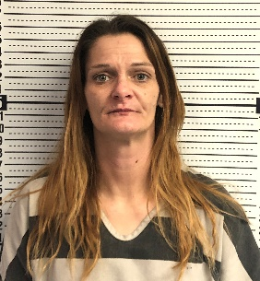A Seneca woman was arrested following a traffic stop in southern Jackson County Wednesday afternoon. A Jackson County Sheriff’s Office deputy stopped a northbound 1999 Honda Civic near 214th Road south of Holton for a traffic infraction. A Jackson County Sheriff’s K-9 responded to the scene. The K-9 alerted on the vehicle, which resulted in the search of the vehicle. The investigation resulted in locating a quantity of marijuana and methamphetamine. The driver, Christina Ann Armstrong, 42, of Seneca was arrested by deputies. Armstrong was booked into the Jackson County Jail for the following: Felony possession of methamphetamine with the intent to distribute, possession of marijuana, possession of drug paraphernalia and felony interference with law enforcement. Armstrong is awaiting bond in the Jackson County Jail.

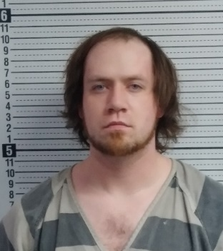**Holton man arrested on methamphetamine distribution charges**

**Jordan Thomas Monaghan**

A Holton man was arrested on Sunday evening at approximately 6 pm as a result of a drug investigation into the distribution of methamphetamine in Jackson County. As a result of the investigation, deputies conducted a traffic stop on the suspect in the 300 block of Vermont Street in Holton. The suspect, Jordan Thomas Monaghan, 24, of Holton, had been driving a 1986 Mazda pickup truck. A quantity of methamphetamine was found in his possession. Monaghan was arrested by Jackson County Sheriff deputies and transported to the Jackson County Jail. Monaghan was booked into the jail on the following charges: possession of methamphetamine, distribution and attempting to distribute methamphetamine, use of communication facility; in the commission of a felony drug crime, attempted use of communication facility; in the commission of a felony drug crime and possession of drug paraphernalia. Monaghan is awaiting bond in the Jackson County Jail.

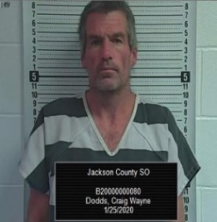**Rossville man arrested on drug charges**

On Saturday January 25, 2020 around 9:30 PM, Jackson County Sheriff’s deputies conducted a traffic stop on US Hwy 75 near 214th Road south of Holton. During the traffic stop, deputies located illegal narcotics. As a result of the traffic stop, Craig W. Dodds, 46, of Rossville, KS was arrested and booked into the Jackson County Jail for possession of methamphetamine, possession of drug paraphernalia, driving while suspended, and no proof of liability insurance. Dodds is awaiting bond at this time.

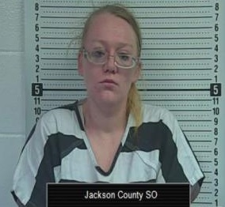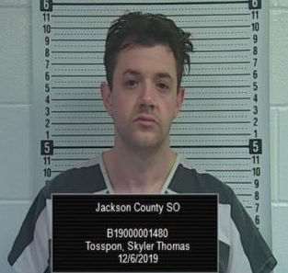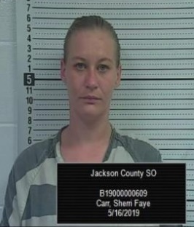

**Ashley Renee Jenkins Skyler Thomas Tosspon Sherri Faye Carr**

**Three convicted as a result of methamphetamine distribution investigation**

On May 16, 2019, Jackson County Sheriff's Office Detectives and Deputies arrested three subjects for possession and distribution of methamphetamine. Ashley Renee Jenkins of Holton, Skyler Tyler Tosspon of Richmond, MO, and Sherri Faye Carr of Sabetha were arrested.

The arrests resulted following an investigation into Tosspon and Jenkins by Jackson County Sheriff's Office Detectives. As a result of the investigation, the trio were arrested during a traffic stop on US 75 Hwy, where methamphetamine and drug paraphernalia were located in the vehicle.

The three were convicted in Jackson County District Court for the following: Sherri Carr was convicted of felony possession of methamphetamine. Ashley Jenkins was convicted felony possession of Methamphetamine. Skyler Tosspon was convicted of felony distribution of methamphetamine.

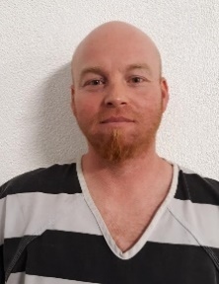**Stalking suspect arrested**

The Jackson County Sheriff’s Office arrested Brandon Ryan Myers, 38, of Topeka on Wednesday on a Jackson County District Court warrant. The warrant was issued following an investigation into allegations of stalking. Myers was charged with felony stalking and violation of stalking order.

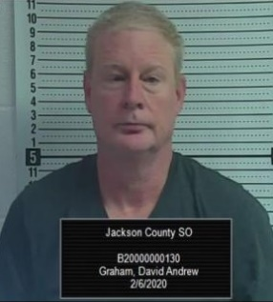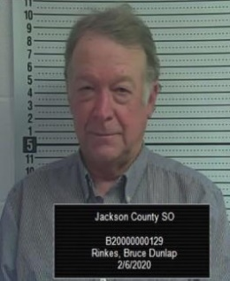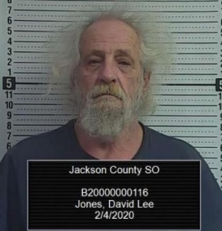

**THREE ARRESTED ON SEX CHARGES**

Three men have been arrested on sex charges in recent days. Two men were arrested in Holton on Thursday evening as a result of a joint human trafficking operation conducted by deputies and detectives of the Jackson County and Shawnee County Sheriff’s Offices. David Andrew Graham II, 50, of Carbondale, Kansas and Bruce Dunlap Rinkes, 64, of Holton were arrested by deputies. Graham and Rinkes were booked into the Jackson County Jail on buying sexual relations and unlawful use of a communication facility. Both men were released on bond this morning.

**ONE INJURED DURING SUNDAY MORNING ACCIDENT**

One woman sustained disabling injuries following a Sunday morning accident at 198th and US Hwy 75 in Jackson County shortly before 8 am. Jerry Bowser of Netawaka was driving a 2018 Ford F-350 pickup truck heading westbound on 198th Road crossing US Hwy 75 and failed to yield to a southbound 2019 Chevy Cruse driven by Mary Pollock of Holton. The Chevy Cruze struck the Ford F-350 sending it into a 2015 Chevy 3500 which was stopped at the stop sign at 198th and US Hwy 75 driven by Patrick Mulroy of Mayetta. Neither Bower or Mulroy reported any injuries and Pollock was transported by Jackson County EMS to Stormont Vail with disabling injuries.

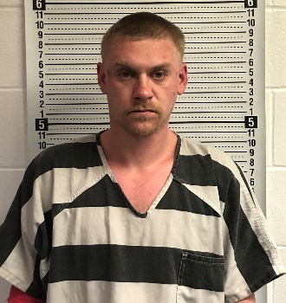**TEXAS MAN JAILED AFTER INCIDENT IN WHITING**

The Jackson County Sheriff’s Office received a 911 call shortly before 10:30 pm Saturday night from a residence located at 437 Pratt Street in the City of Whiting. The caller reported a domestic altercation, reported the male suspect was intoxicated and locked outside of the residence, and broke the window out of the back door. Suspect allegedly broke out many of the windows of the residence south of 437 Pratt Street while shouting at the occupants. The occupants of second residence were unfamiliar with the suspect.

Jackson County Sheriff’s Office deputies arrived on scene and took the suspect into custody. The suspect was identified as Logan Jarrett Brown, 25, of Henderson, Texas. Brown was booked into the Jackson County Jail on the following charges, criminal damage to property, disorderly conduct, three counts of battery on law enforcement officer.

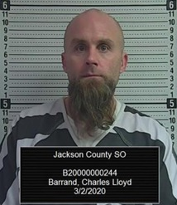**Topeka man arrested on methamphetamine charges**

On Monday March 2, 2020 a Topeka man was arrested on drug charges following a traffic stop in Holton. Charles Lloyd Barrand, 40, of Topeka had been driving a 1978 Nuwa recreation vehicle near 4th and Montana in Holton when a Jackson County Sheriff’s deputy initiated a traffic stop on the vehicle shortly before 5:30 pm. Deputies located a significant amount of what is believed to be methamphetamine and drug paraphernalia in the vehicle.

Barrand was booked into the Jackson County Jail on the following charges: possession of methamphetamine with the intent to distribute, possession of drug paraphernalia, felony interference with law enforcement.

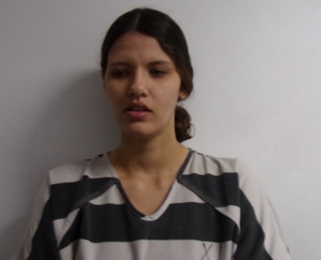

**Woman arrested following two county vehicle pursuit**

The Jackson County Sheriff’s Office received a 911 call at 5:07 p.m. from a caller in Brown County near the Sac and Fox Casino reporting a south bound dark colored SUV driving reckless and passing vehicles on the shoulder of US Hwy 75. The Jackson County Sheriff’s Office continued to receive more calls reporting the vehicle was driving at excessive speeds and passing vehicles on the shoulder. A Jackson County Sheriff’s Office deputy located the Jeep Cherokee bearing Florida tags north of Jackson Heights on US 75 Hwy and attempted to stop the vehicle near 262nd Road when a vehicle pursuit ensued. The vehicle continued southbound on US Hwy 75 through the City of Holton. Jackson County deputies attempted to stop the vehicle by deploying Stop Sticks without success south of Holton. The vehicle continued into Shawnee County where further attempts were made by other agencies to stop the vehicle with tire deflation devices without success. The vehicle continued south across the Kansas River and into the City of Topeka. Shawnee County Sheriff’s deputies and a Kansas Highway Patrol trooper assisted in the pursuit. The driver stopped the vehicle at 10th and Warren Street and surrendered to law enforcement. The driver was identified as Engy Arthur Kerr, 23, of South Daytona, Florida. Kerr was transported to the Jackson County Jail where she is being held on felony fleeing and eluding, reckless driving and numerous traffic offenses.

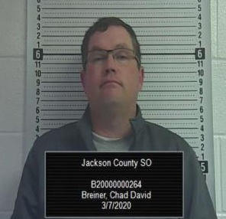**Alma man arrested following traffic accident**

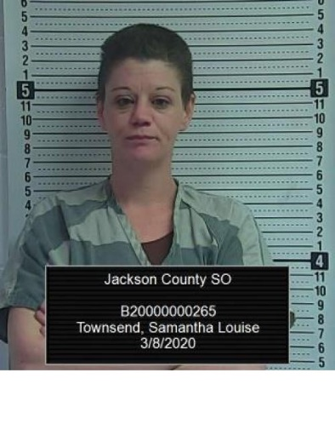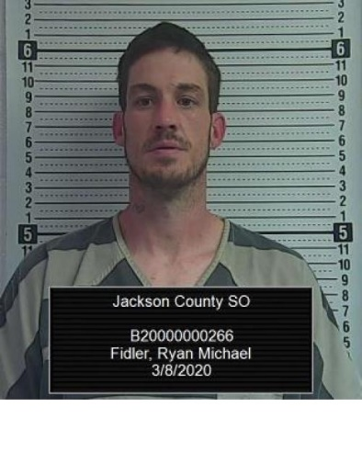On Saturday March 7th at approximately 7:40 p.m. the Jackson County Sheriff’s Office received what was reported as a two vehicle injury accident at 142nd and US Hwy 75. A 2015 Chevy Suburban crashed into the back of a 2010 Toyota Tundra pulling a boat while both vehicles were headed northbound on US 75 Hwy. Both drivers refused medical treatment. The Kansas Highway Patrol investigated the accident while Jackson County Sheriff’s deputies arrested the driver of the Suburban, Chad David Breiner, 44, of Alma for driving under the influence. Breiner was booked into the Jackson County Jail.

**Two arrested following traffic stop**

A Jackson County Sheriff’s Office deputy allegedly stopped a 2005 Infiniti for an equipment violation near 134th and US Hwy 75. The driver, Ryan Michael Fidler, 36, of Topeka was arrested for driving while revoked and driving while a habitual violator. The passenger, Samantha Louise Townsend, 36, of Topeka was arrested for possession of methamphetamine, marijuana and drug paraphernalia. Both subjects were booked into the Jackson County Jail.

**Coronavirus hits Jackson County**

* JACKSON COUNTY, Kan (JASO) (March 18, 2020) Due to the Coronavirus Sheriff Tim Morse has put into effect a variety of restrictions in the Jackson County Jail for the purpose of safeguarding the inmate population as well as staff. The medical screening that inmates receive prior to being introduced into the Jail has been expanded to include screening for the COVID-19 VIRUS. In addition, groups that have visited the Jail in the past have been restricted from accessing the facility. Many of these changes have occurred after consultation with our medical provider. Visitation of inmates remains solely through video visitation. During this difficult time, the Jackson County Sheriff’s Office remains on the job and is here to assist you if needed. Everyone needs to be vigilant and follow the medical direction that has been provided. Citizens should exercise the following practices:
* Stay home if you can and avoid gatherings of more than ten people.
* Practice social distancing by keeping a distance of about six feet from others if you must go out in public.
* Wash your hands often with soap and water for at least 20 seconds, especially after being in a public place, or after blowing your nose, coughing or sneezing. If soap and water are not readily available, use a hand sanitizer with at least 60% alcohol.
* Avoid touching your eyes, nose or mouth with unwashed hands.
* Avoid close contact with people who are sick.
* Stay home if you are sick, except to get medical care.
* Cover your nose and mouth with a tissue when coughing or sneezing; throw used tissues in the trash. If a tissue isn’t available, cough or sneeze into your elbow or sleeve, not your hands.
* Clean and disinfect frequently touched surfaces daily. This includes tables, doorknobs, light switches, handles, desks, computers, phones, keyboards, sinks, toilets, faucets and countertops.
* If surfaces are dirty, clean them - use detergent or soap and water prior to disinfection
* Wear a facemask if you are sick. You should wear a facemask when you are around other people (e.g., sharing a room or vehicle) and before you enter a healthcare provider’s office.

According to the CDC, COVID-19 symptoms include fever, shortness of breath and a cough. Symptoms may appear 2-14 days after exposure. Call your doctor for medical advice if you think you have been exposed to COVID-19 and develop symptoms.

More information can be found at <https://govstatus.egov.com/coronavirus>.

JACKSON COUNTY, Kan (MARCH 26, 2020) Jackson County Sheriff Tim Morse is announcing that the Jackson County Sheriff’s Office has started a new initiative earlier this week in regards to the outbreak of the Coronavirus. The Sheriff’s Office has joined many other sheriff’s offices across the state and nation in providing delivery services for senior or handicapped citizens who are unable to access their medications and groceries from local stores. Senior or handicapped Jackson County citizens who are unable to venture out and who have pre-paid medications and or groceries to be picked up from Jackson County stores, can call the Jackson County Sheriff’s Office at 785-364-2251 to arrange deliveries. Deliveries will be made Monday thru Friday from 8 am to 5 pm. Sheriff Morse believes that the Sheriff’s Office is here to serve our public, and during this national and state emergency, it is important to use our resources to help our most vulnerable citizens. 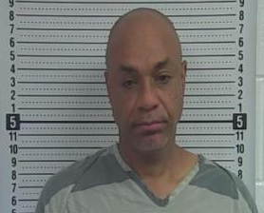

**Topeka man arrested on felony charges following pursuit in southern Jackson County**

A Topeka man was arrested following a short vehicle pursuit in southern Jackson County. A Jackson County Sheriff’s Deputy and a Kansas Highway Patrol Trooper allegedly measured the speed of a southbound Chrysler Sebring near 142nd and US 75 at speeds in excess of 100 mph. The driver of the vehicle allegedly attempted to elude law enforcement when a pursuit ensued. The vehicle came to a stop approximately ½ mile west of US Hwy 75 on 110th Road. The driver and only occupant was arrested. A substance believed to be methamphetamine and an opened alcoholic container were found in the vehicle. The driver was identified as Harold Jesse Sheffield II, 54, of Topeka. Sheffield was booked into the Jackson County Jail for fleeing and eluding a law enforcement officer, possession of methamphetamine, driving while suspended, and transporting and open container. Sheffield had 3 outstanding Jackson County warrants and 1 Shawnee County warrant.

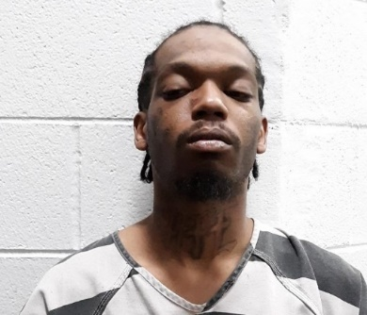**Two in custody following two-county pursuit**

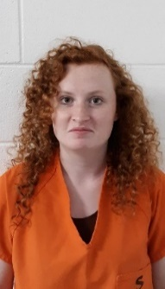JACKSON COUNTY, Kan (April 20, 2020) Sheriff Tim Morse announces two people are in custody following a pursuit that began in southern Jackson County around 10 am this morning. A Jackson County Sheriff’s deputy attempted to stop a theft suspect driving a black Ford Fusion with New Mexico tags. The suspect was believed to be involved in a theft that occurred at the Holton Walmart earlier in the morning. The deputy attempted to stop the vehicle near 142nd and US Hwy 75 when the suspect vehicle failed to yield and a pursuit ensued. The pursuit continued south into Shawnee County. The vehicle pursuit ended when the suspect vehicle crashed into a security gate located at the south side of Hill’s Pet Food Science and Technology Center located north of 39th near Meriden Road.

The two suspects fled west into a wooded area. Sheriff Hill and Shawnee County Deputies and Kansas Highway Patrol Troopers with K-9s and a KHP aircraft assisted with locating the two suspects. The male suspect and driver was identified as Marvin Duane Harvey, 29, of Topeka and the female passenger was identified as Rhiannon, Mae Franklin, 19, of Lincoln, Nebraska.

Harvey is being held in the Jackson County Jail on the following charges: theft, felony fleeing and eluding a law enforcement officer, possession of methamphetamine, possession of drug paraphernalia, possession of marijuana, interference with law enforcement and driving while suspended. Franklin is also being held in the Jackson County Jail on interference of law enforcement.

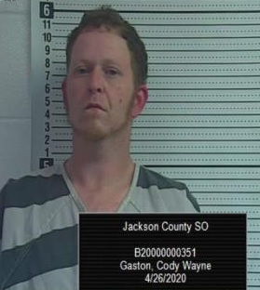**Netawaka man arrested following short pursuit**

A Netawaka man was taken into custody by Jackson County Sheriff’s deputies following a short pursuit Sunday night. Cody Wayne Gaston, 34, of Netawaka was allegedly driving a motorcycle northbound on Q.4 Road near 262nd around 8:30 pm. A Jackson County Sheriff’s deputy attempted to stop the cyclist for a traffic infraction, when the cyclist allegedly fled northbound and wrecked just south of 286th Road. Gaston was arrested and booked into the Jackson County Jail for fleeing and eluding a law enforcement officer, driving while suspended, possession of opiates, possession of marijuana and possession of drug paraphernalia.

**Three arrested on methamphetamine charges**

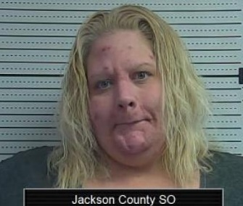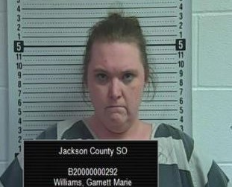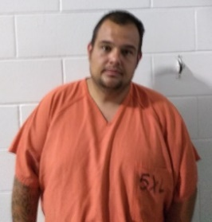

**Nicole Robbins Garnett Williams Joey Howard**

Three individuals were arrested on Tuesday following an ongoing drug investigation into the distribution of methamphetamine. The Jackson County Sheriff’s Office served a search warrant at 714 Idaho, Apt. 11 in Holton Tuesday afternoon. Deputies seized methamphetamine, marijuana, drug paraphernalia and a quantity of U.S. currency from the residence. Nicole Lee Robbins, 37, of Holton, Garnett Marie Williams, 32, of Holton, and Joey Lee Howard, 37, of Topeka were arrested at the scene. Three were booked into the Jackson County Jail on the following charges:

**Nicole Robbins – 37 years old** –

* Distribute Methamphetamine - Felony
* Distribute Marijuana - Felony
* No Drug Tax Stamp - Felony
* Unlawful to acquire Proceeds from a drug transaction - Felony
* Possession of Drug Paraphernalia – Misd.

**Garnet Williams – 32 years old –**

* Possession of Methamphetamine - Felony
* Possession of Marijuana – Misd.
* No Drug Tax Stamp - Felony
* Possession of Drug paraphernalia – Misd.

**Joey Howard – 37 years old –**

* Possession of Marijuana - Misd

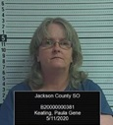**Soldier woman arrested on theft and forgery charges**

The Jackson County Sheriff’s Office arrested Paula G. Keating, 50, of Soldier on a Jackson County District Court warrant on Monday. The warrant was issued as a result of a Jackson County Sheriff’s Office investigation into allegations of theft of funds from the Holton American Legion Auxiliary. The crimes are alleged to have occurred between January 2015 and January 2017. Keating was booked into the Jackson County Jail for 5 counts of misdemeanor theft and four counts of felony forgery. During the time of the thefts, Keating served as the president of the Auxiliary. Keating as one of the signers on the bank account, allegedly diverted money from the account for her own personal use. Some of the transfers of unauthorized funds allegedly were done by forging false signatures and documents. As a result of the monetary loss, the Auxiliary was forced to disband.

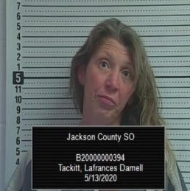**Eskridge woman arrested on methamphetamine charges**

A Jackson County Sheriff’s Deputy stopped a Dodge Caravan on southbound US 75 Hwy near 190th Road for a traffic infraction Wednesday afternoon. The deputy located a substance believed to be methamphetamine inside the vehicle. The driver, Lafrances Darnell Tackitt, 45, of Eskridge was placed under arrest and booked into the Jackson County Jail for the following charges: possession of methamphetamine, possession of drug paraphernalia and for not having a drug tax stamp.

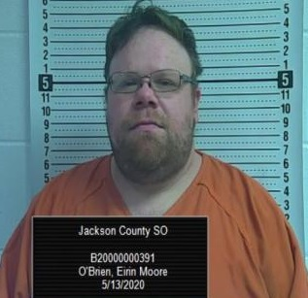**Topeka man arrested on methamphetamine charges**

A Jackson County Sheriff’s Deputy stopped a northbound Ford Explorer on US Hwy near 118th Road on Wednesday morning. The deputy located a substance inside the vehicle believed to be methamphetamine. The driver, Eirin More O’Brien, was arrested and booked into the Jackson County Jail on the following charges: possession of methamphetamine, possession of drug paraphernalia and driving while suspended.

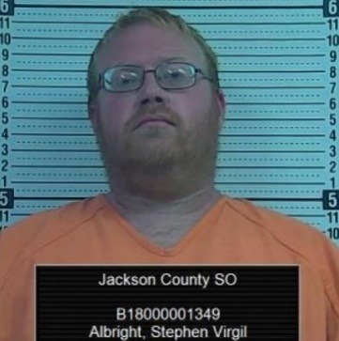**Topeka man arrested on distribution of illegal drugs**

A Topeka man was arrested following a traffic stop near Hoyt Thursday morning. A Jackson County Sheriff’s Deputy stopped a Ford F-250 pickup truck that was northbound on US 75 south of Hoyt. The deputy located a quantity of a substance believed to be ecstasy and marijuana. The driver, Stephen Virgil Albright, 36, of Topeka was arrested on the following charges: distribution of a controlled substance, possession with the intent to distribute a hallucinogenic drug and no drug tax stamp.

**One in custody following disturbance in Holton**

One man is in custody following a Thursday evening disturbance in Holton. Law enforcement was contacted shortly before 6 pm Thursday evening. Multiple reports were received reporting gunshots being fired in the area of 8th and Kansas Street in the City of Holton. Jackson County Sheriff’s Office Deputies, Holton Police Officers and a KHP Trooper responded to the scene. Law enforcement officers determined that the gunfire came from 420 W. 8th Street. The suspect was identified as Justin Lee Judy, 31, of Holton. The Sheriff’s Office attempted without success to order Judy out of the residence by using a public address system. The Sheriff’s Office then was able to establish a telephone connection with Judy, and ordered him to come out of the residence. Judy surrendered to law enforcement and was taken into custody without further incident. Deputies and police officers served a search warrant on the residence seizing evidence from the residence. Judy is being held in the Jackson County Jail on unlawful discharge of a firearm.

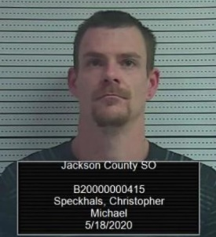

**Hiawatha man arrested on methamphetamine charges**

A Jackson County Sheriff’s deputy observed a blue Chrysler Sebring travelling southbound on Arizona Street in Holton shortly after 9:30 this morning. The deputy stopped the vehicle after confirming the driver did not have a valid driver’s license. The passenger, Christopher Speckhals, 31, of Hiawatha, was subsequently searched and arrested for being in possession of methamphetamine and drug paraphernalia. The driver was released at the scene.

**Covid-19 scam circulating the area**

There are a multitude of Covid-19 scams that are currently being circulated around the country. However, one particular scam has surfaced in Jackson County. A few Jackson County residents have received Covid-19 scam robo calls. The scammers claim the individuals being called need to call a particular phone number about their Covid-19 test results. These scam calls play on the fears of individuals with the recent pandemic. Scammers phish for personal information including financial information. Do not fall prey to these scammers. Your local health department or your primary care physician will contact you directly by phone with results from any Covid-19 testing. Notifications will not be given via text messages or email.

It is important for the public to be alert and vigilant during this time. Scammers typically will play on the fears of individuals in order to acquire your personal information for the purpose of committing theft. Don’t take the bait.

Some other Covid-19 scams include human contact tracing scams. These scams occur when the scammer contacts an unsuspecting person either through the internet or by phone. The scammer will tell the victim that they have come into contact with someone who has Covid-19 symptoms, and will require further personal information from them.

Don’t click on links from sources you don’t know. Ignore online offers for vaccinations. If you want to donate to any organization, do your homework first and don’t rush into making a donation. If anyone asks for a donation in cash, gift card, or wire transfer, don’t do it.

Beware of emails from scammers pretending to be agents of Centers for Disease Control or other public organizations. No legitimate medical provider will ask for sensitive information through email. Beware of calls or emails from those claiming to be from the U.S. Treasury offering Covid-19 related grants or stimulus payments in exchange for personal financial information.

Also, there have been scams for expedited stimulus checks and phony business loan sites. Another scam that has occurred across the country is scammers claiming to be selling hard to get medical supplies. The buyer sends payment and never receives the product. There are also scammers who claim to be medical personnel who are demanding payment for testing, and for treatment that a family member has received.

Scammers are nothing more than thieves who prey on the unsuspecting and vulnerable. Don’t become the next victim. Report scams to your law enforcement agency.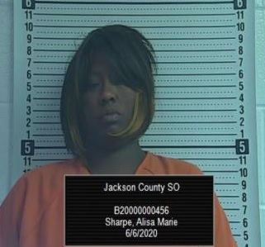

**Topeka Woman Arrested on Methamphetamine Charges**

Sheriff Tim Morse reports on Saturday June 6 at approximately 9:30 pm, a Jackson County Sheriff’s Deputy stopped a Pontiac Aztec that had been traveling northbound on US 75 Hwy just south of the City of Holton for a traffic infraction. During the investigation of the traffic stop, the driver, Alisa Marie Sharpe, 36, of Topeka was subsequently arrested for allegedly being in possession of methamphetamine and drug paraphernalia, no driver’s license, and no insurance. Sharpe also had an outstanding Jackson County District Court warrant for possession of methamphetamine and possession of drug paraphernalia. Sharpe was transported to and booked into the Jackson County Jail.

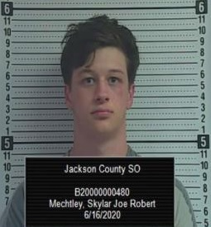**One man arrested following late night pursuit**

A Jackson County Sheriff’s deputy observed a red 2012 Honda Civic travelling southbound on W. Road from 174th Road shortly before 1:30 am this morning. The deputy attempted to stop the vehicle which allegedly eluded the deputy. A pursuit ensued, and the vehicle struck a stop sign. The deputy observed the bumper of the car was found lying in the roadway. The vehicle stopped near 158th and T. Road where the driver allegedly fled on foot. The driver was captured and placed under arrest. The driver was identified as Skylar Joe Robert Mechtley, 18, of Mayetta. Mechtley was arrested and transported to the Jackson County Jail where he was charged with fleeing and eluding a law enforcement officer, possession of marijuana and drug paraphernalia.

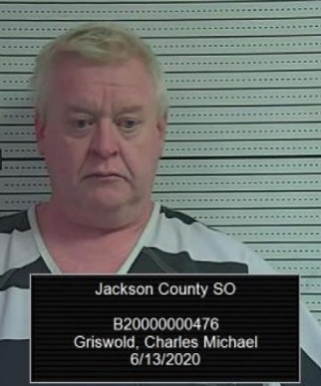**Iowa man arrested on methamphetamine charges**

On June 13th a Jackson County Sheriff’s Deputy stopped a 2004 Acura on US Hwy 75 near K-9 Hwy in northern Jackson County. The vehicle was stopped for allegedly committing a traffic infraction. The driver was identified as Charles M. Griswold, 49, of Atlantic, Iowa. Griswold was arrested for possession of methamphetamine, possession of marijuana, possession of drug paraphernalia and driving while revoked.

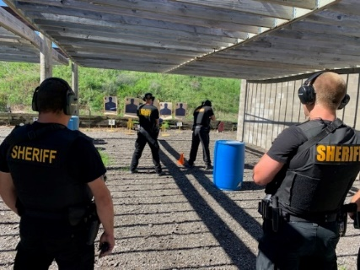

**Two arrested following vehicle pursuit**

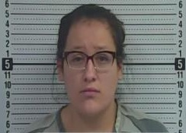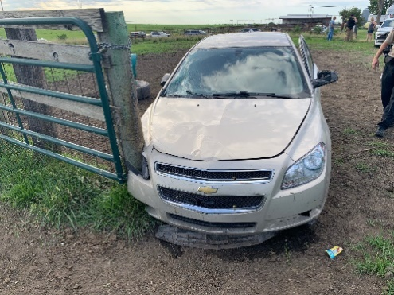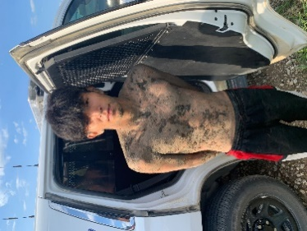At approximately 4:30 pm Saturday afternoon, a Jackson County Sheriff’s Deputy attempted to stop a tan Chevy Malibu for a traffic infraction south of US 75 Hwy and Banner Ave. in Holton. The deputy signaled the vehicle to stop, and the vehicle stopped near the intersection. When the deputy approached the driver, the vehicle sped off heading eastbound on Banner Ave. then south on Q. Road. A vehicle pursuit ensued heading towards southeastern Jackson County. The vehicle headed east on 134th Road into Jefferson County when a Jefferson County Deputy deployed spikes puncturing the front right tire of the suspect’s vehicle. The vehicle continued east as the front tire disintegrated. The vehicle left the roadway through a fence on the south side of the road into a corral striking a cow. The vehicle crashed into a corral fence post. The two occupants of the vehicle fled on foot. The female was quickly apprehended. A KHP helicopter, KHP K-9, Jackson County Sheriff’s K-9 arrived to the scene to search for the male suspect. The male suspect was captured around 6:30 pm. The Kansas Department of Wildlife and Parks and Tourism, Valley Falls Police Department, and the Hoyt Police Department also assisted with the incident. The pair was identified as Skye Joe Covers Up, 18, of Horton and Santana Kay Noriega, 21, of Mayetta. Both are being held in the Jackson County Jail. Noriega is being held on possession of methamphetamine, possession of marijuana, possession of drug paraphernalia, felony interference with law enforcement, and furnishing alcohol to a minor. The alleged driver, Skye Covers Up, is being held in the Jackson County Jail for felony fleeing and eluding a law enforcement officer, transporting an open container, driving while suspended, no insurance, felony interference with law enforcement, reckless driving, and felony criminal damage to property.

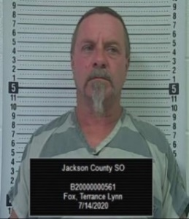**MAYETTA MAN ARRESTED FOLLOWING SEARCH WARRANT**

Shortly before noon on Tuesday, the Jackson County Sheriff’s Office served a search warrant on a Mayetta residence following an ongoing investigation into the distribution of marijuana. Deputies and detectives served a search warrant located at 15464 150th Road, Mayetta. Deputies seized U.S. currency and marijuana from the residence. The occupant of the residence, Terry Lynn Fox, 57, of Mayetta was arrested. Fox was transported to the Jackson County Jail where he was booked for distribution of marijuana, possession of drug paraphernalia, using a communication facility; in the commission of a felony drug violation and no drug tax stamp.

**Horton woman arrested in attempted car theft**

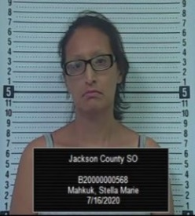Sheriff Tim Morse reports that the Jackson County Sheriff’s Office was contacted shortly before 10 pm Thursday night of someone allegedly attempting to steal a vehicle in the 17000 block of R. Road near Mayetta. The caller stated someone was outside the residence and got into their vehicle and started the engine and was revving the engine. Jackson County Deputies quickly arrived on scene and found a 2005 Dodge pickup belonging to the owner of the residence occupied by a female. The female was identified as Stella Mahkuk, 38, of Horton. Mahkuk was subsequently arrested for attempted theft of a motor vehicle and was booked into the Jackson County Jail.

Sheriff Morse reminds citizens to lock vehicle doors, and keep keys out of vehicles. Make sure to secure valuables and firearms when the vehicle is not in use. When something seems suspicious, follow your gut and contact law enforcement. Many people wait for a considerable amount of time before reporting suspicious situations. Delaying the reporting of a potential crime can result in something really bad happening or the perpetrator escaping. It takes not only law enforcement, but the citizenry working together with law enforcement to make our communities safe.

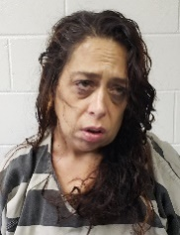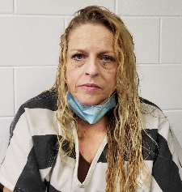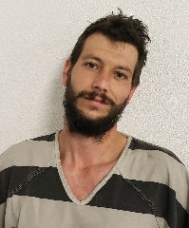**Three arrested on drug charges**

A Jackson County Sheriff’s Deputy stopped a 2001 Chevy Blazer near 110th and U.S. Hwy 75 shortly before 3 pm Friday afternoon for a traffic infraction. The traffic stop resulted in the arrest of the driver and two occupants. The driver, Jimmy Clinton Lininger, 30, of Topeka was arrested for criminal use of a weapon and had an outstanding felony Shawnee County warrant. Annette Marie Martin, 52, of Topeka was arrested for distribution of heroin, possession of methamphetamine and drug paraphernalia. Rebecca Ellen Pollock, 46, of Topeka was arrested for possession of methamphetamine, possession of heroin and drug paraphernalia. All three subjects are being held in the Jackson County Jail.

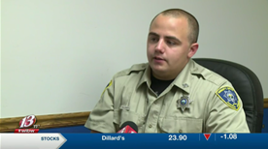**Deputy’s actions saves Hoyt man**

Sheriff Tim Morse reports that the Jackson County Sheriff’s Office received a 911 call from a residence located at 13027 134th Road Saturday evening around 8:30 pm. The caller reported that a car fell on his dad who was stuck beneath the vehicle. Family members attempted to free the man, however, they were unsuccessful. It was reported that the victim was barely breathing due to the weight of the car on his chest. Jackson County Sheriff’s Deputy Chad Ballenger arrived on scene and was able to use a jack to lift the vehicle off the victim. Hoyt and Mayetta Fire Departments and Jackson County EMS responded to the scene as well as the Kansas Highway Patrol. The victim was transported by Jackson County EMS to a Topeka hospital and has since been released.

Sheriff Tim Morse said “The outcome of this incident could have turned very tragic, I am very appreciative of Deputy Ballenger’s quick thinking and the calmness he brought to a very tense situation. Deputy Ballenger was able to provide lifesaving instructions to those on the scene, communicate with the victim at the same time, and rescue the victim from death. Deputy Ballenger is an example of the brave men and women of the sheriff’s office who put their lives on the line each and every day for their community.”

**Topeka man arrested in stolen car case**

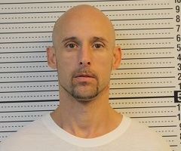A Topeka man was taken into custody following the recovery of a stolen vehicle Wednesday. Deputies and detectives with the Jackson County Sheriff’s Office took Danny Joseph Belisle Jr., 44, of Topeka into custody at a residence located in the 17000 block of W. Road, south of Denison for felony possession of stolen property. Law enforcement officers located a 2017 Nissan Infinity that had been reported stolen from a Topeka car lot on Monday. The vehicle appeared to have been involved in an accident after it was stolen. Belisle remains in the Jackson County Jail.

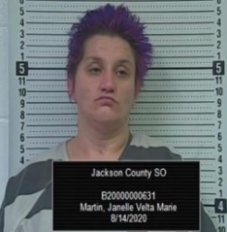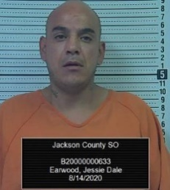**Two arrested on felony drug charges**

On August 15, 2015, shortly before 4 am a Jackson County Sheriff’s Deputy stopped to assist a motorist near 150th and Q.4 Road. The deputy subsequently arrested, Jessie Dale Earwood, 43, of Topeka. Earwood was booked into the Jackson County Jail for possession of methamphetamine, two misdemeanor drug counts, driving while suspended and transporting an open container. The passenger in the vehicle, Janelle Velta Marie Martin, 35, of Topeka was arrested and booked into the Jackson County Jail for possession of methamphetamine, and two misdemeanor drug counts.

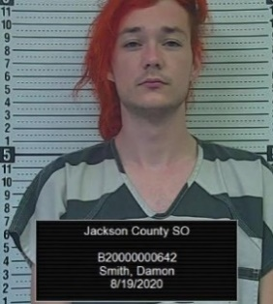**Lansing man arrested on felony drug distribution charges**

Jackson County, Kan. (August 19, 2020) - Sheriff Tim Morse reports that a Jackson County Sheriff’s Deputy stopped a 2004 Chevy Trailblazer on US Hwy 75 near 302nd Road for a traffic infraction shortly after 10:30 pm Tuesday evening. The stop resulted in the arrest of the rear seat passenger who was identified as Damon Lynn Smith, 26, of Lansing, Kansas. Smith was booked into the Jackson County Jail for distribution of methamphetamine, possession of drug paraphernalia, and no drug tax stamp. Smith also had an outstanding warrant for distribution of a hallucinogenic drug out of Atchison, County, and three outstanding warrants out of Lyon County.

**Pursuit that ended in shooting**

On August 19, 2020 at approximately 3:58 pm, a Jackson County Sheriff’s Deputy discovered a Nissan Altima passenger car in the Prairie Band Potawatomi Casino and Resort parking lot that had been reported stolen. The deputy attempted to stop the vehicle that was occupied by a male driver and female passenger.  The vehicle stopped and then quickly fled from the deputy. A pursuit ensued in southern Jackson County.  The driver of the stolen vehicle crashed through a gate to a pasture located west of T. Road on 158th Road.  The pursuit continued across the pasture and into a wooded area where the vehicle lodged in a creek.  The two occupants of the vehicle fled into a wooded area with a rugged terrain. Jackson County Deputies and Kansas State Troopers pursued the pair on foot.  During a standoff with the suspect, the suspect was shot by a Kansas State Trooper. The suspect was transported to an area hospital by Life Star Air Ambulance.  The female was questioned and later released.  The KBI have been requested to investigate the incident.  No law enforcement officers were injured in the incident.

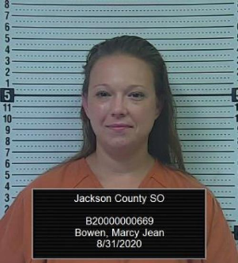**Mclouth woman arrested on meth charges**

A Mclouth woman was arrested after the Jackson County Sheriff’s Office received a report of a truck parked in the middle of Hwy 16 near W. Road. The Sheriff’s Office received the report a little after 4:30 a.m. Monday. Deputies found the truck running, parked in the middle of the highway and the woman asleep behind the steering wheel. The deputies discovered drug paraphernalia and the woman was arrested and booked into the Jackson County Jail for possession of methamphetamine with the intent to distribute and two misdemeanor drug charges. The woman was identified as Marcy Jean Bowen, 37, of Mclouth.

**Suspect arrested in stolen vehicle case**

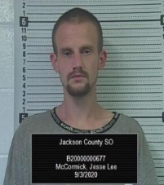The Jackson County Sheriff’s Office received a report of a stolen pickup truck a little after 4 am Thursday morning. The 2001 Ford F-350 pickup was reported to have been taken from the 400 block of Jackson Ave. in the City of Delia. The vehicle was located at shortly after 9 am at the Topeka Walmart on Wanamaker. The Topeka Police Department assisted with the investigation and apprehension of the suspect. Jackson County authorities arrested Jesse Lee McCormick, 27, of Topeka for felony theft. McCormick was transported to the Jackson County Jail.

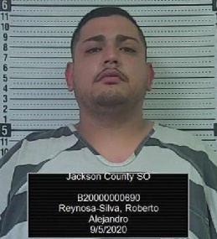**Topeka man arrested on drug and firearms charges**

A Jackson County Sheriff’s Deputy stopped a vehicle near 150th and W. Road in eastern Jackson County for a traffic infraction. The investigation into the stop led to the arrest of the driver, Roberto Alejandro Reynosa-Silva, 27, of Topeka, for possession of methamphetamine, possession of drug paraphernalia, interference with law enforcement, and possession of a stolen firearm.

**Driver injured in single vehicle rollover on US Hwy 75**

A Holton man was injured in a single vehicle accident on US Hwy 75 south of Holton Thursday evening. The Jackson County Sheriff’s Office received a report of the incident around 7 pm. Shawn Lawrence Kramer, 19, of Holton had been headed northbound on US Hwy 75 when his 2001 Dodge Ram left the right side of the roadway and then overcorrected coming back onto the highway. The vehicle lost control and rolled landing on its top. A passerby helped the driver out of the vehicle. The driver was transported to a Topeka hospital with disabling injuries by Jackson County EMS. Traffic was rerouted for approximately one hour.

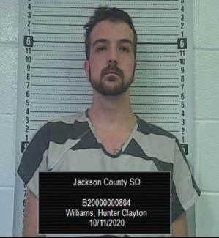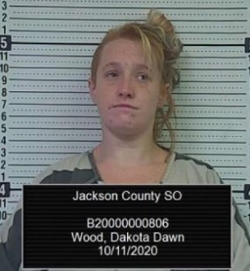**TWO ARRESTED ON METH CHARGES**

Shortly before midnight on October 10th, a Jackson County Deputy Sheriff stopped a vehicle for a traffic infraction near 150th and US Hwy 75. The driver of the vehicle, Hunter Clayton Williams, 22, of Manhattan was arrested for possession of methamphetamine, possession of drug paraphernalia, no drug tax stamp. Williams had an additional charges of trafficking contraband into a correctional facility. A passenger, Dakota Dawn Wood, 29, of Manhattan was also arrested for possession of methamphetamine, possession of drug paraphernalia and no drug tax stamp. A second passenger, Nickolas LaPlant, 42, of Manhattan was arrested on a Shawnee County felony warrant for narcotics.

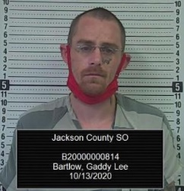**Two Topekans arrested on drug charges**

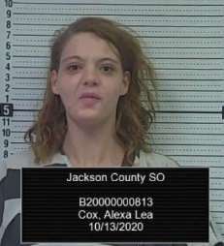On October 13th shortly before 1 am, a Jackson County Sheriff’s Deputy stopped a vehicle for a traffic infraction near 150th and Q. Road. The passenger of the vehicle, Alexa Lea Cox, 24, of Topeka was arrested for possession of methamphetamine and marijuana. The driver, Gaddy Lee Bartlow, 32, of Topeka was arrested for possession of marijuana and drug paraphernalia. Bartlow also had two outstanding warrants from Wabaunsee and Shawnee counties.

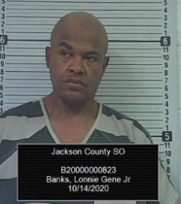**Topeka man arrested on methamphetamine charges**

A Jackson County Sheriff’s Deputy stopped a vehicle near 150th and US 75 Hwy Wednesday night shortly before 11 pm for a traffic infraction. The driver of the vehicle, Lonnie Gene Banks Jr. was arrested following the stop and booked into the Jackson County Jail for possession of methamphetamine, possession of a hallucinogenic drug, trafficking contraband into a correctional facility, possession of drug paraphernalia and transporting an open container.

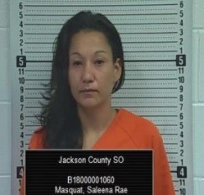**Mayetta woman captured following vehicle burglary and search**

A Mayetta woman was taken into custody by Jackson County deputies Sunday afternoon following the report of a burglary to a farm truck which led to a lengthy search for her by law enforcement. The Jackson County Sheriff’s Office received a report at approximately 2:07 pm of a female that allegedly burglarized a farm truck near 11655 110th Road west of Hoyt. The reporting party stated the female suspect had taken items from the truck, and attempted to flee the field in a 2005 Ford Escape. The reporting party and the owner of the farm truck attempted to stop the suspect by shutting the gate and blocking her in with another truck. The suspect who allegedly drove through the field trying to find a place to exit ran into a fence post causing the airbags to deploy. The suspect allegedly backed up and drove through the gate. The vehicle continued east on 110th Road, and the reporting party followed behind as the suspect turned north on Q. Road. The vehicle appeared to be having mechanical issues when the suspect stopped at a driveway between 126th and 118th Roads on Q. Road and fled eastbound on foot. Jackson County deputies soon arrived in the area and used a Sheriff’s Office K-9 and a Sheriff’s Office Drone with a FLIR camera to track the suspect into the wooded area. A KHP aircraft also searched the area. Area law enforcement agencies maintained a perimeter around the section of land. Deputies located the suspect hiding in a brush pile who was taken into custody at 3:38 pm. The vehicle the suspect had been operating was determined to have been stolen in Shawnee County. The suspect was identified as Saleena Rae Masquat, 35, of Mayetta. Masquat had an outstanding warrant with the Kansas Department of Corrections for a parole violation. Masquat was also wanted by the Brown County Sheriff’s Office for criminal deprivation of property and by the Topeka Police Department for obstruction. Masquat was transported to the Jackson County Jail and is being held on burglary, theft and methamphetamine possession charges. Additional charges may be added to Masquat on Monday.

Masquat was arrested by the Jackson County Sheriff’s Office in August of 2018 in a stolen van and was charged with four burglaries, two of which took place in Whiting and two near 254th and P. Road.

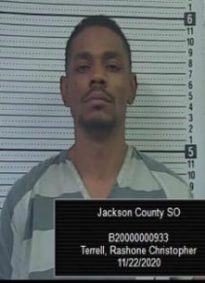**Topeka man arrested in stolen vehicle following pursuit**

A Topeka man is in custody following a short vehicle pursuit in Holton early Sunday morning. The Holton Police Department and the Jackson County Sheriff’s Office were had been looking for a suspicious person and vehicle that had been reported around 5 am Sunday morning in Holton. Shortly after, a Jackson County Sheriff’s Deputy located the person and vehicle near 5th and Pennsylvania Street in Holton. It was discovered that the vehicle had been reported stolen from the Stormont Vail parking lot in Topeka. The deputy attempted to stop the 1998 Honda Civic when a pursuit ensued. The vehicle stopped in the 600 block of Ohio Street in Holton. The driver, Rashone Christopher Terrell, 37, of Topeka was arrested and transported to the Jackson County Jail. Terrell was booked into the Jail for possession of stolen property, fleeing and eluding a law enforcement officer and driving while suspended.

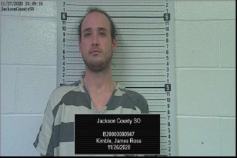 **Man wanted in Oklahoma robbery is in custody**

A Kansas State Trooper stopped a 1995 Cadillac Deville south of Hoyt on US Hwy 75 at approximately 7:38 pm Thanksgiving evening for a traffic infraction. The Trooper requested assistance, Jackson County Sheriff Tim Morse responded to the scene. The Trooper and Sheriff initiated a felony car stop and took 26-year-old Justin Ross Kimble, of Omaha, Nebraska into custody. Kimble was wanted out of the State of Oklahoma for 6 counts of robbery by force or fear. Further inquiry discovered the vehicle Kimble was driving had been taken in an alleged carjacking in Omaha, Nebraska earlier on Thursday. Kimble is currently being held in the Jackson County Jail. Additional charges on Kimble are expected.

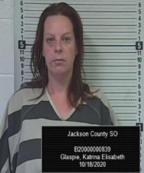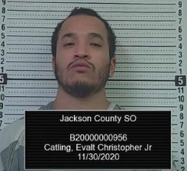[](https://www.jasoks.org/wp-content/uploads/Michael-Gonzales.jpg)**Three in custody following Monday morning pursuit**

Three people are now in custody following a Monday morning pursuit in southern Jackson County. Shortly after 9 am Monday morning a Jackson County Sheriff’s Deputy observed a northbound black 2017 Lincoln MKZ passenger car with an expired registration. The deputy attempted to initiate a car stop on the vehicle. The vehicle continued northbound near 142nd Road and allegedly nearly struck a northbound truck near 150th Road. The vehicle continued to fail to stop and went west at 174th Road and back to 75 Hwy heading southbound. The vehicle reached speeds in excess of 100 MPH. The pursuit continued southbound on 75 Hwy. A Shawnee County Deputy deployed a tire deflation device rupturing both passenger’s side tires of the suspect vehicle. The vehicle excited 75 Hwy at 46th Street and attempted to re-enter the highway on the southbound onramp. The vehicle came to a stop at that location. Troopers with the Kansas Highway Patrol, deputies with the Shawnee County Sheriff’s Office and the Mayetta Police Department assisted with the incident.

Three occupants were taken into custody. A quantity of methamphetamine was seized during the stop. The driver, Michael Gonzales, 32, of Topeka, was arrested for felony fleeing and eluding a law enforcement officer, reckless driving, operating a motor vehicle without a driver’s license. Gonzales also had an outstanding felony probation warrant from Osage County. The front seat passenger and owner of the vehicle, Katrina Glaspie, 40, of Manhattan, was arrested on numerous counts of identity theft and also had outstanding warrants from Riley County. The rear seat passenger, Evalt Catling Jr., 24, of Topeka was arrested for possession of methamphetamine, possession of marijuana drug paraphernalia. Catling also had outstanding warrants from the Topeka Police Department.

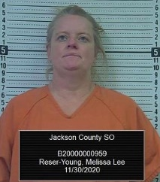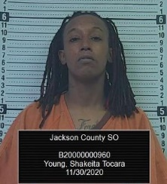**Two arrested on drug distribution charges during traffic stop**

A Jackson County Sheriff’s Office Deputy arrested two females on drug charges following a traffic stop north of Holton. On November 30, and shortly after 4 pm, the deputy stopped a northbound 2007 Dodge Charger for a traffic investigation. During the investigation of the traffic stop, the deputy located drug paraphernalia. The driver and passenger of the vehicle were subsequently arrested. A quantity of methamphetamine, marijuana, drug paraphernalia and U.S. currency was seized from the vehicle. The driver, Shakeita Tocara. Young, 31, of Topeka was arrested and booked into the Jackson County Jail for the following: possession of methamphetamine with intent to distribute, possession of marijuana with intent to distribute, possession of drug paraphernalia, no drug tax stamp and transporting an open container. The passenger, Melissa Reser Young, 49, of Topeka was arrested and booked into the Jackson County Jail for the following: possession of methamphetamine with intent to distribute, possession of marijuana with intent to distribute, possession of drug paraphernalia, no drug tax stamp and transporting an open container.

**JACKSON COUNTY JAIL CONFIRMS ONE CASE OF COVID-19**

**JACKSON COUNTY, Kan. (JASO) -** Sheriff Tim Morse reports that the Jackson County Sheriff’s Office has confirmed that one inmate has tested positive for Covid-19. The inmate was scheduled to be transported to serve time with the Kansas Department of Corrections and was tested prior to being moved to a state facility which is customary procedure. The inmate had been incarcerated since early November 2020 and had been quarantined for 14-days prior to being introduced into general population. The Sheriff’s Office has been in consultation with officials from KDHE and the Sheriff’s contracted medical staff on the next steps to address these circumstances. Inmates were tested on Thursday and results are expected shortly. The Sheriff’s Office will remain diligent in monitoring other inmates and staff for symptoms. For current information on COVID-19 in Kansas visit [www.kdheks.gov/coronavirus](http://www.kdheks.gov/coronavirus).

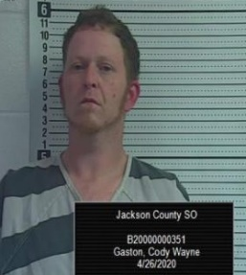 **JACKSON COUNTY, Kan. (JASO) –** Sheriff Tim Morse reports that Jackson County Sheriff Deputies and Kansas Highway Patrol Troopers searched for a suspect in a vehicle pursuit that begin on 126th Road shortly before 11 am. The pursuit ended in the 13500 block of 190th Road east of US 75 Hwy when the driver fled into a wooded area. A female passenger was taken into custody at the scene. Jackson County Sheriff’s K-9s, KHP K-9s, a KHP helicopter and a drone were used in the search. The suspect Cody Wayne Gaston, 35, of Holton, was captured near 190th and R.4 Road shortly after 5:30 pm.  Gaston is being held on a number traffic charges and possession of methamphetamine, possession of drug paraphernalia.  Gaston is also a suspect in an aggravated assault case on 126th Road, and a burglary and theft to an uninhabited residence on R.4 Road. Gaston is currently being held in the Jackson County Jail.

**Day Camp Cancelled for 2020**

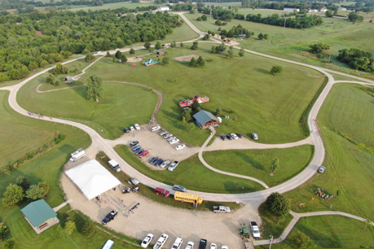

The year 2020 was unlike any year previous. The Covid-19 Pandemic pretty much effected everything around us. Many traditions including many holidays were cancelled in 2020. The Jackson County Sheriff’s Office Day Camp was no exception to Covid-19. While it was the desire of the Sheriff to continue with Day Camp in August, it just wasn’t practical nor safe in being able to carry out the various aspects of Day Camp in a safe manner. It is the hope that Day Camp will continue in 2021, however, the future remains unknown. Nonetheless, the Sheriff’s Office will revive another exciting camp for the younger citizens of our county very soon. The Sheriff states “The next Sheriff’s Day Camp will be bigger and better than ever before.”

**Patrol Division**

The Jackson County Sheriff’s Office Patrol Division is comprised of three elements. These elements include Patrol, Court Security and the School Defender Initiative program. The uniformed Patrol Division is under the leadership of Captain Scott Morris.

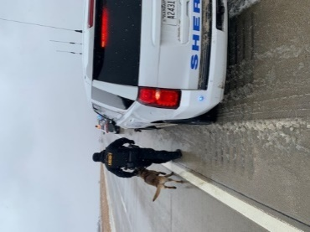The Patrol Division of the Sheriff’s Office is one of the most visible parts of the Sheriff’s Office along with being the primary enforcement division.  The Patrol division has the responsibility of patrolling, traffic enforcement, accident investigation, and responding to calls for service in Jackson County. In 2020, the Patrol Division initiated and/or responded to 20,429 calls for service. The Patrol Division provides proactive enforcement for the citizens of Jackson County. These Deputies vigorously patrol 24 hours a day, 365 days a year. They focus on being visible in the communities and endeavor to keep crime rates low. The Patrol Division strives to remain visible in high crime areas and works to keep crime rates low.

The Jackson County Sheriff’s Patrol Division patrols an estimated 500,000 miles of Jackson County roadways each year. The Patrol Division answers calls for service in the entire county. The Patrol Division also assists other agencies within and surrounding Jackson County.

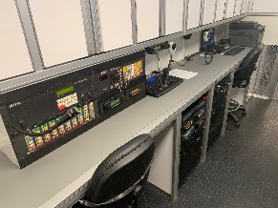In addition to patrolling the roadways of Jackson County, Patrol Deputies also work diligently to provide quality community policing within our county. This is done by working in the communities, participating in programs and events that establish a positive relationship between law enforcement and the public.

Inside JASO Major Incident Response Unit

The Patrol Division currently consists of four shifts, with each being led by a sergeant. Patrol Deputies have a variety of functions while on duty. Deputy Sheriffs serve warrants, patrol Jackson County, conduct investigations, enforce traffic laws, serve civil process and make arrests. Two Police Service Dog teams are assigned to the Patrol Division as well.

**Patrol responses in 2020**

In **2020**, the Patrol Division either responded to, initiated and or investigated the following:

55 - Mental/Suicidal (50 in 2019)

443 - Escorts/Transports (402 in 2019)

914 - Civil Process (853 in 2019)

650 - Arrest Warrants (674 in 2019)

4,599 - Car Stops (3839 in 2019) Highest amount in JASO history

21-Vehicle pursuits(24 in 2019, 20 in 2018)

03-Fatality Accidents (0 in 2019)

238-Non-Injury Accidents (256 in 2019)

79 - Injury Accidents (88 in 2019, 96 in 2018, 104 in 2017)

21 - Structure Fires

72 - Fire calls (non-structure) (59 in 2019)

107- Alarm Calls (165 in 2019, 154 in 2018, 137 in 2017)

12 - Fight Calls (23 in 2019, 33 in 2018, 17 in 2017)

116 - Domestic Violence Calls (118 in 2019, 125 in 2018, 122 in 2017)

30 - Assault/Battery/Harassment Calls (53 in 2019, 101 in 2018, 57 in 2017)

13 - Stolen car (31 in 2019)

445 - Animal Calls (560 in 2019, 595 in 2018, 527 in 2017, 474 in 2016)

1,019 - Assist Citizens Calls (1,106 in 2019, 1,059 in 2018, 1,105 in 2017)

562 - 911 Hang Up Calls (534 in 2019, 332 in 2018, 391 in 2017)

72- Disturbance Calls (64 in 2019, 73 in 2018, 66 in 2017)

304- Suspicious Person/Activity Calls (375 in 2019, 334 in 2018, 354 in 2017)

07 - Missing person (08 in 2019)

86 - Juvenile Calls (91 in 2019, 161 in 2018, 101 in 2017)

31 - Sex Offenses (28 in 2019, 50 in 2018, 31 in 2017)

129 - Welfare Checks (140 in 2019, 114 in 2018, 124 in 2017)

12 - Dead person

161 - Theft Calls (285 in 2019, 280 in 2018, 182 in 2017)

266 - Receive Information/Service Request Calls (376 in 2019, 511 in 2018, 426 in 2017)

814 - Service Request

678 - Traffic Problems (746 in 2018, 750 in 2017, 734 in 2016)

6,593 - Building/Area Checks (5,040 in 2019, 4,825 in 2018, 6,400 in 2017)

3 - Illegal Hunting/Criminal Trespass Calls (12 in 2019, 13 in 2018, 5 in 2017)

173 - Back Up/Assist Other Agency Calls (122 in 2019, 184 in 2018, 252 in 2017)

23 - Search Warrants (31 in 2019, 30 in 2018, 22 in 2017)

4 - Vandalism/Criminal Damage to Property Calls

10 - Illegal Trash Dumps (14 in 2019, 12 in 2018, 8 in 2017)

357 - Speak with Deputy Calls (426 in 2019, 286 in 2018, 262 in 2017)

35 - Road slide offs (58 in 2019, 67 in 2018)

131 - Assist outside agency (130 in 2019)

112 - Abandoned vehicle (104 in 2019, 61 in 2018)

163 - Medicals (222 in 2019, 188 in 2018)

17 - Criminal Trespass (47 in 2019, 34 in 2018)

174 - Back up

267 - Receive information

12 - Dead person

88 - Juvenile calls

7 - Missing person

3 - Gas leak

**K-9 Program**

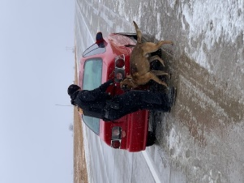The Jackson County Sheriff’s Office Patrol Division includes two Police Service Dog teams. These teams are each comprised of a handler and their assigned K-9 partner.

Sgt. Travis Spiker and PSD Ike

For many years now K-9s in the United States have proven to be a vital part of law enforcement. These dogs utilize their unique skills and abilities to enhance the safety of their human counterparts on a daily basis. Since the 1990’s Canine Teams have been a part of the Jackson County Sheriff’s Office. These teams have been used to locate contraband, find lost citizens, apprehend criminal suspects, recover evidence, and protect officers.

The job of a Sheriff’s canine team is one that is very demanding, it requires a huge commitment from both the handler and dog. To become a certified Police Service Dog Team they must first complete very intensive basic training, which is approximately 10 weeks long. During this training the teams receive instruction in a number of areas, to include narcotic detection, handler protection, tracking, and apprehension. Once the team has successfully completed the basic training and certification, they then must attend weekly maintenance training to maintain their skillsets. Even though the position of canine handler is extremely demanding, it also very rewarding, the longer the team works together, the stronger their bond becomes.

Currently the Jackson County Sheriff’s Canine teams are comprised of Sgt. Travis Spiker with his assigned PSD Ike, and Deputy John Paz with his assigned PSD Kreto.

In addition to Sgt. Spiker’s duties as a PSD handler, he also serves the Sheriff’s Office as a patrol supervisor.

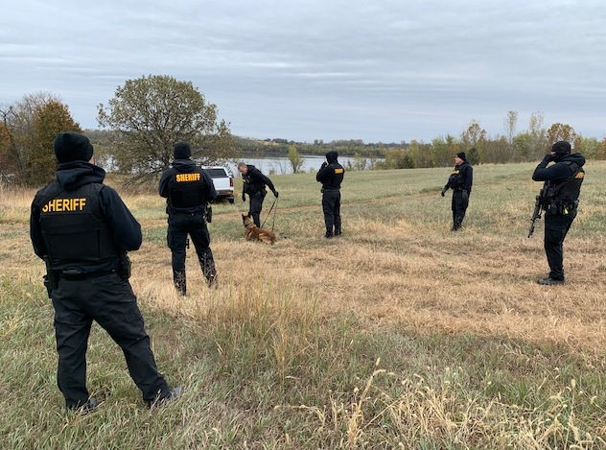

**Sheriff K-9 locates fleeing burglary suspect**

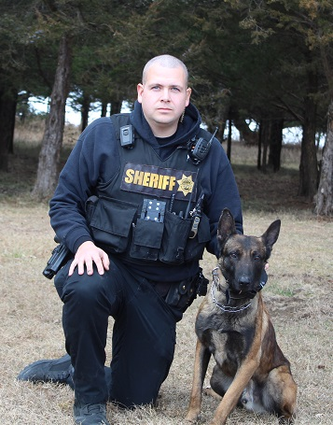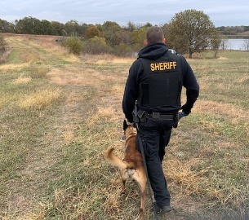

In November of 2020, Deputy John Paz and Kreto responded to a report of a burglary suspect who had fled on foot in a rural part of southern Jackson County. Upon arrival Deputy Paz formed an arrest team and utilized Kreto to track the suspect. After a lengthy track through difficult landscape, Kreto located the suspected hiding in a large brush pile. Once located, coordination with the Jackson County Sheriff’s Drone, the arrest team, and Canine team, allowed the suspect to be safely taken into custody by Deputies. This is just one great example of the service that these K-9s provide for the community, enhancing both public and officer safety on a regular basis.

K-9 Deputy John Paz and Kreto

**Sheriff K-9 assists with illegal drug arrests**

Sgt. Travis Spiker and Ike

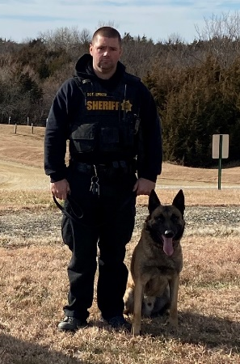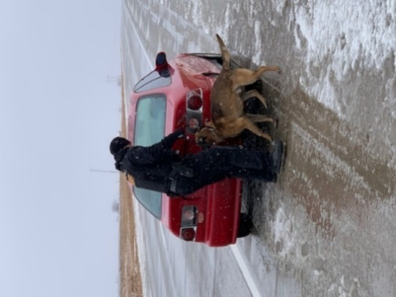In September of 2020, Sgt. Spiker and Ike were requested to assist a Deputy with a traffic stop in Northern Jackson County. A Deputy had conducted a traffic stop, then became suspicious of the occupants activities. Sgt. Spiker responded and conducted a canine sniff on the vehicle, where Ike indicated to the odor of illegal drugs. During a search of the vehicle, illegal drugs were located. The investigation of this case led to multiple arrests, including a felon in possession of a firearm. This specific incident is a great example of the positive impact these canine teams provide to the citizens of Jackson County by apprehending dangerous criminals, and keeping the community safe.

**Training**

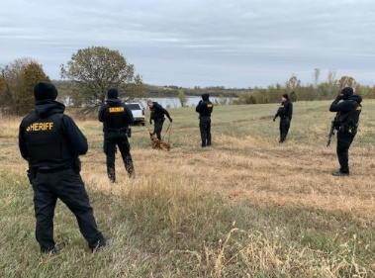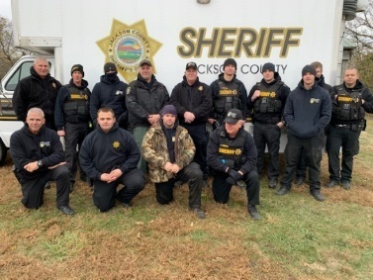Law enforcement is an extremely demanding field that is constantly changing and challenging, therefore it requires specific skills and knowledge. The Jackson County Sheriff’s Patrol Division recognizes that training of deputies is mandatory to develop and maintain the skills and knowledge necessary to do the job both safely, and lawfully. The Patrol Division provided a number of training opportunities throughout 2020, much of this training was offered to other agencies. This training included Police Service Dog training, Open Area Suspect Search (manhunt), Vehicle Stop Tactics/Safety, and Building Clearing to name a few. The Jackson County Sheriffs’ Office understands that a better trained officer, is not only safer for officers, but also the citizens that they are sworn to protect.

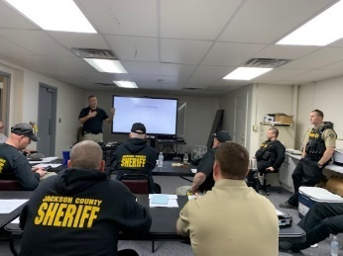**Sheriff’s Office provides training**

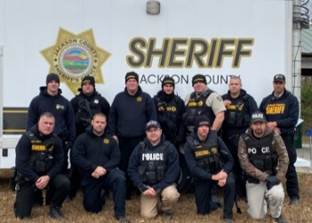In October of 2020 the Jackson County Sheriff provided training in the area of vehicle stop safety and tactics as well as open air suspect searches. During this training deputies received both instructional and practical training, implementing the use of the Sheriff’s Office canines and drones. The training was open to other agencies and held at the Banner Creek recreational area.

**Court Security**

The Jackson County Sheriff’s Office Patrol Division provides court security for the Jackson County District Court. Deputies keep the courtrooms free of weapons and maintain order. In addition, deputies make arrests and take custody of inmates that are remanded to the Sheriff. The year of 2020 was a challenging one for the courtroom. Deputies faced new challenges as they worked to provide security for the courtrooms from not only traditional threats, but also those that come from the pandemic as well. This new threat changed the way that court proceedings were conducted, forcing the Deputies to adjust their operations in accordance. The Deputies handled this challenge very well and continue to provide the citizens of Jackson County with a safe and professional representation in the courtroom.

**School Defender Initiative**

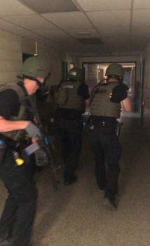In 2018, Sheriff Tim Morse voiced his ideas in making Jackson County Schools safer. Sheriff Morse who has seen senseless killings in our nation’s schools and believes there are better ways in keeping children safe in schools. In 2019, Sheriff Morse was featured in the Kansas Leadership Journal. The article discussed some of Sheriff Morse’s goals in making Jackson County schools safe.

Sheriff Tim Morse stated the following in a 2018 Op-Ed article: *“The first thing parents do after hearing about another school shooting is they confirm it isn’t their child’s school. Enough is enough, when will our politicians get it? For over 20 years now, children have been the targets of deranged persons who have slaughtered innocent children in a place we expect them to be safe, their schools.  In 20 years, our federal and state government has done little to nothing to make them safer. The time has come for the people to stand up and demand that their children be protected from these disturbed individuals. Unfortunately, for a variety of reasons, there has been an increase in deadly violence among some of our young people. Nevertheless, our world is a different place than it once was.”*

Sheriff Morse pointed out the changes in security that have taken place after the Oklahoma City bombing in stepping up security at courthouses and the upgrade in security at airports across the country following the 9/11 terrorist attacks. Sheriff Morse has advocated for enhanced security in county schools due to the threats Jackson County faces with its location next to the capital city, the abundant amount of mental health issues in the community and surrounding areas, along with the proliferation and accessibility of unsecured weapons in the rural community.

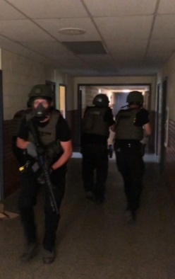Sheriff Morse has stated that school districts in larger counties have their own police departments or added law enforcement already in their schools; however, those schools in the rural area are much more vulnerable. Sheriff Morse believes students, teachers and parents should not have to worry about safety in the school, students should focus on learning, and teachers should be able to focus on teaching.

Since Jackson County is a rural county with little industry and less funding than urbanized counties. Sheriff Morse suggested training reserve deputies that would be charged with securing our schools. These deputies would be sworn law enforcement that would have specialized training in building security, active shooter trainings and a variety of training that would be specific to school security. The Sheriff also proposed a second component to the plan that would allow upon school board approval, a limited number of **non-teaching** school employees to undergo the same training who would serve as a back up to uniformed reserve deputies. All participants would be highly vetted, screened, tested, polygraphed, and would have to undergo the same hiring requirements as any deputy sheriff.

As to date, the armed staff option has not yet been implemented, however, a number of security improvements have been made to the districts through the help of School Defender Initiative Coordinator Deputy Joe Romans.

The insurance company that insures Jackson County has approved Sheriff Morse’ full-plan for school security. Sheriff Morse continues to work with districts in making schools safer.

**School Defender Initiative Coordinator**

Deputy Joe Romans has been tasked with the assignment of implementing Sheriff Morse’s School Defender Initiative program. For over the past two years Deputy Romans has been working with Jackson County School Districts to improve the security of their facilities and provide a much safer environment for our children.

Deputy Romans is an excellent representative for the Sheriff’s Office for this position as he brings great experience and knowledge to the position.

CSM C. Joseph (Joe) Romans retired in December 2008 after a 30 years of active duty service.    Deputy Romans first enlisted in 1968 and served with the Marine Corps as a Corpsman for 4 years. He was honorably discharged in 1973 and then pursued a career as an EMT and Paramedic in Indianapolis and then 5 years as a Remote Arctic Air Force Radar Site Medic in Alaska. He re-enlisted in the Army in 1982 and served for 26 more years.

In 2020, the Jackson County Sheriff’s Office continued to move forward with the school defender initiative despite the challenges presented by the COVID-19 pandemic.

**Comments from Deputy Joe Romans**

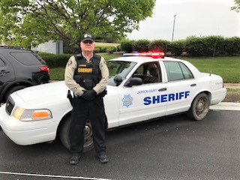 *“I’m Joe Romans, Command Sergeant Major US Army (retired) and Deputy for Jackson County Sheriff’s Office. Sheriff Tim Morse brought me on 2 years ago to assist in his vision of establishing a School Defender Initiative in our County. The mission is to do everything possible to improve the safety and security of our schools. Under the Sheriff’s guidance and leadership, I’m pleased to report to you that we continued to make progress in 2020 towards achieving that goal. The COVID-19 pandemic did have an effect on our efforts but we have improvised and adapted to move forward. With the ongoing support and cooperation of the school district superintendents, staff, teachers, county first responders and our own internal training, I can report to you that as we close out 2020, our schools are more secure today. We have continued to provide a law enforcement presence at our schools, both during school days and at after-hours activities. We have conducted school centric tactical training of our Deputies, conducted detailed an in-depth security assessment of two more Jackson County schools, made security improvements in school infrastructure, assisted in updating the school crisis plans, trained school staff in emergency procedures, improved interior and exterior communications, and much more. I can assure you that the Jackson County Sheriff and his staff are “All-in” on this effort. We still have more to do and will continue to make improvements throughout 2021 as our nation recovers from COVID-19. Every member of the Sheriff’s Office is dedicated to protect our most precious resource, our children.”*

**2020 School Defender Initiative Update**

Deputy Joe Romans and the Jackson County Sheriff’s Office have been very busy in 2020 in improving school security and procedures. Obviously, for the sake of security, not everything can be discussed in detail for that reason. Here are reportable highlights for this past year.

1. Deputy Romans is a “Stop the Bleed” instructor. In 2020, Deputy Romans conducted a “stop the bleed” class for 20 school staff members. Jackson County Sheriff’s Office (JASO) deputies have been trained as well, deputies are issued and carry tourniquets.

2. In 2020, Deputy Romans and other JASO deputies participated in a 2-day Situational Training Exercise (STX) at old Holton Central Elementary school. Stop the Shooter training was conducted using JASO tactics, techniques, and procedures. This is part of an on ongoing training program to maintain the skills necessary to detect, prevent, and respond to crisis situations. JASO Deputies receive firearms training above and beyond the state mandated minimums for law enforcement officer

3. Deputy Romans observed and assisted in crisis drill training for school staff. School infrastructure and security upgrades were implemented. Plans were reviewed and updated. Deputy Romans made over 200 school security presence and foot patrols at Jackson County schools. These visits were random, both day and night. These security visits help ensure that procedures, policies and security practices are being maintained and that students are safe.

4. Deputy Romans is a trained and certified school security assessor. He conducted a multi-week security review of Jackson Heights High School and Middle school, and will continue to assess schools going forward into 2021.

5. Deputy Romans attended the Pottawatomie county first responders’ multi-agency active shooting exercise at Onaga High School in 2019. From his experience a proposal went forward to have a similar exercise for Jackson county in the fall of 2021. This will be a JASO led and coordinated multi-jurisdictional exercise involving Fire, EMS, other law enfacement agencies, and JACO school district staff.

6. Deputy Romans is an A.L.I.C.E. certified instructor (Alert-Lockdown-Inform-Counter-Evacuate). Due to COVID-19 in 2020, training has been delayed, but as the pandemic winds down and the immunizations take effect, this protocol will be further implemented in our schools in 2021.

7. The Sheriff’s Office issued a school bus emergency operation plan for handling violent events, and distributed to all the Jackson County school transportation directors. Holton School District and Jackson Heights School Districts have adopted the bus emergency operations plan. Twelve Jackson Heights school bus drivers were trained in 2019. Deputy Romans has scheduled further training for first quarter of 2021 for Royal Valley Bus Drivers.

8. As school extracurricular events are reinstated, Deputy Romans will be present for school functions (football games, school dances, parents/kids’ events, school plays, etc.) at all three districts.

9. The Jackson County Sheriff’s Office has formed a school defender working group with all 3 Superintendents, the Sheriff, Undersheriff, and Deputy Romans to meet periodically to discuss school security upgrades/plans/progress. The next meeting will be first quarter 2021. In 2020, the Holton School board invited the Sheriff, Undersheriff and Deputy Romans to attend a board meeting to give them a briefing on their district schools security posture.

10. JASO support to the community safety and security. In recent years, organizations such as churches have worked to improve security. In 2020 the leadership of local church in Holton requested the Sheriff’s Office for assistance to improve security for church infrastructure and train their new congregation security team. Deputy Romans was assigned to accomplish this. A two-day security assessment of the building was conducted, and a security team was identified, vetted, and trained. Team members were all certified to carry concealed. (Deputy Romans is a state certified concealed carry firearms instructor).

11. Deputy Romans was trained and certified to run the law enforcement support (LESO) program for the Sheriff’s office. This program allows our office to search for, identity, and acquire surplus military equipment for law enforcement purposes from the U.S Government Department of Defense, through the Defense Logistics Agency. The office obtained a tandem axle trailer that serves as a utility trailer for crime scene and rescue equipment. Also acquired was a forklift, two generators including a 60 KW generator for auxiliary power for the jail, and an up armored Humvee for improved ballistic protection for JASO Deputies to operate in a high-risk environment. All this equipment was obtained for a small fraction of the equipment’s original cost and value, at a huge savings for the Jackson county taxpayer.

**The following are a list of prior accomplishments of the School Defender Initiative previously presented:**

1. We have seen through a variety of studies that simple life saving techniques have been beneficial in saving lives during a crisis event. In 2019, Jackson County Sheriff’s Office (JASO) Deputies were trained in “Stop the Bleed” class. Deputies were trained in the use of tourniquets and other life saving techniques. Deputies are issued and carry tourniquets.

2. JASO Deputies participated in a 2-day Situational Training Exercise (STX) at the old Holton Central Elementary school. Stop the Shooter training was conducted using JASO tactics, techniques, and procedures. This was the third such training event for the Sheriff’s Office in the last two years. Other agencies have also been included in these trainings. Jackson County Sheriff’s Deputies are each issued a complete set of SWAT style protective gear. This protective gear was paid for through a federal grant. Deputies use this equipment as well and simunitions during these exercises.

3. Deputy Joe Romans attended the FBI School Shooter Seminar in Kansas City featuring a detailed case study of the Parkland shooting. In-service training was also provided to Jackson County Patrol Deputies.

4. Deputy Joe Romans underwent an intensive school security assessment training program. This training resulted in Deputy Romans becoming a certified school security assessor for the purpose assessing security issues for our school districts and making recommendations to them for improvement.

5. Deputy Joe Romans became a “Stop the Bleed” instructor in 2019.

6. Deputy Joe Romans attended the Pottawatomie county first responders’ multi-agency active shooting exercise at Onaga High School.

7. The Jackson County Sheriff’s Office provided the Royal Valley High School and Elementary School a 50-hour security assessment. Following the assessment and completion of the report, school district officials received a briefing of the findings along with suggestions on improving infrastructure, security and policy.

8. The Jackson County Sheriff’s Office provided the Holton High School a 50-hour security assessment. Following the assessment and completion of the report, school district officials received a briefing of the findings along with suggestions on improving infrastructure, security and policy.

9. Also in 2019, Deputy Joe Romans, the Holton Superintendent Bob Davies and Royal Valley Superintendent Aaric Davis attended the 3-day Alert-Lockdown-Inform-Counter-Evacuate – (A.L.I.C.E.) Instructor certification course.

10. In 2019, Deputy Joe Romans instructed 40 RV Middle school Staff members in “Stop the Bleed” training.

11. In 2019, Deputy Joe Romans instructed 20 Holton high school bus drivers in “Stop the Bleed” training.

12. The Sheriff’s Office issued a school bus emergency operations plan for handling violent events, and distributed to all the Jackson County School transportation directors. Holton School District and Jackson Heights School Districts have adopted the bus emergency operations plan. Twelve Jackson Heights school bus drivers were trained on the plan as well.

13. More school safety training was scheduled for 1st quarter 2020.

14. Deputy Joe Romans assisted the Royal Valley Superintendent in training 120 Royal Valley schools staff in A.L.I.C.E. protocols.

15. Deputy Joe Romans conducted multiple weekly unscheduled school security visits for Royal Valley and Holton schools. These security visits help insure that procedures, policies and security practices are being maintained and that students are safe.

16. Royal Valley Schools are undergoing security upgrades to doors and windows. Some of these updates are grant funded.

17. Royal Valley School District have purchased and installed crisis communications console equipment.

18. Deputy Joe Romans has attended several after school functions (football games, school dances, parents/kids’ events, school plays, etc.) at all three districts.

19. The Jackson County Sheriff’s Office has provided devices enabling law enforcement to make entry into a secured and locked down school facility during a crisis event.

20. The Jackson County Sheriff’s Office has formed a school defender working group with all 3 Superintendents, the Sheriff, Undersheriff, Deputy Romans to meet quarterly to discuss school security upgrades/plans/progress.

21. In 2020, school security assessments are planned for the remaining Jackson Heights and remaining schools.

22. Further training has been scheduled for transportation directors and staff in 2020.

23. The Jackson County Sheriff’s Office is providing upgrades to school districts free of charge through criminal drug asset forfeiture monies to enhance the ability of law enforcement and emergency responders to be able to communicate on school property. In reviewing a number of case studies of school shootings, there have been instances where responders and law enforcement have had severe radio communication limitations within school buildings, mostly due to concrete and steel. These new systems are making major headway for responders.

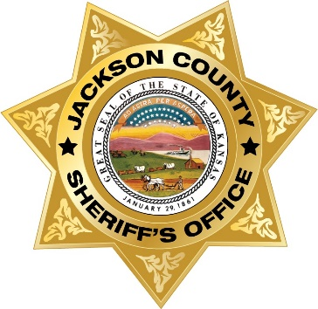

**Captain Scott Morris**

Captain Scott Morris joined the Jackson County Sheriff’s Office in the fall of 2020. Captain Morris spent his previous career with the Kansas Highway Patrol. Captain Morris served as a trooper here in Jackson County and in NE Kansas. Captain Morris served as the Troop Commander for the Kansas Highway Patrol Emergency Services Unit. He managed the operation of the Special Response Team (SWAT), Police Service Dog Unit (entire narcotic, explosive and patrol K-9 program for KHP), and the Hazardous Devices Unit (bomb squad technicians). The KHP Emergency Services Unit consists of more than 50 members, both uniform and civilian employees. Captain Morris was responsible for purchasing, proper use, and maintenance of specialized equipment specific to these fields.

Captain Morris is currently serving the Sheriff’s Office as Captain of Patrol. He oversees the sworn uniformed staff of the Sheriff’s Office. His areas of oversight encompasses patrol deputies, court security and the School Defender Initiative.

Society is becoming more violent and it is important for deputies to have the specialized required training and equipment to deal these increasing issues. Captain Morris is tasked with finding and providing some of the best training available for our deputies along with seeing that they are properly equipped to perform their duties.

Captain Morris also oversees the Jackson County Sheriff’s Office K-9 Program. Captain Morris helped start the current K-9 program for KHP. Captain Morris has served as a K-9 supervisor, instructor, and judge for the KHP Service Dog Unit. He managed training and certification for over 40 outside agency police service dog teams. He has already implemented local K-9 maintenance training that has provided beneficial to JASO PSD teams. This has allowed these teams to stay within the county for the majority of their training. It also has provided for more one-on-one training and with less teams training, it provides for more training repetitions for both teams. There appears to be a noticeable improvement with these teams.

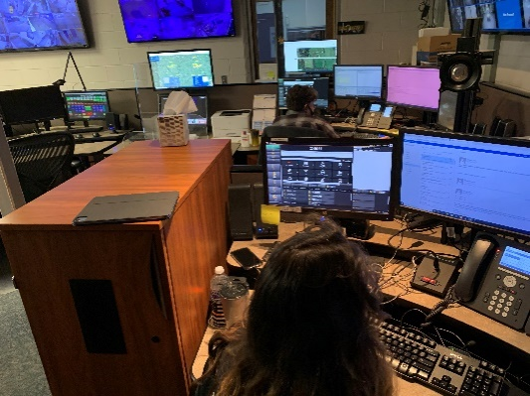**Communications Division**

The Jackson County Sheriff’s Office Communications Division is the central answering point for 911 in Jackson County. The Communications Center dispatches for five law enforcement agencies, eight fire departments and two EMS agencies. In 2020, the Communications Center dispatched over 27,635 incidents, although the vast majority were for law enforcement, a number of fire and ems calls were dispatched as well.

Dispatchers are the true first responders and are the vital link between those in need and emergency services. Dispatchers don’t just answer and dispatch calls, but they also have a variety of other duties. Dispatchers also answer the walk in traffic at the Sheriff’s Office lobby. They also are the holder of the warrants for the Jackson County District Court. There are over 1,200 Jackson County District warrants that are outstanding. Dispatchers have to confirm whether a warrant is valid when a law enforcement officer encounters a fugitive. When the California Highway Patrol stops a subject and finds they have a Jackson County warrant, Jackson County Dispatchers must confirm whether the warrant is valid or not. Stolen items and missing people are also entered in the N.C.I.C. system by dispatchers. Dispatchers also must confirm when those stolen items or missing persons are found.

The Communications Center also has a state-wide function for Wildlife, Parks and Tourism. The Wildlife, Parks and Tourism’s Operation Game Thief hotline is answered at the Jackson County Sheriff’s Office for the entire State of Kansas.

The Jackson County Sheriff’s Office 911 Center has eight dispatch positions.

The Communications Center dispatched the following number of incidents for the various agencies in 2020:

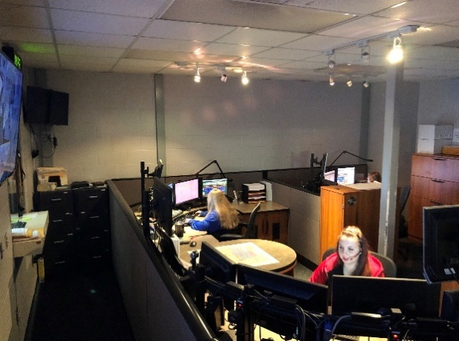**Jackson County Sheriff** **21,290**

**Holton Police Department 647**

**Jackson County EMS 1,401**

**Hoyt Police Department 655**

**Mayetta Police Department 121**

**Wildlife and Parks 30**

**Operation Game Theft 1,364**

**Kansas Highway Patrol 114**

**Potawatomi Tribal Police 274**

**Netawaka Fire Department 124**

**Mayetta Fire Department 459**

**Soldier Fire Department 108**

**Holton Fire Department 75**

**Delia Fire Department 115**

**PBPN Fire/EMS 258**

**Whiting Fire Department 105**

**Hoyt Fire Department 491**

**Jackson Co. Storm Spotters 4**

**Business Office Division**

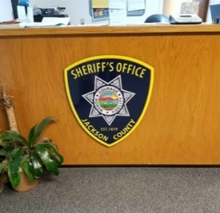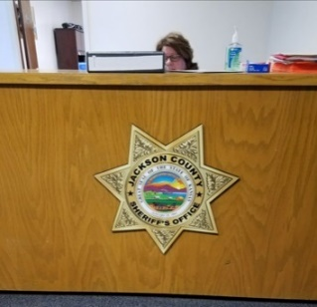The Business Office of the Sheriff’s Office is under the leadership of Sherri Ladner. The Business Office is in charge of numerous responsibilities including: records, fiscal accounting, billing of services, preparing all employee payroll, dissemination of open record documents, accident reports, offense reports, arrest reports, jail commissary, inmate accounts, civil process, vehicle identification inspections, sheriff sales, inventory, computer network and database management, liaison between a variety of agencies, and supports the Sheriff and Undersheriff.

Sherri Ladner also serves as the 911 Coordinator for Jackson County.

**Civil Process**

In 2020, the Sheriff’s Office served 1,365 papers for the District Court of Jackson County, several other Kansas counties and several other states which generated $5,455.00 in revenue. Both the number of papers served and revenue generated were considerably lower than previous years due to Covid-19 shutting down court for a few months. In 2019, the Sheriff’s Office served 2027 papers with $10,810.00 in revenue received. In 2018, the Sheriff’s Office served 2,664 papers with a revenue of $12,582.00. In 2017, the Sheriff’s Office served 2,148 papers with revenue of $10,350.00. In 2016, the Sheriff’s Office served 2,735 papers with revenue of $11,590.00. In 2015, 2,904 papers were served with revenue amounting to $13,440.00.

The Sheriff’s Office served 439 summons, 670 subpoenas, 92 tax warrants, 22 show causes, 7 writs of assistance, 61 orders to appear, 9 citations in contempt, 25 garnishments, 40 protection from abuse orders.

**VIN Inspections**

In 2020, deputies performed 732 vehicle identification number inspections and collected $14,640.00 in revenue. Covid-19 again has shown an impact on VIN Inspections and revenue collected because the service had been suspended for a period of time. In 2019, deputies performed 842 vehicle identification number inspections and collected $15,156.00 in revenue. In 2018, deputies performed 844 vehicle identification number inspections and collected $15,192.00 in revenue. In 2017, deputies performed 916 vehicle identification number inspections and collected $16,488.00 in revenue. In 2016, deputies performed 792 vehicle identification number inspections compared with 740 in 2015. These inspections resulted in $14,256.00 in revenue compared to $13,320.00 in 2015 and $13,302.00 collected in 2014.

**Concealed Carry**

In 2020, 24 concealed carry permits were processed by the Jackson County Sheriff’s Office and $780.00 in revenue was collected. In 2019, 31 concealed carry permits were process by the Jackson County Sheriff’s Office and $1007.50 in revenue was collected. In 2018, 30 concealed carry permits were process by the Jackson County Sheriff’s Office and $975.00 in revenue was collected. In 2017, 24 concealed carry permits were processed by the Jackson County Sheriff’s Office and $780.00 in revenue was collected. Conceal carry permits doubled in 2016 from the year prior. In 2015, following the Kansas legislature easing restrictions on concealed carry 16 permits were issued compared to 57 in 2014. This year 32 permits were issued and $1040.00 in revenue was collected. The Sheriff’s Office receives $32.50 for each concealed carry application.

**Fingerprints**

The Sheriff’s Office in 2020 fingerprinted 55 individuals for employment or background purposes. The Sheriff’s Office collected $550.00 for fingerprints. This is a decrease in revenue from last year as Covid-19 impacted this service.

**Reports**

The Sheriff’s Office collected $957.32 for copies of reports in 2020.

**Sheriff Sales**

In 2020, the Sheriff’s Office conducted 2 sheriff sales and earned revenue from the sales of $15.00. The Federal Government stopped all foreclosures and evictions due to Covid-19 which is reflected in the small numbers listed above.

**Special Law Enforcement Fund**

On January 1, 2020, the balance of the Special Law Enforcement Trust Fund was $16,395.86. Throughout the year, $15,812.92 more was awarded to the Sheriff’s Office through the asset forfeiture procedure. Purchases made from this fund totaled $30,000.00. Ending balance on December 31, 2020 is $2,208.78.

**Technology**

Three new laptops were obtained for the Detective Division to replace units that were aged out at 4 to 5 years and still operated on Windows 7 which is no longer supported. Throughout the year, 2 more additional desktop computers were purchased to replace PC’s that were needing upgraded due to age and outdated operating systems.

**911**

The total number of 911 calls received at the Jackson County Sheriff’s Office in 2020 was 3,663.

Additional information regarding administrative calls in and out of the Sheriff’s Office is as follows:

**Admin calls:** Incoming calls: 24,590

Outgoing calls: 11,796

**COVID-19**

The administrative staff saw many challenges and had to adapt to new ways of conducting business. They had to quickly have laptops programmed by our IT Company so that they could mostly work from home starting in late March. Only having two administrative staff members meant that they couldn’t come to the office and do necessary tasks at the same time so as not to expose both employees. Staff returned back to the office full time in mid-June only to be moved to remote work again in August due to positive Covid-12 tests of other staff. Mid-November saw another surge of the coronavirus that sent the office staff home part-time for about a month. New safety barriers have been placed on desks to protect staff, distancing is ongoing and masks are mandatory within the office if they leave their work station. For a staff of 54 employees, the Jackson County Sheriff’s Office has done extremely well in protecting each other.

**Jail Division**

Corrections work is always a challenge, last year has been challenging to say the least. With Covid-19 front and center, the new normal has changed operations dramatically.

Sheriff Morse implemented measures to try to protect the inmate population from Covid-19. The Jail lobby was closed to the public and the wearing of masks by staff at all times was implemented. A required 14-day quarantine for any new inmates, re-quarantining inmates that leave the facility for court or appointments and many other changes to the daily routine of the jail. Both male and a female quarantine pods were opened. Since inmate workers couldn’t go in to these pods, corrections officers have to provide meals to each cell individually three times a day. The vast majority of court attorney visits and court services has been moved to Zoom or other video services. This along with moving inmates to sick call is certainly a strain. Since the Jail essentially lost two pods to quarantine, having adequate space to put inmates after they pass through their 14-day quarantine has been challenging.

Staff was able to keep Covid-19 out of the Jail most of the year. In November, an inmate tested positive for Covid-19 that was bound for transfer to the Kansas Department of Corrections. This inmate had made it through quarantine and was in the general population showing no signs or symptoms. The Kansas Department of Health and environment tested the entire staff and inmate population. Six more inmates tested positive, however, all were symptom free. All positive inmates were quarantined and tested. Testing continued for the next two weeks which determined the entire facility was negative thereafter.

The daily inmate population has been lower last year due to Covid-19, averaging 78 inmates per day with about 36 being local inmates and 42 being paying inmates. January was the highest count at 97 inmates, and September being the lowest with 63. Transportation of prisoners has not slowed much last year. Corrections Officers have moved over 722 inmates. Inmates in Nebraska, Missouri, Florida and Texas last year along with multiple Kansas counties were transported to Holton by staff. Jail staff transported inmates to the Kansas Department of Corrections, US Marshals, Core Civic Leavenworth, Juvenile detention, treatment centers, District Court, Jackson County Health Department, hospitals and medical appointments. Staff has also transported inmates in need of mental care to Larned and Osawatomie mental facilities. Corrections staff have also transported inmates to other counties as a courtesy. Over 222 inmates had outstanding Jackson County District Court warrants that had to be transported back from other jurisdictions. Corrections staff transported 106 inmates to court. The Jail had 95 Federal prisoner transports and 13 juvenile transports. There were 114 medical appointments or emergency room visits, with 38 transports to the Department of Corrections. Staff transported 10 inmates to drug or alcohol treatment and transported 13 to the Health Department for Covid-19 testing. The Jail transported inmates over 25,000 miles in 2020.

The Jackson County Jail underwent its Prison Rape Elimination Act Audit that concluded in July. The Jail was found to be compliant and met all standards. Several of the housing contracts require PREA certification. Hours of hard work go into becoming compliant. Policy, practice and documentation of practices go into continued compliance. Not only the Jail but also investigations and the administration are affected by ongoing PREA compliance. Most sheriff’s offices across the state do not attempt to gain PREA compliance, therefore, it is a great accomplishment to be included in the few that are.

Last year has been particularly challenging for the corrections staff. They have worked much harder due to Covid-19 than ever before. The agency is blessed with a great staff with great abilities and willingness to get any task accomplished. The Jail has 15 full time corrections officers and two part time. Since the Jail is open and operational 24 hours a day, 7-days a week, these employee work days, evenings and nights regardless of holidays and family events.

Corrections officers booked 1,023 inmates into the Jail in 2020. The Jail held inmates for the United States Marshal Service, Prairie Band Potawatomi Nation, Kansas Department of Corrections, Douglas County, Wyandotte County and Franklin County. Even with the Coronavirus impacting the number of inmates being housed, the Jail was still able to generate $743,328.92 for the year from inmate housing.

The Jail collected $101,333.77 for the Inmate Welfare account. This account is used to purchase supplies for the jail along with paying for other inmate needs.

**Registered Offenders**

Currently, there are 49 registered offenders in the county for 2020, this number does not include registered offenders that are in the Jail. These 49 offenders break down to, 3 violent, 34 sexual and 12 drug offenders. One person was charged and convicted for failing to register in 2020.

**Jail Construction Project**

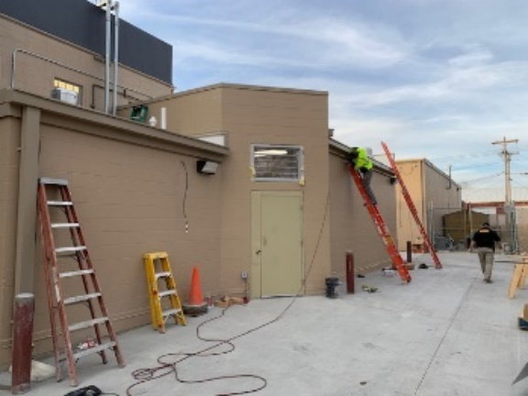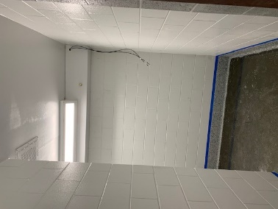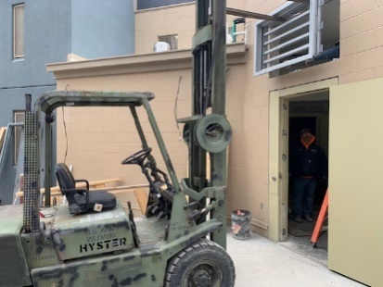In 2020, the Jackson County Sheriff’s Office submitted a Cares Act funded jail construction project to the Jackson County Board of Commissioners. The plan came about due to difficulties the Sheriff’s Office was having in managing inmates with limited space. The Jail has only one holding cell with over 1500 inmates getting booked into the Jail in a typical year. The limited processing holding space makes it very difficult in separating genders and housing inmates with separation issues. In addition, in an attempt in keeping inmates and staff healthy during the Covid-19 Pandemic it is required to quarantine inmates for 14-days. This is extremely difficult with the number of inmates that are housed daily in the Jail and with the never ending constant flow of new inmates. The Jail is required to generate a portion of the Sheriff’s Office budget through out of county housing. The Jail does not have an area where inmates who are infected with a contagious illness can be housed as to not contaminate other inmates. The Jail does not have an emergency overflow housing area where inmates can be housed in emergency situations that can offset the loss of housing space to situations such as a mandated quarantine. The plan that was submitted to the Commissioners to consider provided for two maximum security cells and a day room that can be used for medical isolation. Each cell would have its own shower. This would prevent inmates having the need to expose other inmates by having a self-contained unit. The unit is connected by a secure vestibule to the existing facility. The current recreation yard which was enclosed several years ago would double as an emergency overflow area. This area would require a fire suppression system and 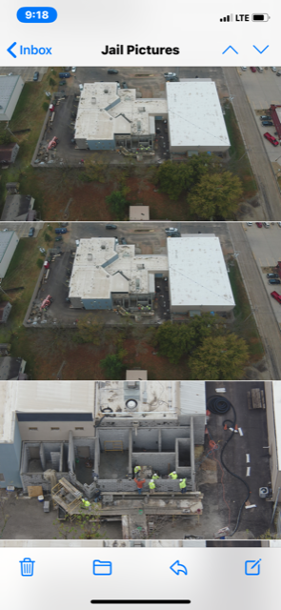would require restroom and shower facilities. The proposed cost of the project would exceed $500,000.00. The Jackson County BOCC approved the request, however, the project was required to be completed by December 31, 2020. HMN Architects designed the project and Kansas Building Systems was awarded the project. Undersheriff Darrel Chapman who has a construction background, was placed in charge of overseeing the project. A number of local contractors were awarded work on the project. Undersheriff Chapman was able to reduce the cost of the project by tens of thousands of dollars.

Touch up on some of the final details was taking place immediately after Christmas 2020. The project provides up to 19 additional beds in an emergency situation. The Isolation Unit may serve for several purposes during normal years. The unit can be used as segregation units, additional holding cells or permanent inmate housing units. These units will be used in some capacity 24 hours a day, seven days a week.

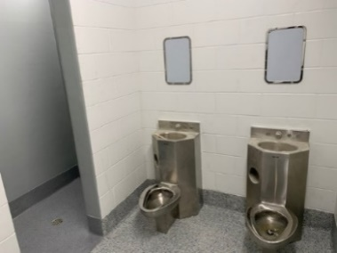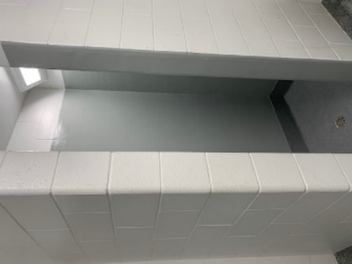These units will allow the Jail to continue at maximum capacity and maximum efficiency by taking care of the incarceration needs of the county, while at the same time allowing the agency to generate its mandated revenue obligations without furthering the burden on the taxpayers through a tax increase.

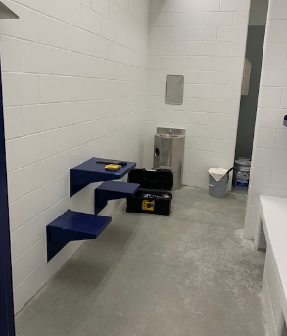 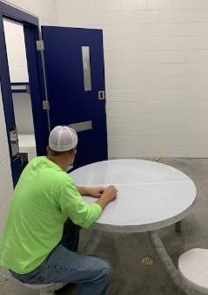 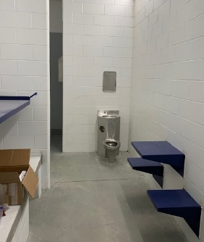

**Investigations Division**

Investigations is a specialized unit that primarily investigates lengthy and more complicated cases. The division investigates person and property crimes. The division has a specific unit that investigates domestic violence, and sex crimes and another unit that focusses strictly on narcotic trafficking cases. The Investigations Division is made up of five investigators. Investigations has worked a numerous amount of investigations in 2020. The unit alone served 64 search warrants, and 37 inquisitional subpoenas for the year of 2020.

In 2020, the investigation unit has re-opened cold cases from years past using new investigation techniques.

Investigations have spent time on cold case and suspicious death investigations. So far, four cases have been and/or are being re-investigated. They are:

**The August 27, 1977, death of a rural Denison, Kansas man who died in a suspicious fire.**

Initially, the 1977 death was ruled an accident. It was never thought to be a suspicious death until the 1990s when then Sheriff Phil McManigal opened it as a cold case. It was investigated for several years and many witnesses came forward. McManigal left the sheriff’s office in 1997 to join the Kansas attorney general’s office. When Sheriff Tim Morse was appointed Jackson County sheriff in 2011, he re-activated the case, allowing McManigal to continue the investigation while still employed by the attorney general’s office. McManigal retired from his state job in 2015 and took a detective job with Sheriff Morse.

The main suspect in the death of the rural Denison man passed away of natural causes in 2010. The deceased man’s father died in 2015 at which time further investigation was halted.

**On July 6, 2000, a 28 year old Holton woman, with the help of a police escort, left her residence following a domestic dispute with her husband.**

There have been no confirmed sightings or contact with her since then. Initially, she was not considered a missing person. Then, suspicions arose and tips began to surface about the woman’s whereabouts. Through modern methods, related in part to electronic means that were not available at the time of her disappearance, Sheriff Morse has provided the necessary tools to search for her “electronic footprint”. In 2019, enough new evidence existed to add the missing woman to the National Crime Information Center (NCIC) database, officially listing her as missing. This investigation continues.

**On October 20, 2015, a Holton city resident called 911 reporting that his 61-year-old wife was** **experiencing medical issues.**

An alert police officer did not think the “story” exactly added up and Sheriff Morse had his cold case investigators look into it. The woman died on October 21, 2015 in a Topeka hospital. The investigation resulted in an arrest. Jackson County Attorney Shawna Miller filed second-degree murder charges and, on December 22, 2017, a jury returned a guilty as charged verdict holding the man responsible for his wife’s death.

**On November 15, 2018, another Holton city resident called 911because he discovered his 52-year-old wife lying unresponsive on their bed.**

The woman was transported by ambulance to Holton Community Hospital and then to a Topeka hospital where she later passed away. In January of 2020, an anonymous caller provided information to the Sheriff’ Investigations Division that resulted in a more in-depth look at the case. This case remains under investigation.

**If you have information about any of these cases, or information about any other case in Jackson County, contact the Jackson County Sheriff’s Office at 785-364-2251, and ask to speak with an investigator.**

In 2020, the Investigations Division has also made advancements to the drone program for small unmanned aircraft system (sUAS). This program has been developed to enhance the overall public safety of the residents of Jackson County through; search and rescue, fugitive apprehension, service of search warrants, documentation of crime scenes and motor vehicle accidents and traffic and crowd control during both scheduled and non-scheduled events.

Jackson County Sheriff’s Office (JASO) currently has two sUAS; a DJI Mavic 2 Enterprise and a DJI Matrice 300 that is equipped with an infrared (IR) camera. The Matrice with its IR camera has already been deployed twice. Once in the search for a runaway teenager that was believed to be suicidal and once during the search for a suspect that fled from Sheriff’s deputies on foot into a wooded area after a motor vehicle pursuit.

In August of 2020, two employees of JASO were certified through the FAA (Federal Aviation Administration) as licensed, Part 107, commercial pilots for the sUAS.

In December of 2020, JASO was granted a COA (Certificate of Waiver or Authorization) through the FAA. This COA allows the JASO sUAS unit the authorization to fly the sUAS for nighttime operations and to train other pilots and visual observers through the Sheriff’s Office. JASO has eight (8) Deputies that will be undergoing this pilot training that will allow us a pool of ten (10) pilots to draw from for use in emergencies when time is of the essence.

The investigation unit has a new tool to diagram crime scenes and accident scenes. Through a grant, the Sheriff’s office was able purchase a Faro Focus S scanner. The scanner provides a comprehensive method for the processing and documenting of crime scenes. Previously a subjective decision had to be made as to what features of a complicated environment needed to be recorded. Now, with the Faro Focus S laser scanners are able to accurately document entire scenes in an all-inclusive method. A typical, rapid 360 degree scan of a crime scene allows investigators to capture millions of data points and to secure measured details down to the millimeter levels of accuracy. Once generated and stored, the resulting authentic, graphic reconstructions facilitate further detailed analysis and examination, as well as allowing ‘virtual’ crime scenes to be revisited at any time in the future. Having first assisted investigators in the documentation process, photorealistic, 3D crime scene models are then able to provide excellent courtroom presentations and enable full- color ‘virtual’ ‘walk-through’. These accurate, life-like graphic reconstructions prove invaluable to a jury’s ‘understanding of crucial evidence and are extremely helpful in enabling them to reach an informed verdict.

In 2019, the investigations division initiated a project specializing in cases of sexual violence, domestic violence and stalking. The purpose of this project is to provide comprehensive investigations, strengthen professional responses to this type of violence and connect victims to support services. In 2020, the detective devoted to this position continued to make significant progress in the success and development of our special victims’ unit.

Detective Caudle, the leader of this project, investigated 42 cases, 36 cases project specific involving reports of domestic violence, dating violence, sexual assault/rape, and stalking. The large majority of these reporting victims were between the ages of 11-24. This type of violent crime impacts our youth more than any other age group. In addition to past trauma informed interviewing certifications, this year Detective Caudle attended and completed a Child First interviewing course and certification to continue professional development and expertise in this unit.

An essential component of this project involves collaboration because of the difficult dynamics and underreported nature of domestic and sexual violence. Detective Caudle has established several collaborative relationships to bring additional expertise, assistance and support to Jackson County residents. For example, Detective Caudle has established relationships with child advocacy centers and other internet crime task forces. These partnerships allow the Sheriff’s Office to access child forensic interviewers, technology assistance and resources when investigating violent crimes against children.

The investigation unit over the past year has expanded its training and its affiliation with other state and federal agencies. Due to new techniques and equipment the Investigations Division is better prepared than ever to take on the events of 2021.

**Citizen Assist Initiative**

In March, Sheriff Tim Morse announced a new initiative to help members of the public during Covid-19. The Citizen’s Assist Initiative is a program where law enforcement delivers prepaid groceries and medications to Jackson County senior citizens, disabled citizens or individuals with medical issues that are unable to get out on their own. This program has helped get needed items to those in need. This program is similar to other programs across the State of Kansas.

**Drug epidemic in America**

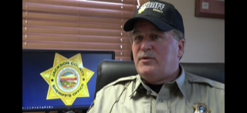The entire United States is plagued by another pandemic other than the coronavirus, and that is the illicit drug epidemic. Jackson County has been no stranger to this issue and has been plagued with it for many years. Methamphetamine currently is being supplied to Kansas and Jackson County by Mexican drug cartels. Methamphetamine is being smuggled across the U.S. border and distributed by drug mules to drug hub cities throughout the United States then to local communities. Methamphetamine is an extremely addictive drug that has caused significant destruction to the lives of many Americans, and continues to be related to crime throughout the nation. Methamphetamine is the most prevalent illicit drug in the Midwest, and is one of the biggest challenges for law enforcement in Jackson County. More common than ever now in the Midwest is heroin, a wicked and destructive drug to its victims.

**Sheriff’s Office Grant Projects**

During last year the Sheriff’s Office continued to utilize federal grant opportunities to strengthen and develop our overall efforts to protect and serve the residents of Jackson County. Since 2016, the Sheriff’s Office grant writer has received **$1,092,716.00** in grant funding for Jackson County. In 2020, the Sheriff’s Office applied for and received three grants explained in more detail below. The Kansas Governor’s Grants Program (KGGP) is assigned to administer these funds for the State of Kansas.

**The Federal Edward Byrne Memorial Justice Assistance Grant (JAG)**

These funds are available to the criminal justice system and partners to improve public safety and address crime. The Kansas Criminal Justice Coordinating Council (KCJCC) is responsible for overseeing these federal funds made available to Kansas through the U.S. Department of Justice.

In 2020, the Jackson County Sheriff’ Office applied for and received $142,542 in JAG funding in order to purchase a 3D crime scene scanner and upgrade our mobile computer terminals. This equipment has a significant impact on safety as well as the quality and effectiveness of our work. Mobile computers allow our patrol division to spend more time out in the community by reducing the need to return to the main office to complete paperwork. Mobile computers provide quick access to essential information while in the field improving safety for the public and law enforcement professionals. Crime scene diagrams are essential for everything from homicide cases to traffic accident reconstruction. Scanners offer countless benefits for law enforcement in terms of improving diagram accuracy, significantly decreasing the amount of time and staff required to diagram a scene and also provides cutting edge 3D visuals for jurors during case prosecutions.

**Federal Services*Training*Officers*Prosecutors Violence Against Women Formula Grant Program (S.T.O.P. VAWA)**

The S.T.O.P. VAWA funding seeks to support communities in their efforts to develop and strengthen effective law enforcement and prosecution strategies to combat violent crimes against women, strengthen victim services and promote a coordinated community response to victims of domestic violence, dating violence, sexual assault/rape, and stalking. This grant allows the Sheriff’s Office to staff a full-time detective position to specialize in investigating these violent crimes. This approach maximizes the quality and effectiveness of these type of investigations which are often time consuming, involve electronic data analysis and require trauma informed professionals. This project began in 2019 and the Sheriff’s Office has applied for and received $52,090 to continue this grant project in 2021.

**The Jackson County Sheriff’s Office grant writer has yielded $1,092,716.00 worth of grants for Jackson County**

**The Federal Victims of Crime Act (VOCA)**

This funding source was made possible by the Victims of Crime Act (VOCA) passed in 1984 which established the Crime Victims Fund. The purpose of this grant funding is to provide a response to the immediate needs of crime victims and provide ongoing assistance to help victims of crime understand and participate in the criminal justice system. The Jackson County Sheriff’s Office was awarded $82,388 for continued funding for our victim service division, Project A.C.T. (Addressing Crime Together). This project, which started in 2015, includes one full time and one part time staff in addition to a small group of volunteers. The mission of this project is to provide crime victims with access to immediate information, referrals, crisis services, ongoing criminal justice support as well as to strengthen and expand aid to crime victims in Jackson County. In 2020, the Victims of Crime Act funding allowed for 109 primary and secondary victims of crime in Jackson County to receive support services.

**Maintenance Division**

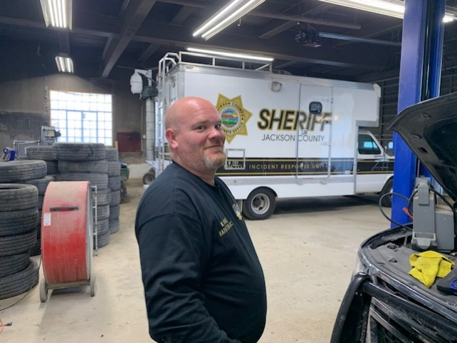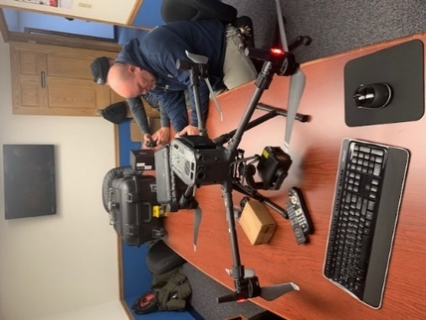The Maintenance Division of the Sheriff’s Office is under the leadership of Kendal Holt. He oversees the entire maintenance of the Sheriff’s Office facilities and Jail. The Jail generally houses close to 100 inmates every day which creates a vast amount of maintenance issues. Kendal Holt also oversees the Jackson County Sheriff’s Office Impound and Maintenance Facility. The facility is where the Sheriff’s Office vehicle fleet is maintained as well as where impounded vehicles are stored as well as being the receiving location for frozen goods for the Jail. Much of the maintenance that is done is preventive. Some of the preventive maintenance tasks are replacing rooftop filters, cleaning and inspecting all kitchen appliances, and ensuring all safety equipment is in working order. Many other smaller repairs have been made as well, these repairs include the clearing of clogged plumbing and toilets as needed. The Jail has an Icon plumbing system that allows the Jail to control all plumbing in the Jail. Maintenance is able to replace these parts and keep the plumbing system operational. In 2020, the Maintenance Division was very instrumental in assisting with the construction of the Covid-19 Isolation Unit. Some of the projects that have been completed in 2020 are the upgrade of the jail lobby ceiling tiles and remodeling of portions of Sheriff’s Office.

Kendal Holt working on one of the JASO drones.

Maintenance Supervisor Kendal Holt

Vehicle fleet maintenance is another large part of the Maintenance Division. The Maintenance Division is responsible for all aspects of these vehicles. Numerous oil changes, brake replacements, and tire replacements occurred in 2020. Maintenance also handles large repairs such as engine and transmission replacements. Maintenance has also been involved in some of the repairs to damaged patrol vehicles caused from deer.

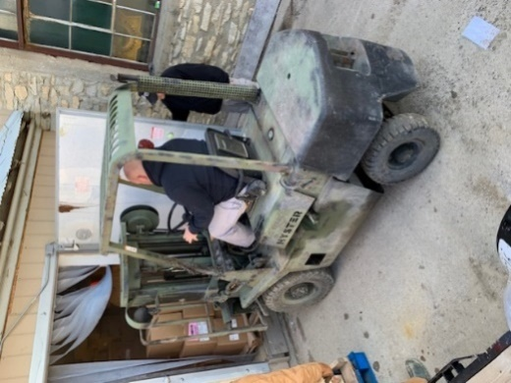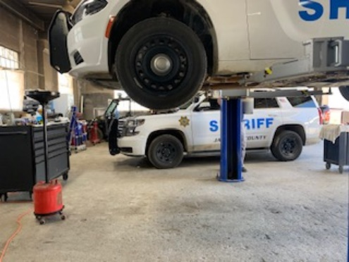The Sheriff’s Office routinely updates vehicles in the fleet and as that happens, the Maintenance Division often disassembles the emergency equipment from the old vehicles. As new vehicles are built, the Maintenance Division coordinates with the builders to supply parts and equipment needed and assist with construction. The Maintenance Division has worked closely with the deputies to address any and all needs/concerns they may have. In doing so the Maintenance Division has been able to repair the Watchguard camera systems in patrol vehicles as needed. Also Maintenance has been involved with the installation and service of communication equipment. The Jackson County Sheriff’s Office Maintenance Division is looking forward to the 2021 work year.

Kendal Holt loading food

Patrol Units receiving maintenance in the JASO Maintenance Facility

Kendal Holt also serves as one of the Sheriff’s Office drone pilots.

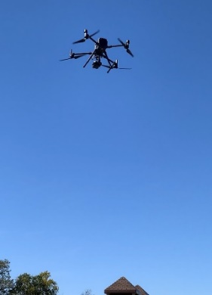

**Retirement of long-term law enforcement officer and administrator**

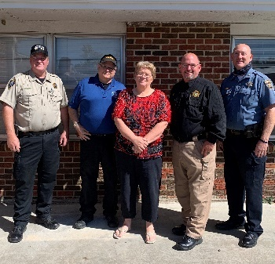In recent years, a number of really tremendous people who have had a major impact on our north east Kansas criminal justice system have retired. In 2019, long time Trooper and Deputy Gary Thiessen retired with 40 years of service to Jackson County and the State of Kansas. Also, in 2019, Jim Cyphers retired after serving the Second Judicial District which includes Jackson County for over 40 years. In 2020, a long time sheriff and leader in Kansas law enforcement retired. Osage County Sheriff Laurie Dunn retired after 39 years of service to her county. Sheriff Dunn started at the Osage County Sheriff’s Office at the very beginning of her work career soon after high school where she began as a dispatcher. Sheriff Dunn served in almost every capacity within the sheriff’s office before becoming sheriff. Sheriff Dunn also was very involved with the Kansas Sheriff’s Association where she served as Sergeant of Arms up until her retirement. Sheriff Dunn was a wealth of information and provided good advice to her fellow sheriffs. She was a good neighbor and partner with law enforcement agencies including Jackson County. Sheriff Morse was honored to be able to attend Sheriff Dunn’s reception along with Franklin County Sheriff Jeff Richards, Lyon County Sheriff Jeff Cope, and Wabaunsee County Sheriff Rob Hoskins. We all wished Sheriff Dunn a well-deserved and fantastic retirement.

Sheriffs Morse, Hoskins, Dunn, Cope and Richards

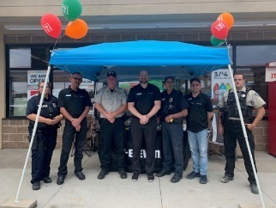**Acts of kindness from the people we serve**

Slurpee with a cop at Seven Eleven

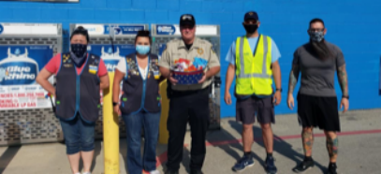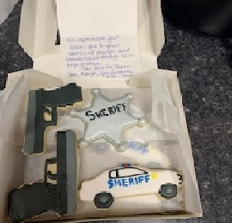This past year in no doubt has been one of the most difficult years for some time. Regardless of all the difficulties that 2020 provided, there was no lack of kind acts from the public towards law enforcement. It was not uncommon to have your lunch paid for by some anonymous source. Countless treats, masks and other items were brought to the sheriff’s office. Time and time again, businesses expressed their appreciation for law enforcement. All these gestures were all appreciated by the men and women of law enforcement. Each member of the Jackson County Sheriff’s Office is thankful for the support of our citizens. We are all proud and honored to be able to serve you.

Treat basket from Walmart

Cookies from a local business

**Hoping for a better New Year**

The year 2020, has been a horrific and tragic year for many of our citizens. Wonderful members of our community have lost their lives due to the coronavirus. Family members have been separated from loved ones in hospitals and nursing homes. Members of our community have suffered economically due to the slow down and some have lost their jobs. It is the hope of all the members of the Jackson County Sheriff’s Office that this year is a safe and healthy one for you and your family.