JACKSON COUNTY SHERIFF’S OFFICE 2019 ANNUAL REPORT

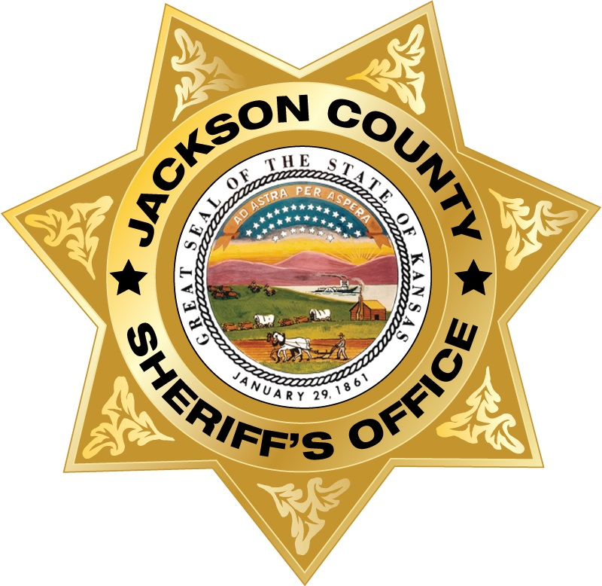

SUBMITTED BY TIM MORSE, SHERIFF
JACKSON COUNTY, KANSAS

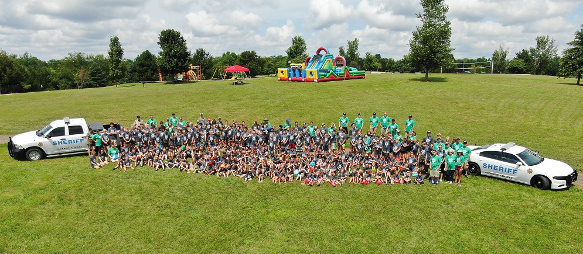
Jackson County Sheriff’s Daycamp 2019
Some may question why the Sheriff’s Office provides an end of the year report each year. The Sheriff is elected by the citizens of Jackson County. The Sheriff is the chief law enforcement officer of the county and answers to directly to the people. All county elected officials are separate, but equal branches of county government and are not subordinate to one another. However, each elected position has specific statutory functions that the others do not possess. When one branch is not functioning properly, it affects all the other branches of county government.
The citizens are the owners and the stockholders of the county government. Every chief executive of a corporation gives a yearly report on their organization. The mayor, governor and president do the same. It is important for the people to be informed where their resources are going and how they are being used to better their county.
This report always focuses on the work that the men and women of the Jackson County Sheriff’s Office is doing for the citizens of Jackson County, Kansas. This report will look at the various divisions of the sheriff’s office and the work completed for the year. It will also present statistical information involving the entire office. Sheriff Morse began reporting the accomplishments of the sheriff’s office after he took office. Few agencies provide this service, but many are following suit. This report will not only mention the successes, but will mention the challenges and struggles that a small county sheriff’s office has to deal with.
Each year Jackson County is challenged with providing the many services it is obligated to provide for its citizens. Jackson County, being a rural county with a small amount of industry, has the task of providing professional services, but doing so with the least possible cost. The Jackson County Sheriff’s Office mission is to protect and serve the community, and does so in a variety of ways.
Proactive approach
The Jackson County Sheriff’s Office uses a proactive approach in fighting crime. Criminals are active 24 hours a day, and seven days a week. Instead of waiting to receive reports of crime from victims, deputies attempt to interdict criminals before they create new victims in Jackson County. Over the years, there has been a reduction in many crimes in Jackson County. A good part of that reduction comes from proactive deputies intercepting criminals before they strike. Typically, deputies apprehend criminals during traffic stops for driving violations, warrants and drug arrests. These criminals are taken off the streets, preventing the opportunity for them to commit further crimes in Jackson County.
Professional law enforcement
The most valuable asset the Jackson County Sheriff’s Office has is the quality of its personnel. The Jackson County Sheriff’s Office has been fortunate in attracting competent and skilled law enforcement officers. While Jackson County does not have the greatest pay package when compared with many larger agencies, it provides a great working environment for the proactive law enforcement officer. Many prospective law enforcement officers have been attracted to the Jackson County Sheriff’s Office due to its proactive policing methods and with it, being one of the most positive law enforcement working environments in Kansas.
Modern policing methods
The sheriff’s office doesn’t just do things like they have always been done, but looks for new and innovative ways to do our job better. Deputies receive some of the best training available and are equipped with some of the best equipment possible within our budget to carry out their mission.
Technology
Along with using modern policing methods, the Jackson County Sheriff’s Office has used technology in solving crimes and catching criminals. In recent years, the sheriff’s office has been able to use various new types of technology and products to aid in the investigation of crimes and the detection of criminal activity.
Solid police work
Sheriff Morse believes deputies are not just report takers, but should be competent investigators as well. Not all cases can be solved, but most cases can be with a little work and effort. Deputies and investigators should do everything possible in solving even the smaller crimes. Solving these crimes can prevent much larger crimes. Many times in law enforcement cases fail to get filed due to inadequate investigations and shoddy police work. Jackson County Deputies are trained and are expected to conduct thorough investigations and forward prosecutable cases to the county attorney.
Strategic planning
Many agencies patrol their communities without a specific plan of action. In Jackson County, deputies are deployed in vital problem areas and communities for the purpose of locating would-be criminals and threats to the safety of citizens. Deputies are assigned to specific patrol zones and work out of substations. This reduces response times to calls and allows for increased patrol in rural areas. Overall, this strategy has been successful in lowering crime and making our county safer.
State of Kansas Crime Statistics
Every year the Kansas Bureau of Investigations publishes crime statistics for the entire state of Kansas. In those reports, there are three different indexes used to score the percentage of certain types of crimes per 1000 people. In Jackson County, there has been a significant decrease in crime overall. The statistics for 2019 will not be available until later in 2019. Therefore, the complete listing of statistics are available for 2018. The total Crime Index for the State of Kansas in 2018 is 31.4 per 1000 people. The Violent Crime Index for the State of Kansas is 4.2 per 1000 people. The Property Crime Index for the State of Kansas is 27.2 per 1000 people.
Crime Index Rate for Jackson County
Jackson County fairs very well when compared to the state average for crime. With the State of Kansas crime index at 31.4 per 1000 people, compared to Jackson County’s crime index at 18.5 per 1000 people, which is 41% less than the state. Jackson County crime index is slightly up from the previous year and the reason for that will be discussed later. When looking at crime statistics it is always important to look at the big picture. There can be fluctuations from year to year depending on a number of factors. It is always good to see how we compare to previous years and decades. In 2008, the Crime Index for Jackson County was 25.7 per 1000 people. Comparing 2008 with 2018, we see over a 28% decrease in the overall crime index for Jackson County. This is a positive number, which shows that progress is being made in reducing all types of crime in Jackson County. When comparing Jackson County’s crime index of 18.5 compared with the neighbor to the south, the City of Topeka with a crime index of 58.4 per 1000 people, one can see the difference. The total crime index for the City of Topeka is 58.4, which is over 3 times the Jackson County Sheriff’s reporting area, making Jackson County’s crime index 68% less than the City of Topeka’s reporting area.
Tactics that helps lower property crime
Unlike violent crime, property crimes are more easily deterred by a number of ways. In Jackson County, the increased law enforcement presence has been a tremendous factor in lowering property crimes. Deputies who have specific territories to patrol and substations to work out of, make them present in the communities where crimes occur. A proactive approach in looking for criminals, and not just taking theft reports, has added in lowering crime. Taking every report seriously and doing everything possible in solving even the smaller crimes helps in lowering property crime. Collaborating with the public through a variety of means such as the Jackson County Community Watch Program and other social media avenues has benefited in solving these crimes. In addition, surveillance cameras have also aided in acquiring the images of suspects and suspect vehicles. Together, all of these have contributed for reducing the Property Crime Index.
Property Crime Index
The Property Crime Index is primarily focused on thefts and burglaries. In 2018, the Property Crime Index for the State of Kansas was 27.2 per 1000 people while it was 14.8 per 1000 people in Jackson County. This means that our Property Crime Index is over 45% less than the State of Kansas’ average. Comparing 2018 with crime figures ten years ago in 2008, we see that the Property Crime Index was at 22.0 per 1000 people. This is nearly a 33% decrease in property crimes since 2008. In 2008, the sheriff’s office received 60 burglary reports and in 2018, only 26 burglaries were reported. This is over a 56% decrease in burglaries when comparing these two years that are a decade apart.
When comparing the crime index from 2017 to 2018 there is a slight increase. Most of this is due to the sheriff’s office fight on retail thefts. The crime index is based upon reports submitted to the Kansas Bureau of Investigations. The more crime reports submitted raises the numbers. In 2018, the Jackson County Sheriff’s Office began partnering with some of our area agencies by using our resources of staff and the Jackson County Community Watch Program and media/social media in the attempt to reduce retail thefts in Jackson County. Retail stores like Walmart have sophisticated surveillance cameras that many times catch the thieves on video while committing crimes. The sheriff’s office has been successful in identifying many of these suspects in just minutes. In the past, law enforcement would canvass neighborhoods in an attempt to gather witnesses of crimes. The new method of canvassing is through social media outlets. The sheriff’s office has been extremely successful in not only identifying criminals, but also locating them as well through these avenues. Many times the sheriff’s office tracks these criminals down in a short time, as well as recovering stolen property. Some of these crimes are minor shoplifting crimes and some are major felony cases involving forgery and identity theft. Some jurisdictions don’t take these crimes very seriously, although many times these suspects are also those that commit other types of crimes and burglaries. Some don’t see large corporations like Walmart as innocent victims. Regardless, if individuals will steal from Walmart who has a variety of security measures in place, they will steal in smaller stores that don’t have those types of security measures in place in this community.
The Sheriff’s Office notes that most of these retail thieves are not residents of Jackson County. A majority of thieves come from the Topeka area and from other surrounding communities. It is very rare after these thieves are apprehended and prosecuted to see them return to Jackson County. These cases have caused the increase in the overall crime index and property crime index for the sheriff’s reporting area. However, a majority of these cases are being solved. The sheriff’s office is seeing over a 90% solvability rating for these types of cases. This is significant, because these investigations and apprehensions will help reduce further crime in the county. It is better to catch a criminal stealing at a retail store than have to investigate the burglary of someone’s home. We fully expect to see an increase in the 2019 statistics due to working these retail crimes. Already, in 2019 the sheriff’s office has been involved with 120 of these cases with over 90% of those cases being solved. There is a zero tolerance for thieves in Jackson County. Sheriff Morse is excited about this project and believes these partnerships will grow, and aid in the reduction in property crimes throughout Jackson County.
Statistics
Statistics don’t always tell the whole story. Statistics are based upon activity that is reported. The more an agency does by seeking out criminals and catching them on unrelated crimes drives the crime index up. More arrests will raise the index, but also takes offenders out of the community, which will eventually reduce crime. An agency can simply take a theft report and fail to investigate the theft. The statistic will show there was a theft crime. The suspect may continue to commit more crimes and will eventually increase the statistics. Another agency will investigate the case and capture the suspect taking him or her off the street. The suspect may go to jail or prison, or return where they came from. Once criminals learn that a particular community is tough on crime, they will go to a community where there is less pressure on them, which will lower the local crime index.
Violent Crime Index
The Violent Crime Index for the State of Kansas is 4.2 per 1000 people compared with a violent crime rate of 3.8 per 1000 people. This is a slight increase from 2008 when the violent crime rate was 3.7 per 1000 people. The main reason for this is there was a homicide in 2018 in Jackson County as well a number of rape cases. In 2017, the Violent Crime Index for the Sheriff’s Reporting area was at 2.4 per 1000 people.
Arrests
Part of reducing crime and keeping the crime indexes low is through apprehending and arresting criminal offenders. The Jackson County Sheriff’s Office has been proactive in apprehending criminals, thus reducing the number of offenders on the streets. Arrests can take offenders off the streets, which can prevent future offenses from occurring. Even if the offender remains free and on probation, the offender may go to another community, where there is less pressure on criminal activity to prevent being re-arrested. In 2018, the Jackson County Sheriff’s Office made more adult arrests than any of the six surrounding county agencies including Shawnee County. Jackson County Sheriff’s Office made 715 adult arrests in 2018.
Second Judicial District Activity
When comparing Jackson County District Court with the other courts in the Second District, Jackson County leads in a number of areas. Jackson County leads all four counties in the number of felony cases that were filed in 2019. Jackson County filed 328 cases compared with Jefferson 112, Pottawatomie 169 and Wabaunsee at 45. Jackson County followed Pottawatomie County in the number of misdemeanor cases. Pottawatomie County 169, Jackson County 187, Jefferson County 158 and Wabaunsee at 46. Jackson County also leads in the number of search warrants and inquisitions filed. The Jackson County Sheriff’s Office recorded filing 195 search warrants in 2019, while court records show Jefferson at 12, Pottawatomie at 80 and Wabaunsee at 28. Jackson County also leads by a high margin in driving under the influence and driving while suspended cases.
Body of missing man found in Jackson County
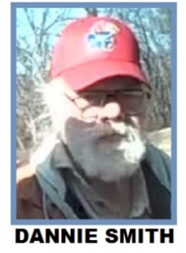
Jackson County deputies and investigators responded to a low maintenance road in southern Jackson County after receiving a report of a deceased person. At approximately 1:20 pm January 9th, the Jackson County Sheriff’s Office received a report of a dead body ½ mile north of the Shawnee County line on P.4 Road and 1 1/2 mile west of US Hwy 75. P.4 Road is a low maintenance road and is impassable during wet weather. Authorities arrived on scene and found a blue Silverado Chevy pickup truck, which was stuck in the mud, and a deceased person including a chocolate Labrador Retriever nearby. The deceased person has been identified as Dannie Smith, 70, of Topeka who was reported missing to the Topeka Police Department on January 6th. However, Mr. Smith had not been seen since Friday January 4th. Mr. Smith was known to travel to the reservation in Jackson County to purchase cigarettes. Mr. Smith’s dog, a Labrador was found in good health at Mr. Smith’s side. The body was transported to Frontier Forensics in Kansas City, Kansas for autopsy.
Three arrested on burglary charges
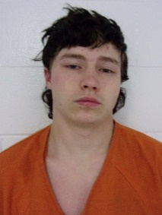
On January 20th, the Jackson County Sheriff’s Office arrested three individuals believed to be involved in recent burglaries to a local establishment. Two men and a juvenile were arrested that afternoon following an early morning burglary to the Muleskinner Lodge in Denison. The lodge in recent years had been operated as a bed and breakfast facility. Trevor James Hurteau, 18, and Christopher Lee McGee, 18, and a 15-year-old male, all of Denison were arrested on burglary, theft, criminal damage to property and trespassing charges. The trio allegedly broke into the lodge after 1:30 am Sunday morning and removed property from the premises. Hurteau and the 15-year-old male juvenile allegedly committed two additional burglaries, thefts, trespassed and damaged property at the same location between November to mid-December of 2018. Jackson County Sheriff’s Deputies served a search warrant at a residence in Denison where the trio had been living. Deputies seized property believed to have been taken in the three burglaries. Hurteau and McGee were held in the Jackson County Jail Division. The juvenile was held in a juvenile detention facility.
Injury accident on US Hwy 75
On January 20, the Jackson County Sheriff’s Office received a report of an injury accident at 190th and US 75 Hwy. Initial indications show that an eastbound 2009 Lexus was crossing US Hwy 75 at 190th Road from the entrance of the One Stop convenience store. A northbound Ford F-250 pickup truck struck the passenger’s side of the Lexus. The two occupants of the Ford F-250, both from Sanborn, Iowa refused medical treatment. The driver of the Lexus, June Rockey, of Topeka was transported to Stormont Vail Regional Medical Center by Jackson County EMS where she died from her injuries.
The intersection has been a site for many injury accidents throughout the years, including a fatal accident that occurred there on June 27, 2018.
The Jackson County Sheriff’s Office, Potawatomi Tribal Police, Kansas Highway Patrol, Mayetta, Hoyt, Holton, PBPN Fire Departments along with Jackson County EMS responded to the scene.
Sheriff’s office awarded new grants
In late January, the Kansas Criminal Justice Coordinating Council (KCJCC) announced the Jackson County Sheriff’s Office was awarded $70,623 from the Federal Edward Byrne Memorial Justice Assistant Grant (JAG). The Sheriff’s Office used these funds to replace outdated camera equipment and acquire essential protective gear for deputies and detectives addressing high-risk situations. These grant funds are administered by the Kansas Governor’s Grants Program.
The Jackson County Sheriff’s Office was awarded $49,214 in grant funds from the Federal S.T.O.P. Violence Against Women Act. This grant will be utilized to develop a detective position to specialize in the areas of sexual and domestic violence, teen dating violence and stalking. This position will serve to further develop our Investigations Division by skill development and easing heavy caseloads on the division overall. These grant funds are administered by the Kansas Governor’s Grants Program.
Injury accident on U.S. Hwy 75 near Hoyt
On February 11th, the Jackson County Sheriff’s Office received a report of an injury accident on US Hwy 75 south of 126th Road near Hoyt at approximately 6:15 pm. A northbound Chrysler passenger car was reported to have struck a mattress in the roadway causing the vehicle to cross the median and both southbound lanes of US Hwy 75, and severed a telephone pole on the west side of the highway, causing power to be lost in southern Jackson County. The driver, Rebecca Gilchrist, 19, of Onaga, front seat passenger, Michelle Hosler, 21, of Topeka and rear passenger, Vernon Tyrell, of 32, of Topeka were all transported by EMS to a Topeka hospital with non-life-threatening injuries. Southbound traffic was reduced to one lane until about 7:30 pm. The Hoyt, Mayetta and PBPN Fire Departments, KHP, Jackson County EMS responded to the scene along with the Jackson County Sheriff’s Office.
Officer involved shooting investigation course
On February 25th, the Jackson County Sheriff’s Office hosted an Officer Involved Shooting Investigation training class in Holton last week. Agencies from across Kansas and Missouri attended the three day training event. The class was provided by Code 4 Consultants of Salt Lake City, Utah. The class focused on techniques used when investigating cases that involve law enforcement officers involved in critical incidents and shootings. Sheriff Morse stated, “It is unfortunate that we have to deal with situations such as these, however, it is important for agencies to be prepared for these types of crises and have a plan in place on how these matters are going to be thoroughly investigated.” When an officer involved shooting takes place, the agency administrator is tasked with seeing that the matter is administratively and criminally investigated.
Western Kansas fugitive captured in Denison
On Friday March 1st, Jackson County deputies apprehended a fugitive that was wanted in multiple counties. Registered sex offender, Eric Paul Shoemaker, 43, of Great Bend, Kansas was arrested at a Denison residence after the Jackson County Sheriff’s Office received information that he was in the Denison area. Deputies approached a residence where Shoemaker was seen. Shoemaker refused initially to come to the door. Deputies who
communicated with the suspect at length were able to convince him to surrender peacefully. Shoemaker who had outstanding warrants in Barton, Pawnee, and Ford counties for failing to register as a sex offender, probation violations, and failing to appear on a domestic battery charge. Shoemaker was held in the Jackson County Jail without bond.

Trio arrested during Walmart incident
On March 8th, three people were arrested at the Holton Walmart. The Holton Police Department and the Jackson County Sheriff’s Office jointly investigated a suspicious theft, which resulted in drug arrests as well. Both agencies were requested to the store for suspicious activity. Crystal Marie Hisaw, 35, of Topeka was arrested for possession of heroin with intent to distribute, possession of methamphetamine, possession of drug paraphernalia, and criminal trespass. Robert E. Love Jr. 40, of Topeka was arrested of possession of methamphetamine, possession of drug paraphernalia, and theft. Jason Michael Moser, 40, of Topeka was arrested for driving while suspended.
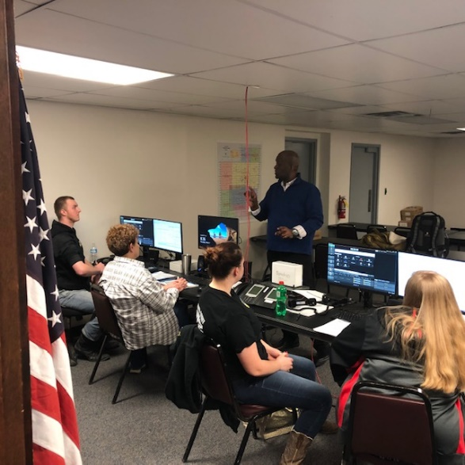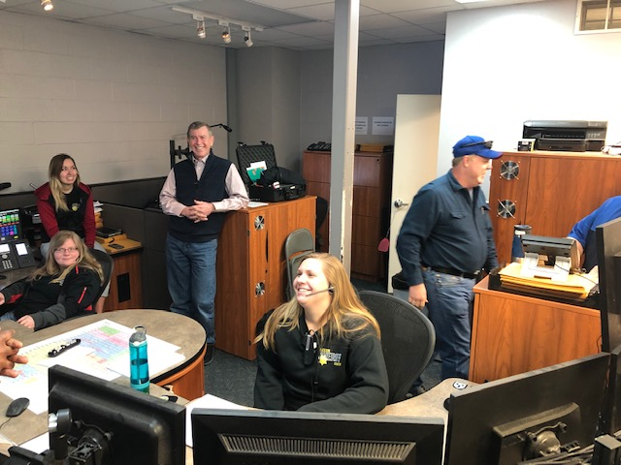
Some of Jackson County Sheriff’s Office Dispatchers training on the new 911 system last week. Jackson County Sheriff dispatchers, administrators from the 911 Coordinating Council and AT&T were present when the new system went live on Tuesday.
New 911 system for Jackson County
On Tuesday, March 12, 2019, Jackson County became the 91st Public Safety Answering Point (PSAP) to join the statewide Next Generation 9-1-1 system. Kansas has a total of 117 PSAPs. AT&T installed the new system over the few weeks and provided the training for sheriff’s office dispatchers. A new feature with this new system is Simple Message Service Text-to-911. Sheriff dispatchers can not only receive 911 phone calls, but now can receive emergency text messages. Dispatchers will be able to text back through the new system to the caller. Incidents where someone may be in danger and does not want the suspect to know they are calling for help, can text for help.
By joining the 911 Coordinating Council’s statewide NG911 system, Jackson County no longer is required to host an in-house 911 system and isn’t required to plan for future 911 updates. The state has 2 different host sites for their 911 system. One in Wichita and the other in Topeka. If Jackson County were to experience an outage or disaster, dispatchers could go to another PSAP in another county and still be able to answer 911 calls for Jackson County. Typically, 911 systems need to be replaced every 5-6 years. These projects can cost a couple hundred thousand dollars or more each time. The 911 Coordinating Council’s system will be upgraded over time and maintained by the council.
This new system provides an upgrade to the Center’s 911 mapping system. Counties receive better mapping for the entire state, rather than just the their own counties. This is important when crimes or emergencies that are in progress and cross county lines. The annual cost for the new system is approximately $39,000.00 and will be paid for out of the 911 taxes collected from cell phones and landlines in the county. Some counties have elected to continue to host their own system or join other systems, however, a majority of counties have joined the state-wide system. Jackson County went live with their first 9-1-1 system on August 3, 1993. This is the sixth system upgrade for Jackson County. The Jackson County Sheriff’s Office 911 Center is the central answering point for all 911 calls in Jackson County.
Former Banner Lake Director arrested
Jackson County Sheriff deputies arrested John D. Kennedy, 63, of Hoyt, on March 28th on a Jackson County District Court Warrant for burglary and theft. On February 11, 2019, deputies served a no trespass warning to Kennedy issued by the Jackson County Board of Commissioners. The trespass warning pertained to the former work place for Kennedy as the director of Banner Lake Reservoir. The order prohibited Kennedy from trespassing at his former office and shop space located at Banner Reservoir. The order also instructed Kennedy to return all county owned property, keys and a county credit card. All county property was to be returned to the county by February 15, 2019.
On February 18, 2019, the sheriff’s office was contacted in reference to a possible unauthorized entry to the shop at Banner Reservoir. Deputies collected evidence of a possible burglary to the facility. Investigators determined county property was missing from the shop. The investigation led investigators to obtain a search warrant for Kennedy’s residence located in southeastern Jackson County on February 20, 2019. Jackson County deputies and investigators seized property and tools belonging to Jackson County. The investigation alleged Kennedy not only possessed county property illegally at his residence, but that Kennedy entered the shop with a key on February 18, 2019 and stole fuel from the shop. It was also alleged that Kennedy stole cash from the office on a previous incident.
Kennedy was arrested and booked into the Jackson County Jail on burglary and theft charges. Bond on Kennedy was set at $1,500.00.

TWO ARRESTED ON BURGLARY CHARGES
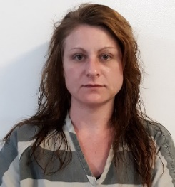
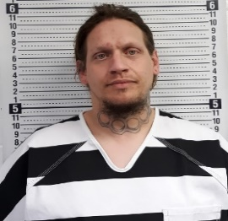
On March 30th, the Jackson County Sheriff’s Office received a report of a suspicious vehicle parked behind a residence in the 13000 block of S. Road near Hoyt. Jackson County Deputies and the Hoyt Police Department responded to the area after 8 pm. Deputies discovered that forced entry was made to the property. Law enforcement stopped the white Saturn passenger car east of T. Road on 126th Road. The occupants of the vehicle, Rachel Leeann Johnson, 34, of Wellsville, Kansas and Bradley Steven Cowling, 36, of Carbondale, Kansas were arrested at the scene. The duo were alleged to be in possession of property that came from the residence at the time of their arrest.
Cowling was booked into the Jackson County Jail for burglary, theft, felony interference with law enforcement, and criminal use of weapons. Cowling also had outstanding warrants for his arrest from other Kansas jurisdictions. Johnson was booked into the Jackson County Jail for burglary and theft.
Topeka man arrested following pursuit
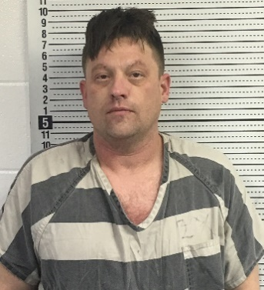
A Topeka man was arrested Tuesday afternoon following a pursuit that originated in Jackson County. A Jackson County deputy attempted to stop a red 2007 Yamaha motorcycle that was allegedly driving erratic and speeding near 102nd and US Hwy 75 in southern Jackson County before 2:30 pm. The motorcyclist continued south into Shawnee County and led law enforcement on a pursuit through northern Shawnee County and into north Topeka. Kansas Highway Patrol Troopers also assisted with the pursuit. Law enforcement was able to stop the pursuit while a KHP air unit pursued the motorcyclist by air. The motorcycle was followed to the 1700 block of NW Taylor where the rider allegedly hid the motorcycle and left on foot. KHP Troopers, Shawnee County Deputies and the Topeka Police Department assisted with the apprehension of the rider. The rider, Austin L. Terry, 35, of Topeka, was arrested by Jackson County deputies. Terry was transported to the Jackson County Jail in Holton where he is facing charges of: Flee and eluding law enforcement, reckless driving, possession of methamphetamine, possession of drug paraphernalia, driving while suspended, no proof of insurance and no registration.

Mayetta man arrested on child exploitation charges
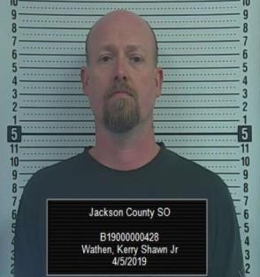
A Mayetta man was arrested April 5th, on a Jackson County District warrant. The warrant was issued stemming from an investigation by the Jackson County Sheriff’s Office into allegations that Kerry Shawn Wathen Jr., 52, of Mayetta had unlawfully video recorded victims in a restroom on multiple occasions. Previously on November 1, 2018, Jackson County Sheriff’s deputies and investigators served search warrants on two Jackson County residences, including Wathen’s home east of Mayetta. Computers, and other electronic items were seized during the search. Wathen was charged with two counts of sexual exploitation of a child and four counts of breach of privacy. Bond was set on Wathen at $10,000.00.
Deputy escapes serious injury while investigating a car deer accident on 75 Hwy
A Jackson County deputy was investigating a non-injury accident on US Hwy 75 north of 278th Road in northern Jackson County Saturday April 7th, where he escaped serious injury when he was struck by a vehicle. The deputy was investigating an accident involving a deer and a 1997 Toyota Corolla passenger car when a southbound 2015 Ford F-150 pickup truck failed to properly yield to emergency personnel, and struck the deputy. The vehicle’s mirror struck the left arm of the deputy. The injury to the deputy appeared to be minor at the time of the incident, however, this situation presents a good time to remind motorists to drive with due regard to the safety of our highway workers and public safety personnel. Unfortunately, there are a significant number of highway workers and emergency responders severely injured or killed each year across the United States. Kansas law requires motorists on a two-lane highway to slow down, drive with due caution at a safe speed for the road, weather and traffic conditions. On a highway with four-lanes or more, motorists are to “proceed with due caution and, if possible and with due regard to the road, weather and traffic conditions, shall change lanes into a lane that is not adjacent to that of the stationary authorized emergency vehicle.” It is important for each of us to be attentive to hazards on the roadway when we operate motor vehicles. Fortunately, this incident did not result in tragedy, and the deputy was able to complete the investigation of the first accident prior to being evaluated by medical staff. A citation was issued to the driver for failing to yield to emergency personnel. The fine for failing to yield to emergency vehicles is $303.00 including court costs.
KSA 8-1530. Duty of driver upon approach of authorized emergency vehicle. (a) Upon the immediate approach of an authorized emergency vehicle making use of an audible signal meeting the requirements of subsection (d) of K.S.A. 8-1738, and amendments thereto, and visual signals meeting the requirements of K.S.A. 8-1720, and amendments thereto, or of a police vehicle properly and lawfully making use of an audible signal only, the driver of every other vehicle shall do the following unless otherwise directed by a police officer:
(1) Yield the right-of-way;

Two injured from accident with tractor
On April 19th, the Jackson County Sheriff’s Office received a report of an accident involving a mini-van and a tractor pulling a farm implement shortly before 10:30 pm. The incident occurred east of B. Road on K-16 Highway, a little more than a mile from the Pottawatomie County line. A westbound 2005 Town and Country Chrysler mini-van struck a farm tractor that was pulling a westbound farm implement in the rear. Three individuals occupied the van. The driver and front seat passenger, both Corning residents, sustained injuries. Both subjects were transported to Stormont Vail Medical Center. Life Star Air Ambulance flew the driver with life threatening injuries and the front seat passenger was transported by Jackson County EMS.
The Soldier and Holton Fire Departments, Jackson County EMS responded to the incident. The Jackson County Sheriff’s Office investigated the incident.
Man arrested in stolen vehicle
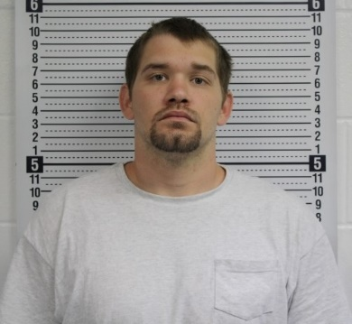
On May 27th at approximately 8 am, the Jackson County Sheriff’s Office received a report of a truck in a residential driveway in the area of 118th and U.4 Road near Hoyt with a man sleeping inside. Deputies made contact with the subject and identified him as Dylan Wayne Massey, 28, of Topeka. The truck that Massey occupied had been reported stolen out of Wabaunsee County near Eskridge. Massey was placed under arrest and was booked into the Jackson County Jail for felony theft.
TOPEKA MAN ARRESTED ON BURGLARY AND STALKING CHARGES
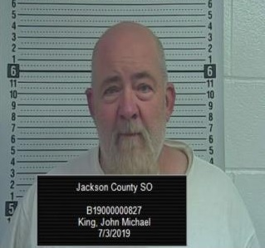
On October 18th the Jackson County Sheriff’s Office arrested John Michael King, 59, of Topeka on in reference to a burglary investigation. King was booked into the Jackson County Jail for aggravated burglary, stalking and criminal trespass that was believed to have occurred on Wednesday morning July 3rd. The incident was believed to have stemmed from a domestic situation. The Jackson County Sheriff’s Office is also investigated an additional burglary and criminal damage to the same residence, believed to have occurred on July 2nd. Bond was set on King at $35,000.00.
DENISON WOMAN INJURED FOLLOWING UTV ACCIDENT
In July, the Jackson County Sheriff’s Office received a 911 call reporting an accident involving a UTV. The Holton Fire Department, Jackson County EMS, Kansas Highway Patrol and the Jackson County Sheriff’s Office responded to the scene located approximately ¾ mile south of 222nd on U. Road. The victim, a Denison woman was reported to have been driving southbound on U. Road prior to the incident, in a Polaris utility vehicle. The victim had approached a low water crossing where some children were fishing. It was reported that the victim’s dog had exited the UTV, and the victim then exited the vehicle to retrieve her dog. At that time, the UTV then started to roll and the victim attempted to stop the vehicle, when it went off the concrete crossing and into the water trapping the victim beneath the UTV in the water. The children tried to free her from beneath the UTV, and with the help of some area neighbors, she was removed from the water. Lifestar Air Ambulance landed near the scene and the victim was flown to Stormont Vail Regional Medical Center with life threatening injuries.

18TH ANNUAL JACKSON COUNTY SHERIFF’S DAYCAMP

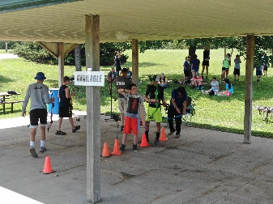
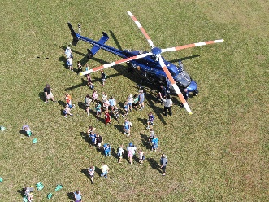
In 2019, the Jackson County Sheriff’s Office again hosted the 18th annual Sheriff’s Day Camp. 240 kids attended the camp. The Sheriff’s Day Camp has been successful in building strong bonds and lasting relationships between the law enforcement community and the youths of our county. Day Camp provides a positive encounter with kids and cops. Unfortunately, kids sometimes encounter law enforcement during difficult times too often. Day Camp has been extremely beneficial to allow kids to see law enforcement as real people who are concerned about their safety.

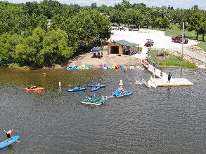
The 18th annual Jackson County Sheriff’s Office Day Camp was held at Banner Lake Reservoir near Holton on August 8th and 9th. The Sheriff’s Day Camp featured the following events and activities: an emergency vehicle demonstration and display, including fire trucks, ambulance, law enforcement vehicles, and an armored swat truck. Emergency responders demonstrated their equipment and techniques. A Kansas Highway Patrol helicopter landing and demonstration was provided. Kids also were able to participate in archery, swimming, canoeing, paddle boats, fishing, hay rack ride, Nuclear Meltdown, Adrenaline Rush Obstacle, Slip N’ Slide, and High Voltage Obstacle Course, A demonstration at the Banner Creek Observatory and Science Center and a program by the Department of Wildlife, Parks and Tourism animal and fishing program were provided.

Numerous volunteers including some elected and local governmental officials assisted with the camp including:

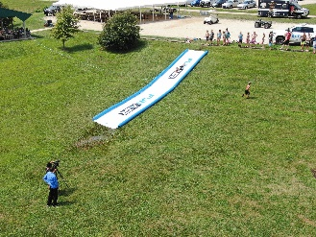
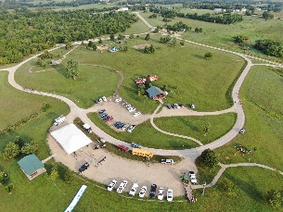
The Jackson County Commissioners, Banner Reservoir, Jackson County EMS, Kansas Department of Wildlife Parks and Tourism, Kansas Highway Patrol, Shawnee County Sheriff’s Office Swat Team, Potawatomi Tribal Fire Department, City of Holton, Holton Police Department, Holton Fire Department, Banner Creek Observatory and Science Center, Honey Do’s Septic Tank and Drain, Walmart, Roush and Son’s Towing and Recovery, LLC, Circleville Christian Church, Jackson County Democrats, City of Onaga Swimming Pool, Shawnee County Parks and Recreation, Bikers Against Child Abuse, many more volunteers and the men and women of the Jackson County Sheriff’s Office assisted with or sponsored the event. We would also like to thank the Banner Creek LLC./Johnsonville for preparing lunch for our campers on that Wednesday and all the volunteers and supporters.

The sheriff’s office provided an announcement for the 2020 event. The 2020 or 19th Annual Sheriff’s Day Camp will be held August 6th and 7th at Banner Creek Reservoir. Volunteers are always needed, and please contact the sheriff’s office if you are interested in helping next year. Registration forms can be found on the Jackson County Sheriff’s Office website at www.jasoks.org and they are available at the Jackson County Sheriff’s Office located at 210 US Hwy 75, Holton, Kansas, or for more information call 785-364-2251.

Horses from 2018 animal cruelty case have been placed

Some 42 horses that were seized in a 2018 Jackson County animal cruelty case have been placed into new homes. Sheriff Tim Morse is pleased to announce that all 42 horses have been placed into homes across the State of Kansas on Saturday August 17th, during a placement event in Holton.

Sheriff Morse is grateful for the assistance from K-HEART, its member equine rescues, Rainbow Meadows, Shooting Star and Hope in the Valley, their volunteers, and the Holton Livestock Exchange, Inc. for their support in this effort. The Jackson County Sheriff’s Office had received numerous applications across the State of Kansas. K-Heart processed the applications, inspected applicant facilities and approved new homes for placement.

The Jackson County Sheriff’s Office is very appreciative of the assistance it received from numerous members of this community during the initial investigation as well as the seizure of the horses. Knowing that these animals will be well cared for into their future was the goal of this placement activity and Sheriff Morse is confident that the goal was met.

Suspicious fire investigated in Denison

On August 25th, the Jackson County Sheriff’s Office received a 911 call concerning a house fire at 301 Highland Street in the City of Denison in eastern Jackson County. The Holton Fire Department and the Jackson County Sheriff’s Office responded to the scene. The fire department was able to extinguish the fire. The residence was not occupied at the time of the fire and no injuries occurred during this incident. The Jackson County Sheriff’s Office and the Kansas State Fire Marshal’s Office investigated the incident.

JACKSON COUNTY SHERIFF’S OFFICE AWARDED GRANT

The Jackson County Sheriff’s Office received notification from the Kansas Criminal Justice Coordinating Council on Monday that Jackson County has been awarded $129,399.00 through the Federal Edward J. Byrne Memorial Justice Assistance Grant Program. The grant monies are designated for updating mobile and portable radios for deputies. The radio equipment used by deputies was in need of being updated due to age. It is important for deputies to have reliable radio communications equipment to be able to better serve the community and to keep deputies safe.

HORTON MAN ARRESTED IN STOLEN VEHICLE
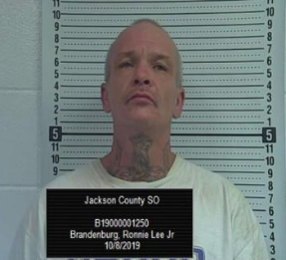
A Horton man was arrested Tuesday evening following a traffic stop by a Jackson County Sheriff’s Office deputy south of Mayetta on US Hwy 75. The deputy discovered that the 1990 Lexus had been reported stolen out of Topeka. The driver, Ronnie Lee Brandenburg Jr. 48, of Horton was arrested for felony possession of stolen property and driving while suspended.
MAYETTA CAPTURED FOLLOWING MORNING PURSUIT
In October, a rural Mayetta man was arrested following a vehicle pursuit in southern Jackson County. A Jackson County Deputy observed a pickup truck near 150th and P. Road shortly before 8:30. The deputy observed alleged traffic violations with the blue 1993 Ford F-250. A pursuit ensued near 142nd and Q. Road in Jackson County and continued east into Jefferson County. The Kansas Highway Patrol helicopter assisted with the pursuit. The vehicle then headed southbound on Meriden Road where a Jefferson County Deputy deployed stop sticks at 102nd and Meriden Road. The suspect vehicle turned west toward Jackson County on 90th Road and became disabled when the front driver’s side tire separated from the wheel. Jefferson County Deputies apprehended the suspect approximately ¼ mile north of 90th Road on Christie Road. The suspect was transported to the Jackson County Jail and identified as Lane Michael Simpson, 23, of Mayetta. Simpson was booked into the Jackson County Jail on the following charges: Felony flee and eluding a law enforcement officer, driving while suspending, reckless driving, operating a vehicle without an interlock device. Simpson also had outstanding warrants from Atchison and Douglas Counties and the City of Topeka. The Ozawkie Police Department also assisted with the incident.
Pursuit leads to crash in Atchison County
In November, a Jackson County Sheriff’s deputy attempted to stop a 2004 Saturn Ion passenger car in the area of 254th Rd. and US Highway 75 at approximately 5 am for traffic infractions. The vehicle failed to yield to the deputy and fled eastbound on 254th Rd. to W Road. The vehicle continued north on W Road to K-9 Hwy then east through the city of Whiting and east into Atchison County. The vehicle failed to negotiate the curves at 159 Highway and continued east off the roadway overturning. Both occupants sustained injuries and were transported to area hospitals for evaluation by Horton and Atchison County EMS. The Kansas Highway Patrol investigated the accident. The driver of the vehicle was identified as Robert Neal Kirk, Jr., 56, of Topeka, formerly of Mayetta. The passenger was identified as Ronald Snowberger, 49, of Saint George, Kansas.

Two arrested in connection with stolen vehicle
In November, two people were in custody following a joint-investigation by the Holton Police Department and the Jackson County Sheriff’s Office.
Holton Police and Jackson County Sheriff’s Office arrived at O’Reilly Auto Parts at 204 US Hwy 75 in Holton on Saturday shortly after 3 pm in reference to a report of a possible stolen vehicle. Law enforcement determined that the 2004 Pontiac Vibe passenger car had been reported stolen out of Rossville, Kansas.
Two subjects believed to be associated with the vehicle, Theresa Michelle Fitzgibbons Miller, 34, of Auburn were booked into the Jackson County Jail for possession of methamphetamine, possession of drug paraphernalia, and Brad A. Emmerson, 52, of Topeka was booked into the Jail for felony possession of stolen property.

MAIL THIEVES IN SOUTHEASTERN JACKSON COUNY

In November, the Jackson County Sheriff’s Office received a report of a subject stealing mail from mailboxes in southeastern Jackson County along the Shawnee County line. One victim/witness observed the suspect driving a dark blue or black extended cab Dodge pickup truck. The vehicle was last seen heading south on Rochester Road into Shawnee County from 94th Road. Another witness stated the vehicle could have been a Ford truck. The Sheriff’s Office requested that anyone who suspects their mail to have been stolen to contact the Sheriff’s Office. In addition, the Sheriff’s Office has asked for those who have video surveillance to check it for any additional suspect and vehicle descriptions.

ONE IN CUSTODY FOLLOWING PURSUIT WITH STOLEN VEHICLE
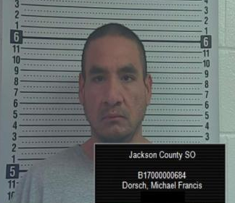
In November, one man was in custody in the Jackson County Jail stemming from two pursuits in two counties. The Jackson County Sheriff’s Office was notified that the Shawnee County Sheriff’s Office had terminated a pursuit near 86th and Topeka Blvd. It was indicated that the suspect(s) were allegedly involved in vehicle burglaries in Shawnee County. Shortly thereafter, a Shawnee County deputy observed the suspect vehicle northbound on S. Road from the county line in Jackson County. A Jackson County Sheriff’s deputy located the vehicle wrecked, but still running in the ditch just north of 102nd and S. Road with no one in the immediate area. The vehicle, a 2002 Toyota Camry, had been reported stolen out of Silver Lake, Kansas. While deputies were on scene, a dark colored 2017 Volkswagen passenger car approached the scene. Deputies believed the vehicle was in the area to pick up the driver of the Camry. A pursuit ensued westbound on 102nd Road. The vehicle allegedly failed to stop at stop signs at US Hwy 75 and continued westbound. The suspect vehicle headed north on P.4 Road and lost control due to excessive speeds and icy conditions and rolled over. Two passengers in the vehicle were evaluated at area hospitals. It was determined the 2017 Volkswagen had been reported stolen out of Lawrence, and the tag on the vehicle was stolen from a residence in Shawnee County. The driver, Michael Francis Dorsch, 34, of Horton was arrested. Dorsch was booked into the Jackson County Jail on a series of charges: Felony possession of stolen property, possession of stolen property, possession of methamphetamine and marijuana, possession of drug paraphernalia, driving while suspended, interference with law enforcement, 2 counts of aggravated battery and fleeing and eluding a law enforcement officer. Dorsch is known to Jackson County law enforcement from a variety of pursuits and manhunts throughout the years.
Undersheriff Darrel Chapman attends Homeland Security Leadership Academy
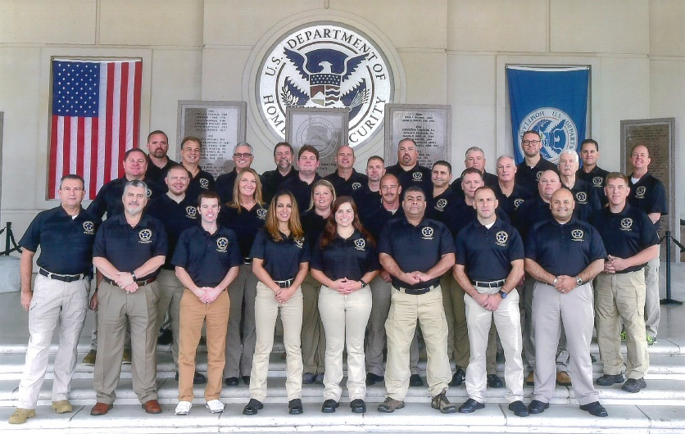
Undersheriff Darrel Chapman attended Department of Homeland Security Leadership Academy Session 8 in November. The training was provided by the Department of Homeland Security, the Federal Law Enforcement Training Center (FLETC) and the National Sheriff’s Association.
The Department of Homeland Security Leadership Academy Session 8 was a two week training course attended by 30 administrative level law enforcement officials from across the country. The Leadership Academy was held at the FLETC Training Center in Glynn County Georgia. The training covered a wide variety of critical events, focusing on core concepts of communication, collaboration, critical thinking and decision making that are applicable in virtually any situation. The leadership in crisis training creates an environment that challenges the participants’ ability to apply leadership, interpersonal and decision making skills in a critical situation. The FLETC Leadership Academy covered several other topics including Resilience in Law Enforcement, Cultural Wellness, Legal Issues in the Use of Force, Principles for Exemplary Leadership, and several de-brief sessions on active shooting incidents.
Undersheriff Chapman said, “This was the best training I have been to in many years, and probably during my entire career. The leadership in crisis training was challenging and presented a wide variety of issues and problem solving ideas.”

BODY OF BRIAN WOOD FOUND DURING SEARCH
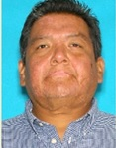
On November 24th the Jackson County Sheriff’s Office assisted with a search party for a missing person on Sunday. Brian K. Wood, 51, of Netawaka had last been seen on November 16th near 266th and US Hwy 75. Several searches of the immediate area and surrounding wooded areas were conducted, along with other attempts to find Wood’s whereabouts. On November 21st, the sheriff’s office requested the assistance from the public in locating Wood. Wood had been suffering from a severe leg infection and was believed to be disoriented.
On Sunday, friends, family members, neighbors and emergency personnel began a search party north of 266th on US Hwy 75. Searchers found clothing on the west side of the highway approximately 1 mile north of 266th Road. A body was found inside a large culvert that runs underneath 75 Hwy. The Jackson County Sheriff’s Office, Kansas Highway Patrol, Holton and Netawaka Fire Departments assisted with the incident. The District Coroner was on scene and ordered an autopsy.

TWO BROTHERS ARRESTED WITH TWO STOLEN VEHICLES

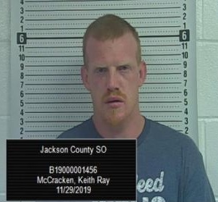
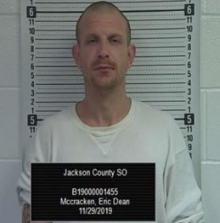
In November, a Jackson County Sheriff’s deputy stopped a 2007 Chevy Trailblazer in the early morning on 150th Road west of Mayetta for a traffic infraction. The driver Eric Dean McCracken, 36, of Topeka was arrested at the scene for driving while suspended and was transported to the Jackson County Jail.

Shortly before 5 am, the Jackson County Sheriff’s Office was notified by the Shawnee County Sheriff’s Office of a stolen 2015 Chevy Silverado that they were tracking by GPS. The stolen vehicle was headed north on US 75 Hwy. An off duty Jackson County Sheriff’s deputy in his personal vehicle began following the vehicle into Holton where a Holton Police Officer attempted to stop the vehicle on Banner Road. The vehicle fled driving through yards and stopped behind the former Country Mart Store where the driver exited the vehicle and fled on foot. Deputies and Holton Police Officers set up a perimeter north of Banner to 3rd Street. A Jackson County Sheriff’s K-9 began to track the suspect when, Undersheriff Darrel Chapman observed the suspect inside the Casey’s General Store on Arizona. Deputies and police officers arrived and took the man into custody. The man was identified as Keith Ray McCracken, 32, of Topeka and is the brother of the earlier suspect, Eric Dean McCracken.

It is believed that the younger McCracken was enroute to the Jackson County Jail to post bail on his older brother in a stolen vehicle. The Sheriff’s Office checked with Jefferson County authorities in regard to the Trailblazer that Eric McCracken was arrested in since it was not registered to McCracken, but was registered to a Meriden address. The owner of the Trailblazer was not aware his vehicle was missing at the time of the stop and later reported it stolen. Eric Dean McCracken was booked into the jail for driving while suspended and possession of stolen property. Keith Ray McCracken was held for fleeing and eluding a law enforcement officer, reckless driving, driving while suspended and possession of stolen property.

Mayetta man arrested on rape charge

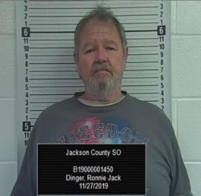
The Jackson County Sheriff’s Office arrested a Mayetta man in November on rape charges. Ronnie Jack Dinger, 63, of Mayetta was arrested by Jackson County Sheriff’s Office investigators on a Jackson County District Court warrant for rape, aggravated indecent liberties to a child under sixteen years of age and aggravated indecent liberties to a child under 14 years of age. Dinger was booked into the Jackson County Jail where he was later released after posting bond. On October 22, 2019, Jackson County Sheriff’s Office investigators and deputies served a search warrant on the home of Dinger located in rural Mayetta. During the search warrant, law enforcement interviewed Dinger, and collected evidence from the scene.

Two arrested following vehicle pursuit

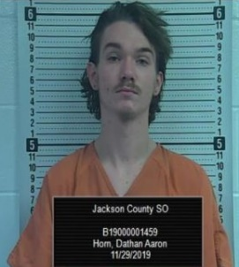
In November, the Jackson County Sheriff’s Office arrested one adult and one juvenile following a vehicle pursuit in southern Jackson County. A Jackson County Sheriff’s Deputy attempted to stop a vehicle for a traffic infraction near 158th and R. Road on the south edge of Mayetta. The vehicle then fled northbound through the City of Mayetta and north on R. Road. The vehicle came to a T intersection at 182nd Road where the vehicle slid off the roadway into a muddy field. The vehicle managed to exit the field and went west on 182nd Road and met deputies east of Hwy 75 on 182nd Road. The vehicle came to a stop and the four occupants surrendered to law enforcement. Two of the vehicle’s occupants were taken into custody. The driver, a juvenile, was arrested for possession of a hallucinogenic drug, possession of drug paraphernalia, felony fleeing and eluding a law enforcement officer and reckless driving. In addition, the juvenile had been entered as a missing person and had an outstanding felony warrant out of Shawnee County for vehicle burglary and theft of a firearm. The adult was identified as Dathan Aaron Horn, 18, of Topeka. Horn was arrested for possession of a controlled substance and possession of drug paraphernalia. The two remaining occupants were released at the scene.

On September 26th Jackson County Sheriff Tim Morse, Undersheriff Darrel Chapman and nearly 200 sheriffs across the United States were invited to the White House. The sheriffs met with the following officials of the executive office of the President: Kellyanne Conway, senior adviser to the president, Uttam Dhillon, Administrator of the DEA, Tom Murphy, local affairs coordinator\office of national drug control policy, Homeland Security Secretary Kevin McAleenan, Kevin Cuccinelli, Director of Citizenship Immigration Services Office, Theo Wold, Special Assistant to the President, Joe Grogan, Assistant to the President and Director of Domestic Policy, and President Donald Trump. The following topics were discussed: Combating the drug crisis and secure borders and safe communities. No taxpayer money was used for this trip. On September 25th the sheriffs met with members of congress on Capitol Hill.
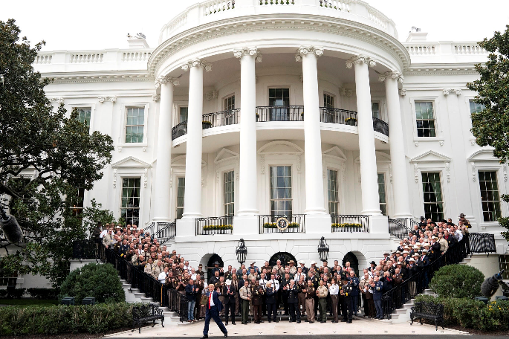
Attribution: Official White House photo by Joyce N. Boghosian

Jackson County and Shawnee County Cross-Deputization
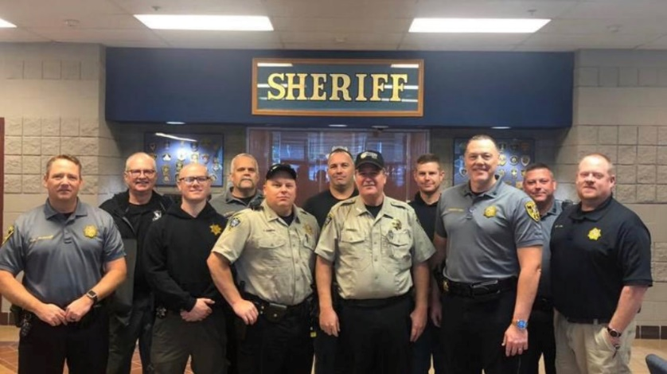
In October, Sheriff Tim Morse and Shawnee County’s new Sheriff Brian Hill entered into a cross-deputization program. Sheriff Morse and Sheriff Hill desired to combine resources to deal with criminal issues that both counties encounter. Sheriff Morse said “Shawnee and Jackson Counties are dealing with some of the same criminals that prey on both counties. It is important that counties work together in dealing with these type of situations. By combining resources, manpower and experience, we can put the needed pressure on criminal activity.” Administrators, detectives and select deputies were cross-deputized in October.

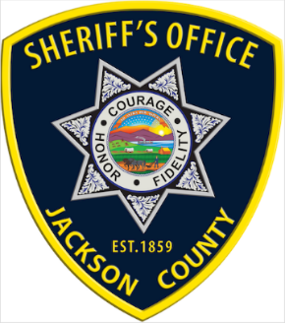

Jim Cyphers Retires

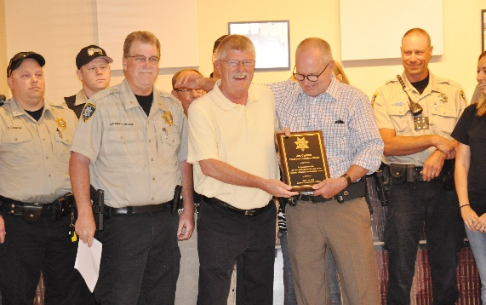
Jim Cyphers retired from the 2nd District Court in 2019. Jim served the 2nd District of Kansas as the Chief Court Services Officer. Jim was responsible for court services in Jackson, Jefferson, Pottawatomie and Wabaunsee Counties. Jim began his service in 1978 and served over
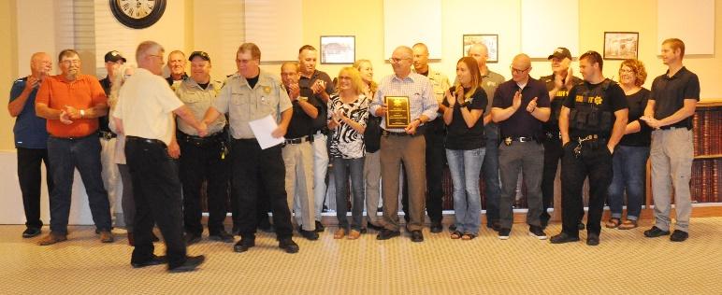
40 years. Jim has always been a great partner to law
Former Sheriff Phil McManigal presents the award to Jim Cyphers
enforcement. On June 14th, 2019 the Jackson County Sheriff’s Office provided a reception and presentation of an award for Jim’s amazing service to the 2nd District and law enforcement.

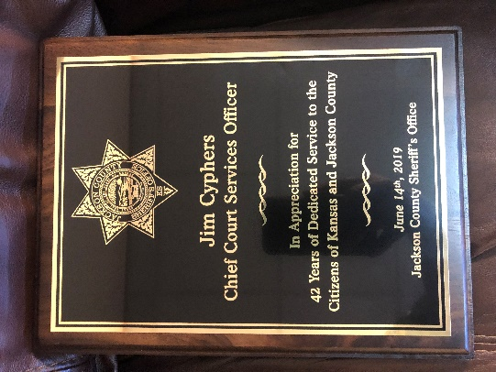
Sheriff Morse said “I want to express my appreciation and the appreciation of law enforcement in Jackson County for the 42 years of dedication and service that Jim Cyphers has had to the citizens of Kansas and Jackson County. Jim Cyphers has always been a positive force and a friend to his law enforcement partners. As the Chief Court Services Officer, Jim diligently worked in the most professional and ethical manner with all the entities of the 2nd Judicial District of Kansas.

Jim Cyphers has left us with a lifetime of service and the example of what a public servant should be. We all wish Jim well with a long and happy retirement.”

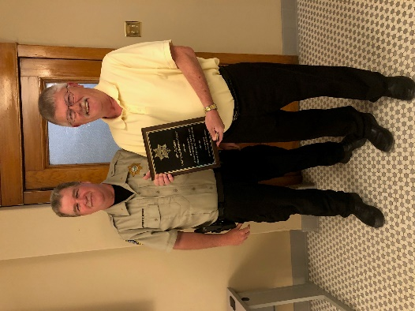

Gary Thiessen Retires
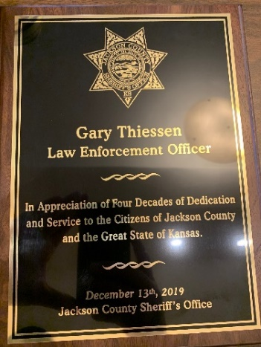
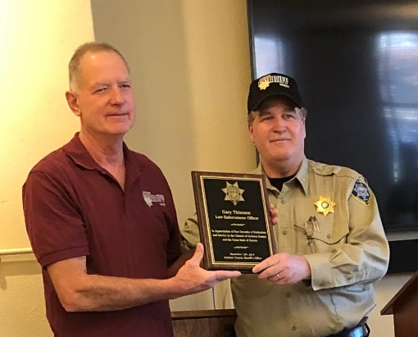
Gary Thiessen is another example of a quality employee at the Jackson County Sheriff’s Office. Gary served our Nation in the United States Marine Corp and then became a corrections officer in the Hutchinson Correctional Facility. After the completion of his training, Gary was stationed in Jackson County as a Kansas Highway Patrol Trooper beginning in 1979. Gary served his entire career based out of Jackson County. Gary kept order in Jackson and surrounding counties when help was few and far between. After retiring from the Kansas Highway Patrol, Gary became the firearms instructor for the Jackson County Sheriff’s Office. Shortly thereafter, Gary headed up the court security team at the Jackson County Courthouse. For over eight years, Gary kept our county courts secure.
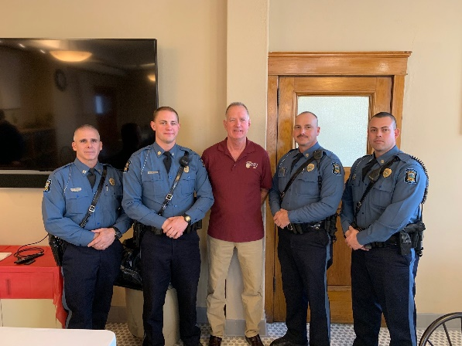
Gary ended his 40-year law enforcement career on December 26, 2019. During Gary Thiessen’s retirement ceremony, Sheriff Morse stated, “Sheriffs have come and gone, but since 1979, there has always been a Gary Thiessen in Jackson County. Gary has been a mentor to many of us. Gary is a person of unquestionable integrity and genuine humility. He is a man of common sense. I don’t even think Gary realizes all he has done for the rest of us in law enforcement, nor the tremendous positive example he has given us. We appreciate Gary for his years of dedication and service and for leaving us with the example of what a law enforcement officer should be.”
Patrol Division
The Patrol Division of the Sheriff’s Office is one of the most visible parts of the Sheriff’s Office along with being the primary enforcement division. The Patrol Division is also the uniformed division of the Sheriff’s Office and has the primary responsibility of patrolling, traffic enforcement, accident investigation, and responding to calls for service in Jackson County. In 2019, the Patrol Division initiated and/or responded to 20,900 calls for service. The Patrol Division strives to remain visible in high crime areas and takes a proactive approach to help keep crime rates low. The Patrol Division operates 24 hours a day, 365 days a year.
The Jackson County Sheriff’s Patrol Division patrols an estimated half a million miles of Jackson County roadways each year. The Patrol Division answers calls for service in the entire county. The Patrol Division also assists other agencies within and surrounding Jackson County.
Currently, the Patrol Division is under the leadership of Undersheriff Darrel Chapman. There are four shifts each led by a sergeant. Patrol Deputies have a variety of functions while on duty. Deputy Sheriffs serve warrants, patrol Jackson County, conduct investigations, enforce traffic laws, serve civil process and make arrests.
Patrol responses in 2019

In 2019, the Patrol Division either responded to, initiated and or investigated the following:
50 - Mental/Suicidal (40 in 2018)

764 - Escorts/Transports (609 in 2018)

1,591-Civil Process (1,908 in 2018)

839 – Arrest Warrants (928 in 2018)

3,839 - Car Stops (4,279 in 2018)

24-Vehicle pursuits

341- Non-Injury Accidents (274 in 2018)

88 - Injury Accidents (96 in 1018, 104 in 2017, 108 in 2016)

16 - Structure Fires (10 in 2017, 15 in 2016)

59 – Fire calls (non-structure)

165- Alarm Calls (154 in 2018, 137 in 2017, 138 in 2016)

23 - Fight Calls (33 in 2018, 17 in 2017, 24 in 2016)

118 - Domestic Violence Calls (125 in 2018, 122 in 2017, 103 in 2016)

53 - Assault/Battery/Harassment Calls (101 in 2018, 57 in 2017, 49 in 2016)

31 – Stolen car (30 in 2018)

560 - Animal Calls (595 in 2018, 527 in 2017, 474 in 2016)

1,106 - Assist Citizens Calls (1,059 in 2018, 1,105 in 2017, 1,031 in 2016)

534 - 911 Hang Up Calls (332 in 2018, 391 in 2017, 476 in 2016)

64- Disturbance Calls (73 in 2018, 66 in 2017, 73 in 2016)

375- Suspicious Person/Activity Calls (334 in 2018, 354 in 2017, 401 in 2016)

20 – Missing person

128 - Juvenile Calls (161 in 2018, 101 in 2017, 107 in 2016)

26 - Sex Offenses (50 in 2018, 31 in 2017, 43 in 2016)

140 - Welfare Checks (114 in 2018, 124 in 2017, 108 in 2016)

12 – Dead person

285 - Theft Calls (280 in 2018, 182 in 2017, 151 in 2016)

376 - Receive Information/Service Request Calls (511 in 2018, 426 in 2017, 938 in 2016)

865- Service Request

803 - Traffic Problems (746 in 2018, 750 in 2017, 734 in 2016)

5,040 - Building/Area Checks (4,825 in 2018, 6,400 in 2017, 5,034 in 2016)

12 - Illegal Hunting/Criminal Trespass Calls (13 in 2018, 5 in 2017, 19 in 2016)

122 - Back Up/Assist Other Agency Calls (184 in 2018, 252 in 2017, 322 in 2016)

31 - Search Warrants (30 in 2018, 22 in 2017, 24 in 2016)

34 - Vandalism/Criminal Damage to Property Calls

14 - Illegal Trash Dumps (12 in 2018, 8 in 2017, 16 in 2016)

426 - Speak with Deputy Calls (286 in 2018, 262 in 2017, 329 in 2016)

1 – Fatality

0 - Homicide

24 – Pursuits (20 in 2018, 15 in 2017)

58 – Road slide offs (67 in 2018, 7 in 2017)

130 – Assist outside agency

104 – Abandoned vehicle (61 in 2018)

222 – Medicals (188 in 2018)

47 - Criminal Trespass (34 in 2018)

183 - Back up

827 - Service requests

510 - Receive information

13- Dead person

160 – Juvenile calls

21 – Missing person

4 – Gas leak

K-9 Program
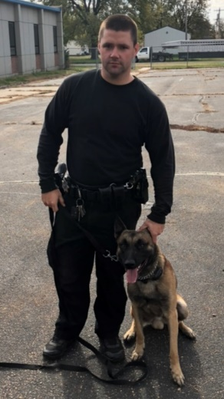
The Sheriff’s Office is made up of some of the greatest public servants in Kansas. The office is comprised of men and woman who have given of themselves unselfishly to keep the Citizens of Jackson County safe and secure. Every single employee is essential in carrying out the mission of the Sheriff’s Office.
Jackson County being small in numbers has a vast array of talented people that are serving in public safety. One employee, Sgt. Travis Spiker is a good example of those who have dedicated themselves to this profession and have given their very best to make us all safer.
Sgt. Spiker serves as a patrol supervisor, making sure that all calls are answered on his shift and that citizens get quality service when needed. Sgt. Spiker has also served for a number of years now as a K-9 handler. His partner, Ike, a Belgian Malinois is certified in drug detection, tracking, handler protection and patrol.
In 2019, Sergeant Travis Spiker and Ike assisted in many drug investigations evolving from search warrants, traffic stops, and school and jail sniffs. K9s are used by law enforcement as a tool to help locate illegal narcotics as well as a protective measure to try to keep our schools and jails free from illegal narcotics. Once certified, K9’s and their handlers attend weekly training to continue building skills for both the dog and the handler. The longer the pair work as a team, the stronger the bond becomes.

In July of 2019, Sgt. Spiker and Ike were requested to sniff a vehicle on a traffic stop. Ike indicated to the presence of a narcotic odor. During a search of the vehicle, narcotics were located. Also located in the vehicle was stolen property, which was traced back to recent burglaries in other jurisdictions.

This case alone shows the important role our K9 partners play in curbing the illegal transportation of narcotics, but also to help solve a wide range of cases.

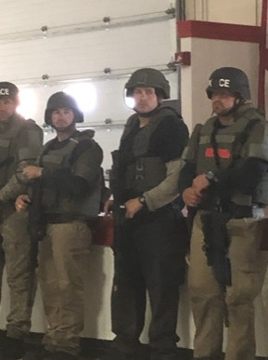
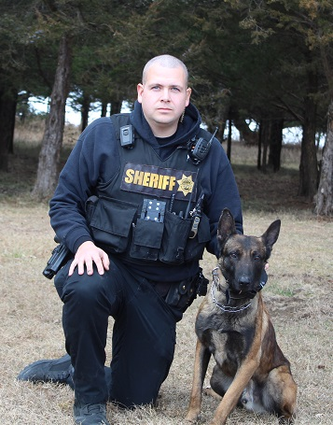
Another fine example of the quality of personnel that makes up the Jackson County Sheriff’s Office is Deputy John T. Paz. Deputy Paz spent a number of years working at Shawnee County Department of Corrections. Deputy Paz then transferred to the Jackson County Jail Division where he served as a corrections officer. Deputy Paz later transferred to the Patrol Division of the Sheriff’s Office. After graduating from the Kansas Law Enforcement Training Center, Deputy Paz has been one of the most proactive deputies in Jackson County. In 2019, Deputy Paz attended Special Weapons and Tactics training in Hutchinson, Kansas. Following graduation from SWAT school Deputy Paz was assigned to the K-9 Unit with the agency’s newest K-9, Kreto. Deputy Paz and Kreto underwent 16 weeks of intensive training through the Kansas Highway Patrol K-9 Program. Kreto, also a Belgian Malinois is a multi-purpose K-9 trained in drug detection, tracking, handler protection and patrol. Deputy Paz and Kreto immediately went to work doing drug work and tracking a suspect that fled from a stolen vehicle.
Court Security
The Jackson County Sheriff’s Office also provides court security for the Jackson County District Court. Deputies keep the court rooms free of weapons and maintain order. In addition, deputies make arrests and take custody of inmates that are remanded to the Sheriff. Deputy Gary Thiessen has been in charge of Jackson County Sheriff’s Court Security since 2011. Gary retired from duty in December 2019.
Investigation Division
The Jackson County Sheriff’s Office Investigation Division is made up of five investigators. All five detectives investigate a variety of crimes. Two of the investigators are assigned to special investigations. One of the two is a specialized investigator that investigates domestic violence and sex crimes. This investigator has specialized training to include interviewing victims. Investigators collect digital evidence to include: computers, cell phones, website history activity, and social media. This new position was created to meet the increasing crimes and demand of these types of investigations. The Sheriff’s Office was able to procure federal funding to help pay for this new position. The grant is reviewed every year and managed by Governor’s office.
The second specialized investigator of the Investigations Division is a Narcotics detective that is tasked with investigating narcotic crimes such as the sales, distribution and possession of illegal drugs. This investigator has worked a myriad of investigations last year and is tasked with being the central point for criminal intelligence sharing in Jackson County. This detective works with the Patrol Division and various state and federal agencies. This detective is also tasked with overseeing the Asset Forfeiture Program, where law enforcement will seize money and property that is attached to the sales and possession of illicit drugs. In 2019, the Sheriff’s Office has seized thousands of dollars in cash and property. These funds are reviewed by the State of Kansas and managed by the sheriff’s office after the forfeiture cases proceed thru the court system. These funds are used to purchase law enforcement equipment and training for deputies. This program helps stop sales and distribution of drugs in Jackson County.
The Investigations Division is tasked with investigating all crimes to include person crimes and property crimes for all of Jackson County. The Investigations Division routinely assists other agencies within and surrounding Jackson County to include the Department of Children and Family Services.
The five investigators in this unit are all very experienced investigators trained in interview and interrogations, crime scene management and evidence collection. The Investigations Division has a combined 96 years of experience in law enforcement.
The Investigations Division is a part of the annual training team that trains other deputies. These trainings sessions include the new methods of collection of evidence, search warrants, crime scene processing and legal case law updates.
In 2019, the Investigations Division purchased a crime scene trailer. This trailer was purchased through the lend-lease program from the U.S. military surplus. This program allows law enforcement agencies to purchase used equipment at a greatly reduced price. The trailer is equipped with search and rescue equipment. The trailer contains a variety of tools and equipment that can be used during a variety of crisis situations such as crime scenes or natural disasters.
The Investigation Division served 195 search warrants in 2019. The search warrants that were served range from searching residences inside and outside of Jackson County, mobile devices, computers and social media. The unit also served 26 investigation-based subpoenas.
During the year, the division investigated 15 burglaries to residences in the county solving six with arrests of suspects and recovery of property. The Investigations Division has a 40% clearance rate on burglary cases for the year. The national average by the Department of Justice and F.B.I. crimes statistics is a 13.5% clearance rate for burglaries.
The Investigations Division investigated 52 sex related crimes in 2019, with a 92 % percent clearance rate thru arrests and prosecutions.
The Investigations Division investigated 18 death investigations. These investigations included deaths by natural causes, accidents and suicides. There were no homicides reported in 2019 for Jackson County.
Additionally, the Investigations Division investigated numerous crimes in 2019 to include thefts of vehicles, thefts from local businesses, and fraud and identity theft cases.
The Investigations Division has had a busy year with investigating crimes with a high clearance rate. The help of the additional investigators that were added to the Investigations Division in 2019 will continue to help successfully meet the challenges of investigating crimes successful.
Jail Division
It has been another busy year at the Jackson County Jail with many positive changes. The Jail Division continues to upgrade and replace old equipment when able. In 2019, the master control board software and hardware were updated. During this procedure, the sheriff’s office was able to purchase new software licensing. This enables the Jail Division to not rely on a particular vendor and will reduce future update and maintenance costs. Previously, the original vendor would take six weeks to arrive on scene, since they were located out of state and would charge $3,800 just to diagnose a problem. Now, the Jail Division can work with a vendor that is within an hour response time, and most of the maintenance issues can be maintained by the Sheriff’s Maintenance Division.
In 2019, the Jail Division updated the washer and dryer, replacing the old equipment with industrial equipment. A new electrical service line run was installed in order to provide the proper electrical power to the new dryer. Preventing disease and foul odors is all a part of maintaining a sanitary jail; therefore, it is important to have a reliable laundry system. At many times, the population of the jail is over 100 inmates, providing the need for a substative laundry system.
The Jail Division continues to be staffed with only 14 full time and 2 part time positions.
The average daily jail population in 2019 was 89 inmates. The Jail Division averaged 50 non-Jackson county inmates and 38 county inmates per day. The Jail Division contracts with the U.S. Marshal Service and the Kansas Department of Corrections. The Jail Division also houses inmates from Franklin, Wyandotte and Douglas counties. In 2019, 1,558 people were booked into the jail.
In 2019, approximately 249 inmates were arrested on Jackson County warrants from 37 Kansas counties and 5 different states. Also, 1,219 Inmates were transported by Jail Division staff. Inmates were transported to district court, prison, treatment, medical visits as well as many other appointments.
Jackson County has a total of 49 registered offenders. 42 are sex offenders, 3 are violent offenders and 4 are drug offenders. In 2019, three offenders were charged with failure to register, which resulted in two convictions with one case pending trial in 2020. The total income in 2019 from Offender Registration was $3,380.00. There are currently 12 additional registered offenders that are housed in the Jackson County Jail.
The Jail Division collected $841,314.46 in 2019 for housing out of county inmates through it’s various housing contracts and agreements. The Jail Division also collected $2,089.56 in medical co-pays, $1,677.37 for booking fees and $6,459.40 in sales tax. The Jail Division also collected $76,199.00 in cash bonds.
Inmate welfare monies collected in 2019 totaled $121,434.56. This account is non-taxpayer money earned from sales of commissary items purchased by inmates and the profit from the inmate phone and visitation system. This money is used to purchase items for the inmates’ daily care and any other inmate needed improvements.
The Jail Division has a lot on its plate. They are charged with transporting wanted fugitives from all over the state and the country. They are responsible for the health and safety of everyone that is incarcerated, including health care and nutrition. The staff has to plan for 100,000 meals each year. What makes this division a success is the stellar employees who makes this all happen. In addition, to all the work they do, they also find time to earn revenue for Jackson County. The Jackson County Jail Division earned at total of $956,991.83 for 2019.
Communications Division
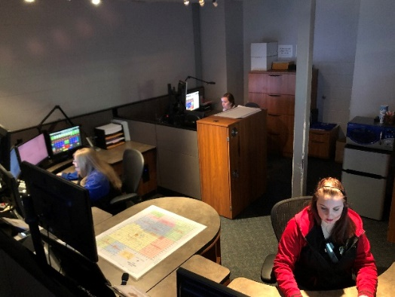
The Jackson County Sheriff’s Office Communications Division is the central answering point for 911 in Jackson County. The Communications Center dispatches for five law enforcement agencies, eight fire departments and two EMS agencies. In 2019, the Communications Center dispatched over 22,000 incidents, although the vast majority were for law enforcement, a number of fire and ems calls were dispatched as well.
Dispatchers don’t just answer and dispatch calls, but they also have a variety of other duties. Dispatchers also answer the walk in traffic at the Sheriff’s Office lobby. They also are the holder of the warrants for the Jackson County District Court. There are over 1,200 Jackson County District warrants that are outstanding. Dispatchers have to confirm whether a warrant is valid when a law enforcement officer encounters a fugitive. When the California Highway Patrol stops a subject and finds they have a Jackson County warrant, Jackson County Dispatchers must confirm whether the warrant is valid or not. Stolen items and missing people are also entered in the N.C.I.C. system by dispatchers. Dispatchers also must confirm when those stolen items or missing persons are found.
The Communications Center also has a state-wide function for Wildlife, Parks and Tourism. The Wildlife, Parks and Tourism’s Operation Game Thief hotline is answered at the Jackson County Sheriff’s Office for the entire State of Kansas.
The Jackson County Sheriff’s Office Dispatch Division dispatched these totals of incidents for the following agencies in 2019:
Jackson County Sheriff 20,900
Holton Police Department 751
Jackson County EMS 1,494
Hoyt Police Department 383
Mayetta Police Department 193
Potawatomi Tribal Police 234
Netawaka Fire Department 106
Mayetta Fire Department 449
Soldier Fire Department 85
Holton Fire Department 53
Delia Fire Department 89
Wildlife and Parks 253
Kansas Highway Patrol 100
Potawatomi Fire Dept. 276
Whiting Fire Department 88
Hoyt Fire Department 465
JACO Storm Spotters 2

Civil Process
In 2019, the Sheriff’s Office served 2,207 papers for the District Court of Jackson County, district courts for other Kansas counties and also the states of California, Colorado, Florida, Illinois, Missouri, Nebraska and Washington. In 2019, $10,810.00 in revenue was received from civil process. In 2018, the Sheriff’s Office served 2,664 papers with a revenue of $12,582.00. In 2017, the Sheriff’s Office served 2148 papers with revenue of $10,350.00. In 2016, the Sheriff’s Office served 2,735 papers with revenue of $11590.00. In 2015, 2,904 papers were served with revenue amounting to $13,440.00.
The Sheriff’s Office served 709 summons, 1004 subpoenas, 171 tax warrants, 22 show causes, 9 writs of assistance, 121 orders to appear, 29 citations in contempt, 89 garnishments, 38 protection from abuse orders, and 15 notices of hearing.
VIN Inspections
In 2019, deputies performed 842 vehicle identification number inspections and collected $15,156.00 in revenue. In 2018, deputies performed 844 vehicle identification number inspections and collected $15,192.00 in revenue. In 2017, deputies performed 916 vehicle identification number inspections and collected $16,488.00 in revenue. In 2016, deputies performed 792 vehicle identification number inspections compared with 740 in 2015. These inspections resulted in $14,256.00 in revenue compared to $13,320.00 in 2015 and $13,302.00 collected in 2014.
Concealed Carry
In 2019, 31 concealed carry permits were process by the Jackson County Sheriff’s Office and $1007.50 in revenue was collected. In 2018, 30 concealed carry permits were processed by the Jackson County Sheriff’s Office and $975.00 in revenue was collected. In 2017, 24 concealed carry permits were processed by the Jackson County Sheriff’s Office and $780.00 in revenue was collected. Conceal carry permits doubled in 2016 from the year prior. In 2015, following the Kansas legislature easing restrictions on concealed carry 16 permits were issued compared to 57 in 2014. In 2019 32 permits were issued and $1040.00 in revenue was collected. The sheriff collects $32.50 for each concealed carry application.
Fingerprints
The Sheriff’s Office in 2018 fingerprinted 124 individuals for employment or background purposes. The Sheriff’s Office collected $1,240.00 for fingerprints. This was increase over previous years due to the new regulations requiring fingerprint background checks on daycare providers and workers in other care facilities.
Reports
The Sheriff’s Office collected $1,037.55 for copies of reports in 2019.

Sheriff Sales
In 2018, the Sheriff’s Office conducted 10 sheriff sales and earned revenue from the sales of $75.00.
Special Law Enforcement Fund
On January 1, 2019, the balance of the Special Law Enforcement Trust Fund was $7,015.57. Throughout the year, $30,168.19 more was awarded to the Sheriff’s Office through the asset forfeiture procedure thru the District Court. Purchases made from this fund totaled $20,787.90. Ending balance on December 31, 2018 is $16,395.86.
Technology
Two new laptops were obtained for the Detective Division for the new detectives. One was purchased with grant monies for the Federal Victims of Crime Act (VOCA) detective. Throughout the year, two more additional desktop computers were purchased to replace PC’s that required upgrading due to ever changing technology. A new planning phase of upgrading several computers to Windows 10 began as Windows 7 will not be fully supported after January 14, 2020.
The Sheriff’s Office upgraded its administrative telephone system in February 2019. The old system wasn’t going to function well with the new 911 system that was installed in March 2019. The new state-wide NG911 system provides the option, if the dispatch center were to fail due to weather or from another emergency, dispatch services could be conducted from a neighboring dispatch center. Jackson County maps and information would just follow to another dispatch center as soon as the dispatcher logged onto the system. This new 911 solution also is fully supported by the state and AT&T so maintenance costs are included.
911
The Jackson County Sheriff’s Office went live with the new 911 system on March 12, 2019. The following stats are from that date to the end of the year.
911 calls 3,347 (2602 – wireless and 745 landline)
Admin calls: incoming calls 21,615
Outgoing calls 8,976
Sheriff’s Office Grant Projects

The Federal Edward Byrne Memorial Justice Assistance Grant (JAG)

This grant provides criminal justice systems and community partners funding opportunities to address crime and public safety concerns. The Kansas Criminal Justice Coordinating Council (KCJCC) is responsible for overseeing these federal funds made available to Kansas through the U.S. Department of Justice. The Kansas Governor’s Grants Program serves as the staff for the KCJCC and point-of-contact for the federal JAG program.

In 2019, the Jackson County Sheriff’ Office applied for and received $129,399 in JAG funding. These funds were used to purchase updated portable/mobile radios to improve crisis response and ensure safety. As the unit of government responsible for coordinating and responding to all major crisis situations in Jackson County, effective reliable communication systems are essential. The portable and mobile radios selected are compactable with potential system upgrades for law enforcement in Kansas, which will maximize the length of time these new radios can be utilized. Two-way portable/mobile radio systems are critical to every aspect of law enforcement’s duty. Whether it’s investigating criminal activity, getting information on a suspect, calling for back up, or coordinating tasks with emergency management crews and other law enforcement agencies, quality radios are essential to effective and safe crisis response. For rural law enforcement officers often forced to respond to calls alone, portable radios are critical devices, which provide a lifeline to outside help. The reality for law enforcement is that every moment in a crisis situation can change the trajectory of the outcome. Modern, updated communication systems are essential to ensuring the best outcomes in these dangerous situations.

The Federal Victims of Crime Act (VOCA)

This funding source was made possible by the Victims of Crime Act (VOCA) passed in 1984, which established the Crime Victims Fund. These funds are generated by fines and penalties collected from convicted federal offenders and distributed to the states by the U.S. Department of Justice. In Kansas, the Kansas Governor’s Grant Program administers these grants. The purpose of this grant funding is to provide a response to the immediate needs of crime victims and provide ongoing assistance to help victims of crime understand and participate in the criminal justice system.

The Jackson County Sheriff’s Office was awarded $79,134 in 2019 for continued funding of the current VOCA grant project, Project A.C.T. (Addressing Crime Together). This award marks the fourth year of project funding. Project staff includes one full time and one part time staff in addition to a small group of volunteers. Victim Service are typically initiated when law enforcement contacts project staff at the time a crime is reported. All services are provided free of charge to victims and their families. This grant project is one of only a handful of victim service positions throughout the state, working directly with law enforcement, making it unique not only in its rural setting but also in the development of victim services in Kansas.

The mission of this project is to provide crime victims with access to immediate information, referrals, crisis services, ongoing criminal justice support as well as to strengthen and expand aid to crime victims in Jackson County. To date the Victims of Crime Act funding has allowed for 414 primary and secondary victims of crime in Jackson County to receive services, serving 89 victims in 2019.
Violence Against Women Formula Grant Program (S.T.O.P. VAWA)

This grant-funding source was established through the 1995 Violence Against Women Act and following reauthorizations. The S.T.O.P. VAWA funding seeks to support communities in their efforts to develop and strengthen effective law enforcement and prosecution strategies to combat violent crimes against women, strengthen victim services and promote a coordinated community response to victims of domestic violence, dating violence, sexual assault/rape, and stalking. In Kansas, the Kansas Governor’s Grants Program administers these funds.

In 2019, the Jackson County Sheriff’s Office applied for and received $49,214 in V.A.W.A. funding to establish an investigator position to be specialized in the crimes of domestic violence, dating violence, sexual assault and stalking. Research widely acknowledges the most effective way, particularly for smaller communities, to investigate these violent crimes is to have at least one specifically trained professional on staff. This is because crimes of this nature are often the most difficult and timing consuming to investigate.

The VAWA investigator was hired in March of 2019 and has investigated 29 reports in this area, with 4 cases resolved by conviction and 10 cases pending in court. Specialized training for the position consisted of a five-day Forensic Experiential Trauma Interview course conducted by Russel Strand and a four-day National Law Enforcement Training on Child Exploitation.

Through partnerships developed by this investigator in 2019, the Jackson County Sheriff’s Office became an affiliate agency to the Kansas ICAC (Internet Crimes Against Children) Task Force whose mission is to properly investigate and prosecute those who sexually exploit children through the use of technology, provide training and community education regarding the prevention of internet crimes against children.

School Defender Initiative

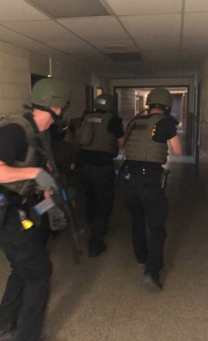
In 2018, Sheriff Tim Morse voiced his ideas in making Jackson County Schools safer. Sheriff Morse who has seen senseless killings in our nation’s schools and believes there are better ways in keeping children safe in schools. In 2019, Sheriff Morse was featured in the Kansas Leadership Journal. The article discussed some of Sheriff Morse’s goals in making Jackson County schools safe.

Sheriff Tim Morse stated the following in a 2018 Op-Ed article: “The first thing parents do after hearing about another school shooting is they confirm it isn’t their child’s school. Enough is enough, when will our politicians get it? For over 20 years now, children have been the targets of deranged persons who have slaughtered innocent children in a place we expect them to be safe, their schools. In 20 years, our federal and state government has done little to nothing to make them safer. The time has come for the people to stand up and demand that their children be protected from these disturbed individuals. Unfortunately, for a variety of reasons, there has been an increase in deadly violence among some of our young people. Nevertheless, our world is a different place than it once was.”

Sheriff Morse pointed out the changes in security that have taken place after the Oklahoma City bombing in stepping up security at courthouses and the upgrade in security at airports across the country following the 9/11 terrorist attacks. Sheriff Morse has advocated for enhanced security in county schools due to the threats Jackson County faces with its location next to the capital city, the abundant amount of mental health issues in the community and surrounding areas, along with the proliferation and accessibility of unsecured weapons in the rural community.

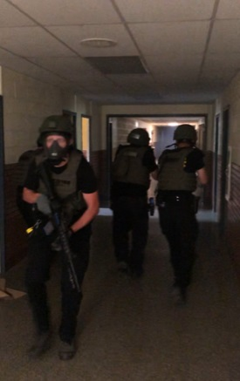
Sheriff Morse has stated that school districts in larger counties have their own police departments or added law enforcement already in their schools; however, those schools in the rural area are much more vulnerable. Sheriff Morse believes students, teachers and parents should not have to worry about safety in the school, students should focus on learning, and teachers should be able to focus on teaching.

Since Jackson County is a rural county with little industry and less funding than urbanized counties. Sheriff Morse suggested training reserve deputies that would be charged with securing our schools. These deputies would be sworn law enforcement that would have specialized training in building security, active shooter trainings and a variety of training that would be specific to school security. The Sheriff also proposed a second component to the plan that would allow upon school board approval, a limited number of non-teaching school employees to undergo the same training who would serve as a back up to uniformed reserve deputies. All participants would be highly vetted, screened, tested, polygraphed, and would have to undergo the same hiring requirements as any deputy sheriff. As to date, the armed staff option has not yet been implemented, however, a number of security improvements have been made to the districts through the help of School Defender Initiative Coordinator Deputy Joe Romans.

The insurance company that insures Jackson County has approved Sheriff Morse’ full-plan for school security. Sheriff Morse continues to work with districts in making schools safer and is planning for a reserve law enforcement academy to start in the near future.

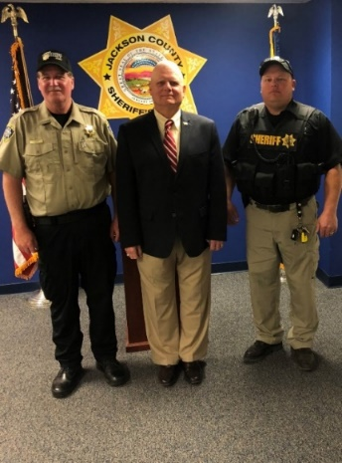
Deputy Romans has been tasked in helping make our children safer within our school districts. Deputy Romans will play an essential part in training other volunteer reserves for the purpose of securing our schools. CSM C. Joseph (Joe) Romans retired in December 2008 after a 30 year active duty career. Deputy Romans first enlisted in 1968 and served with the Marine Corps as a Corpsman for 4 years. He was honorably discharged in 1973 and then pursued a career as an EMT and Paramedic in Indianapolis and then 5 years as a Remote Arctic Air Force Radar Site Medic in Alaska. He re-enlisted in the Army in 1982 and served for 26 more years.

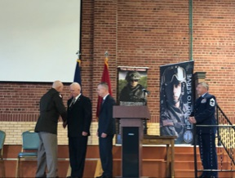
Deputy Romans attended every level of the Army Non-Commissioned Officer Education system culminating with the Sergeant Major Academy. He served in the following military occupational specialties; Medic, Infantryman, Cavalry Scout and Armor Crewman. He held the following leadership positions; Team leader, Squad leader, Tank Commander, Scout Platoon Sergeant, Mortar Platoon, Armor Platoon Sergeant, Company First Sergeant, Intelligence Sergeant and Operations Sergeant Major. Deputy Romans was a Command Sergeant Major at the Battalion, Regiment and Brigade level. Joe was the NCOIC of the Kansas National Guard Counterdrug Special Operations Team. Deputy Romans attended the DEA Drug Unit Commanders Course, DEA Highway Interdiction Course, DOJ Community Policing Course, KBI SWAT Course, KBI Aerial Narcotics Smuggling Course, Reduced Light Firearms Instructor Course, Close Quarters Battle Course, ASP Baton Instructors Course, Topeka Police Department Law Enforcement Firearms Instructors Course, DEA Clan Lab Course, Armed Vehicle Operations Course, Edged Weapons Course and many others.

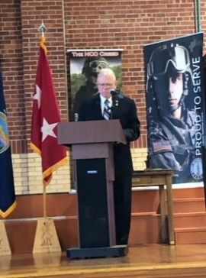
Deputy Romans served in the following campaigns or countries. Viet Nam era, Operation Desert Shield, Operation Desert Storm, Operation Joint Guardian and Operation Iraqi Freedom. He served in Saudi Arabia, Kuwait, Iraq, Kosovo, Macedonia, Japan, Germany and Korea. Deputy Romans served in or was attached to the following units. 1st Battalion - 635th Armor Regiment 35th Infantry Division, 1st Marine Regiment-1st Marine Division; 235th Regiment (RTI); 32nd Armor Regiment -1st Cavalry Division; 5th Battalion (Eskimo Scouts) 297th Infantry Brigade; and 2ndBrigade 40th Infantry Division. Deputy Romans was attached to the 5th Special Forces Group and SEAL Team 3 as part of the Combined Joint Special Operations Task Force-Arabian Peninsula; in Iraq. Deputy Romans has 25 ribbons and medals to include various combat, campaign, service awards and achievement awards. This includes foreign decorations from Saudi Arabia, Kuwait, Denmark, Germany and a NATO Meritorious Service Medal. He has two unit awards, Superior Unit Citation and Meritorious Unit Commendation. Badges include the Combat Action Badge and Navy Enlisted Expeditionary Warfare Badge.

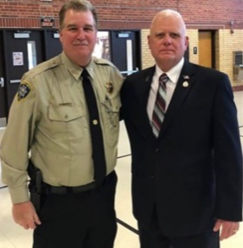
Deputy Romans is married to a loving and wonderful wife, Nancy. He has four children, Kyle, Debbie, Joe Jr and Holly. Kyle is an Assistant Fire Chief and reserve Police Officer, who is married with one son and lives in Montana. Debbie is a homemaker and mother with two daughters and lives in Texas. Joe Jr is Sergeant in the U.S. Army Infantry and is on his second combat deployment. Holly is a U.S. Navy Petty Officer Second Class on the Littoral Combat ship USS Jackson, home ported in San Diego. Deputy Romans and Nancy reside in Hoyt Kansas. Deputy Romans is also a graduate of the Kansas Law Enforcement Training Center.

Sheriff Tim Morse said, “Most active shootings and acts of violence take place in seconds or in just a few minutes. Response times could be more than 10 minutes, and in some places, much longer. The quicker the response, the greater the chance to save lives. Trained and armed personnel on scene are much more effective than waiting for help to arrive. The only effective way to stop an armed person is with a trained and armed person. While a lot has been done in dealing with the aftermath of school shootings, little has been done to prevent these tragedies from occurring in the first place. As Sheriff, I am willing to do whatever it takes to keep every child safe.”

Comments from Deputy Joe Romans
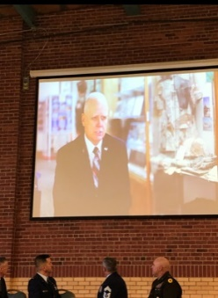
“I’m Joe Romans, Command Sergeant Major US Army (retired) and Deputy for Jackson County Sheriff’s Office. Sheriff Tim Morse brought me on a year ago to assist in his vision of establishing a School Defender Initiative in our County. The goal is to do everything possible to improve the safety and security of our schools. Under the Sheriff’s guidance and leadership, I’m pleased to report to you that we have made substantial progress in 2019 towards achieving that goal. With the support and cooperation of the school district superintendents, staff, teachers, and county first responders and outside agency training to include the FBI, I can report to you that our schools are much safer and more secure today. We have increased law enforcement presence at our schools, both during school days and at after-hours activities. We have conducted tactical training of our Deputies, conducted detailed and in-depth security assessments of our schools, made improvements in school infrastructure, assisted in updating the school crisis plans, trained school staff in emergency procedures, improved interior and exterior communications, and much more. I can assure you that the Jackson County Sheriff and his staff are “All-in” on this effort. We still have much to do and will continue to make improvements throughout the coming year. Every member of the Sheriff’s Office is dedicated to protect our most precious resource, our children.”

2019 School Defender Initiative Update
Deputy Joe Romans and the Jackson County Sheriff’s Office has been very busy in 2019 in improving school security and procedures. Obviously, for the sake of security, not everything can be discussed to its entirety in this report. However, we will discuss many of the highlights for this past year.
1. We have seen through a variety of studies that simple life saving techniques have been beneficial in saving lives during a crisis event. In 2019, Jackson County Sheriff’s Office (JASO) Deputies were trained in “Stop the Bleed” class. Deputies were trained in the use of tourniquets and other life saving techniques. Deputies are issued and carry tourniquets.
2. JASO Deputies participated in a 2-day Situational Training Exercise (STX) at old Holton Central Elementary school. Stop the shooter training was conducted using JASO tactics, techniques, and procedures. This was the third such training event for the Sheriff’s Office in the last two years. Other agencies have also been included in these trainings. Jackson County Sheriff’s Deputies are each issued a complete set of SWAT style protective gear. This protective gear was paid for through a federal grant. Deputies use this equipment as well and simunitions during these exercises.
3. Deputy Joe Romans attended the FBI School shooter seminar in Kansas City featuring a detailed case study of the Parkland shooting. In-service training was also provided to Jackson County Patrol Deputies.
4. Deputy Joe Romans underwent an intensive school security assessment training program. This training resulted in Deputy Romans becoming a certified school security assessor for the purpose assessing security issues for our school districts and making recommendations to them for improvement.
5. Deputy Joe Romans became a “Stop the Bleed” instructor in 2019.
6. Deputy Joe Romans attended the Pottawatomie county first responders’ multi-agency active shooting exercise at Onaga High School.
7. The Jackson County Sheriff’s Office provided the Royal Valley High School and Elementary School a 50-hour security assessment. Following the assessment and completion of the report, school district officials received a briefing of the findings along with suggestions on improving infrastructure, security and policy.
8. The Jackson County Sheriff’s Office provided the Holton High School a 50-hour security assessment. Following the assessment and completion of the report, school district officials received a briefing of the findings along with suggestions on improving infrastructure, security and policy.
9. Also in 2019, Deputy Joe Romans, the Holton Superintendent Bob Davies and Royal Valley Superintendent Aaric Davis attended the 3-day Alert-Lockdown-Inform-Counter-Evacuate – (A.L.I.C.E.) Instructor certification course.
10. In 2019, Deputy Joe Romans instructed 40 RV Middle school Staff members in “Stop the Bleed” training.
11. In 2019, Deputy Joe Romans instructed 20 Holton high school bus drivers in “Stop the Bleed” training.
12. The Sheriff’s Office issued a school bus emergency operations plan for handling violent events, and distributed to all the Jackson County School transportation directors. Holton School District and Jackson Heights School Districts have adopted the bus emergency operations plan. Twelve Jackson Heights school bus drivers were trained on the plan as well.
13. More training has been scheduled for 1st quarter 2020.
14. Deputy Joe Romans assisted the Royal Valley Superintendent in training 120 Royal Valley schools staff in A.L.I.C.E. protocols.
15. Deputy Joe Romans conducted multiple weekly unscheduled school security visits for Royal Valley and Holton schools. These security visits help insure that procedures, policies and security practices are being maintained and that students are safe.
16. Royal Valley Schools are undergoing security upgrades to doors and windows. Some of these updates are grant funded.
17. Royal Valley School District have purchased and installed crisis communications console equipment.
18. Deputy Joe Romans has attended several after school functions (football games, school dances, parents/kids’ events, school plays, etc.) at all three districts.
19. The Jackson County Sheriff’s Office has provided devices enabling law enforcement to make entry into a secured and locked down school facility during a crisis event.
20. The Jackson County Sheriff’s Office has formed a school defender working group with all 3 Superintendents, the Sheriff, Undersheriff, Deputy Romans to meet quarterly to discuss school security upgrades/plans/progress.
21. In 2020, school security assessments are planned for the remaining Jackson Heights and remaining schools.
22. Further training has been scheduled for transportation directors and staff in 2020.
22. Grant requests will be placed for upgrades in 2020.
23. The Jackson County Sheriff’s Office is providing upgrades to school districts free of charge through criminal drug asset forfeiture monies to enhance the ability of law enforcement and emergency responders to be able to communicate on school property. In reviewing a number of case studies of school shootings, there have been instances where responders and law enforcement have had severe radio communication limitations within school buildings, mostly due to concrete and steel. These new systems are making major headway for responders. Upgrades at Royal Valley and Holton have been completed and Jackson Heights is planned in the first part of 2020.
The Sheriff’s Office has an active agenda for 2020 in improving the security of our schools and the safety of our children.
Joe Romans inducted into the Kansas Army National Guard Hall of Fame
In 2019, Deputy Joe Romans was the only living of three inductees that were inducted into the Kansas National Guard Hall of Fame. Deputy Romans has demonstrated his commitment in making America safe throughout his entire military career, and Deputy Romans desires to make our children safe right here at home. Sheriff Tim Morse is very honored to have someone with Joe Roman’s dedication and abilities. Sheriff Morse said, “Deputy Romans is a fine example of the type of individuals the Sheriff’s Office plans to recruit in the School Defender Initiative.”

Maintenance Division

The Maintenance Division has done many things for the year of 2019. Vehicle and building maintenance were the main focus but also included assisting with the Sheriffs day camp, helping citizens along and around highway 75 and inside the city of Holton, and working alongside corrections officers.

The Maintenance Division has been able to make great improvements to the Jackson County Jail. These improvements include replacement of old inefficient lighting with LED lighting. Preventive maintenance has also been a priority of the Maintenance Division. Changing rooftop filters, cleaning and inspecting all kitchen appliances and making sure all safety equipment is in working order. Many other smaller repairs have been made as well, including the clearing of toilets as needed, and replacement of icon water system parts. Some of the more major improvements the Maintenance Division has assisted with in 2019 were the addition of a new electrical service for the jail kitchen, and the installation of a commercial washer and dryer for the jail laundry facility. The Maintenance Division has also completed the construction of a new food storage freezer that has helped increase the efficiency of the jail kitchen. Some of the projects to be completed in 2020 are the upgrade of dispatch ceiling tiles and lighting and upgrade of the jail lobby ceiling tiles.
Fleet maintenance is another large part of the Maintenance Division. The Maintenance Division is responsible for all aspects of these vehicles. The approximate number of oil changes performed for the year of 2019 is around 65. The number of full brake replacement is approximately 20 and partial brake replacement was approximately 25. Tire repair/replacement was approximately 50 for 2019. The Maintenance Division has added many new tools and equipment to its inventory from military surplus. One of the more notable additions is a diesel forklift that is used for every aspect of shop duty's including unloading food pallets. The Maintenance Division has also added two large generators that will be placed at tower sites located in Jackson County in 2020. One of the many repairs that took place in 2019 was the replacement of radiators, wheel bearings and many more parts. There have also been a few wrecks with deer and other vehicles that the Maintenance Division has played a part in repairing. The sheriff’s office routinely updates vehicles in the fleet and as that happens the Maintenance Division often disassembles law enforcement equipment from the old vehicles. As the new vehicles are built, the Maintenance Division coordinates with the builders to supply parts and equipment they may need and assist with construction. The Maintenance Division has worked closely with the deputies to address any and all needs/concerns they may have. In doing so, the Maintenance Division has been able to repair the WatchGuard vehicle and body camera systems as needed, and install and service communication equipment.

Best Wishes for 2020

All in all, 2019 has been a productive year at the Jackson County Sheriff’s Office. The Sheriff’s Office wants to thank those they serve for their continued support. Sheriff Tim Morse and staff are proud to be able to serve the citizens of such a great county. The agency looks forward to the challenges of 2020 and wishes everyone a safe and productive year ahead.

