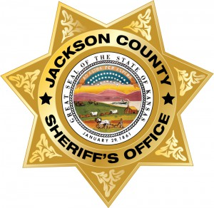
JACKSON SHERIFF
MOST WANTED
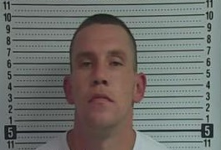
Name: Shaun Justin Barber
Alias: Shaun J. Barber
Description
Sex:--------------------------Male
Race:------------------------Native American
Year of Birth:--------------1984 (33 yrs)
Place of Birth:-------------Ks Shaun Justin Barber
Height:----------------------600
Weight:---------------------170 lbs
Eyes:------------------------Brown
Hair:-------------------------Brown
Skintone:-------------------Medium
Scars/Tattoos:------------

Wanted For: …Kidnapping, Aggravated Assault (2 counts) Aggravated Battery and Domestic Battery.
Warrant Issued: ....…..Jackson County District Court
Date of Warrant: ....….12/11/2017, 12/11/2017, 12/15/2017
Warrant #: 17CR446, 17CR448, 17TR625
Bond: None

UPDATE: Subject frequents the Prairie Band Potawatomi Nation, Delia, Northern Shawnee County and the Topeka area.

REWARD: A reward is being issued for information that leads to the capture of Shaun Justin Barber.
Contact: The Jackson County Sheriff’s Office, 210 US Hwy 75, Holton, Kansas 66436 or call 785-364-2251.
NOTICE: Before arrest, verify warrant through the National Crime Information Center (NCIC). If subject is arrested or whereabouts known, contact the nearest law enforcement agency. Have a tip? E-mail tim.morse@jasoks.org For more information, see the JASO website: www.jasoks.org

