Jackson County Sheriff’s Office
Missing Person For Over 6 Months
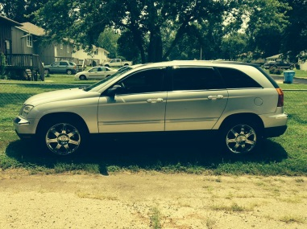
Name: Joan M. Rebar
Alias: Joanie
Description
Sex:---------------------------- Female
Race:-------------------------- Native American
Age:---------------------------- 71-years-old
Height:-------------------------506
Weight-------------------------230
Eyes: -------------------------- Blue
2005 Silver Chrysler Pacifica
Hair: --------------------------- Brown
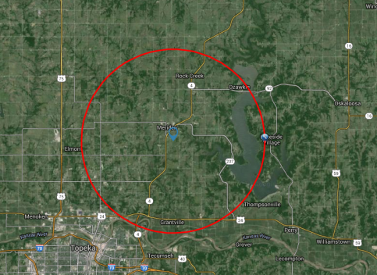
Skin tone: ---------------------Medium

Missing Person: Joan Rebar Joan Rebar
Last seen: At the VFW post in Meriden, Kansas after
1 am on Saturday Sept. 26th, 2015.

Rebar may have been on her way back to her residence
on the Potawatomi Reservation in Jackson County, Ks.

Rebar had been driving her silver 2005 Chrysler Pacifica
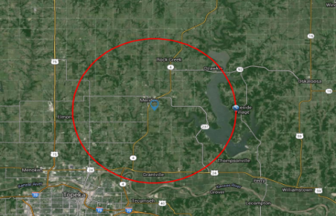
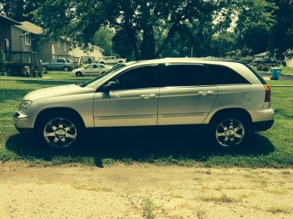
bearing Kansas disabled tag 71664.
Last known cell phone ping from the cell phone tower in Meriden, Ks on Saturday Sept. 26th around 4 pm. Cell phone company indicates phone may have been within 7 miles of the tower.

2005 Chrysler Pacifica Last known location of Rebar’s phone
REWARD: A reward is being issued for information that leads to the location of or circumstances that led to the disappearance of Joan Rebar.
Contact: The Jackson County Sheriff’s Office, 210 US Hwy 75, Holton, Kansas 66436 or call 785-364-2251 or the Potawatomi Tribal Police at 785-966-3024. A multi-jurisdictional task force has been established to investigate the disappearance of Joan Rebar.
NOTICE: If whereabouts known, contact the nearest law enforcement agency. Have a tip? E-mail tim.morse@jasoks.org For more information, see the JASO website: www.jasoks.org

